**Understanding How Genetics and**

**Environments Shape the**

**Development of Schizophrenia**

[**Choi Shing Wan**](mailto:choishingwan@gmail.com)

A thesis submitted in partial fulfillment of the requirements for

the Degree of Doctor of Philosophy



Department of Psychiatry

University of Hong Kong

Hong Kong

December 15, 2015

**Abstract**

Schizophrenia (SCZ) is a detrimental disorder affecting approximately 1% of the pop- ulation worldwide. To fully understand the disease mechanism for the development of proper treatments, it is important not only to examine how certain genetic polymor- phisms can predispose individuals to the disease development, but also how environ- mental factors triggers the disorder in apparently healthy individuals.

Genome Wide Association Study (GWAS) is now a standard approach for investi- gating associations of common genetic variations (mainly the Single Nucleotide Poly- morphisms (SNPs)) with SCZ. A recent meta-analysis of GWAS of SCZ has identified

108 loci significantly associated with SCZ. However, due to the limitation of sample size and the moderate-to-small effect size of an unknown number of causal loci, many SNPs associated with SCZ may be left undetected and a much larger sample size of GWAS may be required. However, it is also possible that these 108 loci have already contained all or near most of the SNPs associated with the disease. So estimating the contribution of these common SNPs to SCZ (and other complex diseases) has important implications for future research strategy.

In this thesis, we proposed an alternative approach for estimating the contribution of SNPs to SCZ (SNP-heritability) from GWAS summary statistics, called the SNP HeRitability Estimation Kit (SHREK). Our simulation results suggested that when compared to the existing method (LD SCore regression (LDSC)), SHREK provided a more robust estimate for oligogentic traits and in case-control designs in which no confounding variables was present. Using the summary statistics from the latest meta- analysis of GWAS of SCZ, we estimated that SCZ has a SNP-heritability of 0.174 (SD=0.00453), which is similar to the estimate of 0.197 (SD=0.0058) by our competitor LDSC. The result indicated that common SNPs have relatively less contribution to the genetic predisposition of individuals to SCZ as measured by the heritability estimated. Also, it suggested that alternative strategies like whole genome sequencing would be more efficient for identifying additional SCZ genes, compared to GWAS.

On the other hand, prenatal infection has been identified as the single largest environmental risk factor of SCZ. It was estimated that prenatal infection may account for one-third of the cases of SCZ. It has now been developed that the effect of prenatal infection was mainly mediated by maternal immune response to the infection. So it is important to understand how this triggers the disorder through studying the change in global gene expressions in mouse cerebellum.

In this thesis, we also performed a RNA-sequencing study for the effect of ma- ternal immune activation (MIA) in mouse cerebellum. By using the polyriboinosinic- polyribocytidilic acid (PolyI:C) mouse model, we found that several pathways related to neural functioning and calcium ion signaling were likely to be disrupted by MIA in the cerebellum. In addition, we investigated how a n-3 polyunsaturated fatty acid (PUFA) rich diet can help to reduce the SCZ-like phenotype in mice exposed to early MIA insults. We found that Sgk1, a gene that can regulate the glutamatergic sys- tem, is potentially affected by the n-3 PUFA rich diet in the PolyI:C exposed mice. In conclusion, our results suggested that genes related to neural function or calcium ion signaling, as well as glutamate-related genes such as Sgk1, are potential targets for future SCZ research.

(550 words)

**Declaration**

I declare that this thesis represents my own work, except where due acknowledgments is made, and that it has not been previ- ously included in a thesis, dissertation or report submitted to this University or to any other institution for a degree, diploma or other qualification.

Signed....................................................................

Choi Shing Wan

iii

**Acknowledgements**

This thesis would not be possible without my supervisors, Professor Pak Sham, Dr Stacey Cherny and Dr Wanling Yeung and I would like to thank them for taking me in and giving my guidance whenever I need during my study. I would like to especially thanks Professor Pak Sham for his trust, guidance and support to me and provide me the valuable opportunity to work on different projects.

I am also blessed to have Dr Johnny Kwan, Dr Timothy Mak and Dr Desmond Campbell to have the patience to teach me all the statistical problems I have encountered during my studies and especially Dr Johnny Kwan for his constant guidances. Without my helpful and lovely colleagues, my life will be much different and I am in debt to them for giving me such a memorable and enjoyable time for the past 4 years. Thank you Beatrice Wu, Dr Li Qi, Tomy Hui, Vicki Lin, Nick Lin, John Wong, Dr Clara Tang, Dr Amy Butler, Dr Allen Gui, Dr Sylvia Lam, Yung Tse Choi, Oi Chi Chan Pui King Wong and Dr Miaoxin Li for their constant support and advice and for giving such a lovely atmosphere in the department.

Finally, I must thanks Beatrice Wu and my family for without their support and constant encouragement, I won’t be able to complete my thesis.

THANK YOU!

bp base pair.

DEG differentially expressed gene. EGF epidermal growth factor.

ERCC External RNA Controls Consortium. FGF fibroblast growth factor.

GD Gestation Day. GO Gene Ontology.

GWAS Genome Wide Association Study. IL-6 Interleukin-6.

LD Linkage Disequilibrium. LDSC LD SCore regression. LRT likelihood ratio test.

maf minor allele frequency.

MAPK mitogen-activated protein kinase. MIA maternal immune activation. MSigDB Molecular Signatures Database.

NGS next generation sequencing. PCA principle component analysis.

PET positron emission tomography.

PGC Psychiatric Genomics Consortium. PI3K phosphatidylinositol 3-kinase.

PolyI:C polyriboinosinic-polyribocytidilic acid. PUFA polyunsaturated fatty acid.

QC quality control.

RIN RNA integrity number. rt-PCR real time PCR.

SHREK SNP HeRitability Estimation Kit. SNP Single Nucleotide Polymorphism.

**Abstract i Declaration iii Acknowledgments v Abbreviations vii Contents ix**

**1 Introduction 1**

1.1 Schizophrenia . . . . . . . . . . . . . . . . . . . . . . . . . . . . . . . . 1

1.2 Diagnosis . . . . . . . . . . . . . . . . . . . . . . . . . . . . . . . . . . 3

1.3 Risk Factors of Schizophrenia . . . . . . . . . . . . . . . . . . . . . . . 3

1.4 Broad Sense Heritability . . . . . . . . . . . . . . . . . . . . . . . . . . 8

1.5 Narrow Sense Heritability . . . . . . . . . . . . . . . . . . . . . . . . . 9

1.6 Liability Threshold . . . . . . . . . . . . . . . . . . . . . . . . . . . . . 12

1.7 Twin Studies of Schizophrenia . . . . . . . . . . . . . . . . . . . . . . . 14

1.8 Genetic Analysis of Schizophrenia . . . . . . . . . . . . . . . . . . . . . 16

1.8.1 Genetic Architecture of Schizophrenia . . . . . . . . . . . . . . . 16

1.8.2 The Human Genome Project and HapMap Project . . . . . . . 18

1.8.3 Genome Wide Association Study . . . . . . . . . . . . . . . . . 19

1.8.4 Genome-wide Complex Trait Analysis . . . . . . . . . . . . . . . 24

1.8.5 LD SCore regression . . . . . . . . . . . . . . . . . . . . . . . . 26

1.8.6 Partitioning of Heritability of Schizophrenia . . . . . . . . . . . 29

1.9 Summary . . . . . . . . . . . . . . . . . . . . . . . . . . . . . . . . . . 32

**2 Heritability Estimation 35**

2.1 Introduction . . . . . . . . . . . . . . . . . . . . . . . . . . . . . . . . . 35

2.2 Methodology . . . . . . . . . . . . . . . . . . . . . . . . . . . . . . . . 37

|  |  |  |  |  |  |  |  |  |  |  |  |  |  |  |  |  |  |  |  |  |
| --- | --- | --- | --- | --- | --- | --- | --- | --- | --- | --- | --- | --- | --- | --- | --- | --- | --- | --- | --- | --- |
| 2.2.1 | Heritability Estimation . . . . . | . | . | . | . | . | . | . | . | . | . | . | . | . | . | . | . | . | . | 38 |
| 2.2.2 | Calculating the Standard error | . | . | . | . | . | . | . | . | . | . | . | . | . | . | . | . | . | . | 43 |
| 2.2.3 | Case Control Studies . . . . . . | . | . | . | . | . | . | . | . | . | . | . | . | . | . | . | . | . | . | 46 |
| 2.2.4 | Extreme Phenotype Sampling . | . | . | . | . | . | . | . | . | . | . | . | . | . | . | . | . | . | . | 47 |

|  |  |  |  |  |  |  |  |  |  |  |  |  |  |  |  |
| --- | --- | --- | --- | --- | --- | --- | --- | --- | --- | --- | --- | --- | --- | --- | --- |
| 2.3 | Comparing Different LD correction Algorithms . | . | . | . | . | . | . | . | . | . | . | . | . | . | 55 |
| 2.4 | Comparison with Other Algorithms . . . . . . . | . | . | . | . | . | . | . | . | . | . | . | . | . | 58 |
|  | 2.4.1 Sample Size . . . . . . . . . . . . . . . . | . | . | . | . | . | . | . | . | . | . | . | . | . | 59 |
|  | 2.4.2 Number of SNPs in Simulation . . . . . | . | . | . | . | . | . | . | . | . | . | . | . | . | 60 |
|  | 2.4.3 Genetic Architecture . . . . . . . . . . . | . | . | . | . | . | . | . | . | . | . | . | . | . | 61 |
|  | 2.4.4 Extreme Effect Size . . . . . . . . . . . . | . | . | . | . | . | . | . | . | . | . | . | . | . | 63 |
|  | 2.4.5 Case Control Studies . . . . . . . . . . . | . | . | . | . | . | . | . | . | . | . | . | . | . | 64 |
|  | 2.4.6 Extreme Phenotype Sampling . . . . . . | . | . | . | . | . | . | . | . | . | . | . | . | . | 66 |
| 2.5 | Application to Real Data . . . . . . . . . . . . . | . | . | . | . | . | . | . | . | . | . | . | . | . | 68 |
| 2.6 | Result . . . . . . . . . . . . . . . . . . . . . . . | . | . | . | . | . | . | . | . | . | . | . | . | . | 70 |
|  | 2.6.1 LD Correction . . . . . . . . . . . . . . . | . | . | . | . | . | . | . | . | . | . | . | . | . | 70 |
|  | 2.6.2 Comparing with Other Algorithms . . . | . | . | . | . | . | . | . | . | . | . | . | . | . | 71 |
|  | 2.6.3 Extreme Phenotype Simulation . . . . . | . | . | . | . | . | . | . | . | . | . | . | . | . | 86 |
|  | 2.6.4 Application to Real Data . . . . . . . . . | . | . | . | . | . | . | . | . | . | . | . | . | . | 92 |
| 2.7 | Discussion . . . . . . . . . . . . . . . . . . . . . | . | . | . | . | . | . | . | . | . | . | . | . | . | 93 |
|  | 2.7.1 LD Correction . . . . . . . . . . . . . . . | . | . | . | . | . | . | . | . | . | . | . | . | . | 94 |
|  | 2.7.2 Simulation Results . . . . . . . . . . . . | . | . | . | . | . | . | . | . | . | . | . | . | . | 97 |
|  | 2.7.3 Application to Real Data . . . . . . . . . | . | . | . | . | . | . | . | . | . | . | . | . | . | 104 |
|  | 2.7.4 Limitations and Improvements . . . . . . | . | . | . | . | . | . | . | . | . | . | . | . | . | 107 |
| 2.8 | Supplementary . . . . . . . . . . . . . . . . . . | . | . | . | . | . | . | . | . | . | . | . | . | . | 110 |

**3 n-3 Polyunsaturated Fatty Acid Rich Diet in Schizophrenia 119**

|  |  |  |  |  |  |  |  |  |  |  |  |  |  |  |  |  |  |  |  |  |  |  |  |  |  |  |  |  |  |  |  |  |  |
| --- | --- | --- | --- | --- | --- | --- | --- | --- | --- | --- | --- | --- | --- | --- | --- | --- | --- | --- | --- | --- | --- | --- | --- | --- | --- | --- | --- | --- | --- | --- | --- | --- | --- |
| 3.1 | Introduction . . . . . . . . . | | | | | | | | . | . | . | . | . | . | . | . | . | . | . | . | . | . | . | . | . | . | . | . | . | . | . | . | 119 |
| 3.2 | Methodology . . . . . . . . | | | | | | | | . | . | . | . | . | . | . | . | . | . | . | . | . | . | . | . | . | . | . | . | . | . | . | . | 123 |
|  | 3.2.1 Sample Preparation . | | | | | | | | . | . | . | . | . | . | . | . | . | . | . | . | . | . | . | . | . | . | . | . | . | . | . | . | 123 |
| 3.2.2 RNA Extraction, Quality Control and Sequencing . . . . . . . . 124 | | | | | | | | | | | | | | | | | | | | | | | | | | | | | | | | | |
| 3.2.3 | | Sequencing Quality Control . . | | | | | | | | | | | | | . | . | . | . | . | . | . | . | . | . | . | . | . | . | . | . | . | . | 126 |
| 3.2.4 | | Alignment . . . . . . . . . . . . | | | | | | | | | | | | | . | . | . | . | . | . | . | . | . | . | . | . | . | . | . | . | . | . | 126 |
| 3.2.5 | | Differential Expression Analysis | | | | | | | | | | | | | . | . | . | . | . | . | . | . | . | . | . | . | . | . | . | . | . | . | 127 |
| 3.2.6 | | Functional Annotation . . . . . | | | | | | | | | | | | | . | . | . | . | . | . | . | . | . | . | . | . | . | . | . | . | . | . | 129 |
| 3.2.7 | | Designing the Replication Study | | | | | | | | | | | | | . | . | . | . | . | . | . | . | . | . | . | . | . | . | . | . | . | . | 129 |
| 3.3 | Results . . . . . . . . . . . . . . . . . . | | | | | | | | | | | | | | . | . | . | . | . | . | . | . | . | . | . | . | . | . | . | . | . | . | 130 |
| 3.3.1 | | Sample Quality . . . . . . . . . | | | | | | | | | | | | | . | . | . | . | . | . | . | . | . | . | . | . | . | . | . | . | . | . | 130 |
| 3.3.2 | | Differential Expression Analysis | | | | | | | | | | | | | . | . | . | . | . | . | . | . | . | . | . | . | . | . | . | . | . | . | 131 |
| 3.3.3 | | Functional Annotation . . . . . | | | | | | | | | | | | | . | . | . | . | . | . | . | . | . | . | . | . | . | . | . | . | . | . | 133 |
| 3.3.4 | | Designing the Replication Study | | | | | | | | | | | | | . | . | . | . | . | . | . | . | . | . | . | . | . | . | . | . | . | . | 136 |
| 3.4 | Discussion . . . . | | . | . | . | . | . | . | . | . | . | . | . | . | . | . | . | . | . | . | . | . | . | . | . | . | . | . | . | . | . | . | 136 |
|  | 3.4.1 Limitation | | . | . | . | . | . | . | . | . | . | . | . | . | . | . | . | . | . | . | . | . | . | . | . | . | . | . | . | . | . | . | 140 |
| 3.5 | Supplementary . | | . | . | . | . | . | . | . | . | . | . | . | . | . | . | . | . | . | . | . | . | . | . | . | . | . | . | . | . | . | . | 143 |

**4 Conclusion 145**

4.1 Challenge in SNP-Heritability Estimation . . . . . . . . . . . . . . . . . 146

4.2 Schizophrenia: Future Perspectives . . . . . . . . . . . . . . . . . . . . 148

**Bibliography 153**

1.1 Hypothesized model of the impact of prenatal immune challenge on fetal

brain development . . . . . . . . . . . . . . . . . . . . . . . . . . . . . 6

1.2 Risk factors of schizophrenia . . . . . . . . . . . . . . . . . . . . . . . . 7

1.3 Lifetime morbid risks of schizophrenia in various classes of relatives of a proband . . . . . . . . . . . . . . . . . . . . . . . . . . . . . . . . . . . 17

1.4 Enrichment of enhancers of SNPs associated with Schizophrenia . . . . 22

2.1 Cumulative Distribution of “gap” of the LD matrix . . . . . . . . . . . 52

|  |  |  |  |  |  |  |  |  |  |  |  |  |  |  |
| --- | --- | --- | --- | --- | --- | --- | --- | --- | --- | --- | --- | --- | --- | --- |
| 2.2 | GWAS Sample Size distribution . . . . . . . . . . | . | . | . | . | . | . | . | . | . | . | . | . | 60 |
| 2.3 | Effect of LD correction to Heritability Estimation | . | . | . | . | . | . | . | . | . | . | . | . | 70 |
| 2.4 | Mean of Quantitative Trait Simulation Results . . | . | . | . | . | . | . | . | . | . | . | . | . | 72 |
| 2.5 | Variance of Quantitative Trait Simulation Results | . | . | . | . | . | . | . | . | . | . | . | . | 73 |
| 2.6 | Estimation of Variance in Quantitative Trait Simulation . | | | | | | . | . | . | . | . | . | . | 74 |
| 2.7 | Mean of Extreme Effect Size Simulation Result . . . . . . | | | | | | . | . | . | . | . | . | . | 78 |
| 2.8 | Variance of Extreme Effect Size Simulation Result . . . . . | | | | | | . | . | . | . | . | . | . | 79 |
| 2.9 | Estimation of Variance in Extreme Effect Size Simulation . | | | | | | . | . | . | . | . | . | . | 80 |
| 2.10 | Mean of Case Control Simulation Results (10 Causal) . . . | | | | | | . | . | . | . | . | . | . | 82 |
| 2.11 | Variance of Case Control Simulation Results (10 Causal) . | | | | | | . | . | . | . | . | . | . | 83 |
| 2.12 Estimation of Variance in Case Control Simulation (10 Causal) . . . . . 84 | | | | | | | | | | | | | | |
| 2.13 | Mean of Extreme Phenotype Selection Simulation Results . . | | | | | | | . | . | . | . | . | . | 88 |
| 2.14 | Variance of Extreme Phenotype Selection Simulation Results | | | | | | | . | . | . | . | . | . | 89 |
| 2.15 | Estimation of Variance in Extreme Phenotype Selection . . . | | | | | | | . | . | . | . | . | . | 90 |
| 2.16 Effect of LD correction to Heritability Estimation with 50,000 SNPs . . 95 | | | | | | | | | | | | | | |
| 2.17 | Effect of Extreme Sampling Design . . . . . . . . . . . . . . . . | | | | | | | | | . | . | . | . | 102 |
| 2.18 | Mean of Case Control Simulation Results (50 Causal) . . . . . . | | | | | | | | | . | . | . | . | 110 |
| 2.19 | Variance of Case Control Simulation Results (50 Causal) . . . . | | | | | | | | | . | . | . | . | 111 |
| 2.20 | Estimation of Variance in Case Control Simulation (50 Causal) . | | | | | | | | | . | . | . | . | 112 |
| 2.21 | Mean of Case Control Simulation Results (100 Causal) . . . . . | | | | | | | | | . | . | . | . | 113 |
| 2.22 | Variance of Case Control Simulation Results (100 Causal) . . . | | | | | | | | | . | . | . | . | 114 |
| 2.23 | Estimation of Variance in Case Control Simulation (100 Causal) | | | | | | | | | . | . | . | . | 115 |
| 2.24 | Mean of Case Control Simulation Results (500 Causal) . . . . . | | | | | | | | | . | . | . | . | 116 |
| 2.25 | Variance of Case Control Simulation Results (500 Causal) . . . | | | | | | | | | . | . | . | . | 117 |
| 2.26 | Estimation of Variance in Case Control Simulation (500 Causal) | | | | | | | | | . | . | . | . | 118 |

3.4 Schematic of signalling through the PI3K/AKT pathway . . . . . . . . 139

4.1 Relationship between Effect Size and Allele Frequency . . . . . . . . . 149

|  |  |  |
| --- | --- | --- |
| 1.1 | Top 20 leading cause of years lost due to disability . . . . . . . . . . . . | 2 |
| 1.2 | Enrichment of Top Cell Type of Schizophrenia . . . . . . . . . . . . . . | 32 |
| 2.1 | MSE of Quantitative Trait Simulation with Random Effect Size . . . . | 76 |
| 2.2 | MSE of Quantitative Trait Simulation with Extreme Effect Size . . . . | 81 |
| 2.3 | MSE of Case Control Simulation . . . . . . . . . . . . . . . . . . . . . | 87 |
| 2.4 | Comparing the MSE of Extreme Phenotype Sampling and Random Sam-  pling . . . . . . . . . . . . . . . . . . . . . . . . . . . . . . . . . . . . . | 91 |
| 2.5 | Heritability Estimated for PGC Data Sets . . . . . . . . . . . . . . . . | 92 |
| 2.6 | Heritability Estimated for PGC Data Sets without Intercept Estimation | 105 |
| 3.1 | Sample Information . . . . . . . . . . . . . . . . . . . . . . . . . . . . . | 125 |
| 3.2  3.3 | Significant Pathways When Comparing Effect of Diet in PolyI:C Exposed  Mouse . . . . . . . . . . . . . . . . . . . . . . . . . . . . . . . . . . . . Significant Pathways When Comparing Effect PolyI:C in Mouse Given n-6 polyunsaturated fatty acid (PUFA) Rich Diet . . . . . . . . . . . . | 134  135 |
| 3.4 | Design for Follow Up Study . . . . . . . . . . . . . . . . . . . . . . . . | 144 |

**Chapter 1**

**Introduction**

**1.1 Schizophrenia**

Schizophrenia is a detrimental psychiatric disorder, affecting around 0.3 ∼ 0.7% of the population (American Psychiatric Association, 2013). It is characterized by positive symptoms including delusions, hallucinations, disorganized speech, grossly disorganized behavior, and negative symptoms such as the diminished emotional expression (Amer- ican Psychiatric Association, 2013) with a typical age of onset at late adolescent or late 20s in male and late 20s or early 30s in female (Schultz, North, and C. G. Shields,2007).

Schizophrenia not only impose long lasting health, social and financial bur- den to the patients, but also to their families (Knapp, Mangalore, and Simon, 2004). Moreover, patients with schizophrenia have an increased tendency to suicide (Saha, Chant, and Mcgrath, 2007), leading to a higher mortality. Based on the World Health Organization (WHO) report, schizophrenia is one of the top 20 leading cause of years lost due to disability (YLD) in 2012, ranking 16 among all possible causes (table 1.1), demonstrating the extent of impact from schizophrenia to patients.

**Table 1.1:** Top 20 leading cause of YLD calculated by WHO in year 2012. Schizophrenia was considered as one of the top 20 leading cause of YLD(World Health Organization, 2013)

|  |  |  |  |  |
| --- | --- | --- | --- | --- |
| Rank | Cause | YLD (000s) | % YLD | 100k population |
| 0 | All Causes | 740,545 | 100 | 10466 |
| 1 | Unipolar depressive disorders | 76,419 | 10.3 | 1080 |
| 2 | Back and neck pain | 53,855 | 7.3 | 761 |
| 3 | Iron-deficiency anaemia | 43,615 | 5.9 | 616 |
| 4 | Chronic obstructive pulmonary disease | 30,749 | 4.2 | 435 |
| 5 | Alcohol use disorders | 27,905 | 3.8 | 394 |
| 6 | Anxiety disorders | 27,549 | 3.7 | 389 |
| 7 | Diabetes mellitus | 22,492 | 3 | 318 |
| 8 | Other hearing loss | 22,076 | 3 | 312 |
| 9 | Falls | 20,409 | 2.8 | 288 |
| 10 | Migraine | 18,538 | 2.5 | 262 |
| 11 | Osteoarthritis | 18,096 | 2.4 | 256 |
| 12 | Skin diseases | 15,744 | 2.1 | 223 |
| 13 | Asthma | 14,134 | 1.9 | 200 |
| 14 | Road injury | 13,902 | 1.9 | 196 |
| 15 | Refractive errors | 13,498 | 1.8 | 191 |
| 16 | Schizophrenia | 13,408 | 1.8 | 189 |
| 17 | Bipolar disorder | 13,271 | 1.8 | 188 |
| 18 | Drug use disorders | 10,620 | 1.4 | 150 |
| 19 | Endocrine, blood, immune disorders | 10,495 | 1.4 | 148 |
| 20 | Gynecological diseases | 10,227 | 1.4 | 145 |

Due to the severity of schizophrenia, it has drawn much attention from the research community, hoping to delineate the disease mechanics and to identify risk factors associated with schizophrenia. Ultimately, the goal of schizophrenia research is to identify treatment(s)/cure(s) to help improving the quality of life of the patients. Arguably, the most important first step to any schizophrenia study is to have a robust and reliable disease diagnosis.

**1.2 Diagnosis**

Schizophrenia was first named “Dementia Praecox” by Dr. Emil Kraepelin and was later renamed as schizophrenia by Dr. Eugen Bleuler (Jablensky, 2010). Early noso- logical entity for schizophrenia such as Diagnostic and Statistical Manual of Mental Disorders (DSM)-I and DSM-II were vague and unreliable where the inter-rater agree- ment can be as low as 54%. (Tsuang, Stone, and Faraone, 2000; Harvey et al., 2012)

Later nosologies addressed these problem by introducing structural assessment and clear defined criteria. With these improvements, the inter-rater agreement of DSM- III raised to ∼ 90% (Harvey et al., 2012), suggesting the diagnosis were much more reliable.

Currently DSM is at its 5th edition (American Psychiatric Association, 2013). A patient will be diagnosed with schizophrenia (F20.9) if they suffered from 2 or more of the following symptoms for a significant portion of time during a 1-month period:

1) delusion; 2) hallucinations; 3) disorganized speech; 4) grossly disorganized or catatonic behaviour; and 5) negative symptoms such as diminished emotional expression, where one of the symptom must be either (1), (2) or (3). Signs of disturbance also need to persist for at least 6-month before the patient can be diagnosed with schizophrenia.

**1.3 Risk Factors of Schizophrenia**

Considerable efforts have been made to identify possible risk factors of schizophrenia. It was first observed that there was an increased risk of schizophrenia in individual who were fetuses during the 1957 influenza epidemic (Mednick, 1958). Subsequently, other infectious agents such as HSV-2 and T.gondii were also found to increase the risk of schizophrenia if an individual’s mother were infected during pregnancy. As different infectious agents all increase the risk of schizophrenia, it leads to the hypothesis of maternal immune activation (MIA) (A S Brown and Derkits, 2010). The MIA theory suggest that instead of a particular infectious agents, it was the maternal immune response that disrupt the brain development in the offspring, leading to an elevated risk of schizophrenia.

To study the effect of MIA, rodent models were generated to allow empirical testing of the effect of MIA on the fetal brain development. A common model is to use the viral analogue polyriboinosinic-polyribocytidilic acid (PolyI:C) to induce the maternal immune response during pregnancy in rodents where behaviours and brain of the offspring were then examined. It was found that offspring exposed to PolyI:C displays phenotypes mirrors that observed in schizophrenia (Q. Li, C. Cheung, Wei, Hui, et al., 2009; Urs Meyer, Joram Feldon, and Fatemi, 2009; Q. Li, C. Cheung, Wei, V. Cheung, et al., 2010) such as deficiency in prepulse inhibition (Cadenhead et al., 2000). Because PolyI:C only induce the MIA without infecting the fetuses, the PolyI:C model provide strong evidence that MIA, instead of the specific infection, contributes to the increased risk of schizophrenia.

Smith et al. (2007) were able to show that a single injection of Interleukin-6 (IL-6) to the pregnant mouse can induce schizophrenia-like behaviour in the adult offspring. What was most interesting was by eliminating the IL-6 from the mater- nal immune response using either genetic methods (IL-6 knock out) or with blocking antibodies, the behaviour deficits associated with MIA were not present in the adult offspring, suggesting that IL-6 is central to the process by which MIA causes long-term behavioral changes.

Further studies of global gene expression patterns in MIA-exposed rodent fetal brains (Oskviga et al., 2012; Garbett et al., 2012) suggest that the post-pubertal on- set of schizophrenic and other psychosis-related phenotypes might stem from attempts of the brain to counteract the environmental stress induced by MIA during its early development (Garbett et al., 2012). For example, genes with neuroprotective function such as crystallins might also have additional roles in neuronal differentiation and axonal growth (Garbett et al., 2012). By over-expressing these genes to counteract the environmental stress, the balance between neurogenesis and differentiation in the embryonic brain maybe disrupted. Based on these observations, Garbett et al. (2012) propose that once the immune activation disappears, the normal brain development programme resumes with a time lag, result in permanent changes in connectivity and neurochemistry that might ultimately leads to schizophrenia-like behaviours.

It was also demonstrated that MIA might leads to a complex pattern of age- dependent structural abnormalities in the mesoaccumbal and nigrostriatal dopamine systems (Vuillermot et al., 2010). Specifically, MIA induces an early abnormality in spe- cific dopaminergic systems such as those in the striatum and midbrian region (Vuiller- mot et al., 2010). Based on these observations, U Meyer, Yee, and J Feldon (2007) hypothesize that inflammation in the fetal brain during early gestation not only can disrupt neurodavelopmental processes such as cell proliferation and differentiation, it also predispose the developing nervous system to additional failures in subsequent cell migration, target selection, and synapse maturation (fig. 1.1) (U Meyer, Yee, and J Feldon, 2007).

In a separate study by Giovanoli et al. (2013), mice were exposed to low dosage of PolyI:C during early gestation. Offspring born were then left undisturbed or exposed to unpredictable stress during peripubertal development. It was observed that offspring exposed to PolyI:C has an increased level of dopamine in the nucleus accumbens independent to whether if they were exposed to postnatal stress whereas serotonin (5-HT) were decreased in the medial prefrontal cortex when exposed to postnatal stress regardless of prenatal exposure. Only when the offspring were exposed to both PolyI:C and postnatal stress will they have an increased dopamine levels in the hippocampus or will sensorimotor gating and psychotomimetic drug sensitivity be affected (Giovanoli et al., 2013). Giovanoli et al. (2013) therefore suggest that the prenatal insult serves as a “disease primer” that increase offspring’s vulnerability to subsequent insults.

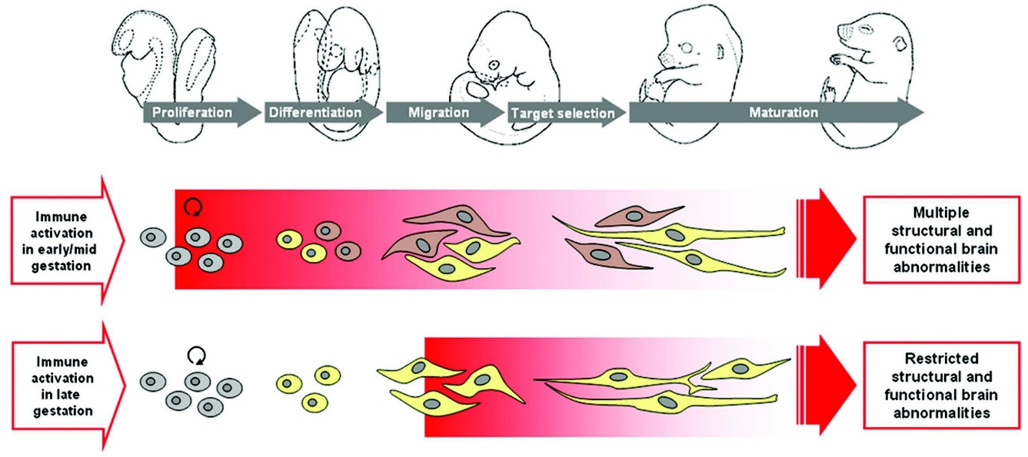

**Figure 1.1:** Hypothesized model of the impact of prenatal immune challenge on fetal brain development. Maternal infection in early/mid pregnancy may affect early neurodevelopmental events in the fetal brain, thereby influencing the differentiation of neural precursor cells (grey) into particular neuronal phenotype (yellow or brown). This may predispose the developing fetal nervous system to additional failures leading to multiple structural and functional brain abnormalities in later life. Figure used with permission from Journal (U Meyer, Yee, and J Feldon, 2007)

Another interesting observation in Giovanoli et al. (2013)’s study was that the combined immune activation and stress led to a 2.5 to 3 fold increase in hippocampal and prefrontal expression of markers characteristic of activated microglia. Considering that microglia is responsible for synaptic pruning during brain development (Paolicelli et al., 2011), perturbation of microglia in the fetal brain might also mediate schizophrenia. Indeed, Onore et al. (2014) demonstrated that MIA has a prolonged effect on macrophages, leading to a shift towards to proinflammatory M1 phenotype. Immune dysfunction in the pathophysiology of schizophrenia has long been speculated (Muller and Schwarz, 2010) and evidence shown that there was a strong influence of the pro- and anti-inflammation cytokines on the glutamatergic neurotransmission (Mu¨ller and Schwarz, 2010), suggesting the immune system might played an important role in disease etiology of schizophrenia.

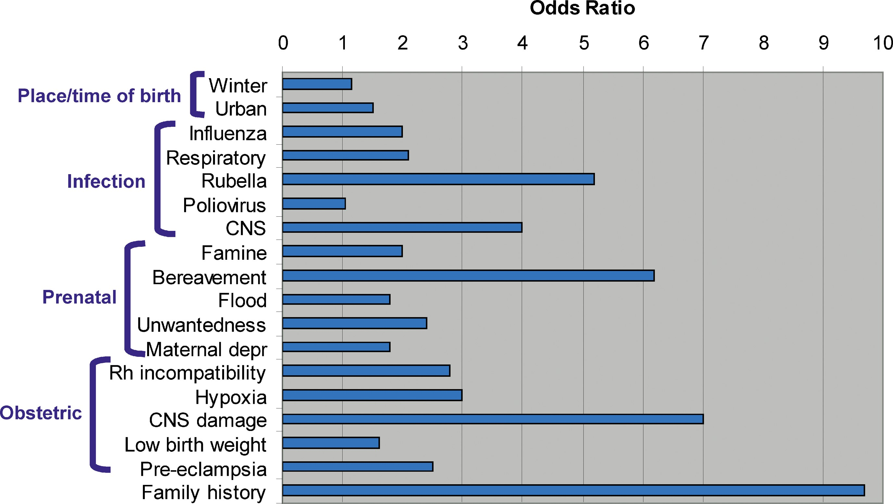

**Figure 1.2:** Risk factors of schizophrenia. It was observed that family history of schizophrenia was the largest risk factors. Risk of schizophrenia can be more than 9 times higher than the general population for individual with a family history of schizophrenia

Together, these results supports the involvement of MIA in the development of schizophrenia. It was even estimated that one third of all schizophrenia cases could have been prevented shall all infection were prevented from the entire pregnant population (A S Brown and Derkits, 2010).

Similarly, tobacco consumption (Kelly and McCreadie, 1999) and socio eco- nomic status were also found to be associated with increased risk of schizophrenia (McGrath et al., 2008). However, by and large, the single largest risk factor was fam- ily history of schizophrenia (fig. 1.2) (Sullivan, 2005). Studies conducted by Ernst Ru¨din, Franz J. Kallmann and Hans Luxenburger, all demonstrated that the relatives of schizophrenia tends to have increased risk of schizophrenia (Irving I Gottesman and James Shields, 1982). The implication of such observation was twofold: as family mem- bers usually shares larger portion of their genetic effects with each other than that of the population, the genetic effects might be the main mediator of schizophrenia; on the other hand, culture, socio-economic status and area of birth usually transmit within the family, so one cannot separate the environmental factors from the genetic factors.

It was important to study the relative contribution of genetic and environ- mental influence to individual differences in schizophrenia. If schizophrenia was indeed a genetic disease, one may then focus the resources into study of genetic variations in schizophrenia patients. To quantify the relative contribution of genetic and environ- mental influence, one will need to estimate the heritability of schizophrenia.

**1.4 Broad Sense Heritability**

A key concept in quantitative genetics is heritability, which was defined as proportion of total variance of a trait in a population explained by variation of genetic factors in the population. One can partition observed phenotype into a combination of genetic and environmental components (Falconer and Mackay, 1996)

Phenotype (P) = Genotype (G) + Environment (E)

where the variance of the observed phenotype ( $σ_{P}^{2}$) can be expressed as variance of genotype ($σ_{G}^{2}$) and variance of environment ( $σ_{E}^{2}$)



The broad sense heritability can then be defined as the ratio between the variance of the observed phenotype and the variance of the genetic effects



One key feature of heritability is that it is a ratio of population measurement at a specific time point. As a result of that, the heritability estimation might differ from one population to another due to difference in minor allele frequency (maf) and one might obtain a different heritability estimate if the method or time-point of measurement of the trait differs because of different environmental factors coming into play. A classic example was the study of intelligence quotient (IQ) where the heritability estimation increases with age (Bouchard, 2013). It was hypothesize that the shared en- vironment has a larger effect on individuals when they were young, and as they become more independent, the effect of shared environment diminishes, leading to an increased portion of variance in IQ explained by the variance in genetic (Bouchard, 2013).

**1.5 Narrow Sense Heritability**

In reality, the problem of heritability was more complicated for there were different forms of genetic effects. For example, one can partition the genetic variance into variance of additive genetic effects ($σ_{A}^{2}$), variance of dominant genetic effects ( $σ_{D}^{2}$) and other epistatic genetic effects ($σ_{I}^{2}$) such that

*I*



where additive genetic variance was the variance explained by the average effects of all loci involved in the determination of the trait, whereas dominant genetic effects and epistatic genetic effects were the interaction between alleles at the same locus or different loci respectively.

As individuals only transmit one copy of each allele to their offspring, relatives other than full siblings and identical twins will only share a maximum of one copy of the allele. Considering that dominance and non-additive genetic effects were the interactive effect, which usually involve more than one copy of the alleles, these effects are unlikely to contribute to the resemblance between relatives (Peter M Visscher, William G Hill, and Naomi R Wray, 2008). On the other hand, the additive genetic effects is usually transmitted from parent to offspring, thus it is more useful to consider the narrow sense heritability (h2) which only consider the additive genetic effects:



To obtain the additive genetic effect, we can first consider the genetic effect of parents to be**. As only half of the additive effect were transmitted to their offspring, the child will have a genetic effect of  where A’ is the additive genetic effect obtained from another parent by random and D’ is the non-additive genetic effect in the offspring. If we then consider the parent offspring covariance, we will get



Under the assumption of random mating, A’ should be independent from A and D. On the other hand, as D’ was specific to the child, it should be independent from A and D. Moreover, the covariance between the additive genetics and non-additive genetics should be zero (Falconer and Mackay, 1996). Thus, eq. (1.2) becomes



Now if we assume the variance of phenotype of the parent and offspring were the same, then using eq. (1.3), we can obtain the narrow-sense heritability as



If we consider the simple linear regression equation Y = X β + c, its slope can be calculated as



which resemble eq. (1.4). Therefore, we can calculate the narrow sense heritability as

*h*2 = 2*βOP* (1.6)

where *βOP* is the slope of the simple linear regression regressing the phenotype of an offspring to the phenotype of *one* of its parents. We can further generalize eq. (1.6) to all possible relativeness



where *r* is the relativeness of *X* and *Y* .

A key assumption in this calculation was that the relatives does not share anything other than the additive genetic factors. However, this was usually not the case as relatives does tends to be in the same cultural group and might have similar socio-economic status which might all contribute to the variance of the trait. This might therefore lead to bias in eq. (1.7) and we shall discuss the partitioning of variance in the later sections.

Nonetheless, eq. (1.7) was still useful for the understanding of the calcula- tion of heritability. However, in the case of discontinuous trait (e.g. disease status) the calculation becomes more complicated because the variance of the phenotype was dependent on the population prevalence. As eq. (1.7) does not account for the trait prevalence, it cannot be directly applied to discontinuous traits. In order to perform heritability estimation, we will need the concept of liability threshold model popularized by Falconer, 1965.

**1.6 Liability Threshold**

According to the central limit theorem, if a phenotype is determined by a multitude of genetics and environmental factors with relatively small effect, then its distribution will likely follow a normal distribution as is the case of many quantitative traits (Peter M Visscher, William G Hill, and Naomi R Wray, 2008). The variance of phenotype can therefore be calculated as the variance under the normal distribution. However, such is not the case for disease such as schizophrenia where instead of having a continuous distribution of phenotype, only a dichotomous labeling of “affected” and “normal” were obtained. The variance of these phenotype were therefore more difficult to obtain.

Falconer (1965) proposed the liability threshold model, which suggesting that these discontinuous traits also follow a continuous distribution with an additional pa- rameter called the “liability threshold”. Under the liability threshold model, the discon- tinuous traits were affected by combination of multitude of genetics and environmental factors, each with a small effects, as in the case of the continuous traits. The main difference was that the phenotype of an individual is determined by whether if the com- bined effects of these factors (“liability”) were above a particular threshold (“liability threshold”). So for example, in the case of schizophrenia, only when an individual has a liability above the liability threshold will he/she be affected.

One can then estimate the heritability of the discontinuous by comparing the mean liability of the general population when compared to the relatives of the affected individuals. For example, if we consider a single threshold model of a dichotomous trait, where

*TG* = Liability threshold of the general population

*TR* = Liability threshold of relatives of the index case

*qG* = Prevalence in the general population

*qR* = Prevalence in relatives of the index case

*La =* Mean Liability of the index case

by assuming both the liability distribution of the general population and the relative of the index case both follows the standard normal distribution, we can align the two distribution with respect to *TG* and *TR*. We can then calculate the mean liability of the index case *La* as $La=\frac{ZG}{qG}$ where $ZG$ is the density of the normal distribution at the liability threshold *TG*. Then we can express the regression of relatives’ liability on the liability of the index case as



Thus, by applying eq. (1.8) to eq. (1.7), we get



**1.7 Twin Studies of Schizophrenia**

The key limitation of eq. (1.7) was its inability to discriminate the genetic factors from the shared environmental factors. Such problem arise as family not only shared some of their genes, but they also tends to share some of the environmental factors such as diet. In fact, this was the main reason for researchers to discord the argument that schizophrenia is a genetic disorder.

A classical adoption study carried out by Heston (1966) in 1966 set off to discriminate whether if the increased risk of schizophrenia in relatives of schizophrenia was caused by the shared environmental factors or the shared genetic factors. An advantages of adoption studies was that if the child was separated from their family early after birth, then the shared environmental factors should be minimized, thus any resemblance between the parent and child should be driven mainly by the shared genetic factors. Heston (1966) collected data of 47 individuals born from a schizophrenic mother during the period from 1915 to 1947. They were separated from their mother within three day of birth and were sent to a foster family. 50 matched control were also recruited to the study. It was observed that there was an increased risk of schizophrenia in individual born to schizophrenic mother when compared to the control group even- though they were brought up in a different environment as that of their mother. This result suggested that schizophrenia was likely driven by the shared genetic factors instead of the shared environmental factors.

Despite the usefulness of adoption studies in delineating the effect of shared environment from the genetic factors, collection of adoption data were difficult. More- over, any prenatal influence such as alcohol abuse during pregnancy might confound the results. Therefore, an alternative way would be the twin studies using the relationship between the monozygotic (MZ) and dizygotic (DZ) twins.

Theoretically, MZ twins should share all their genetic components (both additive (A) and non-additive (D) genetic factors) and also their common environmental factors (C) where the only difference between a twin pair would be the non-shared environmental factors (E). As for the DZ twins, they also share the same common environmental factors yet they only share 0.5 of their additive genetic factors and 0.25 of their non-additive genetic factors. The non-shared environmental was also by definition not shared among the twins (Rijsdijk and Pak C Sham, 2002). Based on these assumptions, Falconer and Mackay, 1996 derived the heritability as

**

where *ρM Z* and *ρDZ* were the phenotype correlation between the MZ twins and DZ twins respectively.

By combining Falconer’s formula and the concept of liability threshold model, I I Gottesman and J. Shields (1967) estimated that the heritability of schizophrenia to be > 60% based on previously collected twin data, strongly suggest schizophrenia as a genetic disorder. The result was further supported by one of the landmark meta-analysis study conducted by Sullivan, Kendler, and M. C. Neale (2003). Based on data obtained from 12 published schizophrenia twin studies, Sullivan, Kendler, and M. C. Neale (2003) found that although there was a non-zero contribution of environmental influence on liability of schizophrenia (11%, confidence interval (CI) =3% − 19%), there was a much larger contribution from genetics (81%, CI=73%−90%), further supporting that schizophrenia was largely mediated by the genetic factors.

Such findings were not limited to twin-studies but were also reported in large scale population based studies. A recent large scale population based study in Sweden population (Lichtenstein et al., 2009) also found that there was a large genetic contri- bution in schizophrenia (64%). Although the estimated heritability (64% (Lichtenstein et al., 2009) vs 81% (Sullivan, Kendler, and M. C. Neale, 2003)) differs between the two studies, there is no doubt that schizophrenia is highly heritable, leading to the initiative of genetic research in schizophrenia.

**1.8 Genetic Analysis of Schizophrenia**

**1.8.1 Genetic Architecture of Schizophrenia**

Studies on estimation of heritability of schizophrenia strongly support schizophrenia as a genetic disorder. However, little was known about the mechanism of schizophrenia nor the genetic architecture of the disorder. All data from adoption studies, twin studies and family studies shown that schizophrenia does not follow the Mendelian framework (I I Gottesman and J. Shields, 1967; Irving I Gottesman and James Shields, 1982). Specifically, shall schizophrenia be a Mendelian disorder, then we would expect all MZ siblings of the proband to also suffer from schizophrenia. However, the life time morbid risk of monozyogitc twins were only 48% (fig. 1.3) (I. Gottesman, 1991), making it unlikely for schizophrenia to follow a Mendelian pattern.

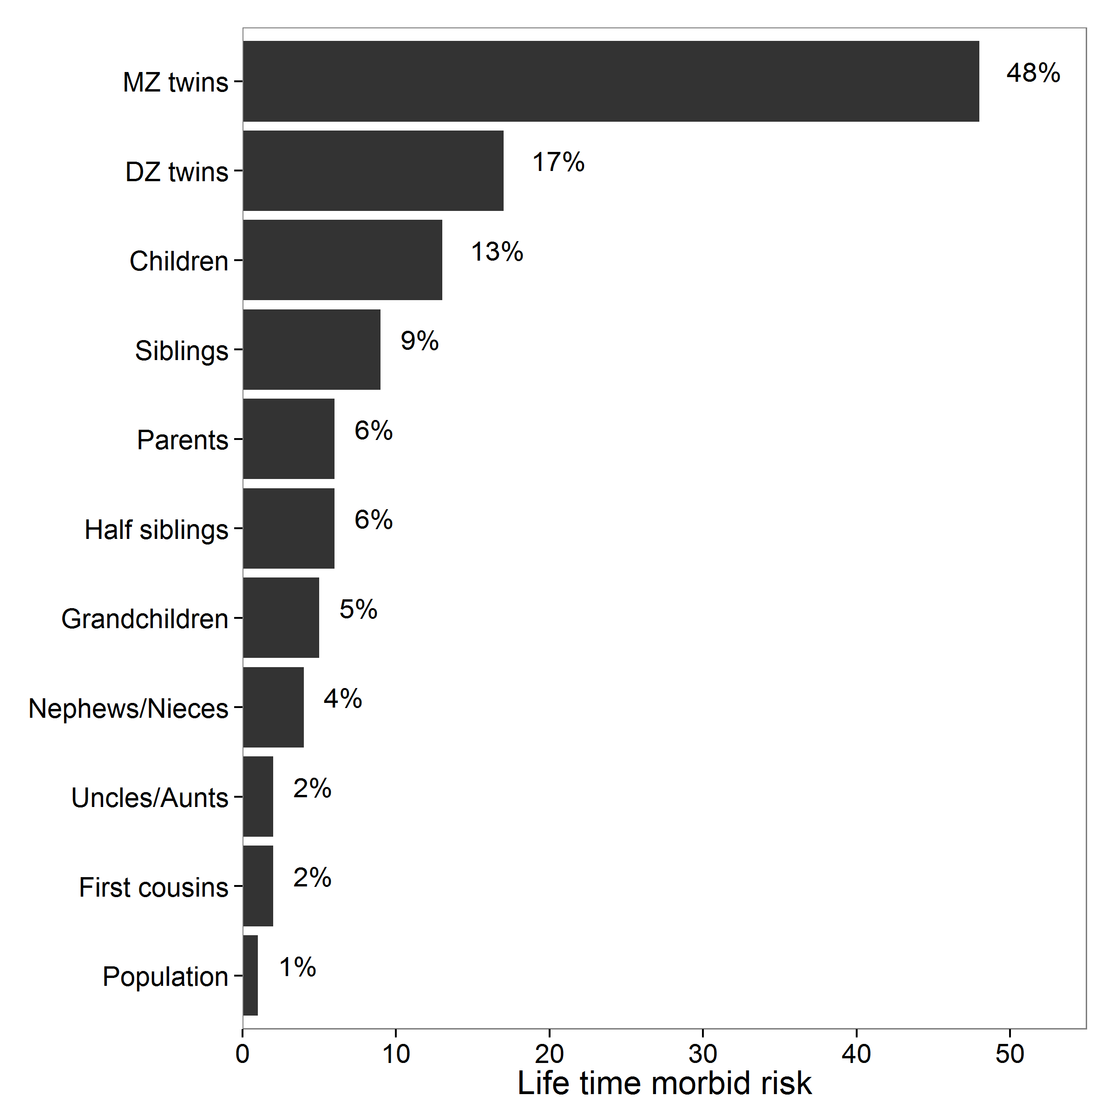

**Figure 1.3:** Lifetime morbid risks of schizophrenia in various classes of relatives of a proband. It was noted that the morbid risk of monozygotic (MZ) twins were only

48%, much lower than one would expect if schizophrenia follows a Mendelian pattern. Reproduced with permission from journal (Riley and Kendler, 2006).

Based on these observations, I. Gottesman and J. Shields (1967) proposed that schizophrenia follows a polygenic model where disease phenotype were determined by the additive effects from multiple genes. Thus, schizophrenia is likely to be a com- plex genetic disorder with complicated pattern of inheritance. Their hypothesis was supported by the calculation of Risch (1990a).

Based on these observations, I. Gottesman and J. Shields (1967) proposed that schizophrenia follows a polygenic model where disease phenotype were determined by the additive effects from multiple genes. Thus, schizophrenia is likely to be a com- plex genetic disorder with complicated pattern of inheritance. Their hypothesis was supported by the calculation of Risch (1990a).Not only does Risch (1990a) supports the polygenic model for schizophrenia, Risch (1990a) also estimated the possible effect size of individual locus in schizophrenia. By comparing the observed life time morbid risk and the expected risk from different models, Risch (1990a) proposed that genetic models with a single locus with risk of 3.0 and with all other loci of small effect or models with two or three loci with risk of 2.0 were most consistent with the observed life time morbid risk of schizophrenia (Risch, 1990b).

Risch (1990a)’s calculation provided an explanation for the early inconsistent findings of linkage studies in schizophrenia (Harrison and Weinberger, 2005). As link- age studies were aimed to identify genetic variation of large effect size they failed to capture genetic loci with small effect size. It was therefore tempting to suggest that schizophrenia only follows the “common disease-common variant” model, which stated that schizophrenia is mediated by large amount of common variants such as Single Nucleotide Polymorphism, each carries a small effect size.

However, another possible hypothesis was that the variation mediating schizophre- nia were rare, therefore require a large sample size to detect and the inconsistent results of early linkage studies might be due to the inadequate sample size. This lead to some researchers suggesting the “common disease-rare variant” hypothesis, which propose that schizophrenia was mediated by a small amount of rare variants, each with a large effect size (McClellan, Susser, and King, 2007).

Nevertheless, success in genetic research of schizophrenia remains limited. Only until the initiation of Human Genome Project and technological advance resulted from that does genetic research of schizophrenia entered an era of success

**1.8.2 The Human Genome Project and HapMap Project**

In 1990, the Human genome project was initiated, aiming at constructing the first physical map of the human genome at per nucleotide resolution (E S Lander et al., 2001). The completion of the human genome project has opened up a new era of genetic research, allowing researchers to identify Single Nucleotide Polymorphisms (SNPs) on the human genome, which is one of the major source of genetic variation.

Soon after the completion of the human genome project, the HapMap Project was initiated (T. I. H. Consortium, 2005), aiming to provide a genome-wide database of common human sequence variation such as SNPs with maf ≥ 0.05. More importantly was that the HapMap Project also provided a detailed Linkage Disequilibrium (LD) map of the human genome.

LD was of particular importance to genetic research for it was the non-random correlation of genotypes between 2 genetic loci. SNPs in high LD were usually observed together in the human genome. When a large amount of SNPs were in high LD together, they form what was known as a LD block. By performing association testing on SNPs representing a LD block (“tagging”), one can avoid the need of performing association on the whole genome, therefore reducing the cost of the experiment. This was the fundamental concept of Genome Wide Association Study (GWAS) which was now extensively used in the genetic research.

**1.8.3 Genome Wide Association Study**

In GWAS, genome-wide genotyping array were commonly used to systematically detect genetic variants such as SNP and copy number variation (CNV). For quantitative traits, the association between the trait and frequency of the variants were calculated using methods such as linear regression. On the other hand, for dichotomous traits such as schizophrenia, the frequency of the variants were compared between the case and control samples using methods such as chi-square test or logistic regression. Because of the problem of multiple testing, only variants with a p-value passing a genome wide threshold (p-value ≤ 5 × 10−8) were considered significant. Another possible method to decide the significant threshold was to consider the “effective number” of tests (M.-X. X. Li et al., 2011), taking into consideration of LD as not all tests in a GWAS were independent of each other. The power of the GWAS were determined by the magnitude of effect, sample size, and required level of statistical significance (the false-positive, or type I, error rate) (S Purcell, Cherny, and P C Sham, 2003).

**Single Nucleotide Polymorphism**

Despite the great promise from GWAS, early GWAS in schizophrenia remain largely disappointing and were unable to identify any robust genetic markers associated with schizophrenia. The failure of early GWAS in schizophrenia were mainly due to the relative small sample size of the studies, which result in low detection power.

To overcome the problem of small sample size, large consortium were formed such that data from different research groups from different countries were combined, which provides a large sample size for the analysis. By 2014, the Schizophrenia Working group of the Psychiatric Genomics Consortium (PGC) has collected 34,241 schizophre- nia samples and 45,604 controls (Stephan Ripke, B. M. Neale, et al., 2014). By combining the samples with those obtained by deCODE genetics, a total of 36,989 schizophrenia samples and 113,075 controls were used for the largest meta-analysis of schizophrenia. In their study (Stephan Ripke, B. M. Neale, et al., 2014), 128 linkage- disequilibrium-independent SNPs were found to exceeded the genome-wide significance (p-value ≤ 5 × 10−8), corresponding to 108 genetic loci. 75% of these loci contain protein coding genes and a further 8% of these loci were within 20kb of a gene. It was found that genes involved in glutamatergic neurotransmission (e.g. GRM3, GRIN2A and GRIA1 ), synaptic plasticity and genes encoding the voltage-gated calcium channel subunits (e.g. CACNA1C, CACNB2 and CACNA1I ) were among the genes associated within these loci. Importantly, DRD2, the target of all effective anti-psychotic drug were also associated with schizophrenia. This result converges with existing knowledge of DRD2 being involved in the pathology of schizophrenia, supported by multiple lines of research (Talkowski et al., 2007). It was further demonstrated that schizophrenia association were significantly enriched at enhancers active in brain and enriched at enhancers active in tissues with important immune functions (fig. 1.4)(Stephan Ripke, B. M. Neale, et al., 2014).

The enrichment of immune related enhancers remains significant even after the removal of major histocompatibility complex (MHC) region from the analysis, provided further genetic support of the involvement of the immune system in the etiology of schizophrenia. Because of its role in neural development (Zhao and Schwartz, 1998; Deverman and Patterson, 2009), it is likely that the perturbation in the immune system might disrupt the brain development, therefore increasing the risk of schizophrenia. Indeed, studies on MIA has demonstrated that cytokine imbalance might predispose individual to schizophrenia (U Meyer, J Feldon, and Yee, 2009).

**Figure 1.4:** Enrichment of enhancers of SNPs associated with schizophrenia. It was observed that the largest enrichment were in cell lines related to the brain and in tissues with important immune functions. Graphs reproduced with permission from the journal (Stephan Ripke, B. M. Neale, et al., 2014).

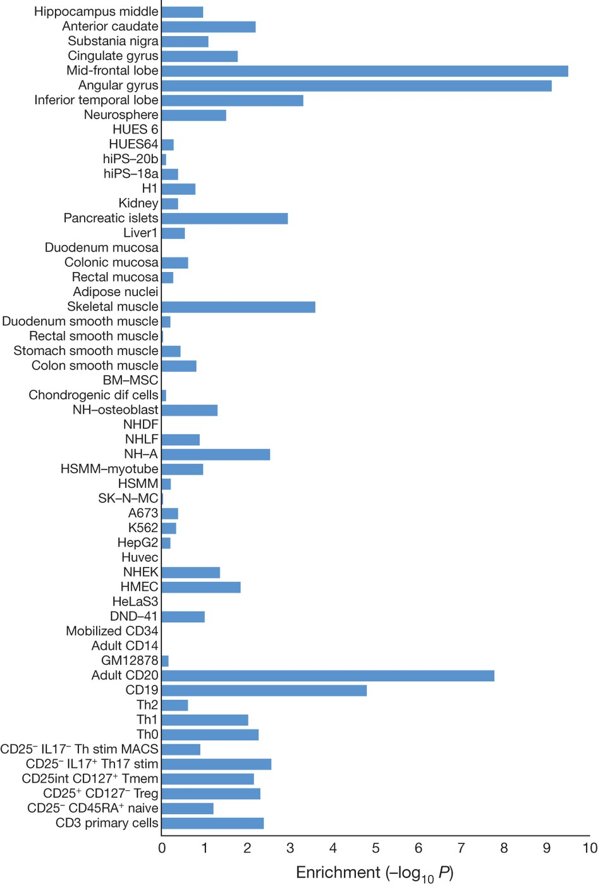

**Copy Number Variation**

Another important arm of genetic research in schizophrenia was to identify copy number variation (CNV) associated with schizophrenia. CNV were classified as segment of DNA that is 1kb or larger and that is present at a different copy number when compared to the reference genome, usually in the form of insertion, deletion or duplication (Feuk, Carson, and Scherer, 2006). Due to the length of these variants, the CNV might contain the entire genes and their regulatory regions which might in turn contribute to significant phenotypic differences (Feuk, Carson, and Scherer, 2006).

To identify robust association between CNV and schizophrenia, Szatkiewicz et al. (2014) conducted a GWAS for CNV association with schizophrenia used the Swedish national sample (4,719 schizophrenia samples and 5,917 controls). In their study, they were able to association between schizophrenia and CNV such as 16p11.2 duplications,

22q11.2 deletions, 3q29 deletions and 17q12 duplications were identified. Through the gene set association analysis, calcium channel signaling and binding partners of the fragile X mental retardation protein were found to be associated with these CNV (Sza- tkiewicz et al., 2014). Interestingly, the calcium channel signaling were also enriched in the PGC GWAS on SNP association, suggesting that the variants were converging on similar set of pathway or gene sets.

Unlike the result from the GWAS on SNP data, the CNV identified were rare (≤ 12 in 4,719 samples) and has a relative large effect (e.g. 22q11 deletion has an odd ratio of 16.32 (Szatkiewicz et al., 2014)). The results from the SNP GWAS supports the “common disease-common variant” model whereas the GWAS on CNV supports the “common disease-rare variant” model, illustrating the complex genetic model behind the etiology of schizophrenia.

Although the GWAS in schizophrenia seems to return a lot of interesting results, the question remains: How much of the genetic variations of schizophrenia were captured by GWAS? To answer the question, we need to estimate the heritability based on the GWAS data. The challenge however, was that in order to acquire sufficient participants for the association studies, participants were randomly sampled from the population where they were usually not related to each other.

**1.8.4 Genome-wide Complex Trait Analysis**

As the participants were unrelated, one will need to estimate the relativeness between individuals to estimate the heritability. Given the genotypes of each individuals were known, one can estimate the “genetic distance” between two individual, which can be used to represent their relativeness. By calculating the “genetic distance” between all individuals within the GWAS, one can obtain the Genetic Relationship Matrix (GRM) (J Yang et al., 2011).

Given that the genotypes were usually coded as 0, 1 or 2 (homozygous refer- ence, heterozygous and homozygous alternative respectively), the genotypes follow the binomial distribution. The expected mean and variance of a genotype *i* will be 2pi and 2pi (1 − pi) respectively where pi is the frequency of the reference allele. Based on this information, J Yang et al. (2011) estimates the genetic relationship between individuals *j* and *k* as:



where xij is the number of copies of the reference allele for the *i*th SNP of the *j*th individual. The effects of all the SNPs were then fitted as random effects by a mixed linear model (MLM)



where y is an n × 1 vector of phenotypes with n samples, β is a vector of fixed effects such as sex and age, g is an n × 1 vector of the total genetic effects of the individuals, $σ_{g}^{2}$ is the variance explained by all the SNPs and finally, $σ_{e}^{2}$ is the variance explained by residual effects.

The main concept of the method is that instead of testing the associations for individual SNPs, one fit the effects of all SNPs as random effects in a MLM and estimate a single parameter, i.e. the variance explained by all SNPs or SNP-heritability. Given the information of the GRM, J Yang et al. (2011) implemented the restricted maximum likelihood (REML) using the average information algorithm to estimates the $σ_{g}^{2}$ and $σ_{e}^{2}$ where the REML is a form of maximum likelihood estimation that allows unbiased estimates of variance and covariance parameters. The heritability of the trait is then defined as.

Based on the above concept, Jian Yang, Benyamin, et al. (2010) were able to estimate the variance in height explained by SNPs from the height GWAS to be around 45%, much larger than previously reported 5%. The main difference in the estimates was because the MLM REML were able to consider all SNPs simultaneously without limited on significant SNPs. Although the estimates was still less than 80% which was the expected heritability of height, Jian Yang, Benyamin, et al. (2010) was able to demonstrated that one possible source of “missing heritability” might be due to incomplete LD. By taking into consideration of incomplete LD, it was estimated that the proportion of variance explained by causal variants can be as high as 0.84 with standard error (SE) of 0.16 (Jian Yang, Benyamin, et al., 2010), close to the expected heritability. Together, J Yang et al. (2011) provide a possible method for the estimation of the variance explained by SNPs in GWAS data and the method is now implemented in Genome-wide Complex Trait Analysis (GCTA) which is wildly adopted.

The problem with GCTA was that genotype data are required to calculate the GRM. For complex disease like schizophrenia, the data were usually obtained from multiple data source where the raw genotypes were usually unavailable due to privacy concerns. Instead, summary statistics were usually provided. Therefore estimation of variance explained by SNPs in these GWAS can only rely on the summary statistics.

**1.8.5 LD SCore regression**

An important observation of GWAS results was that sometimes a general inflation of test statistics can be observed. It was usually considered to be contributed to the presence of confounding factors such as population stratification, under the assumption that most of the SNPs should have no association to the disease. It was therefore a common practice for one to perform the Genomic Control (GC) on the GWAS results (Zheng, Freidlin, and Gastwirth, 2006).

The problem of the GC was that the basic assumption of a small number of causal SNPs might not be true. Through careful simulation, Jian Yang, Weedon, et al. (2011) demonstrated that in the absence of population stratification and other form of technical artifacts, the presence of polygenic inheritance can also inflate the test statistic (Jian Yang, Weedon, et al., 2011). More importantly, they observed that the magnitude of inflation was determined by the heritability, the LD structure, sample size and the number of causal SNPs of the trait.

Following on this observation, B. K. Bulik-Sullivan et al. (2015) developed the LD SCore regression (LDSC). The fundamental concept of LDSC was that the more genetic variants a SNP tag (e.g. in high LD with many other SNPs), the more likely for it to be able to tag a causal variant; whereas population stratification and cryptic relatedness should not be associated with LD. The number of genetic variants tagged by a SNPj (lj )(LD score) was then defined as the sum of r2 of *k* SNPs within a 1cM window of SNP j :



When there is no confounding factors, the expected χ2 of SNP*j* can be defined as a function of the LD score (*lj* ), the number of samples (*N* ), the number of SNPs in the analysis(M ) and most importantly, the heritability (*h2*):



Interestingly, when confounding factors were present in the study (e.g. population stratification), eq. (1.15) simply becomes



where *a* is the contribution of confounding bias.

As a result of that, the heritability *h2* will be the slope of the regression and the intercept minus one will represent the mean contribution of the confounding bias such as those of population stratification. Thus eq (1.16) can be used for the estimation of heritability given that only the summary statistics and population LD were provided.

Although LDSC can be used for heritability estimation, the main focus of B. K. Bulik-Sullivan et al. (2015)’s paper was to delineating the confounding factors from the polygenicity of a trait. To test whether if LDSC can delineate the confounding factors such as cryptic relationship and population stratification from the polygenicity of a trait, B. K. Bulik-Sullivan et al. (2015) simulated multiple GWAS where the trait can have a polygenic architecture or where confounding factors can present. When the simulated trait is polygenic and no confounding factors were presented, the average LDSC intercept was close to one, as expected by the authors. Only when the number of causal variants was small will the standard error of the estimates become very large. However, even with the enlarged variance, the estimates remained unbiased. On the other hand, when the GWAS was simulated with only the confounding factors such as population stratification, the intercept estimated was approximately equal to the GC inflation factor with only a small positive bias in the regression slope.

The most important simulation was to investigate the performance of LDSC in GWAS of a polygenic trait where confounding factors were present. It was found that even when both polygenicity and confounding factors were presented in the GWAS, the intercept of LDSC was approximately equal to the mean χ2 statistic among null SNPs, providing strong evidence that LDSC can partition the inflation in test statistic even in the presence of both bias and polygenicity.

Although the main focus of B. K. Bulik-Sullivan et al. (2015) was not the estimation of SNP-heritability in their paper, they did provide an estimate of variance explained by the SNPs in the PGC schizophrenia GWAS (Stephan Ripke, B. M. Neale, et al., 2014). By applying the liability threshold adjustment, B. K. Bulik-Sullivan et al. (2015) estimated the SNP-heritability of schizophrenia should be 0.555 with SE of 0.008. The estimated SNP heritability was lower than the heritability estimated from population based study (64% (Lichtenstein et al., 2009)) and twin studies (81% (Sulli- van, Kendler, and M. C. Neale, 2003)) suggesting that it is possible for variants other than common SNPs were accounting for the variation in schizophrenia. An example will be CNV which was also found to be associated with schizophrenia (Szatkiewicz et al., 2014).

Another possibility of the“missing” heritability can be due to interaction be- tween the genetic and environmental factors. Although previous studies (I I Gottesman and J. Shields, 1967) suggested that the non-additive genetic factors were unlikely to contribute to schizophrenia, the possibility of involvement of gene-environmental inter- action G × E were not ruled out. Indeed, in the adoption study conducted by Tienari et al. (2004), it was found that individuals with higher genetic risk were significantly more sensitive to “adverse” vs “healthy” rearing patterns in adoptive families than are adoptees at low genetic risk (Tienari et al., 2004), providing support to a possible interaction between genetic and environmental factors. Therefore, in order to account for the “missing” heritability, one might need to consider genetic variations other than SNPs and might need to take into consideration of the G × E interaction. On the other hand, as demonstrated by Jian Yang, Benyamin, et al. (2010), the “missing” heritabil- ity might simply because of incomplete LD between the SNPs and the causal variants. A possible method would be to perform sequencing studies variants across the whole genome can be detected at the same time.

Nonetheless, the SNP-heritability estimation from Stephan Ripke, B. M. Neale, et al. (2014) were still encouraging, as for the first time in genetic research of schizophre- nia, a large portion of heritability of schizophrenia were finally identified. This permit the genetic research of schizophrenia to move beyond statistical association and focus on the functional basis of the genetic susceptibility locus of schizophrenia.

**1.8.6 Partitioning of Heritability of Schizophrenia**

Traditionally, functional enrichment analysis in GWAS only take into account of SNPs that passed the genome wide significance threshold. However, for complex traits such as that of schizophrenia, much of the heritability might lies in SNPs that do not reach genome wide significance threshold at the current sample size. For example, in 2013, only 13 risk loci were detected using 13,833 schizophrenia samples and 18,310 controls (S Ripke et al., 2013). When the sample size increased to 34,241 schizophrenia samples and 45,604 controls in 2014, 108 risk loci were identified (Stephan Ripke, B. M. Neale, et al., 2014). Thus, if one only consider the significant loci, risk loci that have not reach genome wide significance threshold might be ignored from the analysis, decreasing the power of the functional enrichment analysis.

Unlike traditional functional enrichment analysis, LDSC uses information from all SNPs and taking into account of the LD structure to partition heritability into different functional categories. It should therefore be more powerful when compared to traditional analysis and should help to provide useful insight into the disease etiology of schizophrenia.

Finucane et al. (2015) used data from Stephan Ripke, B. M. Neale, et al. (2014) and functional categories derived from the ENCODE annotation (ENCODE Project Consortium, 2012), the NIH Roadmap Epigenomics Mapping Consortium an- notation (Bernstein et al., 2010) and other studies (Finucane et al., 2015) to identify functional categories that were most enriched in schizophrenia. In their study, it was found that brain cell types were most enriched in schizophrenia, especially those re- lated to the central nervous system (CNS). Of all the functional categories, the most enriched category in schizophrenia was the H3K4me3 mark in the fetal brain(table 1.2). As H3K4me3 was mostly linked to active promoters, this suggest that genes that were activated in fetal brain (e.g. genes related to brain development) were associated with schizophrenia, supporting the idea of schizophrenia as a neuro-developmental disorder.

Moreover, it was also observed that the second most enriched cell types were those related to immunity. Undoubtedly, the CNS and the immune system have an important role in the disease etiology of schizophrenia.

(Table shown in PDF document)

**1.9 Summary**

To conclude, schizophrenia is a complex disorder affecting approximately 1\% of the population worldwide. It is now known that the disease is affected by a combination of genetic and environmental factors. Therefore, to fully understand the disease mechanism for the development of proper treatments, it is important not only to examine how certain genetic polymorphisms can predispose individuals to the disease development, but also how environmental factors can act as a trigger for the disorder in apparently healthy individuals.

In this thesis, we would like to develop an algorithm for the estimation of SNP heritability from GWAS summary statistics that is robust to traits with different genetic architectures. We would also like to investigate the effect of case control sampling and extreme phenotype sampling on the performance of LDSC. On the other hand, as prenatal infection is the largest environmental risk for schizophrenia, we would like to understand how prenatal infection triggers schizophrenia through studying the change in global gene expressions in mice cerebellum.

First, in Chapter 2, we performed a series of empirical simulations to assess the performance of LDSC in the estimation of SNP heritability. We also proposed an alternative approach for the estimation of SNP-heritability from GWAS summary statistics that is robust to different genetic architectures.

In Chapter 3, a hypothesis generation study was performed to study the effect of MIA on the gene expression pattern of mouse cerebellum. On top of that, as recent study suggested that n-3 PUFA rich diet can help to reduce the schizophrenia-like behaviour observed mouse exposed to early MIA (Q. Li, Leung, et al., 2015), we also investigated the effect of n-3 PUFA rich diet on the gene expression pattern of mouse cerebellum.

Lastly, we summarize and conclude all findings in Chapter 4 and give future perspectives on the research.

**Chapter 2**

**Heritability Estimation**

**2.1 Introduction**

Research in schizophrenia genetics has finally entered an era of success with PGC schizophrenia GWAS identifying 108 loci significantly associated with SCZ (Stephan Ripke, B. M. Neale, et al., 2014). The results from the GWAS has bring valuable resources for the communities and have provided a large volume potential candidates for functional studies. However, it is unclear whether if the SNPs from the GWAS has accounted for majority of the genetic variation of schizophrenia. It is possible that due to the limitation of sample size and the moderate-to-small effect size of an unknown number of causal loci, many SNPs associated with SCZ may be left undetected and a much larger sample size of GWAS may be required. If that is the case, more samples should be collected and larger GWAS should be performed in order to elucidate the remaining genetic variations of schizophrenia. On the other hand, it is also possible that the current GWAS has already contained all or near most of the SNPs associated with the disease. Shall that be the case, alternative approaches in addition to GWAS should be performed to identify genetic variations of schizophrenia (e.g. whole genome sequencing). So estimating the contribution of these common SNPs to SCZ (and other complex diseases) has important implications for future research strategy.

Before the development of LDSC, one can only estimate the SNP heritability given the raw sample genotypes. However, large scale meta-analysis usually only pro- vide the summary statistics thus the estimation of the SNP heritability were generally impossible.

Nowadays, with LDSC, one can estimates the SNP heritability given only the summary statistics. This is very helpful in determining the future research strategy. However, as noted by the author of LDSC, when the number of causal variants were small, or when working on targeted genotype array (e.g. PsychArray), LDSC tends to have a larger standard error or might produce unexpected results (B. K. Bulik-Sullivan et al., 2015). It is therefore interesting to see if a robust algorithm can be developed that are not affected by the genetic architecture of the trait.

Moreover, as schizophrenia is usually defined as “affected” or “normal”, the estimation of SNP heritability might have to adjusted for the ascertainment bias introduced by the case control sampling. The ascertainment bias correction was usually performed based on the liability threshold model. It the estimation of heritability is not as simple as the estimation of heritability for quantitative traits for one will require adjusting case control sampling bias using the liability threshold model. However, this adjustment might not be as straightforward as it seems. For example, it has been suggested that GCTA, the most popular heritability estimation tools for GWAS, will provide highly biased estimates for case control studies (Golan, Eric S Lander, and Rosset, 2014). As B. K. Bulik-Sullivan et al. (2015) did not perform any empirical simulation of the effect of the case control sampling to their estimates, it is therefore important for us to perform empirical simulations to investigate whether if the case control sampling has any impact to the estimates of LDSC.

Herein, we would like to develop a robust algorithm to estimate the SNP heritability based on GWAS summary statistics such that a robust estimation can be obtained for traits with different genetic architectures. We would also like to inspect whether if LDSC’s heritability estimation is robust to prevalence of a trait and if it is biased in the same way as GCTA. This is achieved by performing empirical simulations where we varies the genetic architecture of the traits. Last but not least, we would like to investigate the true contribution of SNP to schizophrenia using the PGC schizophrenia GWAS summary statistics and would like to compare our estimates with the estimates from B. K. Bulik-Sullivan et al. (2015) to see if the two algorithm can reach the same conclusion.

The work in this chapter were done in collaboration with my colleagues who have kindly provided their support and knowledges to make this piece of work possible. Dr Johnny Kwan, Dr Miaxin Li and Professor Sham have helped to lay the foundation of this study. Dr Timothy Mak has derived the mathematical proof for our heritability estimation method. Miss Yiming Li, Dr Johnny Kwan, Dr Miaxin Li, Dr Desmond Campbell, Dr Timothy Mak and Professor Sham have helped with the derivation of the standard error of the heritability estimation. Dr Henry Leung has provided critical suggestions on the implementation of the algorithm.

**2.2 Methodology**

The overall aims of this study is to develop a robust algorithm for the estimation of the narrow sense heritability using only the summary statistic from a GWAS and to study the performance of the heritability estimation algorithms for different type of traits.

It was noted that in GWAS, the test statistic of a particular SNP should increases with its own effect size and the effect size from all the other SNPs in LD with it. Based on this property, we may use the information from the LD matrix and the test statistic of the GWAS SNP the estimate the narrow sense heritability.

**2.2.1 Heritability Estimation**

**PLEASE REFER TO THE PDF Document**

**2.2.2 Calculating the Standard error**

**PLEASE REFER TO THE PDF Document**

**2.2.3 Case Control Studies**

When dealing with case control data, we cannot directly use eq. (2.17) to estimate the heritability. Instead, we will need to employ the concept of liability threshold model from section 1.6.

Based on the derivation of Jian Yang, Naomi R. Wray, and Peter M. Visscher (2010), the approximate ratio between the non-centrality parameter (NCP) obtained from case control studies (NCPCC) and quantitative trait studies (NCPQT) were



Where



Using this approximation, we can directly transform the NCP between the case control studies and quantitative trait studies. As we are not interested in transforming the NCP between two different studies, the sample size of the case control study (NCPCC) and sample size of the quantitative trait study (NPCQT) will be the same in eq. (2.22), therefore eq. (2.22) becomes

**

By combining eq. (2.23) and eq. (2.14), we can then have



where ${χ^{2}}_{CC}$ is the test statistic from the case control association test. As eq. (2.24) is only eq. (2.14) multiply with the constant, the heritability estimation of case control studies can be simplified to



**2.2.4 Extreme Phenotype Sampling**

The development of GWAS now provide unprecedented power to perform hypothesis free association throughout the whole genome. However, a challenge for the studies of complex traits is to obtain sufficient sample size with a limited budgets. It is therefore important to design the experiment in a way where sample size can be reduced without affecting the power of the study. A common technique is to perform extreme pheno- type sampling in the detection stage of the study. The extreme phenotype sampling will inflate the frequency distortion between samples from the two extreme end of phe- notype, thus increase the statistical power (Guey et al., 2011). It was estimated that for a 0.5% variant with a fivefold effect in the general population, a discovery studies using extreme phenotype sampling requires four times less samples in the replication to achieve 80% power when compared to studies using random samples (Guey et al., 2011). This allows studies to be conducted using a smaller amount of samples with the same degree of power, therefore reducing the cost of the study.

A problem of extreme phenotype sampling was that the variance of the se- lected phenotype will not be representative of that in the population. The effect size are generally overestimated (Guey et al., 2011). Thus, to adjust for this bias, one can multiple the effect size by the ratio between the variance before VP and after VP‘the selection process (Pak C Sham and Shaun M Purcell, 2014), which is equivalent to the multiplication of  to *f* in eq. (2.14).



**2.2.5 Inverse of the Linkage Disequilibrium matrix**

In order to obtain the heritability estimation, we will require to solve eq. (2.17). If ***Rsq*** is of full rank and positive definite, it will be straight-forward to solve the matrix equation. However, more often than not, the LD matrix are rank-deficient and suffer from multicollinearity, making it ill-conditioned, therefore highly sensitive to changes or errors in the input. To be exact, we can view eq. (2.17) as calculating the sum of $\hat{h2 }$ from eq. (2.16). This will involve solving for



which requires the inverse of ***Rsq.***

In normal circumstances (e.g. when ***Rsq*** is full rank and positive semi- definite), one can easily solve eq. (2.27) using the QR decomposition or LU decom- position. However, when ***Rsq*** is ill-conditioned, the traditional decomposition method will fail. Even if the decomposition can be performed, the result tends to be a meaningless approximation to the true $\hat{h2 }$.

Therefore, to obtain an unique solution, regularization techniques such as the Tikhonov Regularization (also known as Ridge Regression) and Truncated Singular Value Decomposition (tSVD) has to be performed (Neumaier, 1998). There are a large variety of regularization techniques, yet the discussion of which is beyond the scope of this study. In this study, we will focus on the use of tSVD in the regularization of the LD matrix. This is because the Singular Value Decomposition (SVD) routine has been implemented in the EIGEN C++ library (Guennebaud and Jacob, 2010), allowing us to implement the tSVD method without much concern with regard to the detail of the algorithm.

To understand the problem of the ill-conditioned matrix and regularization method, we consider the matrix equation ***Ax*** = ***B*** where ***A*** is ill-conditioned or singular with *n × n* dimension. The SVD of ***A*** can be expressed as

***A*** = ***U* Σ*V*** *t* (2.28)

where ***U*** and ***V*** are both orthogonal matrix and **Σ** = diag(*σ*1*, σ*2*, . . . , σn*) is the diagonal matrix of the *singular values* (*σi*) of matrix ***A***. Based on eq. (2.28), we can get the inverse of ***A*** as

***A****−*1 = ***V* Σ***−*1***U*** *t* (2.29)



***Ax*** = ***B U* Σ*V*** *t****x*** = ***B***

***x*** = ***V* Σ***−*1***U*** *t****B*** (2.30)

A matrix ***A*** is considered as ill-condition when its condition number κ(***A***) is large or singular when its condition number is infinite where the condition number can be calculated as Therefore it can be observed that when  is tiny, ***A*** is likely to be ill-conditioned and when  = 0, ***A*** will be singular.

One can also observe from eq. (2.30) that when the singular value  is small, the error  in ***Bi*** will be drastically magnified by a factor of . Making the system of equation highly sensitive to errors in the input.

To obtain a meaningful solution from this ill-conditioned/singular matrix ***A***, we may perform the tSVD method to obtain a pseudo inverse of ***A***. Similar to eq. (2.28), the tSVD of ***A*** can be represented as

***A***+ = ***U* Σ***k* ***V*** *t* and **Σ***k* = diag(*σ*1*, . . . , σk ,* 0*, . . . ,* 0) (2.31)

where **Σ***k* equals to replacing the smallest *n − k* singular value by 0 (Hansen, 1987). Alternatively, we can define

**

where *t* is the tolerance threshold. Any singular value *σi* less than the threshold will be replaced by 0 during the inversion.

By selecting an appropriate *t*, tSVD can effectively regularize the ill-conditioned matrix and help to find a reasonable approximation to *x*. A problem with tSVD however is that it only work when matrix ***A*** has a well determined numeric rank (Hansen,1987). That is, tSVD work best when there is a large gap between *σk and* *σk*+1. If a matrix has ill-conditioned rank, then *σk − σk*+1 will be small. For any threshold *t*, a small error can change whether if *σk*+1 and subsequent singular values should be truncated, leading to unstable results.

According to Hansen (1987), matrix where its rank has meaning will have well defined rank. The LD matrix is the correlation matrix between each individual SNPs, thus the rank of the LD matrix is the maximum number of linear independent SNPs in the region. Because the rank has a meaning, the LD matrix is likely to have well-defined rank.

The easiest way to test whether if the threshold t and if the matrix A has well-defined rank is to calculate the “gap” in the singular value:

*gap* = *σk /σk*+1 (2.33)

a large gap usually indicate a well-defined gap. In this study, we adopt the threshold as defined in MATLAB, NumPy and GNU Octave: *t* = *c ×* max(*m, n*) *×* max(**Σ**) where *c* is the machine epsilon (the smallest number a machine can define as non-zero). And we perfomed a simulation study to investigate the performance of tSVD under the selected threshold. Ideally, if the “gap” is large under the selected threshold, then tSVD will provide a good regularization to the equation.

1,000 samples were randomly simulated from the HapMap (Altshuler et al., 2010) Northern Europeans from Utah (CEU) population with 1,000 SNPs randomly select from chromosome 22. The LD matrix and its corresponding singular value were calculated. The whole process were repeated 50 times and the cumulative distribution of the “gap” of singular values were plotted (fig. 2.1). It is clearly show that the LD matrix has a well-defined rank with a mean maximum “gap” of 466,198,939,298. Therefore the choice of tSVD for the regularization is appropriate.

By employing the tSVD as a method for regularization, we were able to solve the ill-posed eq. (2.16), and obtain the estimated heritability.

**Figure 2.1:** Cumulative Distribution of “gap” of the LD matrix, the vertical line indicate the full rank. It can be observed that there is a huge increase in “gap” before full rank is achieved. Suggesting that the rank of the LD matrix is well defined

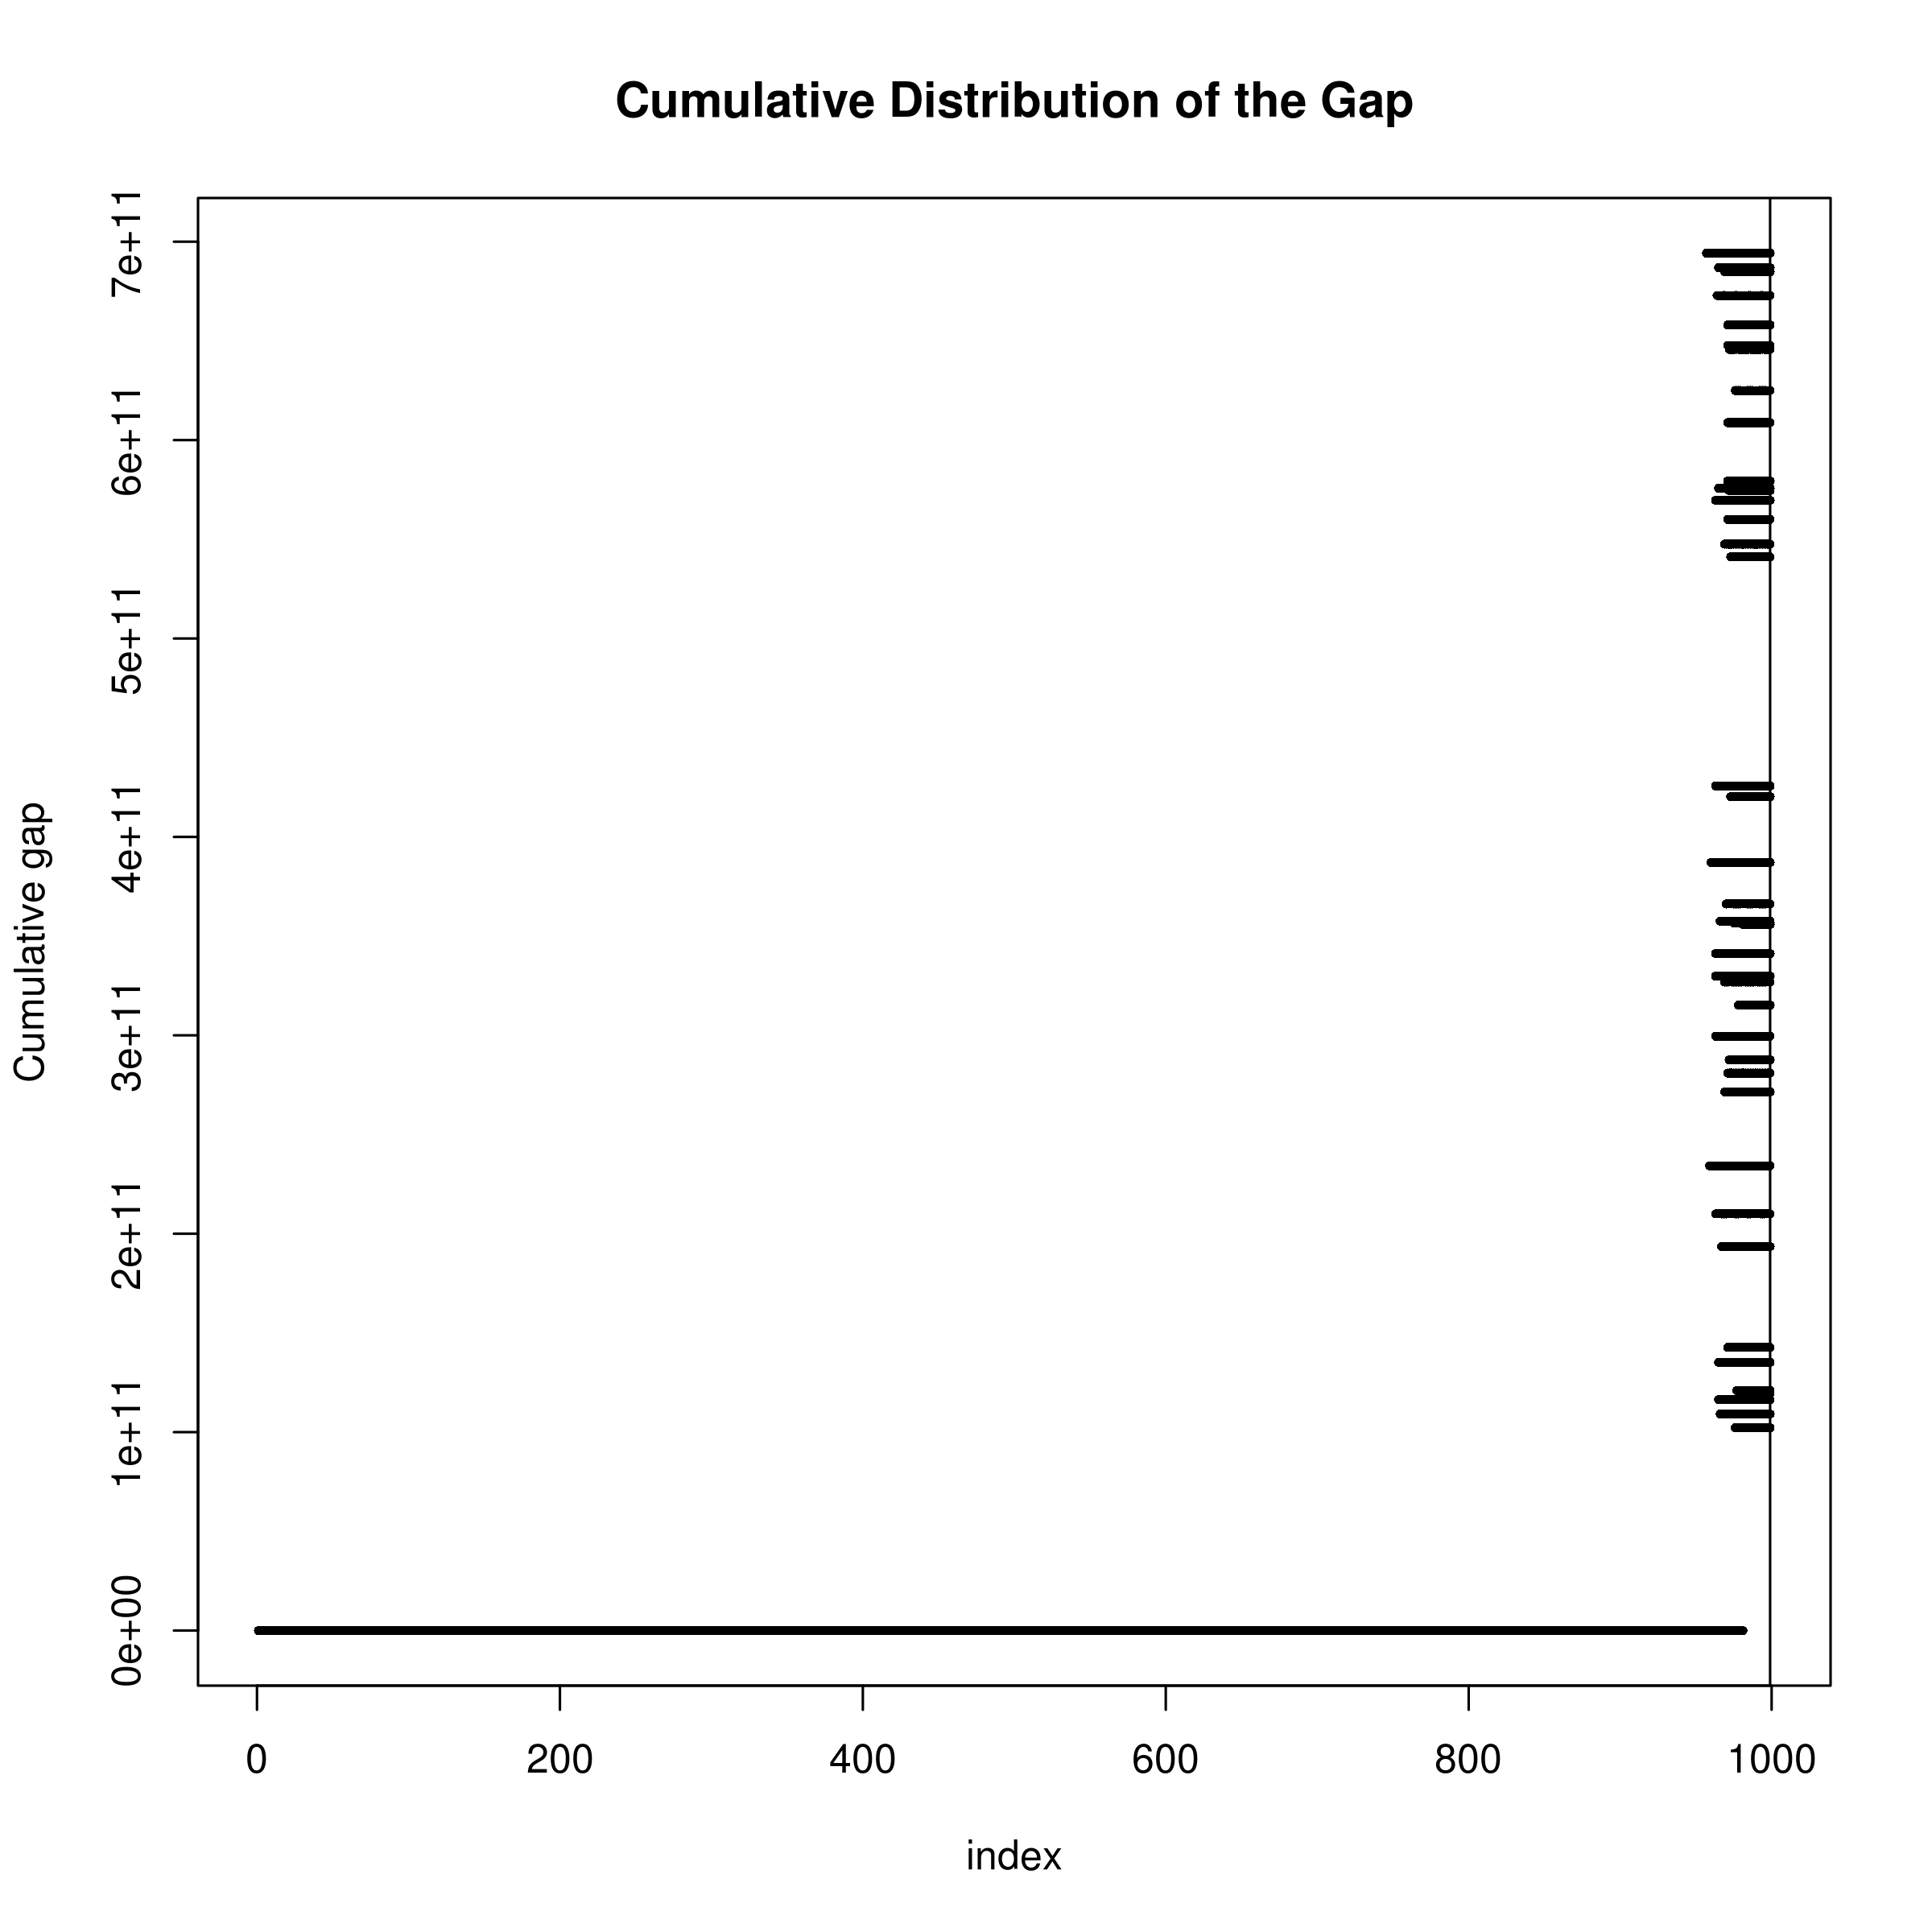

**2.2.6 Implementation**

Our algorithm was implemented using C++ programming languages (version C++11) and the matrix algebra was performed using the EIGEN C++ header library (Guen- nebaud and Jacob, 2010). In spite of the fact that the Armadillo library (Sanderson,

2010) is much faster in the calculation of SVD when compared to EIGEN (Ho, 2011), it is dependent on additional libraries such as OpenBLAS. The use of EIGEN therefore simplify the programme installation, making it more user friendly.

Although tSVD allow one to approximate the ill-posed eq. (2.16), it is an *O (n3)* algorithm, making the computation run time prohibitive when the number of SNPs is large. Unfortunately, the number of SNPs in a GWAS is generally large, making it impossible for one to calculate the tSVD of the whole genome at once.

If we consider eq. (2.28), the matrix ***U*** and ***V*** are the eigenvectors of ***AA***t and ***A****t****A*** respectively. So for any symmetric matrix such as that of the LD matrix, ***U*** and ***V*** should be the same. Thus eq. (2.28) reduce into the problem of eigenvalue decomposition where the singular values are the magnitude of the eigenvalues. Although the eigenvalue decomposition is still an O (*n*3) algorithm, it has a smaller constant, therefore has a faster run time when compared to the computation of SVD.

However, even with the use of eigenvalue decomposition in place of SVD, the size of the LD matrix is still too big for a feasible computation. Given that it is unlikely for inter chromosomal LD to exists or for SNPs 1megabase (mb) apart to be in LD with each other, one can safely assume SNPs more than 1mb apart or SNPs on different chromosomes are independent of each other. We therefore separate SNPs into 1mb bins where start of each bin are at least 1 mb away from each other. Three bins are then combined to form one window, and we perform the decomposition on each windows using eq. (2.16) and only update the ***h*ˆ2** for the bin forming the center of the window. We then transverse the genome with step size of 1 bin until ***h*ˆ2** for all bins were computed. By breaking down the genome into windows, we were able to reduce the matrix dimension which makes the analysis believable. Users can also choose distance other than 1mb as the distance between bins, allowing for a more flexible usage of the algorithm.

**2.2.7 Comparing with LD SCore regression**

Conceptually, the fundamental hypothesis of LDSC and our algorithm were quite different. LDSC were based on the “global” inflation of test statistic and its relationship to the LD pattern. LDSC hypothesize that the larger the LD score, the more likely will the SNP be able to “tag” the causal SNP and the heritability can then be estimated through the regression between the LD score and the test statistic.

On the other hand, our algorithm focuses more on the per-SNP level. Our main idea was that the individual test statistic of each SNPs is a combination of its own effect and effect from SNPs in LD with it. Thus, based on this concept, our algorithm aimed to “remove” the inflation of test statistic introduced through the LD between SNPs and the heritability can be calculated by adding the test statistic of all SNPs after “removing” the inflation.

Mathematically, the calculation of LDSC and our algorithm were also very different. LDSC take the sum of all *R2* within a 1cM region as the LD score and regress it against the test statistic to obtain the slope and intercept which represent the heritability and amount of confounding factors respectively. In their model, LDSC assume that each SNPs will explain the same portion of heritability



As for our algorithm, the whole LD matrix were used and inverted to decompose the LD from the test statistic. There were no assumption of the amount of heritability explained by each SNPs. However, our algorithm does assumed that the mean of the χ2 test statistic to be one (e.g. no inflation in the summary statistics), thus our estimation might inflates shall there be any confounding factors in the GWAS summary statistics.

**2.3 Comparing Different LD correction Algorithms**

Another important consideration in our algorithm is the bias in LD. In reality, one does not have the population LD matrix, instead we have to estimate the LD based on various reference panels such as those from the 1000 genome project (Project et al., 2012) or the HapMap project (Altshuler et al., 2010). These reference panels were a subsamples from the whole population and therefore LD estimated from the reference panels usually contains sampling bias. Under normal circumstances, because the symmetric nature of sampling error, one would expect there to be little to no bias in the estimated LD. However, in our algorithm, the R2 is required for the estimation of heritability (eq. (2.17)). Because we were using the squared LD, the sampling error will also be squared, generating a positive bias.

On average, there were around 500 samples for each super population from the 1000 genome project reference panel. Given the relatively small sample size, the sam- pling bias might be large, therefore lead to systematic bias in the heritability estimation in our algorithm.

To correct for the bias, we would like to apply a LD correction algorithm to correct for the bias in the sample LD. Different authors (Weir and W G Hill, 1980; Zhongmiao Wang and Thompson, 2007) have proposed methods for the correction of sample R2 and can be applied for the correction of sample bias in LD. Therefore we considered the following R2 correction algorithms:



Where n is the number of samples used to calculate the R2, is the sample R2 and  is the corrected R2.

In order to assess the performance of each individual correction methods, we perform simulations to compare the performance of our algorithm using different LD bias correction algorithms. Most importantly, we would like to assess the performance of different algorithms not only under one specific LD range, but also under the complex LD structure observed in real life scenarios. First, 5,000 SNPs with maf ≥ 0.1 were randomly selected from chromosome 22 from the 1000 genome CEU haplotypes and were used as an input to HAPGEN2 (Su, Marchini, and Donnelly, 2011) to simulate 1,000 individuals. HAPGEN2 is a simulation tools which simulates new haplotypes as an imperfect mosaic of haplotpyes from a reference panel and the haplotypes that have already been simulated using the Li and Stephens (LS) model of LD (N. Li and Stephens, 2003). This allow us to simulate genotypes with LD structures comparable to those observed in CEU population. Of those 5,000 SNPs, 100 of them were randomly selected as the causal variant. Orr (1998) suggested that the exponential distribution can be used to approximate the genetic architecture of adaptation. As a result of that, we used the exponential distribution with λ = 1 as an approximation to the effect size distribution:

**

with a random direction of effect. The simulated effects were then randomly distributed to each causal SNPs.

Using the normalized genotype matrix of the causal SNPs of all individuals (X ) and the vector of effect size (β), we can simulate a phenotype with target heritability of h2 as

**

To simulate the whole spectrum of heritability, we varies the target h2 from 0 to 0.9 with increment of 0.1.

The summary statistics of association between the genotype and phenotype were then calculated using PLINK (Shaun Purcell et al., 2007). Resulting summary statistic were then input to our algorithm to estimate the heritability, using different LD correction algorithms. An independent 500 samples, a size roughly correspond to the average sample size of each super population form the 1,000 genome project, were simulated as a reference panel for the calculation of LD matrix. This is because in reality, one usually doesn’t have access to the sample genotype and has to rely on an independent reference panel for the calculation of LD matrix. Thus this simulation procedure should provide a realistic representation of how the algorithm will be commonly used in real life scenario.

The whole process will be repeated 50 times such that a distribution of the estimate can be obtained. In summary, we simulate a large population of samples (e.g. 50 × 1, 000 + 500 = 50,500) where 500 samples were randomly selected as a reference panel. In the subsequent iteration of simulation, 1,000 samples were randomly selected from the population without replacement and estimation were performed.

1. Randomly select 5,000 SNPs with maf *>* 0*.*1 from chromosome 22

2. Simulate 500 samples using HAPGEN2 and used as a reference panel

3. Randomly generate 100 effect size with following eq. (2.40)

4. Randomly assign the effect size to 100 SNPs with heritability from 0 to 0.9 (increment of 0.1)

5. Simulate 1,000 samples using HAPGEN2 and calculate their phenotype according to eq. (2.41)

6. Perform heritability estimation using our algorithm with different ways of LD correction

7. Repeat step 5-6 50 times

**2.4 Comparison with Other Algorithms**

After identifying the optimal LD correction algorithm, we would like to compare our algorithm to existing methods for the performance in estimating the SNP-heritability.

It is important for us to consider most if not all conditions in our simulation. Therefore, we would like to simulate quantitative traits and case control studies with different number of causal SNPs; quantitative traits with extreme effect sizes; and last but not least, quantitative traits with extreme phenotype sampling.

Currently, the only other algorithm that is capable to estimate the SNP- heritability using only summary statistic from GWAS is the LDSC (B. K. Bulik-Sullivan et al., 2015) whereas GCTA (J Yang et al., 2011) is the most commonly used programme for the estimation of SNP-heritability from GWAS data. Therefore, we choose to com- pare the performance of our algorithm to that of LDSC and GCTA. It is important to note we did not simulate any confounding factors yet for LDSC, the default intercept estimation function allows it to estimate and correct for confounding factors with an in- crease in SE. The simulation will therefore be unfair to LDSC with intercept estimation, as the SE is increased yet there are little confounding factors for it to correct. Thus, we also compared results from LDSC with a fixed intercept (--no-intercept) parameters to avoid bias against LDSC.

**2.4.1 Sample Size**

One important consideration in our simulation was the sample size of the simulated GWAS study. The sample size was the most important parameter in determining the standard error of the estimate. As sample size increases, study will be more representative of the true population. The increased number of information also means a better estimation of parameters, therefore a smaller standard error (SE). Based on informa- tion from GWAS catalog (Welter et al., 2014), we calculate the sample size distribution using simple text mining and exclude studies with conflicting sample size information in multiple entries. The average sample size for all GWAS recorded on the GWAS catalog was 7,874, with a median count of 2,506 and a lower quartile at 940 (fig. 2.2). We argue that if the algorithm works for studies with a small sample size (e.g lower quartile sample size), then it should perform even better when the sample size is larger. Thus, we only simulate 1,000 samples in our simulation, which roughly represent the lower quartile sample size range.

**2.4.2 Number of SNPs in Simulation**

Another consideration in the simulation was the number of SNPs included. In a typical GWAS study, there are usually a larger number of SNPs when com- pared to the sample size. For example, in the PGC schizophrenia GWAS, more than 9 million SNPs were included, with around 700,000 SNPs on chromo- some 1. In reality, the estimation of SNP heritability based on 700,000 SNPs can be done quickly. However, in our simulation, we will repeat the calculation 50(iteration) × 10(number of heritability) = 500 times for each condition tested. The time required to finish all the simulation quickly becomes infeasible given the large amount of SNPs. To compromise, we simulate a total of 50,000 SNPs from chromo- some 1 as a balance between run time of simulation and the total SNPs simulated. With 50,000 SNPs, there are roughly 200 SNPs within a 1 mb region.

**2.4.3 Genetic Architecture**

Of all simulation parameter, the genetic architecture was the most complicated and important parameter. The LD pattern, the number of causal SNPs, the effect size of the causal SNPs and the heritability of the trait were all important factors contribute to the genetic architecture of a trait.

First and foremost, because the aim of the algorithm was to estimating the heritability of the trait, it is important that the algorithm works for traits from different heritability spectrum. We therefore simulated traits with heritability ranging from 0 to 0.9, with increment of 0.1.

Secondly, in real life scenario, the “causal” variant might not be readily in- cluded on the GWAS chip and were only “tagged” by SNPs included on the GWAS chip. However, to simplify our simulation, all “causal” variants were included in our simulation (e.g. perfectly “tagged”).

Thirdly, to obtain a realistic LD pattern, we simulate the genotypes using the HAPGEN2 programme (Su, Marchini, and Donnelly, 2011), giving the 1000 genome CEU haplotypes as an input. In a typical GWAS , one usually only have power in detecting “common variants”, defined as variants with maf ≥ 0.05. We therefore only consider scenario with “common” variants and only use SNPs with maf ≥ 0.05 in the CEU haplotypes as an input to HAPGEN2 to simulate 1,000 samples.

Finally, we would like to simulate traits with different inheritance model such as oligogenic traits and polygenic traits. We therefore varies the number of causal SNPs (k) with k ∈ {5, 10, 50, 100, 500}. The effect size were then simulated using eq. (2.40) and the phenotype were simulated using eq. (2.41).

For GCTA, the sample genotypes were provided to calculate the genetic relationship matrix and the sample phenotypes were used in combination with the genetic relationship matrix to estimate the heritability.

For GCTA, the sample genotypes were provided to calculate the genetic relationship matrix and the sample phenotypes were used in combination with the genetic relationship matrix to estimate the heritability.On the other hand, for LDSC and our algorithm, an independent 500 samples were simulated as the reference panel for the calculation of LD scores and LD matrix, mimicking real life scenario where an independent reference panel were used. The genotype association test statistics calculated from PLINK and the LD score / LD matrix were then used for the estimation of SNP heritability for LDSC and our algorithm respectively.

The whole process will be repeated 50 times such that a distribution of the estimate can be obtained. 10 independent population were simulated and the whole processed were repeated. In summary, the simulation follows the following procedures:

1. Randomly select 50,000 SNPs with maf*>* 0*.*05 from chromosome 1

2. Simulate 500 samples using HAPGEN2 to be served as a reference panel

3. Randomly generate *k* effect size with *k ∈ {*5*,* 10*,* 50*,* 100*,* 500*}* following eq. (2.40), with heritability ranging from 0 to 0.9 (increment of 0.1)

4. Randomly assign the effect size to *k* SNPs

5. Simulate 1,000 samples using HAPGEN2 and calculate their phenotype according to eq. (2.41)

6. Perform heritability estimation using our algorithm, GCTA, LDSC with fixed intercept and LDSC with intercept estimation.

7. Repeat step 5-6 50 times

8. Repeat step 1-7 10 times

**2.4.4 Extreme Effect Size**

On top of the original quantitative trait simulation, another condition we were interested in was the performance of the algorithms when there is a small amount of SNPs with a much larger effect size. This can be observed in disease such as Hirschsprung’s disease. The Hirschsprung’s disease is a congenital disorder where deleterious mutations on RET account for ≈50% of the familial cases yet there is still missing heritability, suggesting that there might be more variants with small effects that have not been identified (Gui et al., 2013).

To simulate extreme effect size, we consider scenarios where m SNPs accounts

50% of all the effect size with m ∈ {1, 5, 10}. The effect size was then calculated as



The effect size were then randomly assigned to 100 causal SNPs and phenotype will be calculated as in eq. (2.41). The simulation procedure then becomes

1. Randomly select 50,000 SNPs with maf > 0.05 from chromosome 1

2. Simulate 500 samples using HAPGEN2 and used as a reference panel

3. Randomly generate 100 effect size where m has extreme effect, following eq. (2.42), with m ∈ {1, 5, 10}

4. Randomly assign the effect size to 100 SNPs

5. Simulate 1,000 samples using HAPGEN2 and calculate their phenotype according to eq. (2.41)

6. Perform heritability estimation using our algorithm, LDSC with fixed intercept, LDSC with intercept estimation and GCTA

7. Repeat step 5-6 50 times

8. Repeat step 1-7 10 times

**2.4.5 Case Control Studies**

The simulation of case control studies was similar to the simulation of quantitative trait. However, there were two additional parameters to consider: the population prevalence and the observed prevalence. These parameters were required to simulate the samples under a liability model for case control studies.

Although there were only two additional parameter, it is significantly more challenging for to simulate when compared to the simulation of quantitative traits. It is mainly because of the number of samples required to simulate under the liability threshold model. Take for example, if one like to simulate a trait with population prevalence of p and observed prevalence of q and would like to have n cases in total, one will have to simulate min( n/p , n/q ) samples. Considering the scenario where the observed prevalence is 50%, the population prevalence is 1%, if we want to simulate 1,000 cases, a minimum of 100,000 samples will be required.

Given limited computer resources, it will be infeasible for us to simulate 1,000 cases with 50,000 SNPs when the population prevalence is small (e.g. 1%). To simplify the simulation and reduce the burden of computation, we limited the observed prevalence to 50% and varies the population prevalence p such that p ∈ {0.5, 0.1, 0.05, 0.01}. Most importantly, we reduce the number of SNPs simulated to 5,000 on chromosome 22 instead of 50,000 SNPs on chromosome 1. The change from chromosome 1 to chromosome 22 allow us to reduce the number of SNPs without significantly changing the SNP density. We acknowledged that the current simulation was relatively brief, how- ever, it should serves as a prove of concept simulation to study the performance of the algorithms under the case control scenario.

In the case control simulation, we randomly select 5,000 SNPs from chromo- some 22 with maf ≥ 0.05 in the CEU haplotypes as an input to HAPGEN2. We then randomly select k SNPs where k ∈ {10, 50, 100, 500}, each with effect size simulated based on eq. (2.40). In order to simulate a case control samples with 1,000 cases, we then simulate 1,000 / p samples and calculate their phenotype using eq. (2.41). The phenotype was then standardized and cases were defined as sample with phenotype passing the liability threshold with respect to p. An equal amount of samples were then randomly selected from samples with phenotype lower than the liability threshold and defined as controls.

Finally, the case control simulation were performed as:

1. Randomly select 5,000 SNPs with maf> 0.05 from chromosome 22

2. Simulate 500 samples using HAPGEN2 and used as a reference panel

3. Randomly generate k effect size following eq. (2.40) where k ∈ {10, 50, 100, 500}

4. Randomly assign the effect size to k SNPs

5. Simulate 1,000/p samples using HAPGEN2 and calculate their phenotype according to eq. (2.41)

6. Define case control status using the liability threshold and randomly select the same number of case and controls for statistical analysis

7. Perform heritability estimation using our algorithm, LDSC with fixed intercept, LDSC with intercept estimation and GCTA

8. Repeat step 5-7 50 times

9. Repeat step 1-8 10 times

**2.4.6 Extreme Phenotype Sampling**

With a limited budget, it is usually difficult to obtain adequate sample size for a GWAS, leading to studies with insufficient power. A possible approach was to perform the extreme phenotype sampling which only select samples with phenotypes on the extreme end of the distribution. This allow one to obtain the same degree of power using a smaller sample size. It is therefore interesting to see how the selection of extreme phenotype will affect the performance of the SNP heritability estimation.

Herein, we performed simulations on extreme phenotype sampling. 50,000 SNPs with maf > 0.05 were selected from chromosome 1 and were used as an input for HAPGEN2 similar to that in the quantitative trait simulation. 500 samples were first simulated to serves as the reference panel.

From the 50,000 SNPs we randomly select 100 as the causal SNPs and their effect was simulated based on eq. (2.40). We then simulate 1000/ (K ×2) samples where K is the portion of extreme samples selected (e.g. 0.1 or 0.2). Phenotype of the individuals were then simulated using eq. (2.41) and were standardized. 500 samples were selected at both end of the phenotype distribution (500 top and 500 bottom, total of 1,000) and were used for the statistical analysis. To compare the performance of extreme phenotype sampling and the general random sampling strategies, we also drawn 1,000 samples from the 1000/ (K ×2) samples at random and perform statistical analysis on them. At the end, we compare the heritability estimated from samples using the two different strategies and the whole procedure was repeated 50 times.

It was noted that the extreme phenotype sampling were not supported by the LDSC and GCTA. To allow comparison in such scenario, we apply the extreme phenotype adjustment from Pak C Sham and Shaun M Purcell (2014) to the estimation obtained from LDSC and GCTA. In summary, the following simulation procedures were used:

1. Randomly select 50,000 SNPs with maf> 0.05 from chromosome 1

2. Simulate 500 samples using HAPGEN2 and used as a reference panel

3. Randomly generate 100 effect size following eq. (2.40), with heritability ranging from 0 to 0.9 (increment of 0.1)

4. Randomly assign the effect size to 100 SNPs

5. Simulate 1,000/ (K×2) samples using HAPGEN2 where K is the portion of extreme samples selected and K ∈ {0.1, 0.2}

6. Phenotype of the samples were calculated according to eq. (2.41) and were standardized

7. Top 500 and bottom 500 samples (ranked by phenotype) were selected, representing the extreme phenotype sample selection strategy

8. 1,000 samples were also randomly selected to represent the general random sampling strategy

9. Perform heritability estimation using our algorithm, GCTA, LDSC with fixed intercept and LDSC with intercept estimation.

10. Adjust the estimation from LDSC and GCTA by the extreme phenotype adjustment factor as proposed by Pak C Sham and Shaun M Purcell (2014)

11. Repeat step 5-10 50 times

12. Repeat step 1-11 10 times

**2.5 Application to Real Data**

To test the performance of our algorithm under real life scenario, we apply our algorithm to the PGC data, including Bipolar (Psychiatric GWAS Consortium Bipolar Disorder Working Group, 2011), Major depression disorder (Stephan Ripke, Naomi R Wray, et al., 2013), and schizophrenia (Stephan Ripke, B. M. Neale, et al., 2014). We also performed LDSC alongside our algorithm to compare the results from the two algorithm. Unfortunately, as the sample genotypes were not provided, we cannot per- form GCTA analysis. For the bipolar and major depression data, we performed liftover (Hinrichs et al., 2006) to convert the genomic coordinates to genome version hg19 such that it is compatible with the data from 1000 genome.

The reference genome were downloaded from 1000 genome (Project et al., 2012) and were converted to plink binaries using plink --vcf function. We used the European super population which contain a total of 503 samples where singleton and non-biallelic SNPs were filtered out. To filter related samples, genotypes were first pruned before the identity by descent (IBD) were calculated. Samples pairs with pi hat larger than 0.125 were considered related, which roughly correspond to third degree relativeness. Samples were removed on a stepwise fashion where samples related to most samples were removed first, until none of the samples were related. In total, 57 samples were removed, leaving us with 446 reference samples. For LDSC, we calculated the LD score based on the 446 samples using a 1mb window size and filter out SNPs with maf < 0.1. To allow for the adjustment of confounding factors, we performed the intercept estimation with LDSC.

As only summary statistics were available, there is no way for us to determine the male to female ratio in the samples. This makes the analysis on the sex chromosome problematic, thus we only performed the SNP heritability estimation on the autosomal chromosomes.

All the studies were case control GWAS, thus the population prevalence of the trait has to be provided in order to adjust for the attenuation bias. Therefore we used prevalence of 0.15 for major depression disorder and 0.01 for schizophrenia and bipolar disorder.

Unfortunately, the density of the SNPs in the PGC schizophrenia samples were too high, making it impossible for SNP HeRitability Estimation Kit (SHREK) to finish the analysis with the current available computation resources using the default window size, even if we separate the analysis to individual chromosome. To facilitates the analysis, we reduce the distance between each bin to 50,000 bp instead of the original 1mb distance. This might leads to inflation in the estimates and therefore the heritability estimates from SHREK should only be considered as an upper bound of the true SNP heritability.

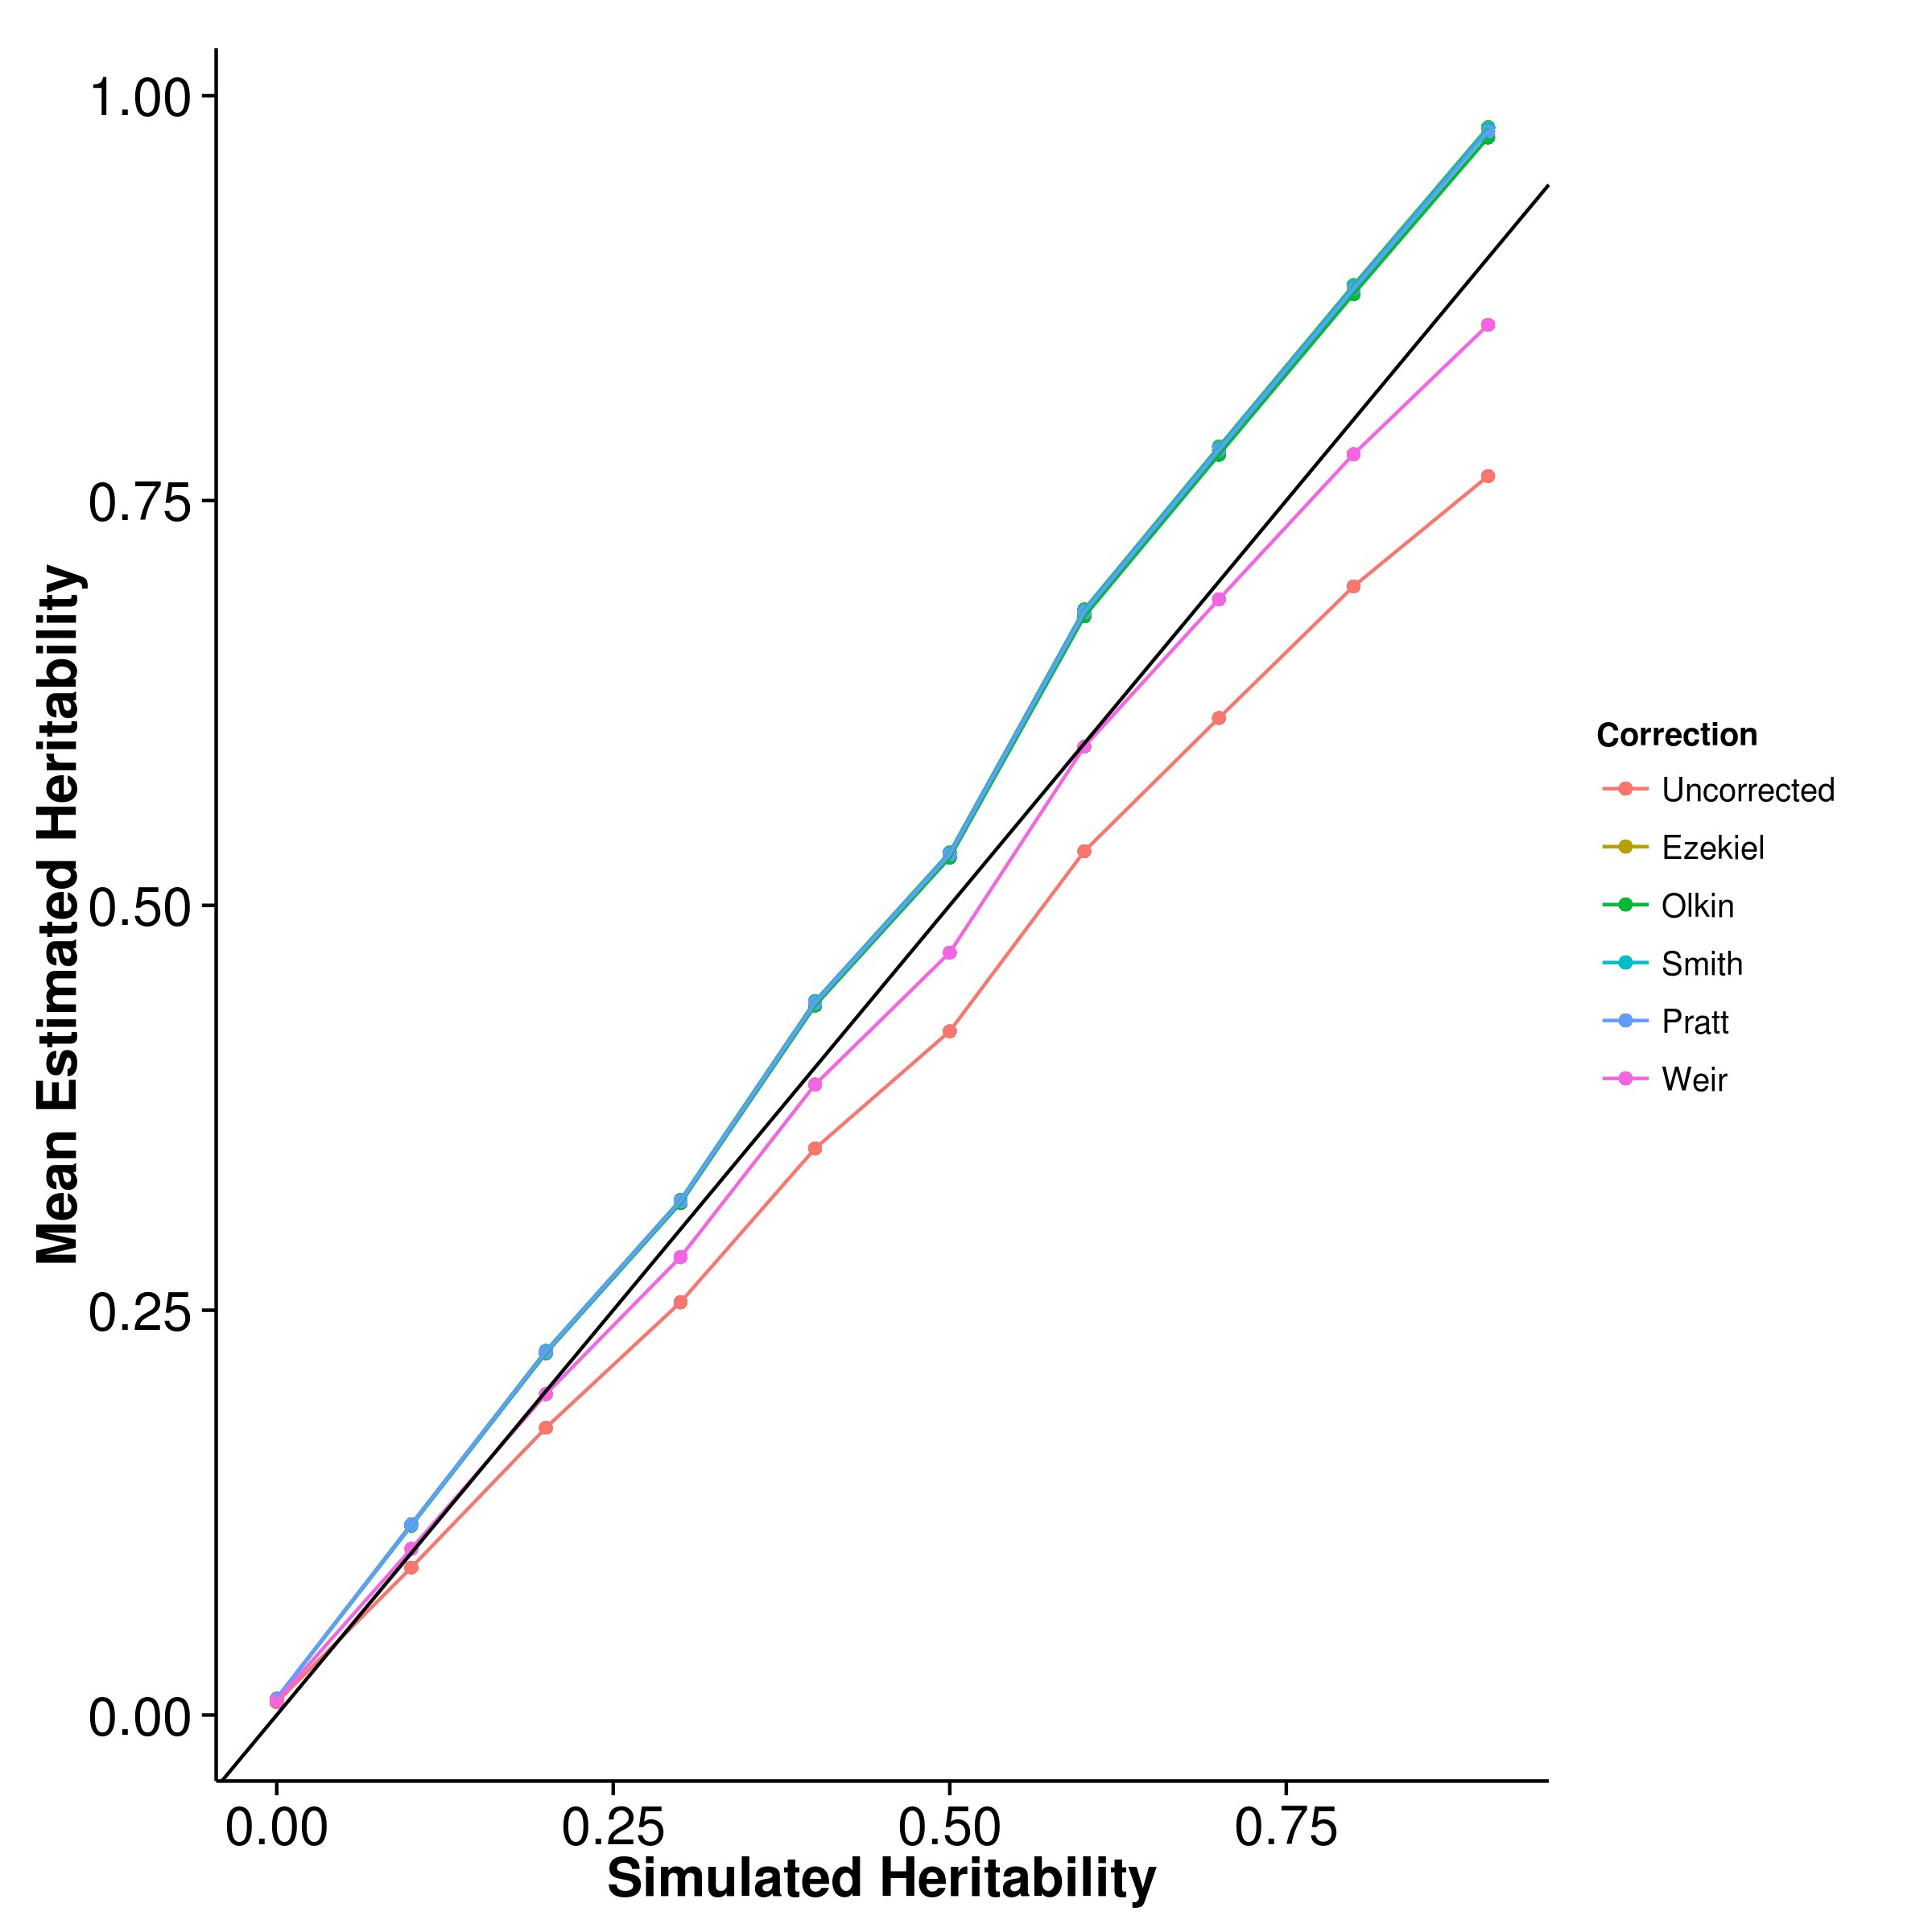

**(a)** Mean Estimation **(b)** Empirical Variance

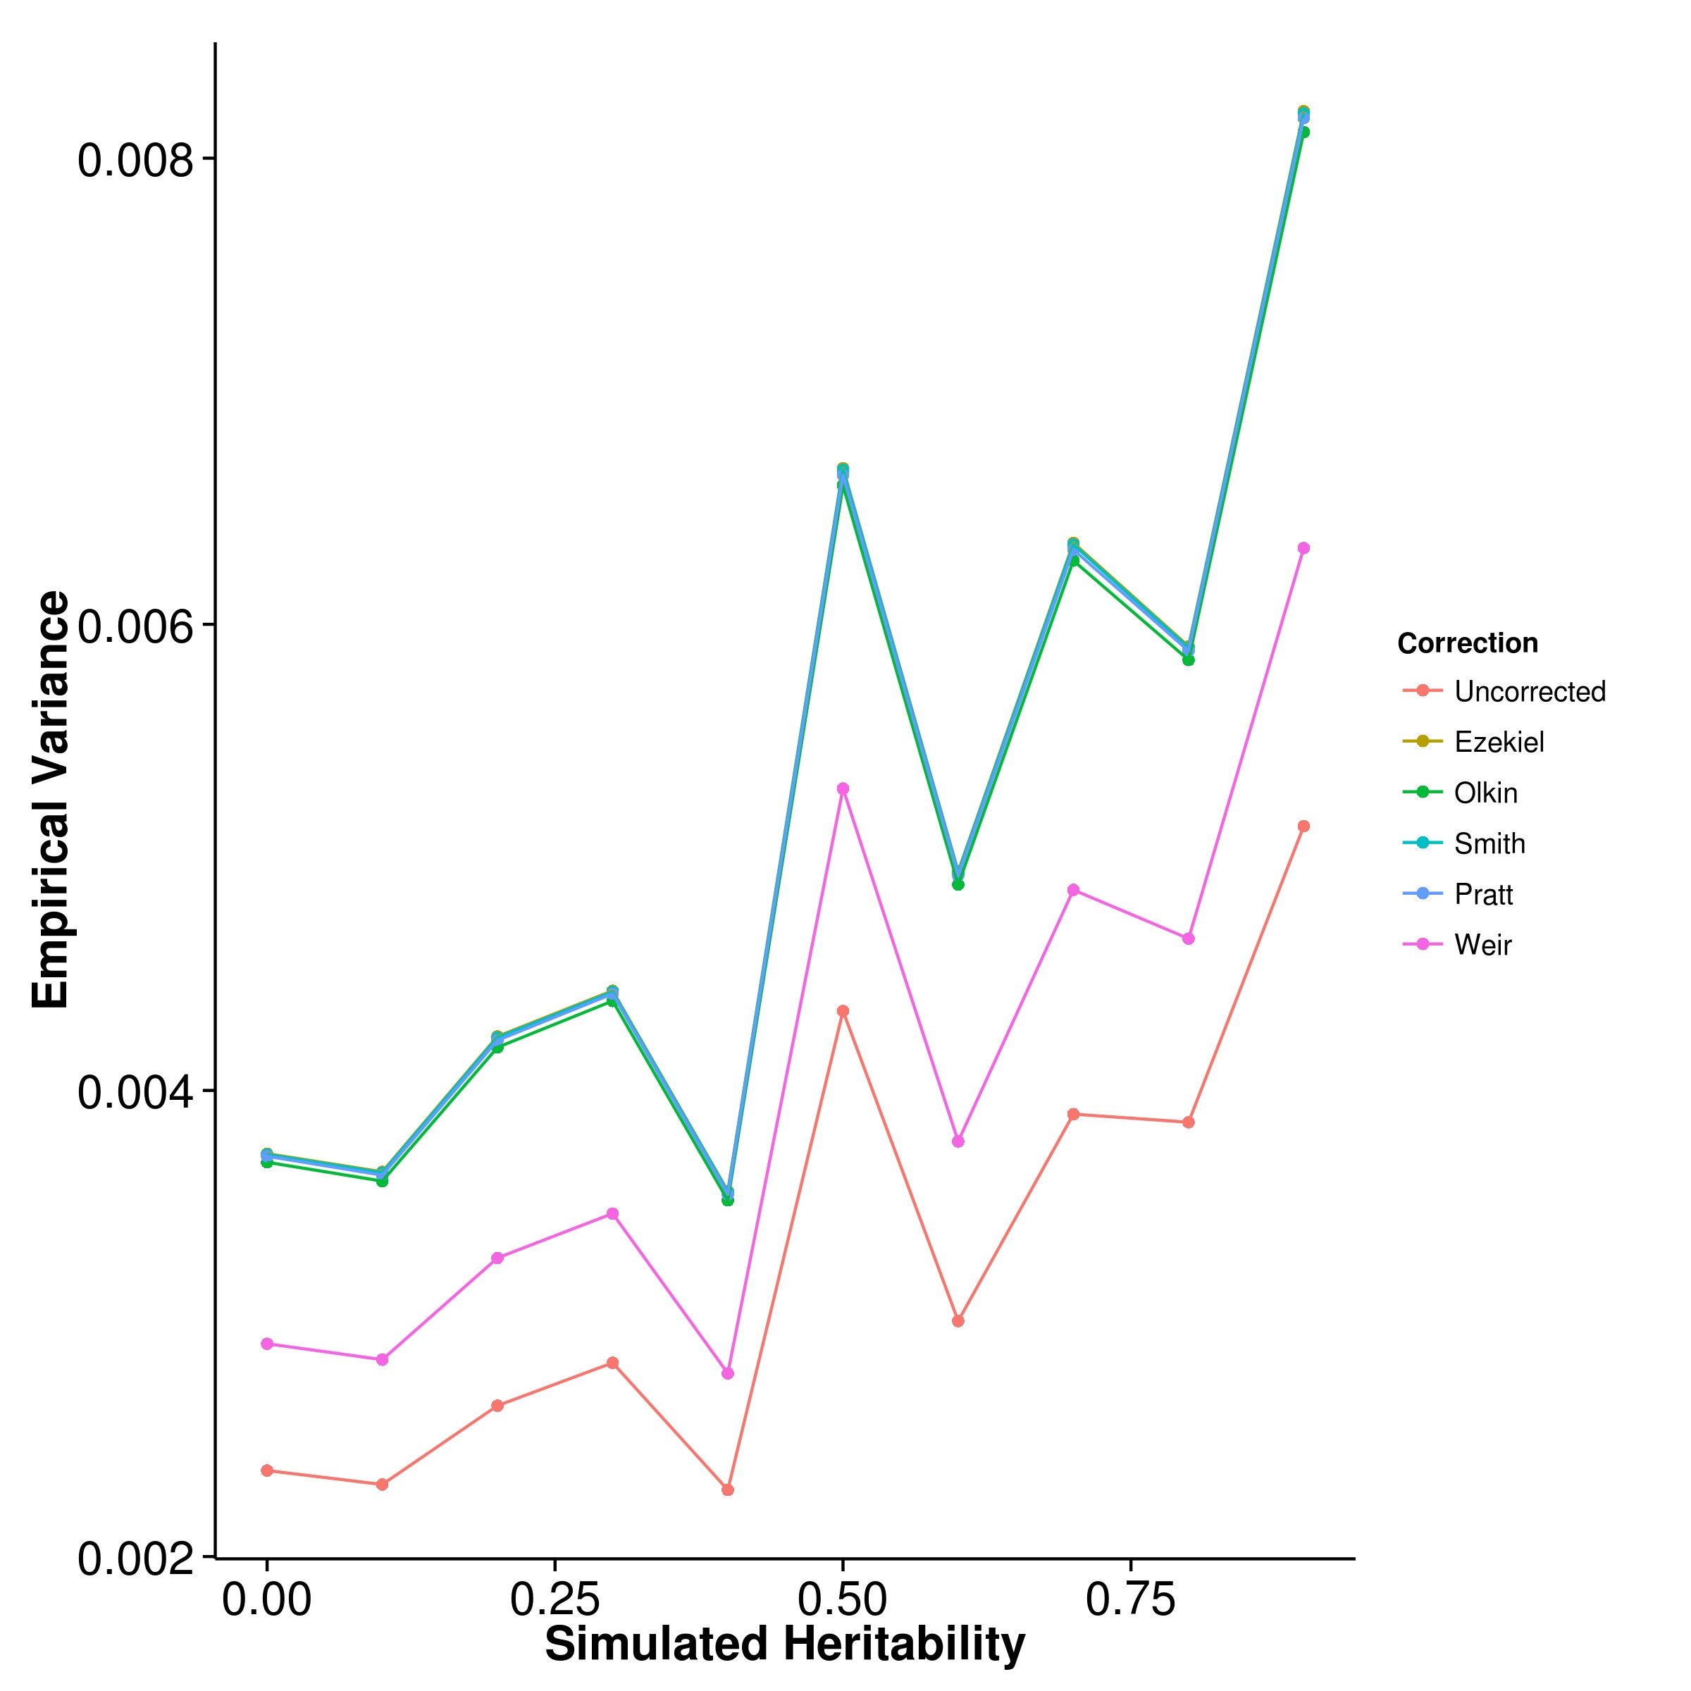

**Figure 2.3:** Effect of LD correction to Heritability Estimation. We compared the performance of our algorithm when different *R2* bias correction algorithm was used. When no bias correction was carried out, a downward bias was observed. After the application of the bias correction algorithms, the mean estimations of all except in the case of Weir eq. (2.39) algorithms leads to an overestimation of heritability. On the other hand, the corrections all lead to increase in variance of the estimation.

**2.6 Result**

The heritability estimation were implemented in SHREK and is available on <https://github.com/choishingwan/shrek>.

**2.6.1 LD Correction**

First, we would like to assess the effect of LD correction on the heritability estimation and the impact of different bias correction algorithms. By performing the simulation using HAPGEN2, we were able to simulate samples with LD structure comparable to the LD of the 1000 genome CEU samples.

First, we would like to compare the performance of SHREK when different bias correction algorithms were applied (fig. 2.3a). From the graph, it was observed that when no bias correction was applied, the mean estimation were in general downwardly biased. This was consistent with our expectation of a general upward bias in sample R2 which will downwardly penalize the resulting heritability estimation. On the other hand, the bias correction algorithms all worked as expected where they increases the mean estimation of heritability as removing the upward bias in the sample R2, the heritability estimation should increase. However for most algorithms except for Weir’s formula (eq. (2.39)) an over adjustment were observed, leading to a general upward bias in the estimation. Taking into account of the variance of estimation (fig. 2.3b), Weir’s formula was the most suitable for SHREK where not only it reduces the bias in the final heritability estimation, it does not introduce too much additional variance into the estimation. As a result of that, we selected the Weir’s formula as our default LD correction algorithm.

**2.6.2 Comparing with Other Algorithms**

Having selected the optimal LD correction algorithm, we then compared the performance of SHREK with existing algorithms to understand the relative performance of these algorithms under different conditions. First, we examined the performance of the algorithms under the quantitative trait scenario where the trait heritability and the number of causal SNPs were varied.

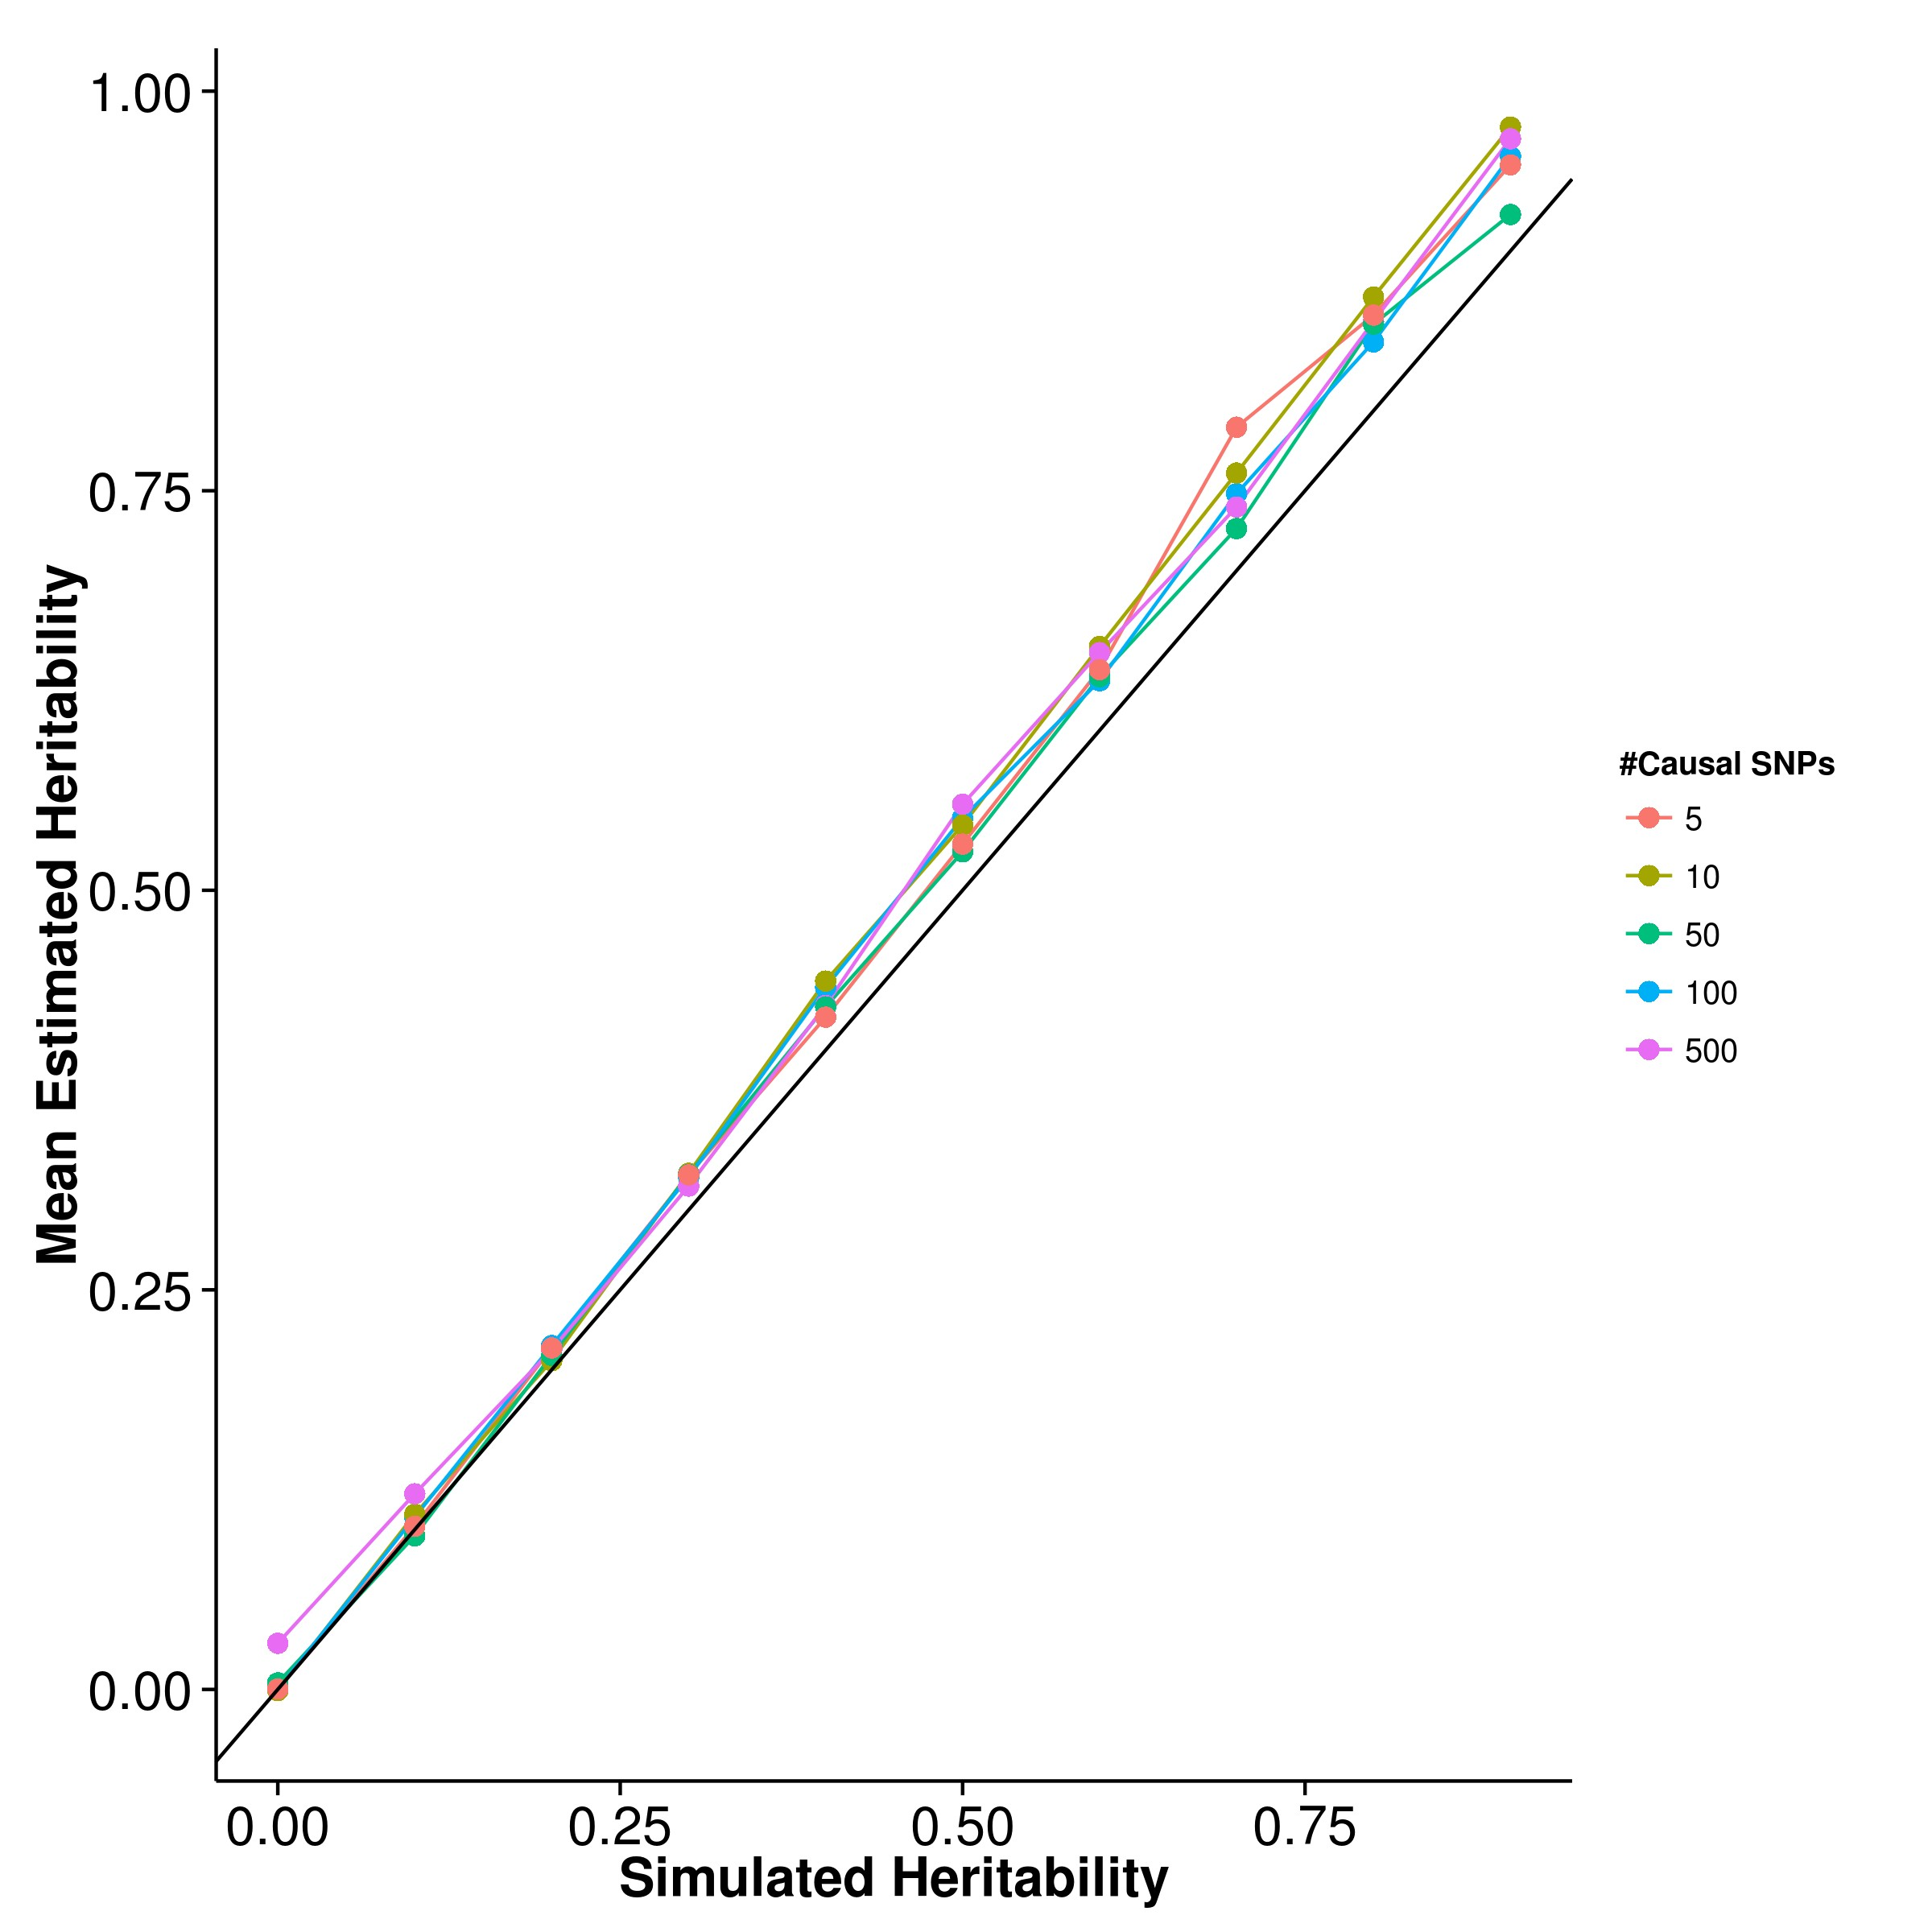

**(a)** SHREK **(b)** GCTA

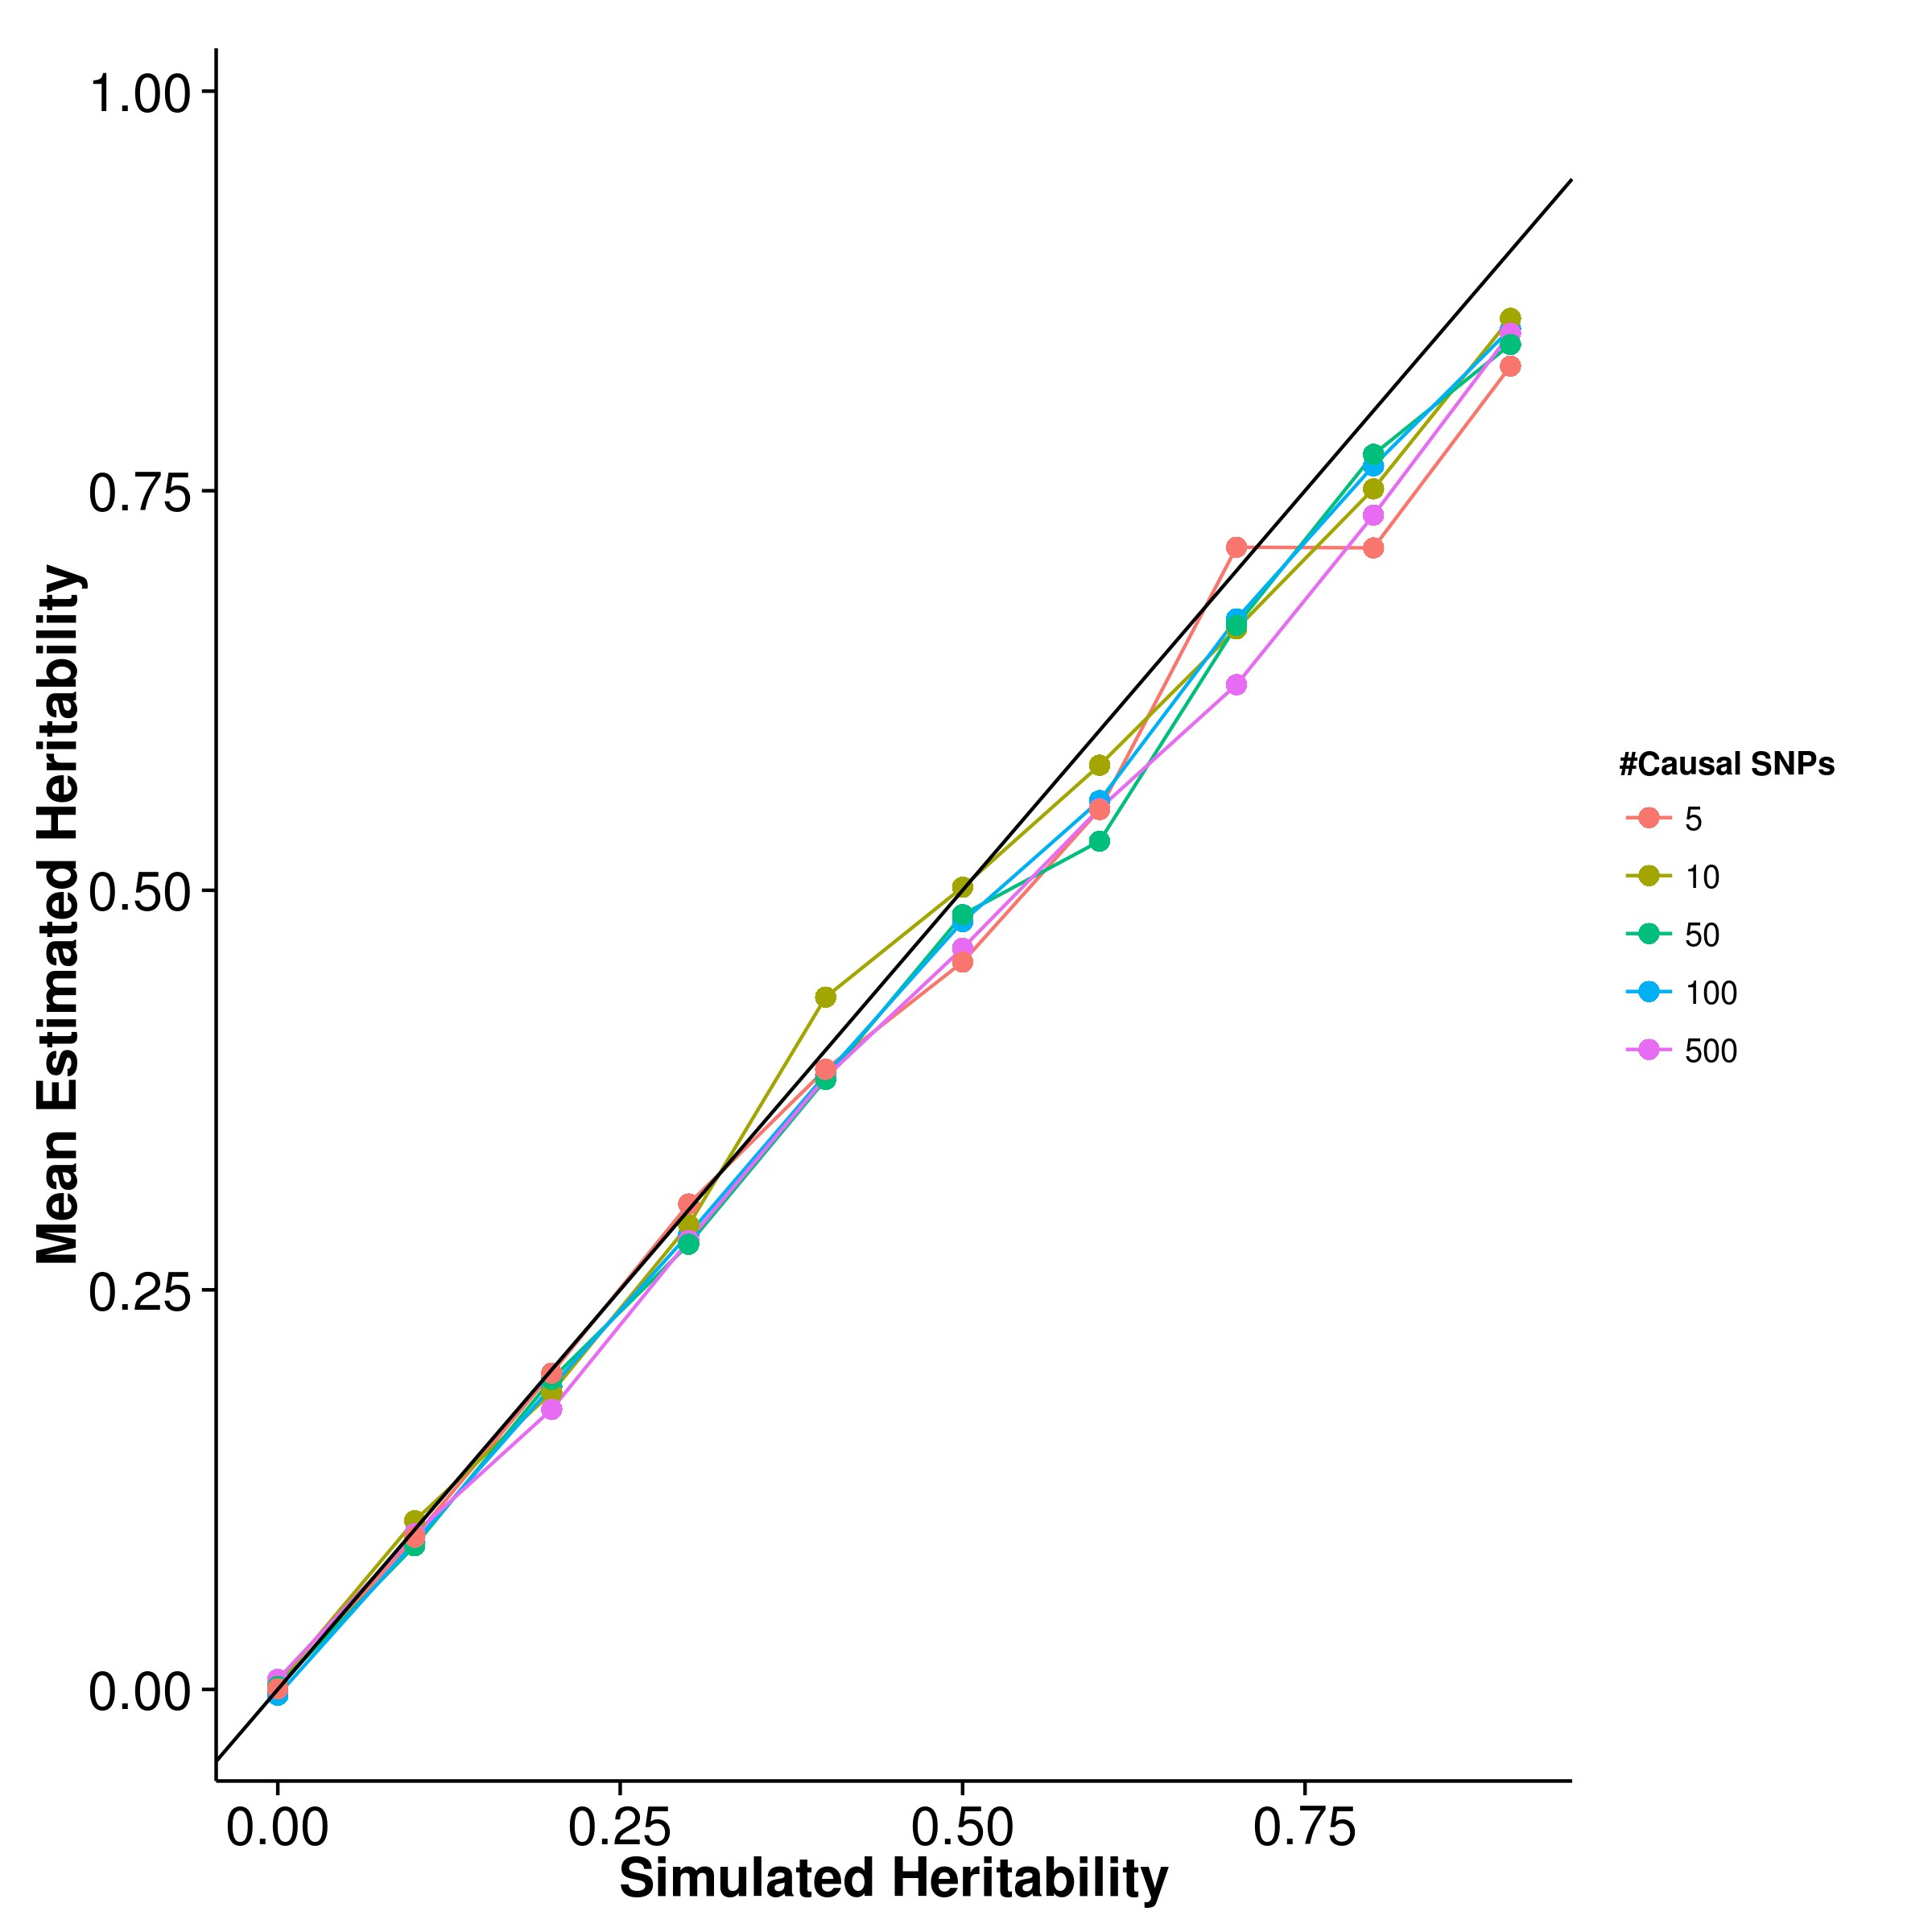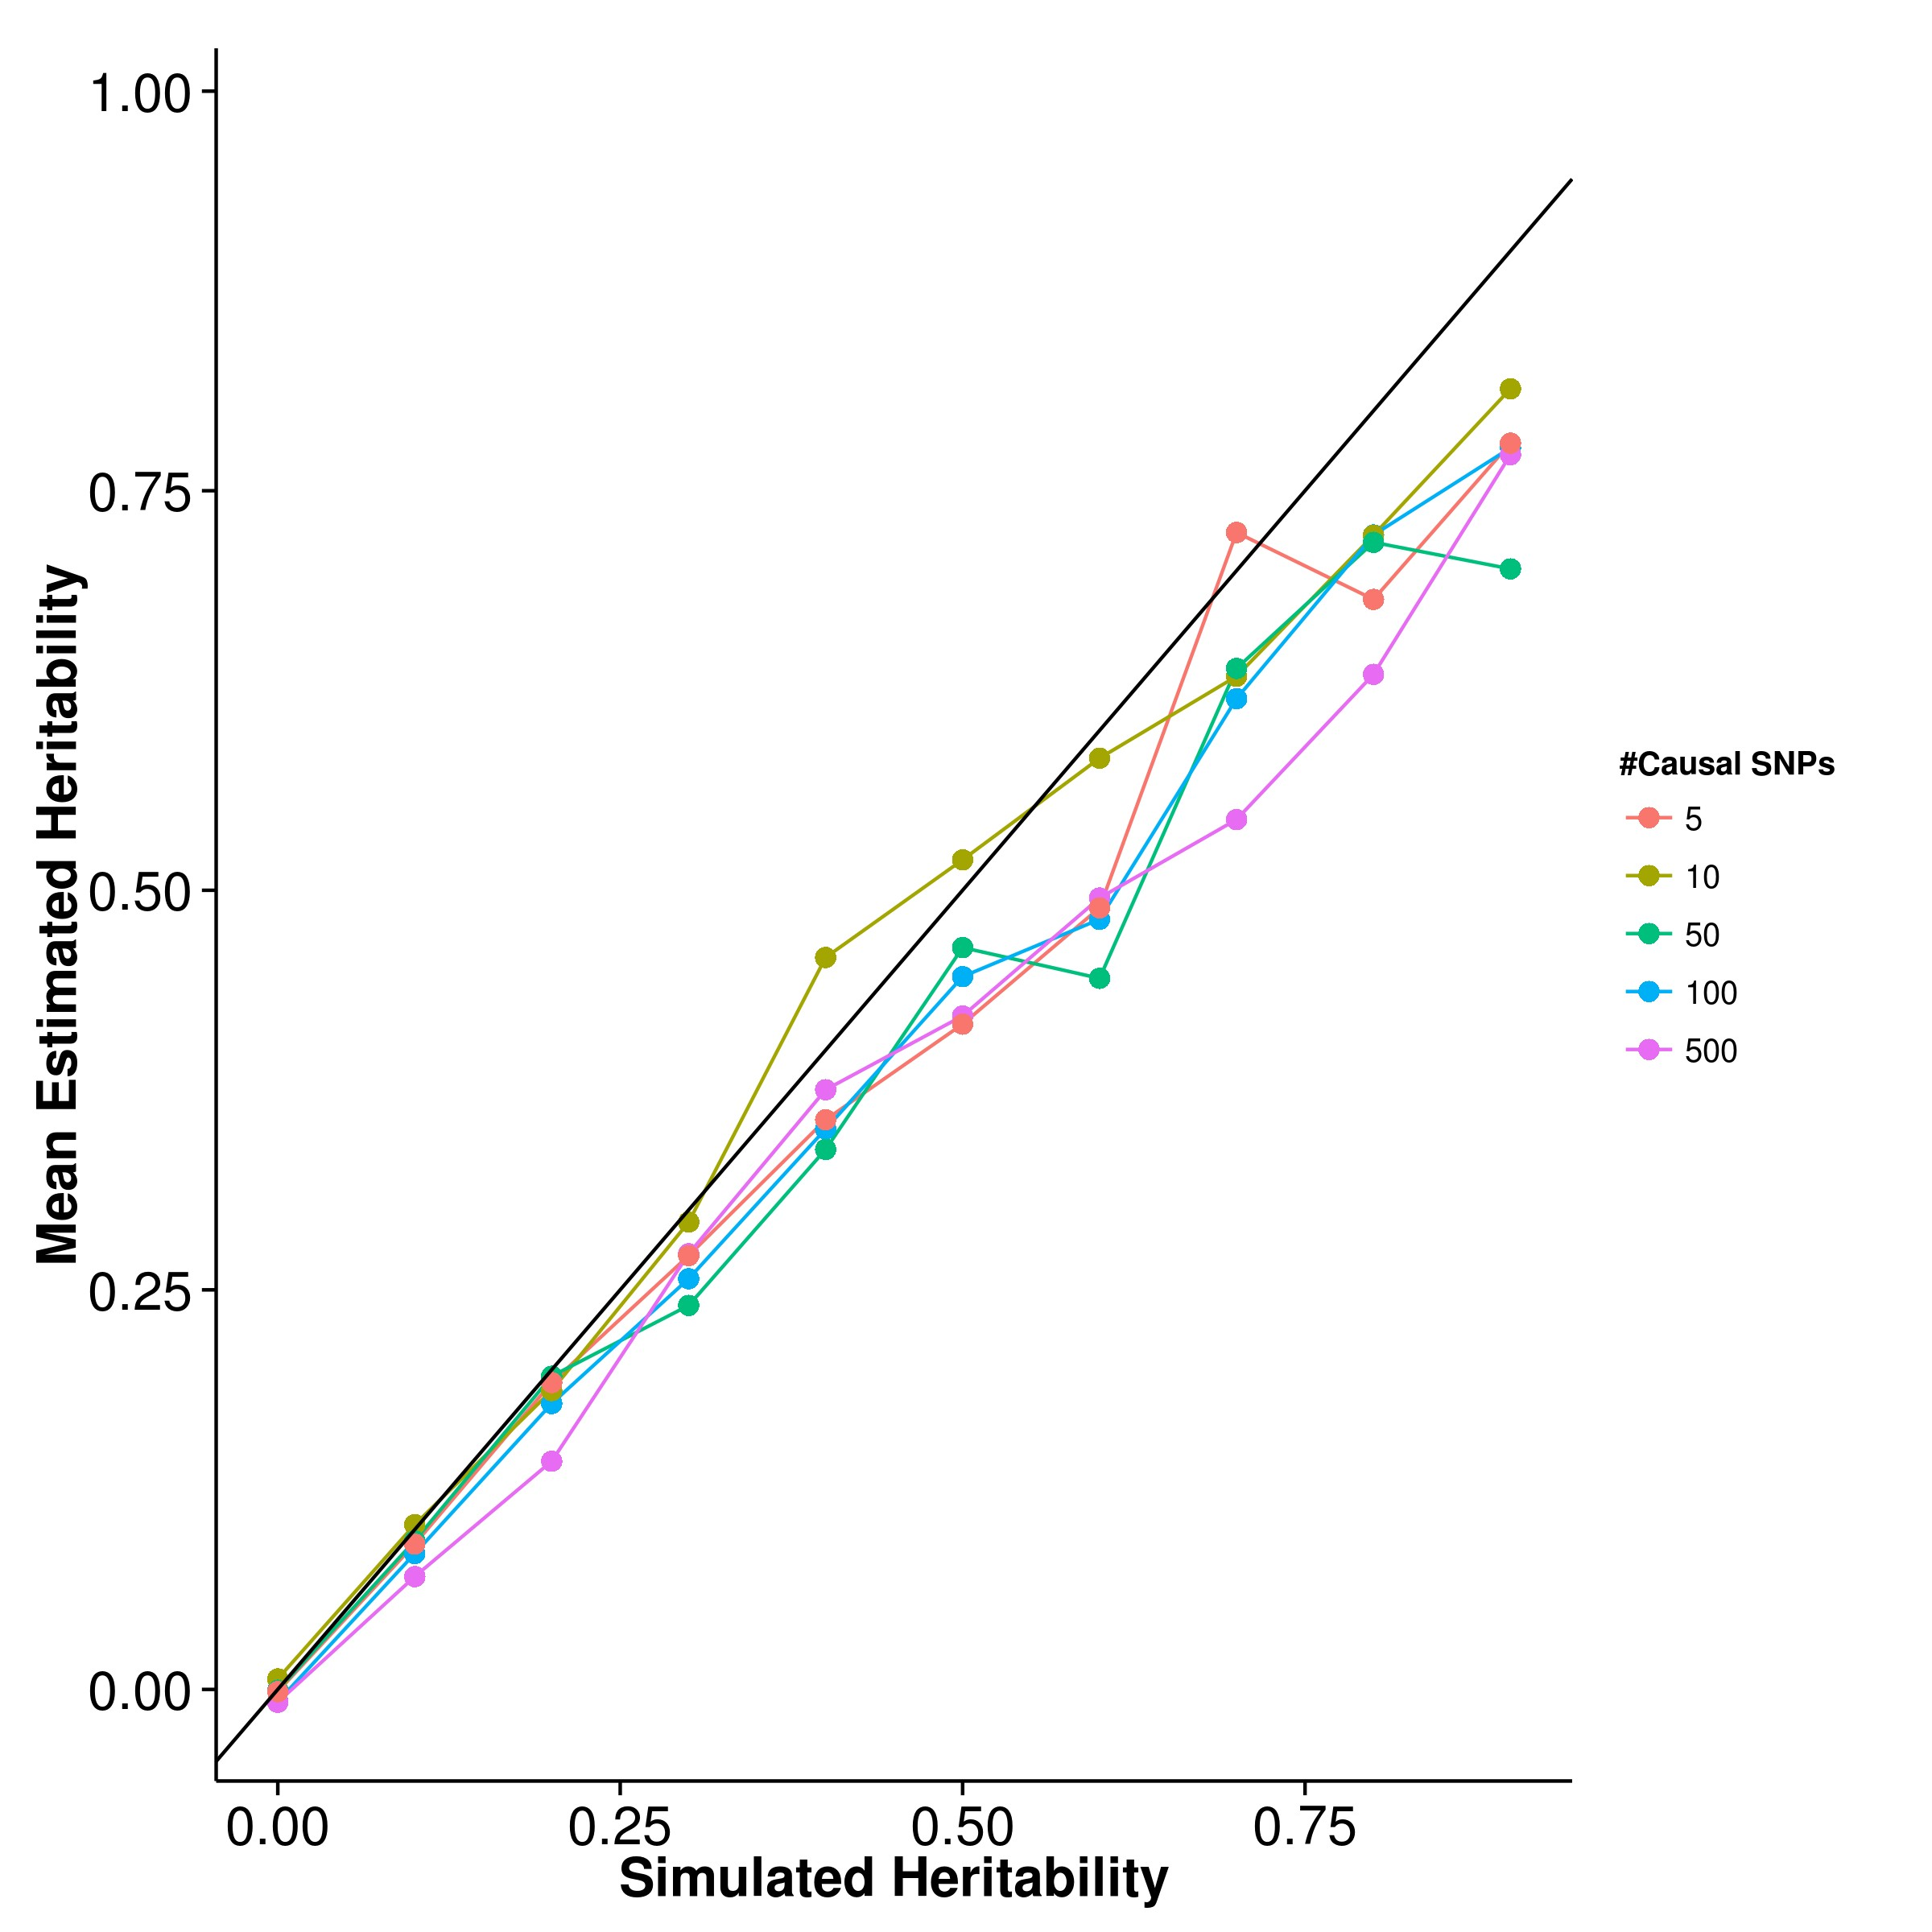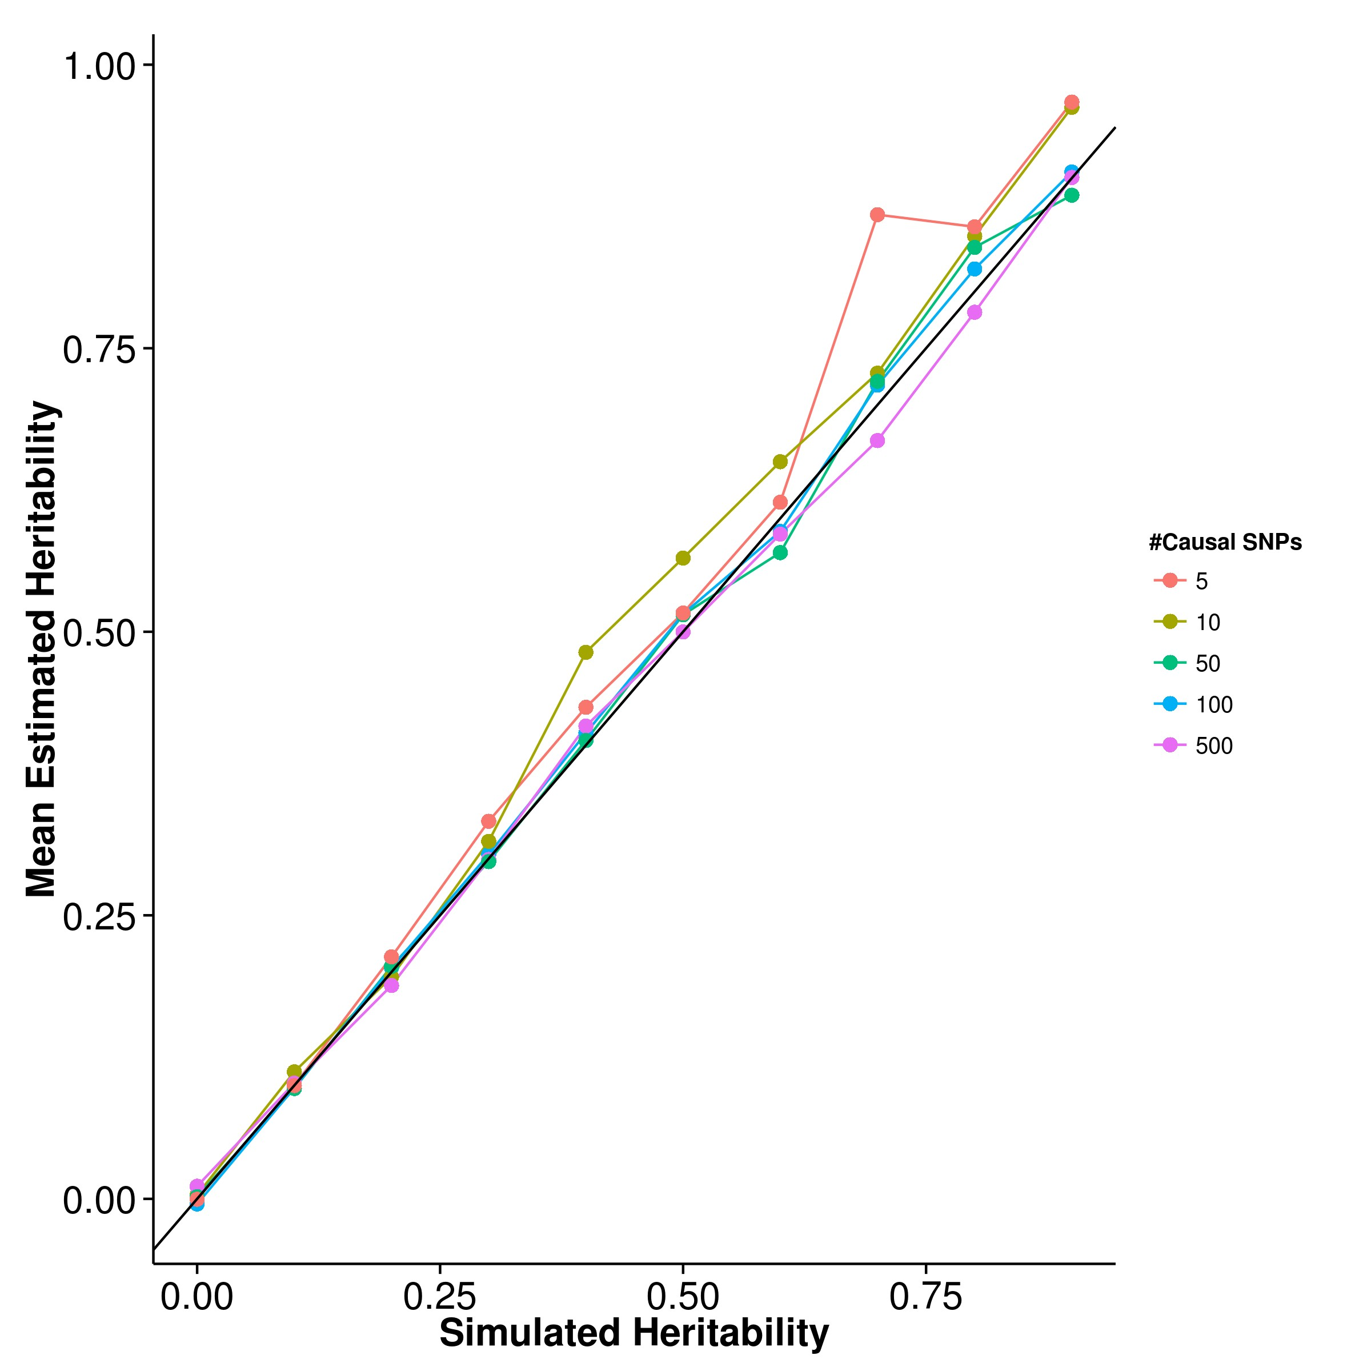

**(c)** LDSC with fix intercept **(d)** LDSC with intercept estimation

**Figure 2.4:** Mean of results from quantitative trait simulation with random effect size simulation. Estimations form SHREK were slightly biased upwards whereas GCTA and LDSC with intercept estimations both biased downwards. On the other hand, LDSC with fixed intercept provides least biased estimates under polygenic conditions. However, when the number of causal SNPs is small (e.g. 5 or 10), an upward bias was observed.

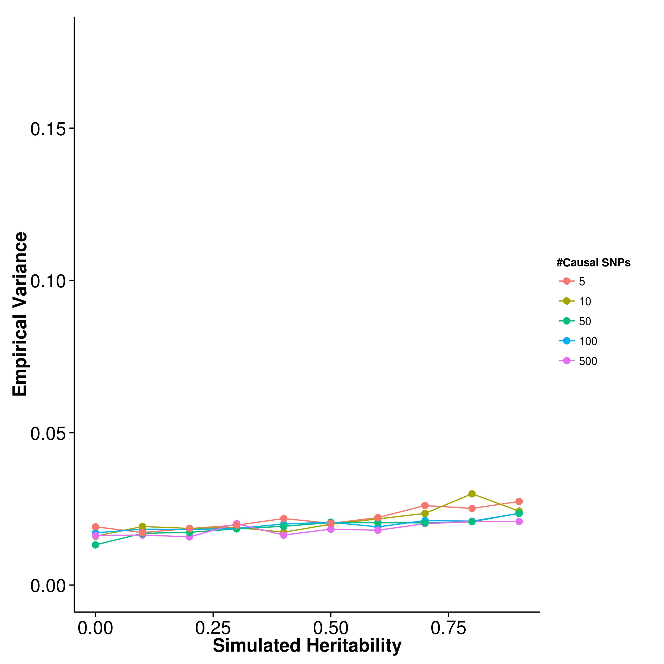

**(a)** SHREK **(b)** GCTA

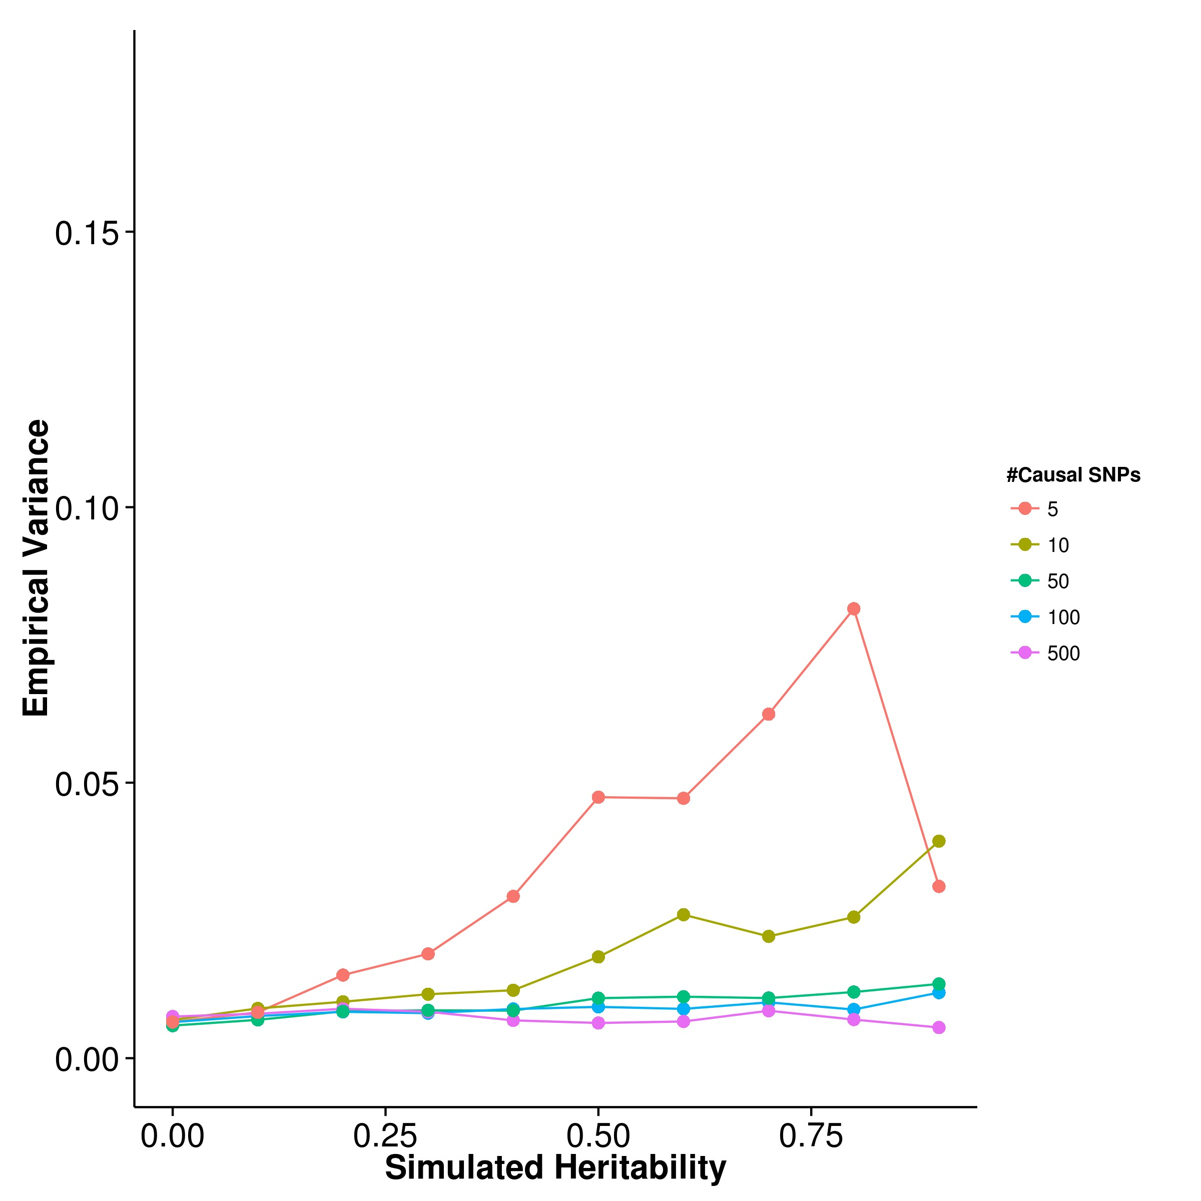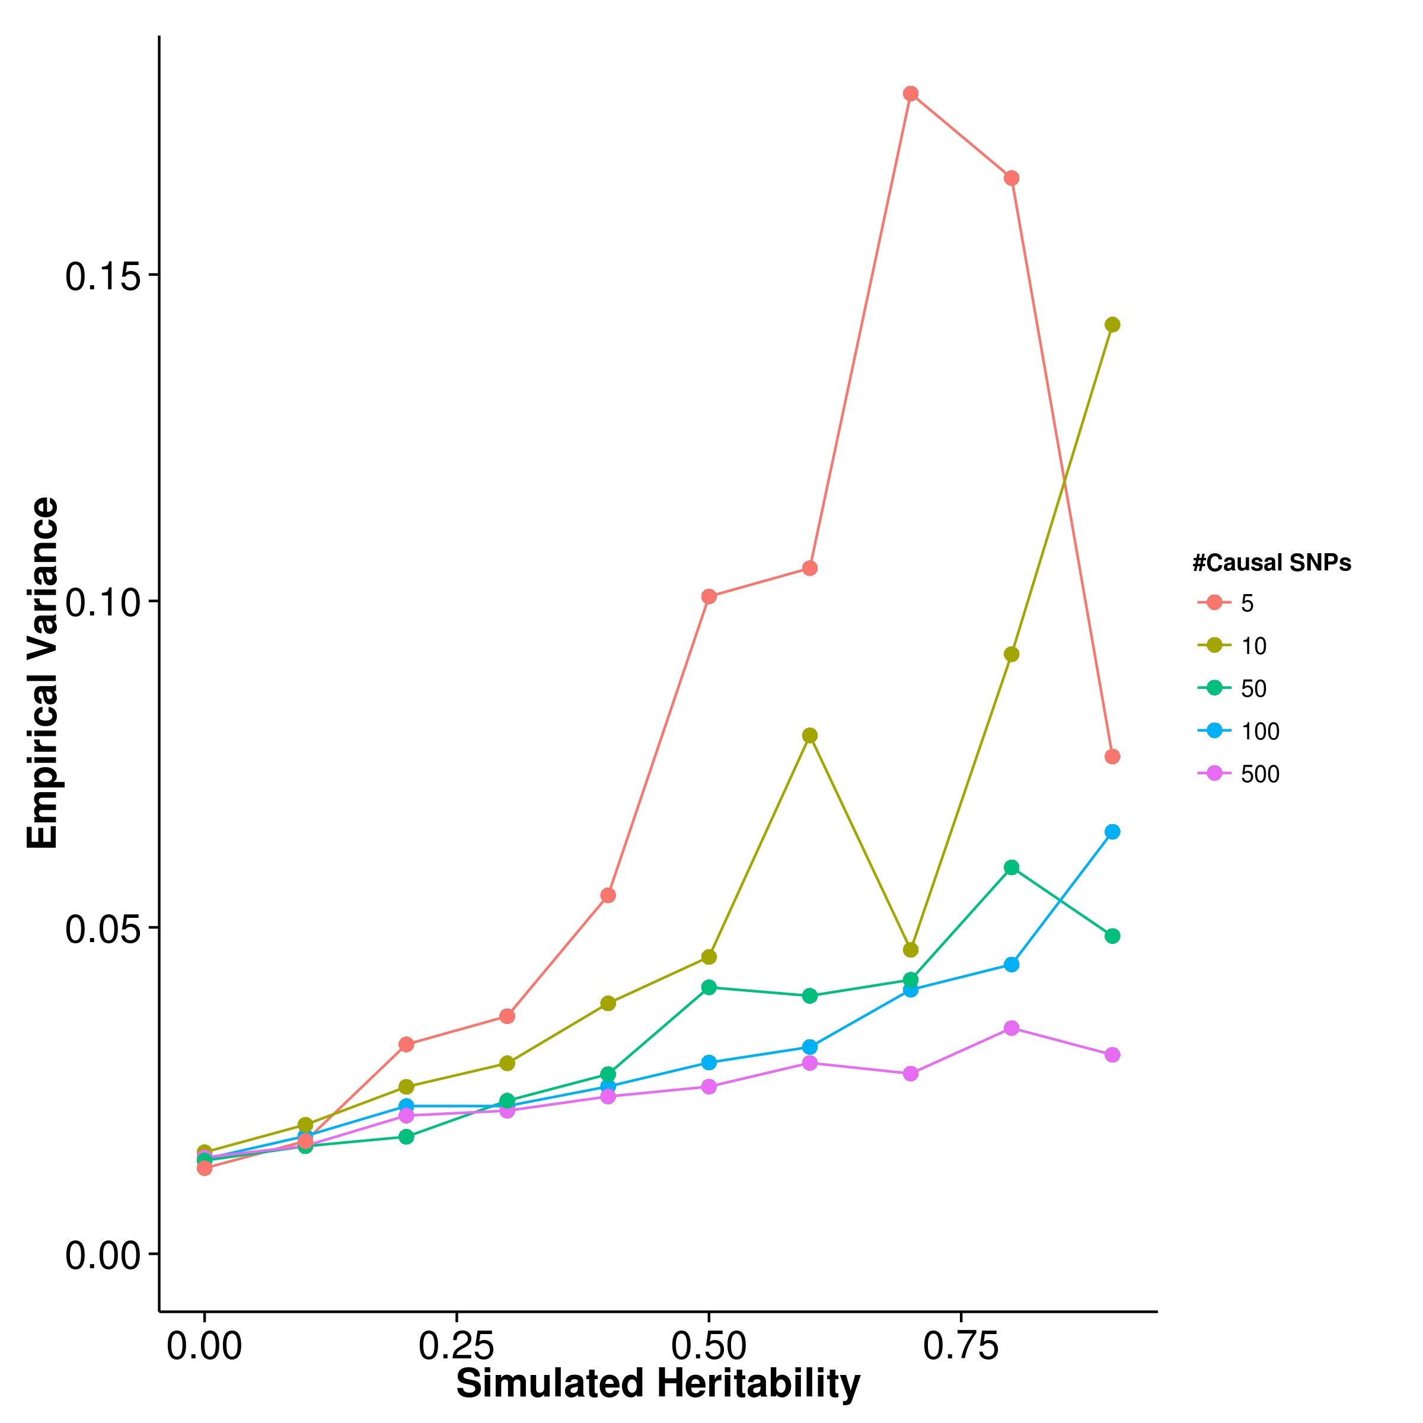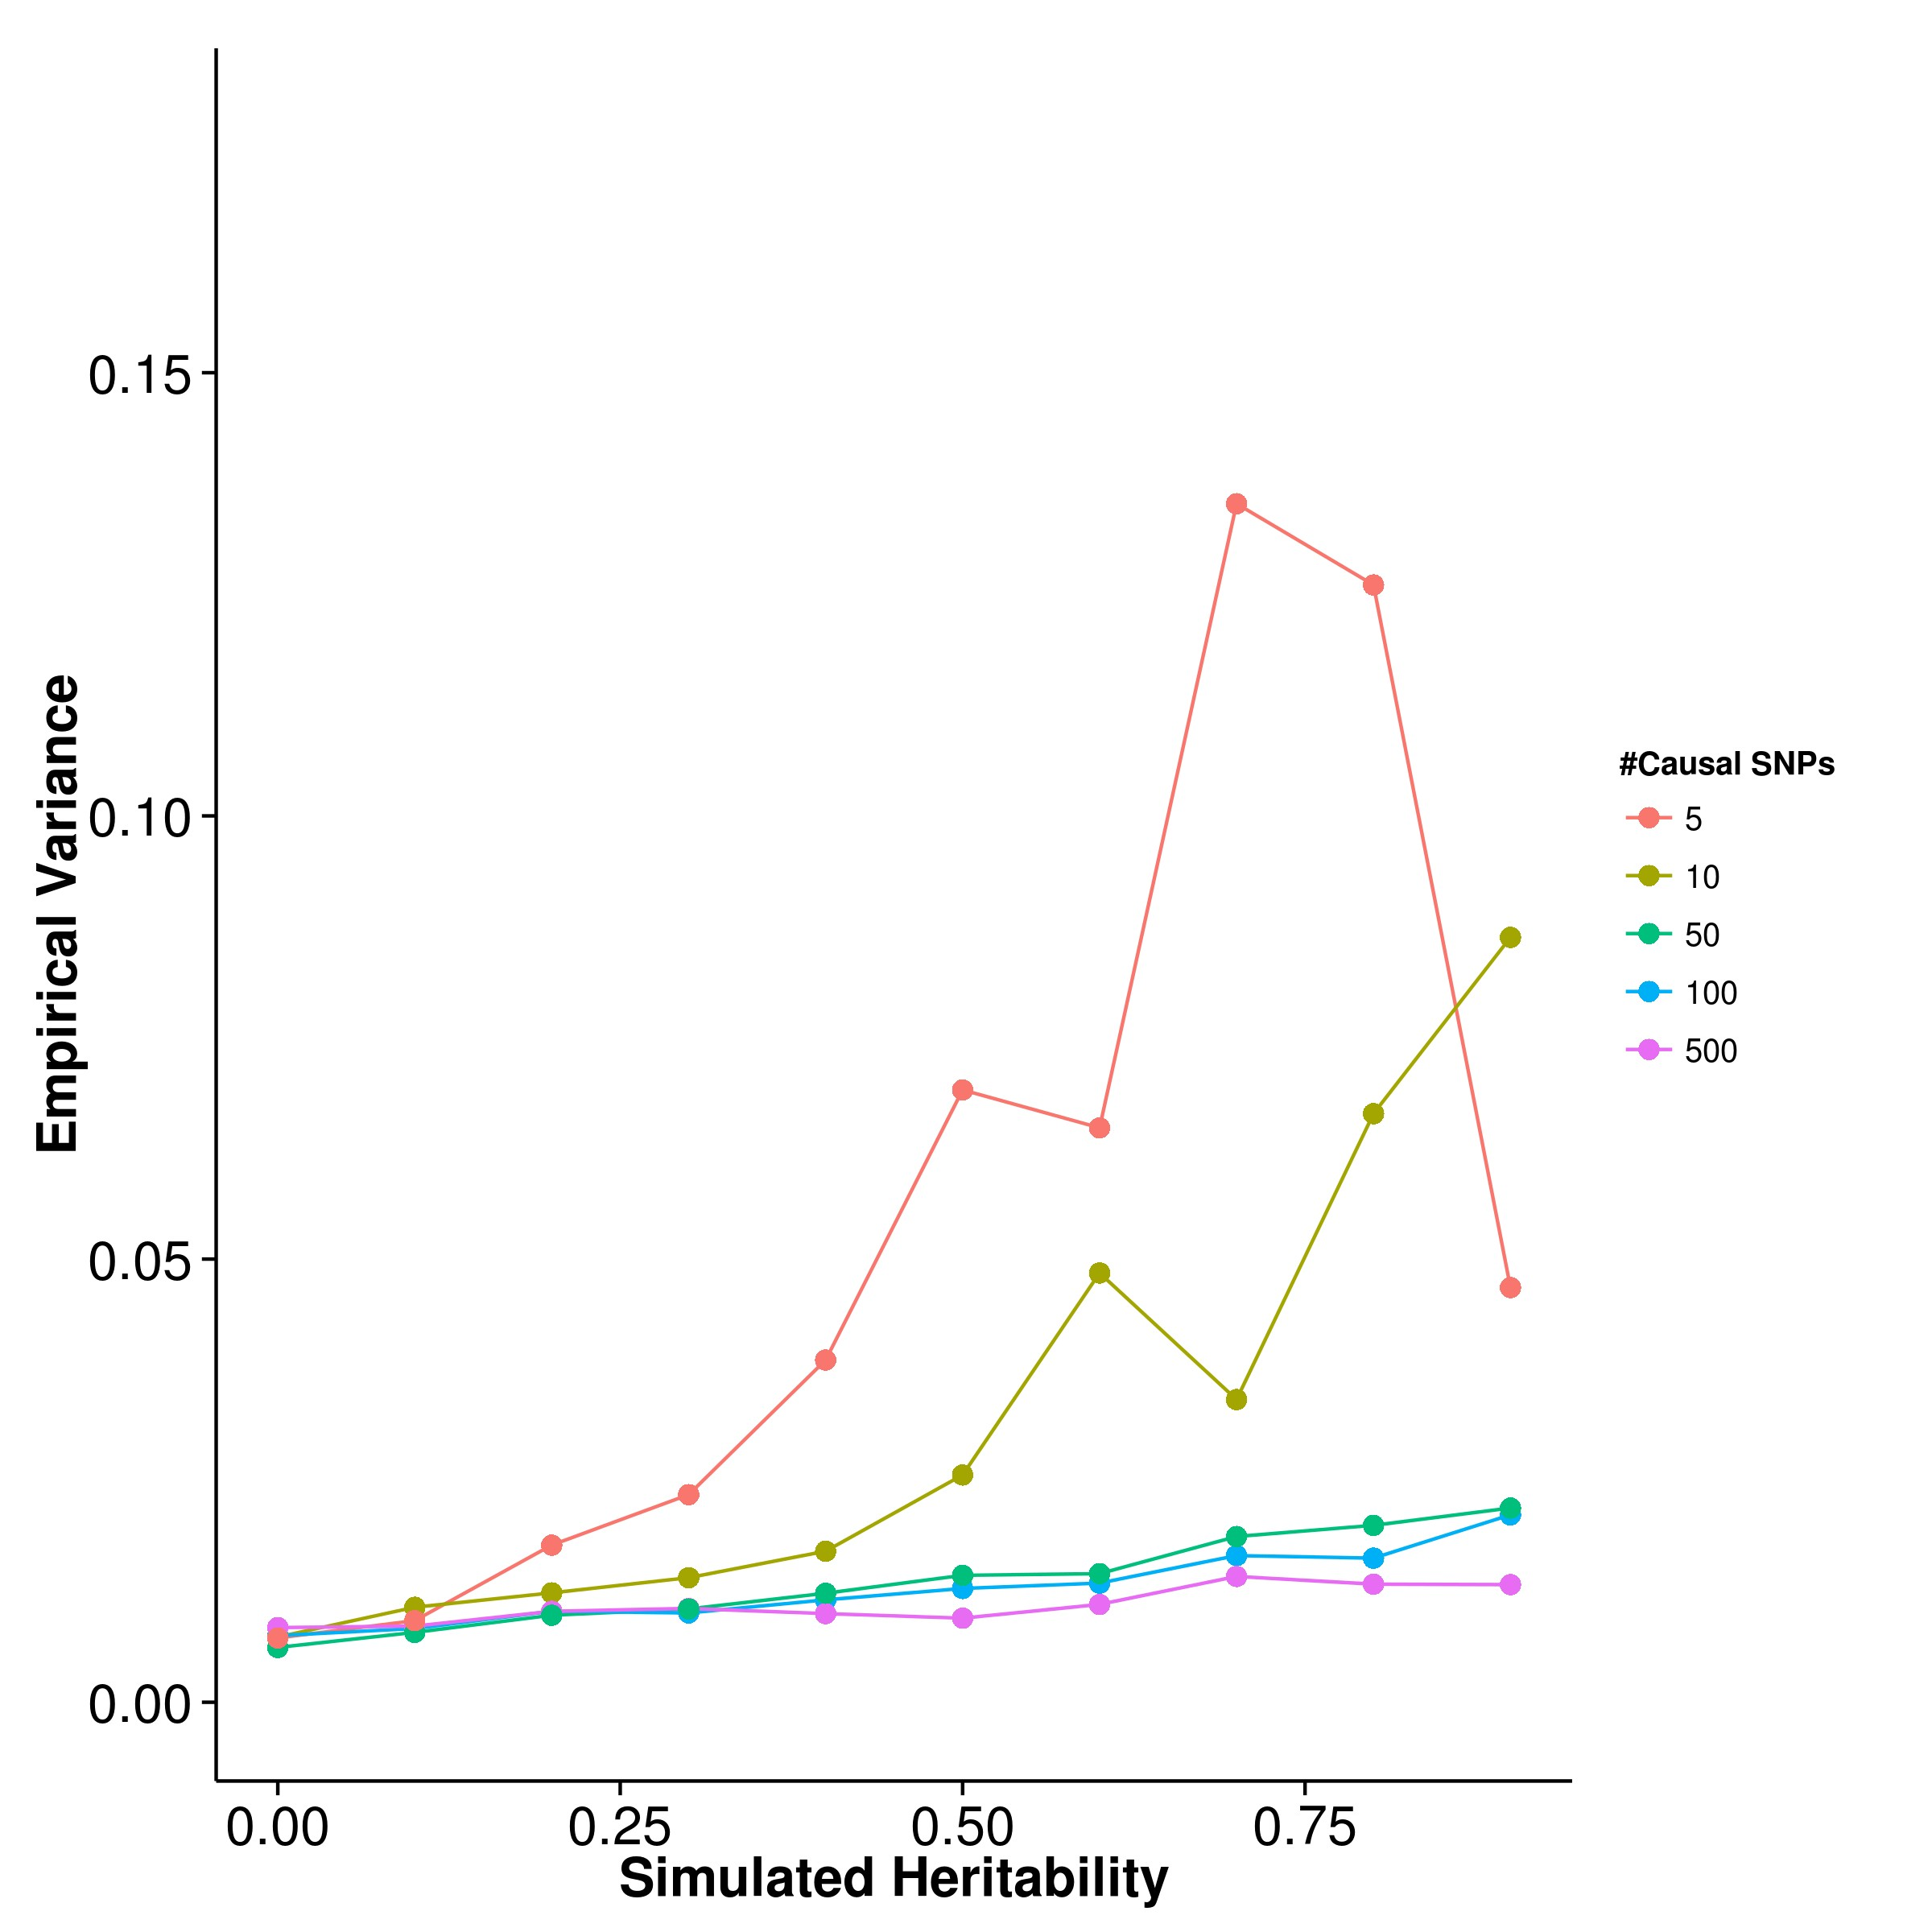

**(c)** LDSC with fix intercept **(d)** LDSC with intercept estimation

**Figure 2.5:** Variance of results from quantitative trait simulation with random effect size simulation. Under the polygenic conditions, GCTA has the smallest variance, follow by LDSC. However, it was observed when the number of causal SNPs decreases, the variance of the estimation increases for all algorithm, with variance of the SHREK estimate being the least affected. In fact, under oligogenic conditions, SHREK has a lower empirical variance when compared to LDSC.

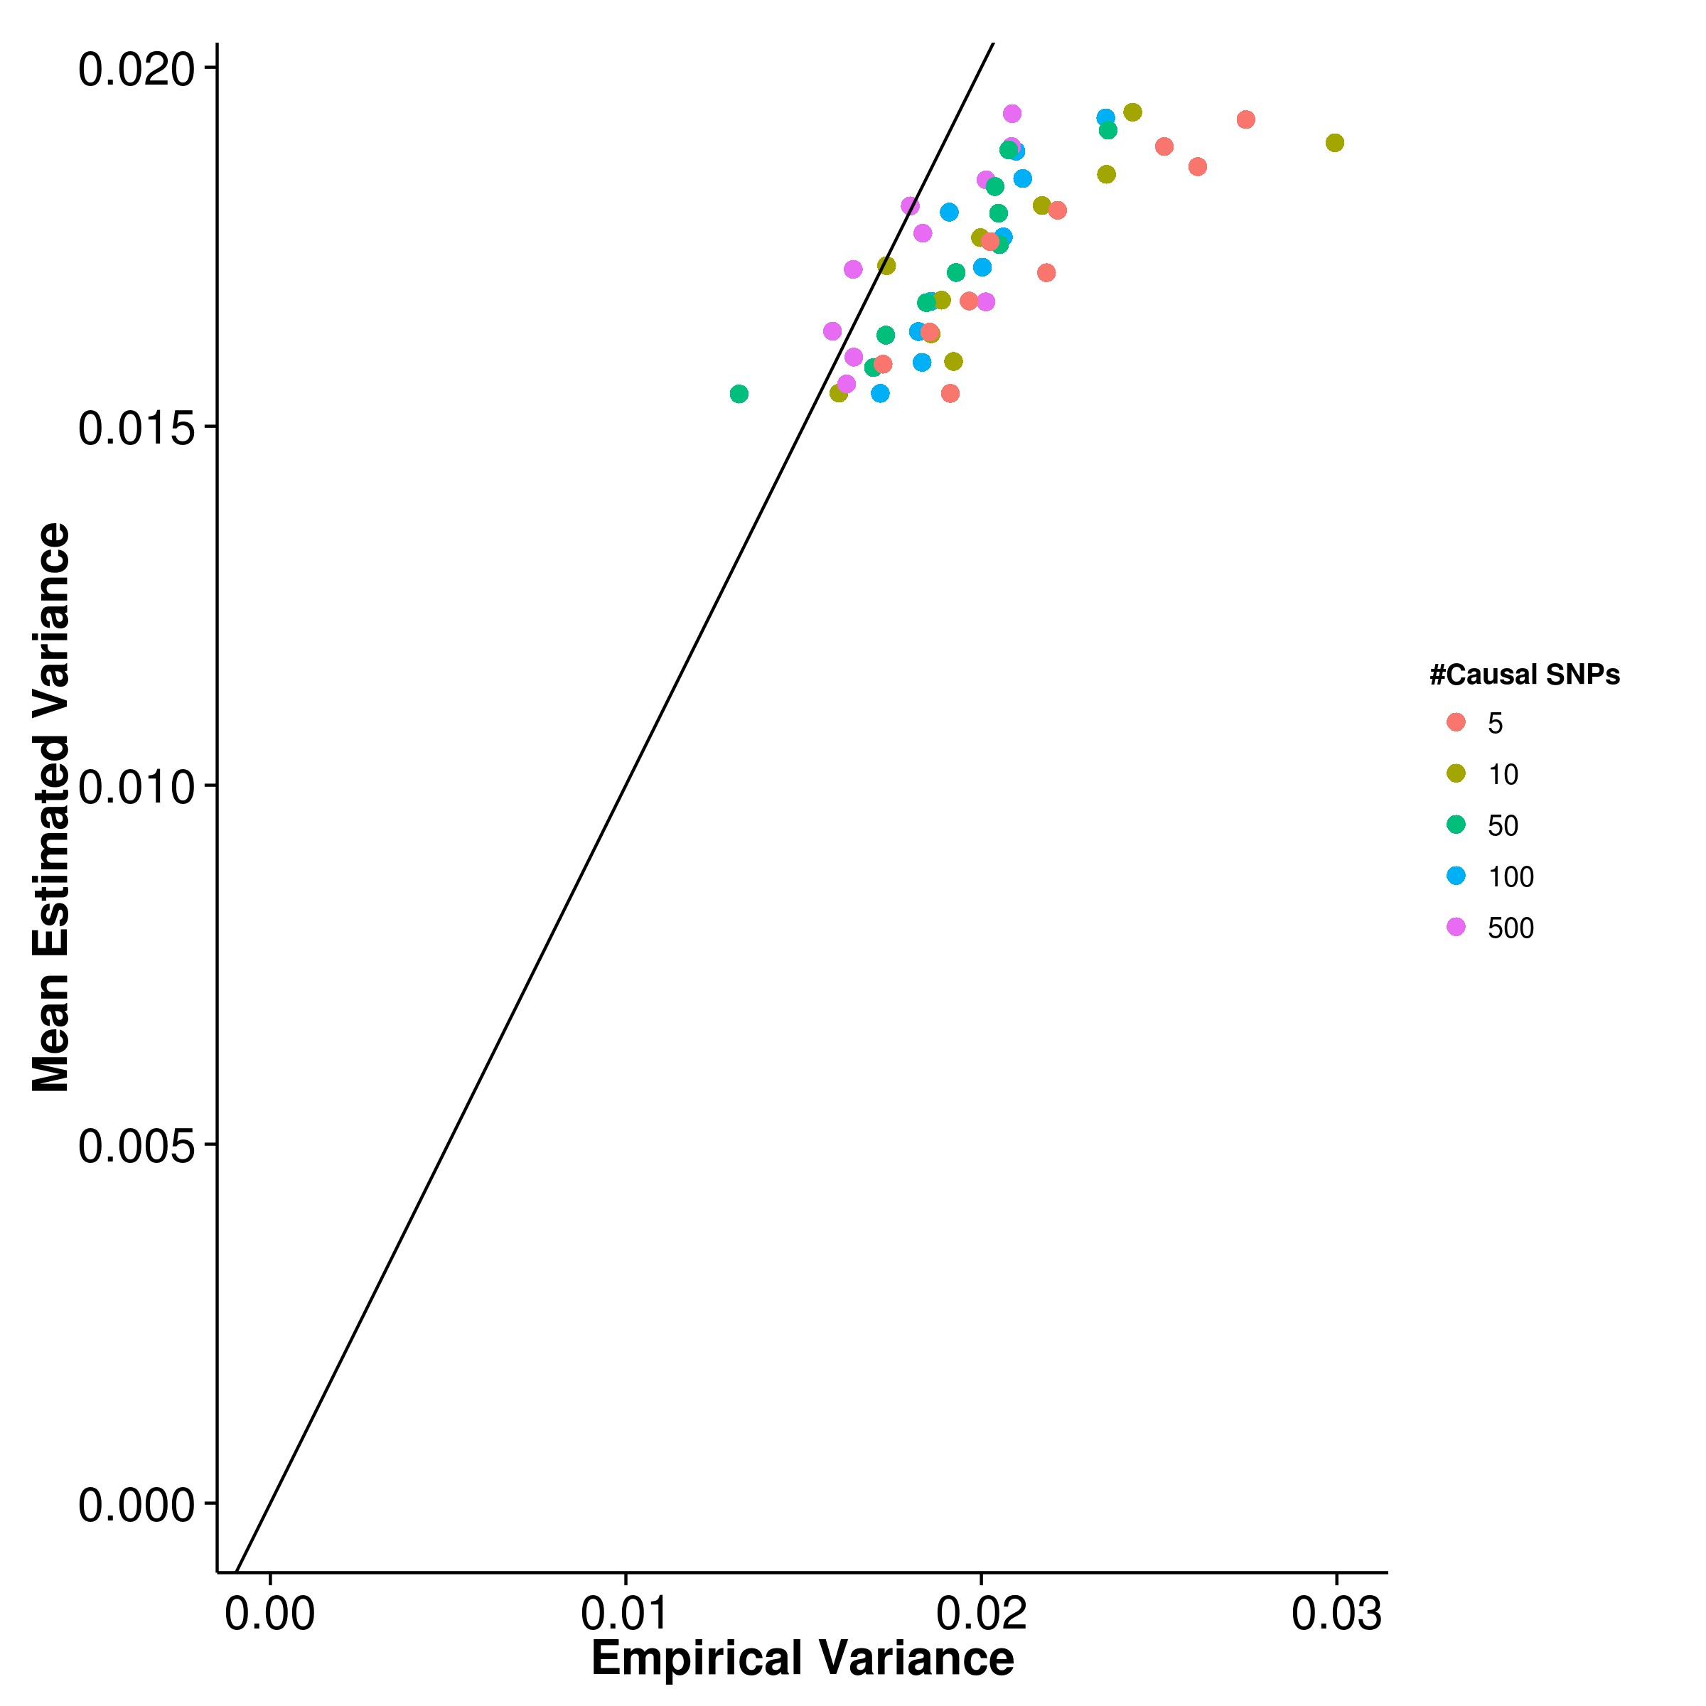

**(a)** SHREK **(b)** GCTA

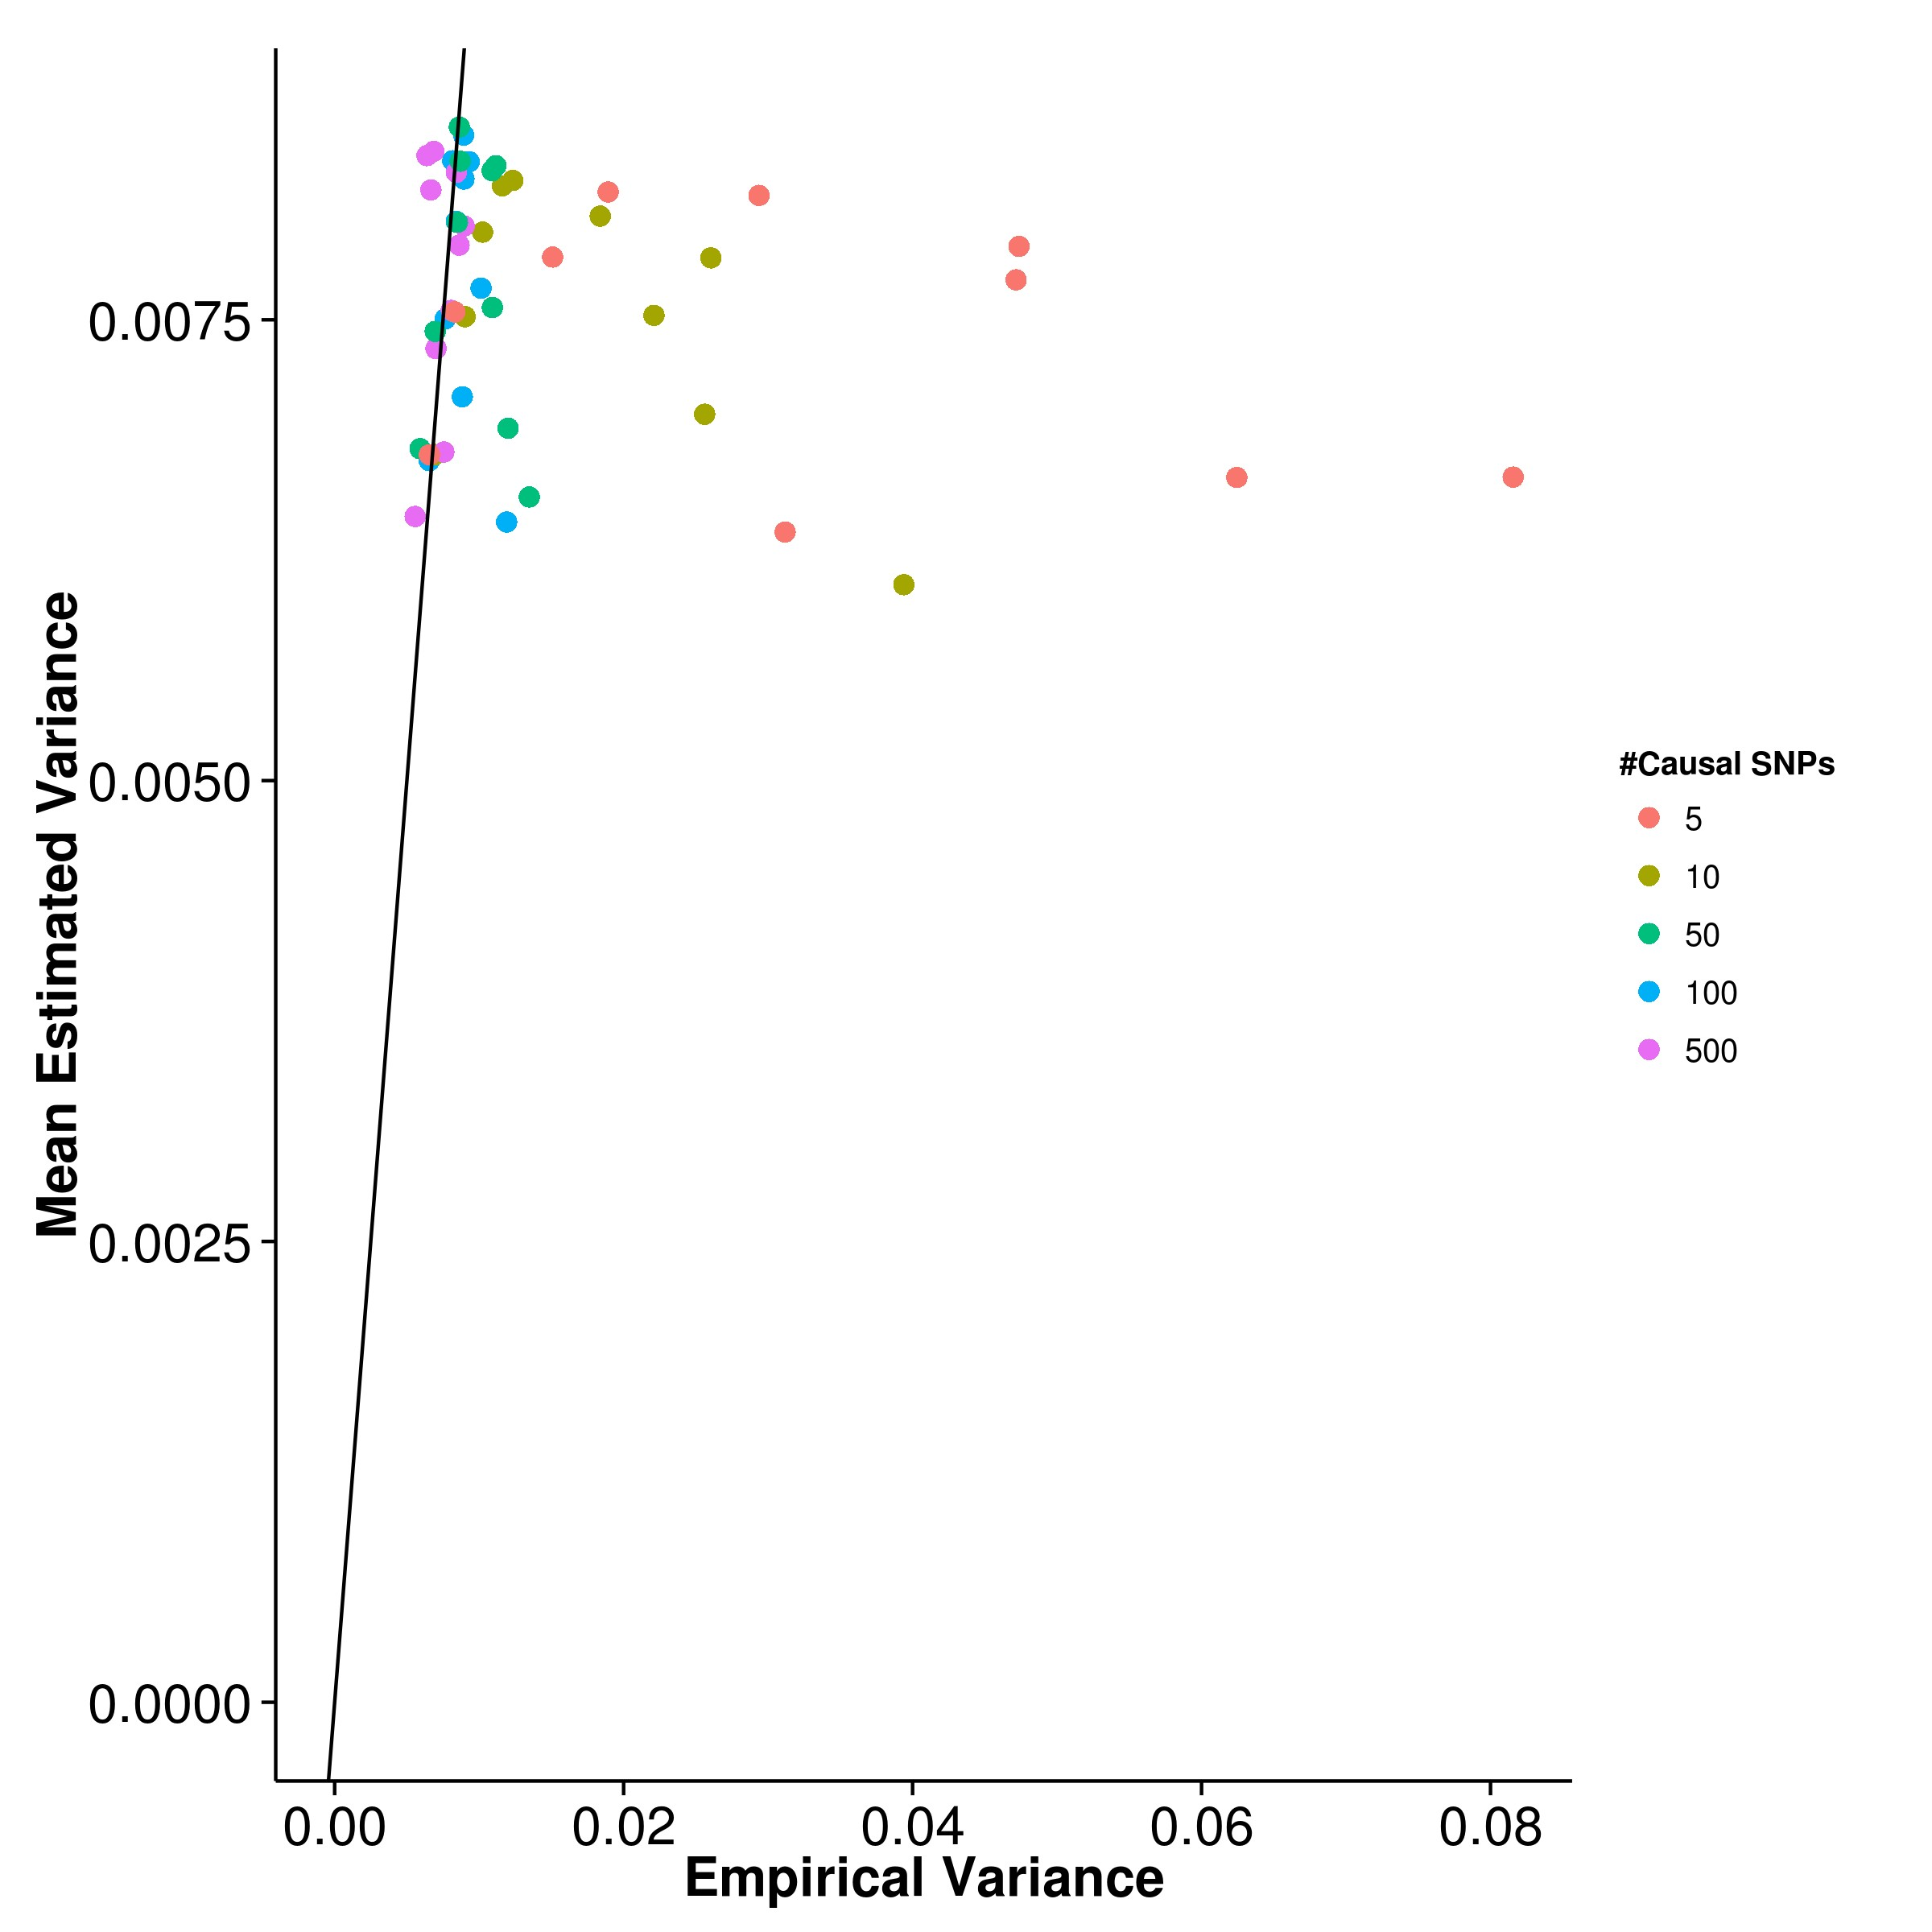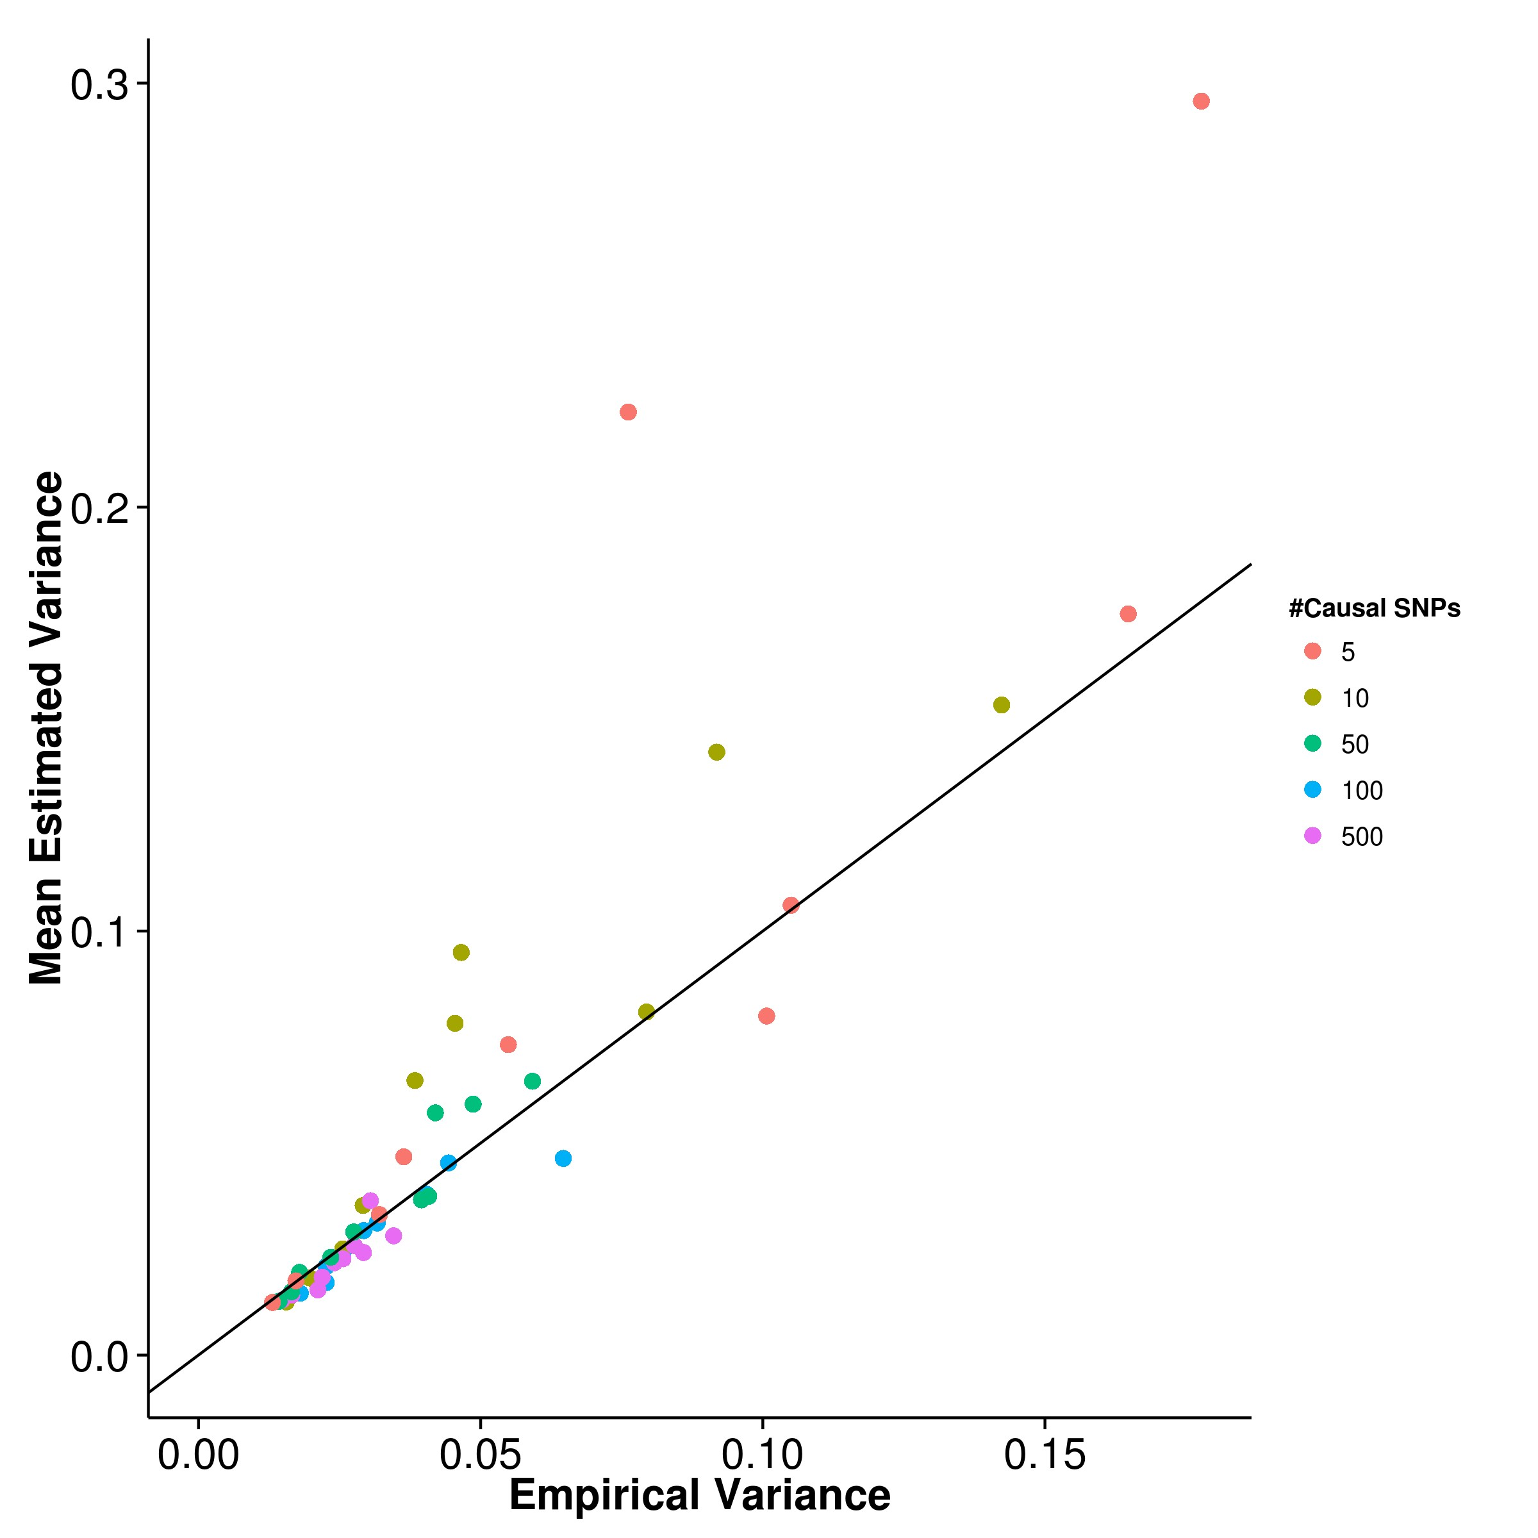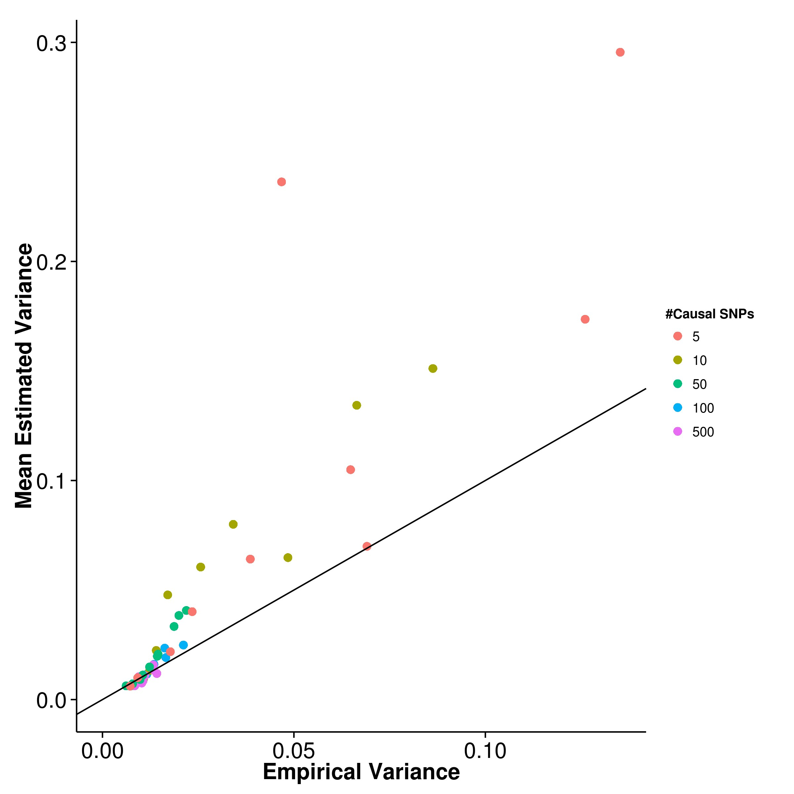

**(c)** LDSC with fix intercept **(d)** LDSC with intercept estimation

**Figure 2.6:** Estimated variance of results from quantitative trait simulation with random effect size simulation when compared to the empirical variance. GCTA has the best estimate of its empirical variance under the polygenic conditions whereas SHREK tends to under-estimate its empirical variance. On the other hand, LDSC to over- estimate the variance especially when the number of causal SNPs is small.

**Quantitative Trait Simulation**

In the simulation of quantitative trait scenario, the effect size were randomly drawn from the exponential distribution with λ = 1 and traits with different number of causal SNPs and traits with different heritability were simulated. The main aim of this simulation was to assess the effect of number of causal SNPs and trait heritability on the power of estimation of different algorithms.

First, the mean heritability estimation were compared to the simulated heritability in order to identify the bias in estimation for each algorithms. From the graph (fig. 2.4), it was observed that the mean estimations of SHREK has a small upward bias (fig. 2.4a). However, the bias was insensitive to the change in number of causal SNPs suggesting that SHREK is relatively robust to trait complexity. On the other hand, estimations form GCTA were moderately biased downward (fig. 2.4b), similar to the estimations from LDSC with intercept estimation (fig. 2.4d), but with a smaller variability. Finally, when the intercept is fixed, LDSC has the smallest bias when the trait is polygenic but an upward bias is also observed when the number of causal SNPs is small.

Furthermore, while comparing the empirical variance of the estimates (fig. 2.5), variance of estimations from LDSC were sensitive to the number of causal SNPs. As the number of causal SNPs decreases (figs. 2.5c and 2.5d), the variance of LDSC es- timates increases, similar to what was reported by B. K. Bulik-Sullivan et al. (2015). The variance were also higher when intercept estimation was performed. On the other hand, although the variance of SHREK was relatively higher when compared to LDSC when the intercept was fixed, the variation of its estimations was insensitive to the number of causal SNPs. When the number of causal SNPs was small, the variance of estimates from SHREK can even be lower than LDSC (fig. 2.5a). Finally, of all the algorithms, the estimations from GCTA has the lowest variation when compared to other algorithm (fig. 2.5b), except when it was the case of 5 causal SNPs where it has a slightly higher variance in comparison to SHREK when the simulated heritability was high (e.g. ≥ 0.8).

|  |  |  |  |  |
| --- | --- | --- | --- | --- |
| Number of Causal SNPs | SHREK | LDSC | LDSC-In | GCTA |
| 5 | 0.0235 | 0.0576 | 0.0828 | 0.0365 |
| 10 | 0.0231 | 0.0343 | 0.0555 | 0.0189 |
| 50 | 0.0196 | 0.0157 | 0.0494 | 0.0114 |
| 100 | 0.0210 | 0.0129 | 0.0363 | 0.00961 |
| 500 | 0.0205 | 0.0115 | 0.0308 | 0.00887 |

**Table 2.1:** Mean squared error (MSE) of quantitative trait simulation with random effect size. Of all the algorithms, GCTA has the lowest MSE except when there is only

5 causal SNPs. When comparing the performance of SHREK and LDSC with fixed intercept, the performance of SHREK is better under the oligogenic condition whereas LDSC with fixed intercept excels under the polygenic condition. On the other hand, when intercept estimation were performed, the MSE of LDSC increases, mainly due to the increased SE. Therefore SHREK outperform LDSC with intercept estimation when there are minimal confounding variables.

Another important factor to consider was the estimation of the SE. Of all the algorithms, GCTA (fig. 2.6b) has the best estimate, follow by SHREK (fig. 2.6a). However, it was noted that a consistent underestimation of variance was observed with SHREK whereas GCTA only underestimate the variance when the number of causal SNPs is small. On the other hand, when the intercept was fixed (fig. 2.6c), LDSC cannot accurately estimate its variance and tends to overestimate, especially when the number of causal SNPs were small. When intercept estimations was performed (fig. 2.6d), the estimation of variance was relatively better yet the overestimation were still observed when the number of causal SNPs is small.

By taking into consideration of both the bias and variance of the estimates, GCTA has the best overall performance. Under the oligogenic condition (e.g. number of causal SNPs ≤ 10), SHREK has relatively better performance when compared to LDSC. Whereas under the polygenic condition, LDSC has better performance.

**Quantitative Trait Simulation with Extreme Effect Size**

For some diseases such as Hirschsprung’s disease, a small number of SNPs can account for majority of the effect with a large number of SNPs with small effect size. Therefore we were interested to test the performance of SNP heritability estimation in such sce- nario. We performaned the quantitative trait simulation with 100 causal SNPs where 1, 5 or 10 of those SNP(s) has a large effect.

When assessing the mean estimation of heritability (fig. 2.7), the performance of the algorithms were similar to that in the quantitative trait simulation. The only exception was when 1 SNP with large effect was simulated, the mean estimation of LDSC and GCTA fluctuates (figs. 2.7b to 2.7d). The same fluctuation was not observed in SHREK (fig. 2.7a). Similarly, the empirical variance of the estimation (fig. 2.8) from GCTA and LDSC increases and fluctuates when only 1 SNP with large effect was simulated. It was most obvious in the case of LDSC where the variance increased drastically as the heritability is high (fig. 2.8c). However, SHREK does not seems to be affected and were robust to the number of SNPs with large effect.

The estimated variance were also affected by the number of SNPs with large effect where the larges discrepancy between the estimated and empirical variance was observed when only 1 SNP with large effect was simulated. It was observed that both SHREK and GCTA tends to underestimates their empirical variance whereas LDSC tends to overestimates the empirical variance. The difference between the estimated and empirical variance for LDSC with fixed effect can be as much as 3 fold.

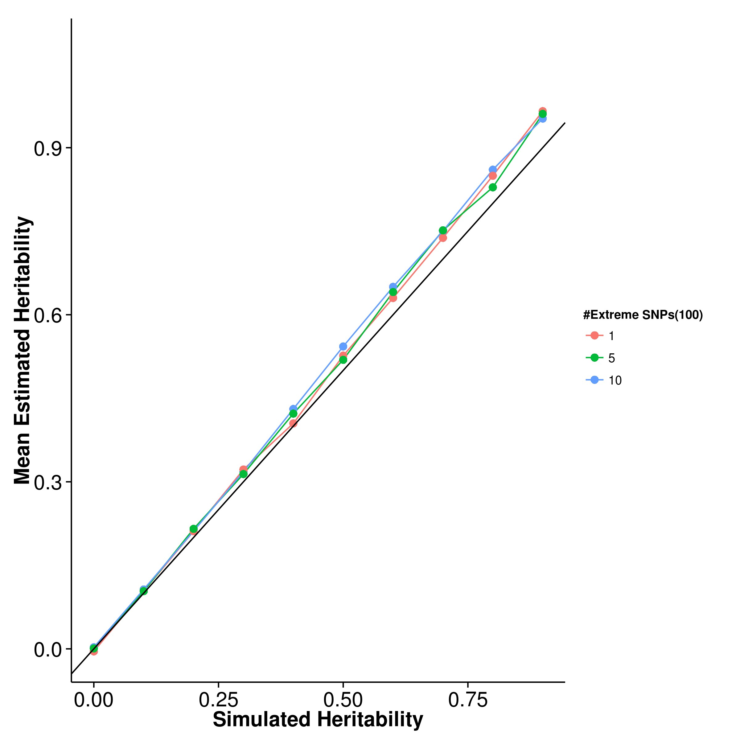

**(a)** SHREK **(b)** GCTA

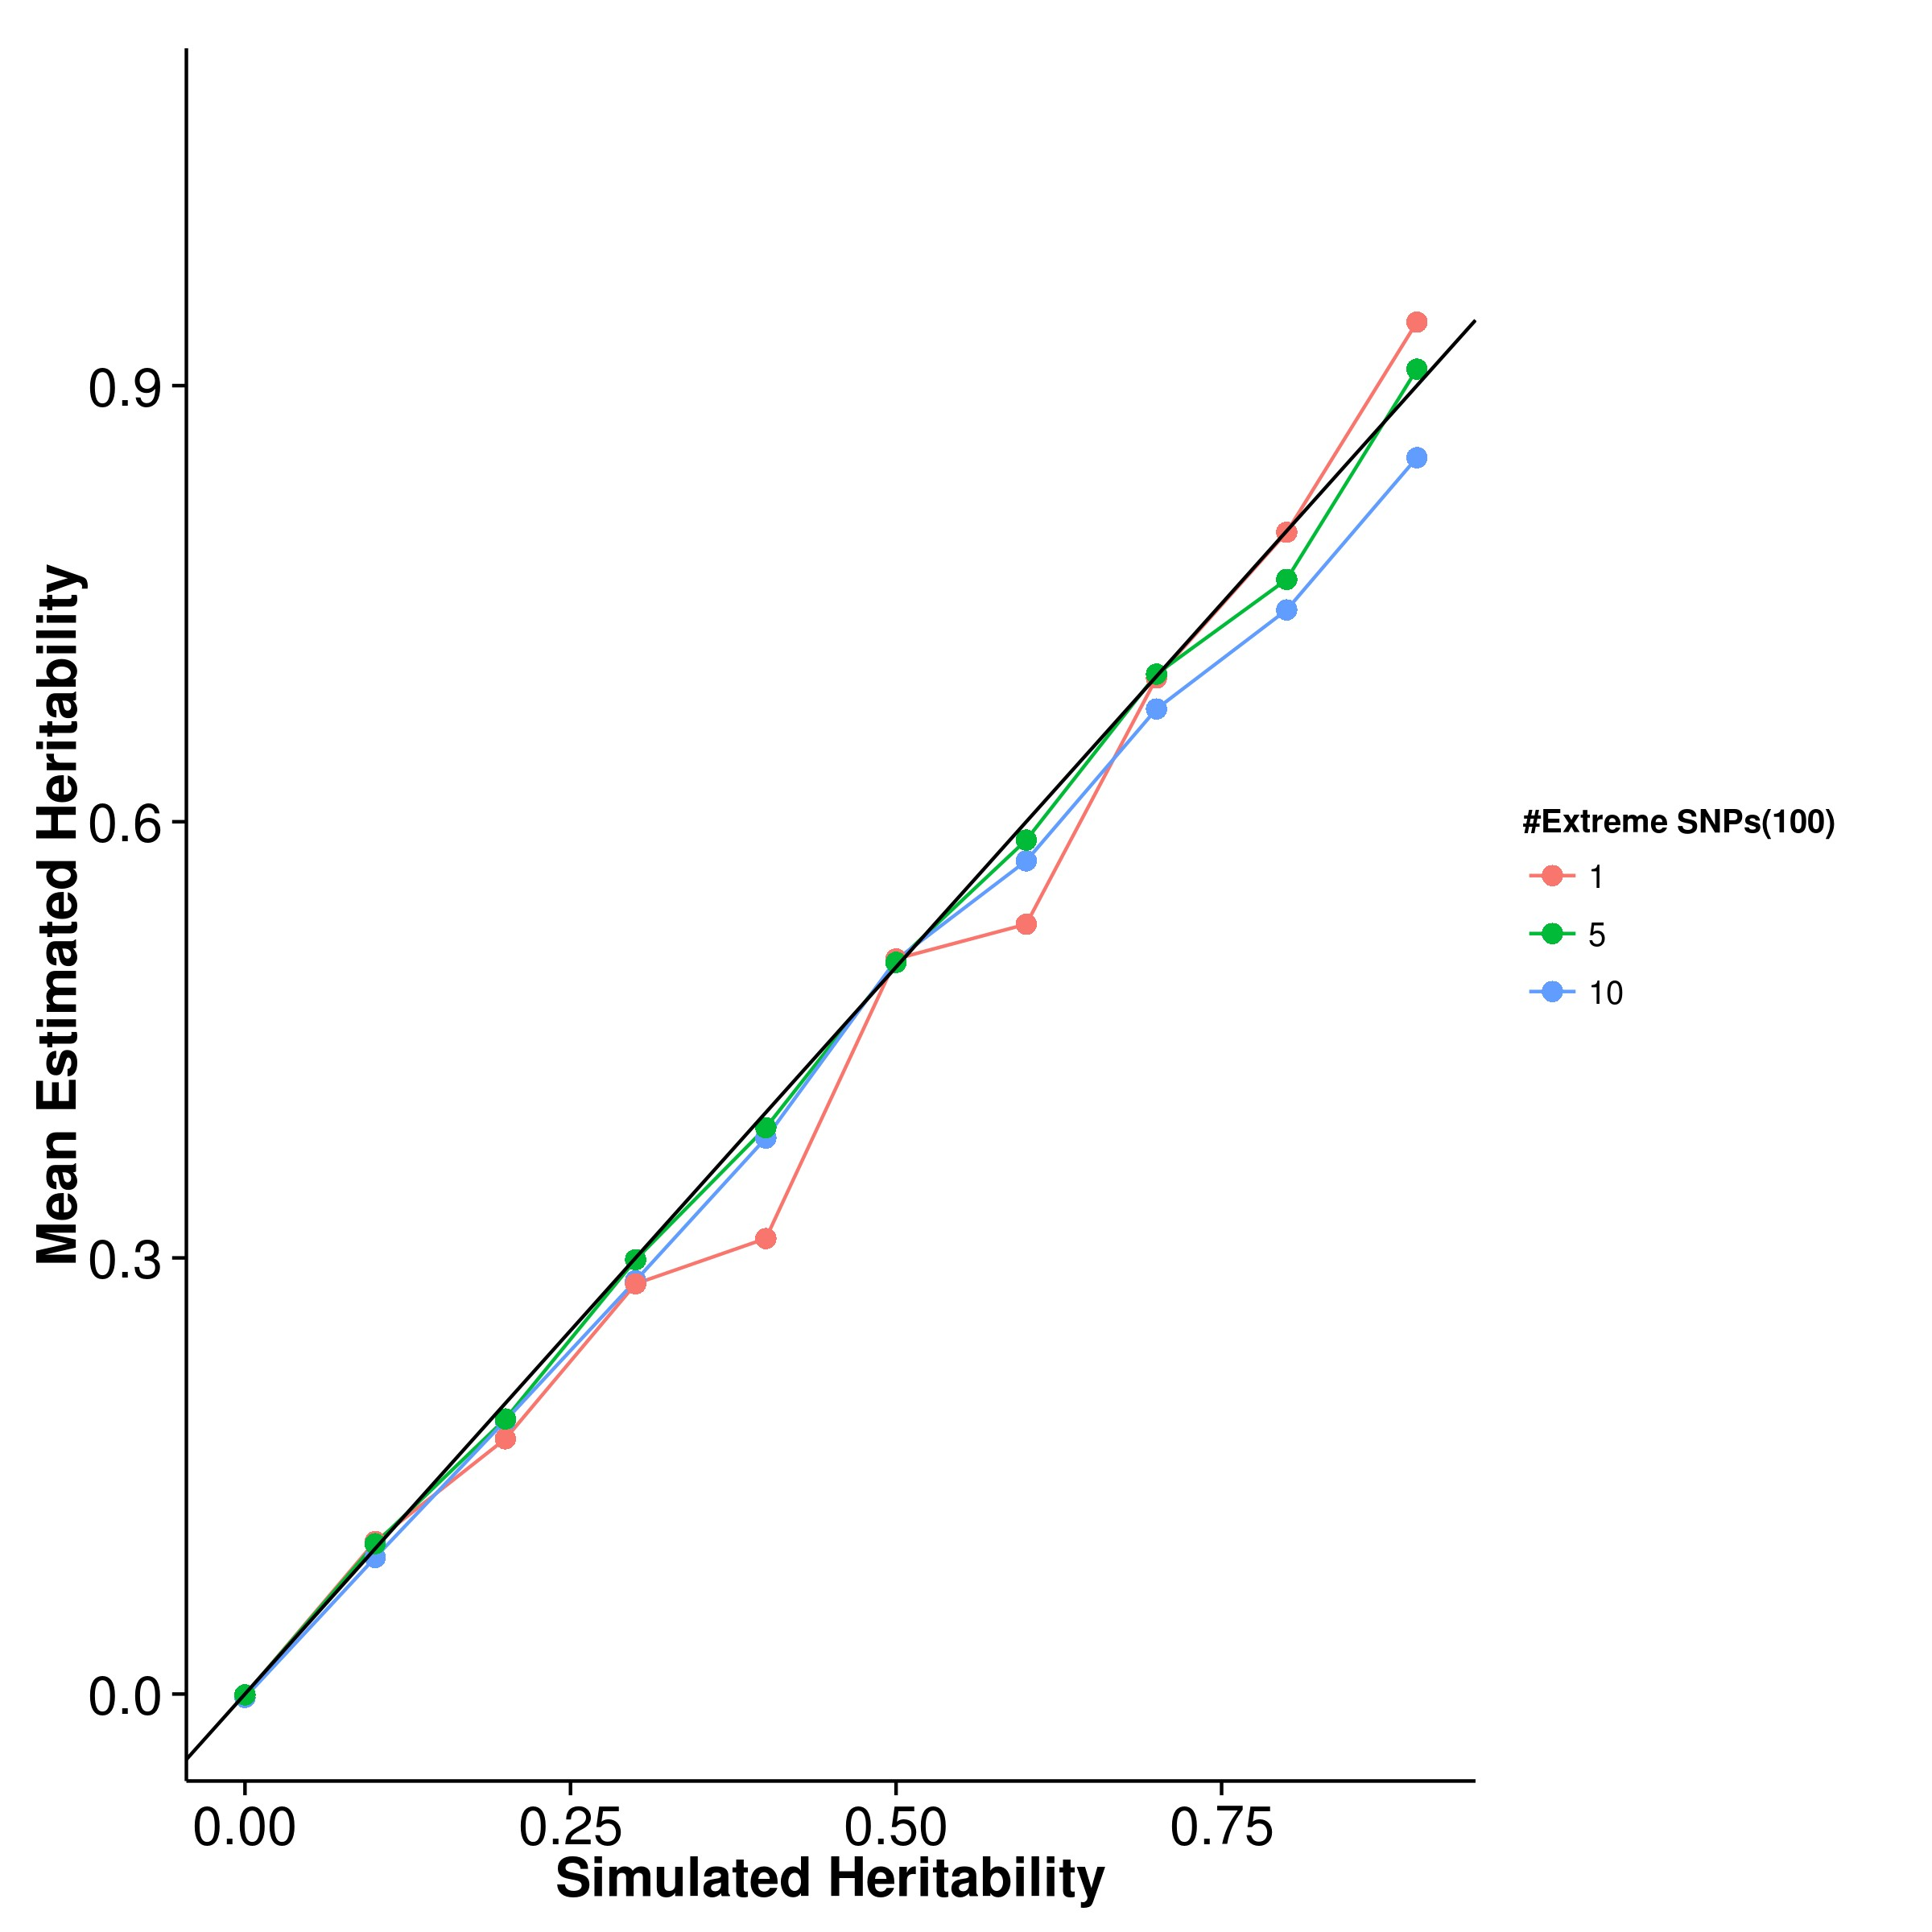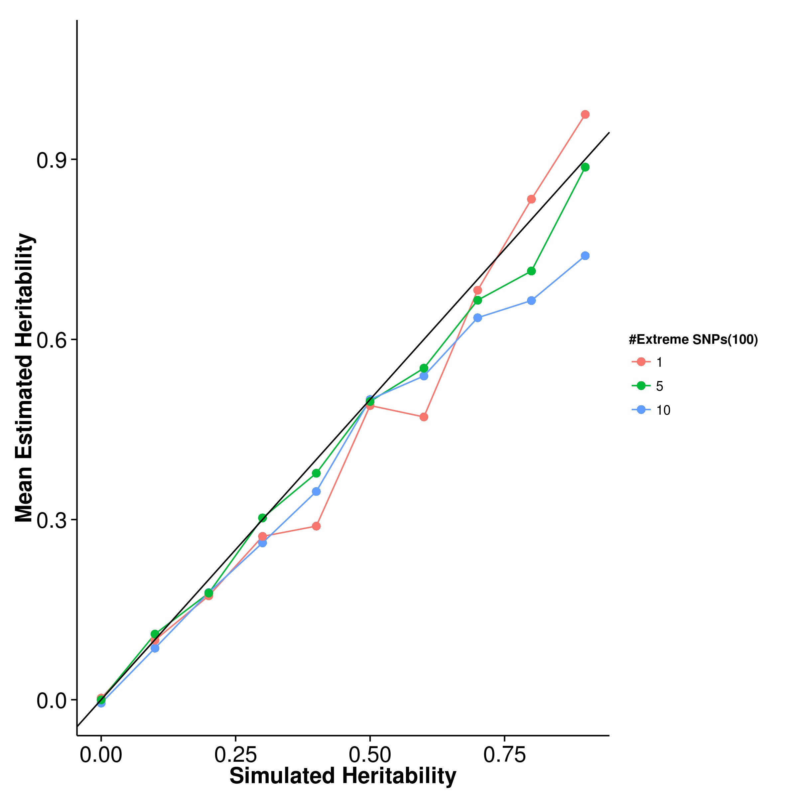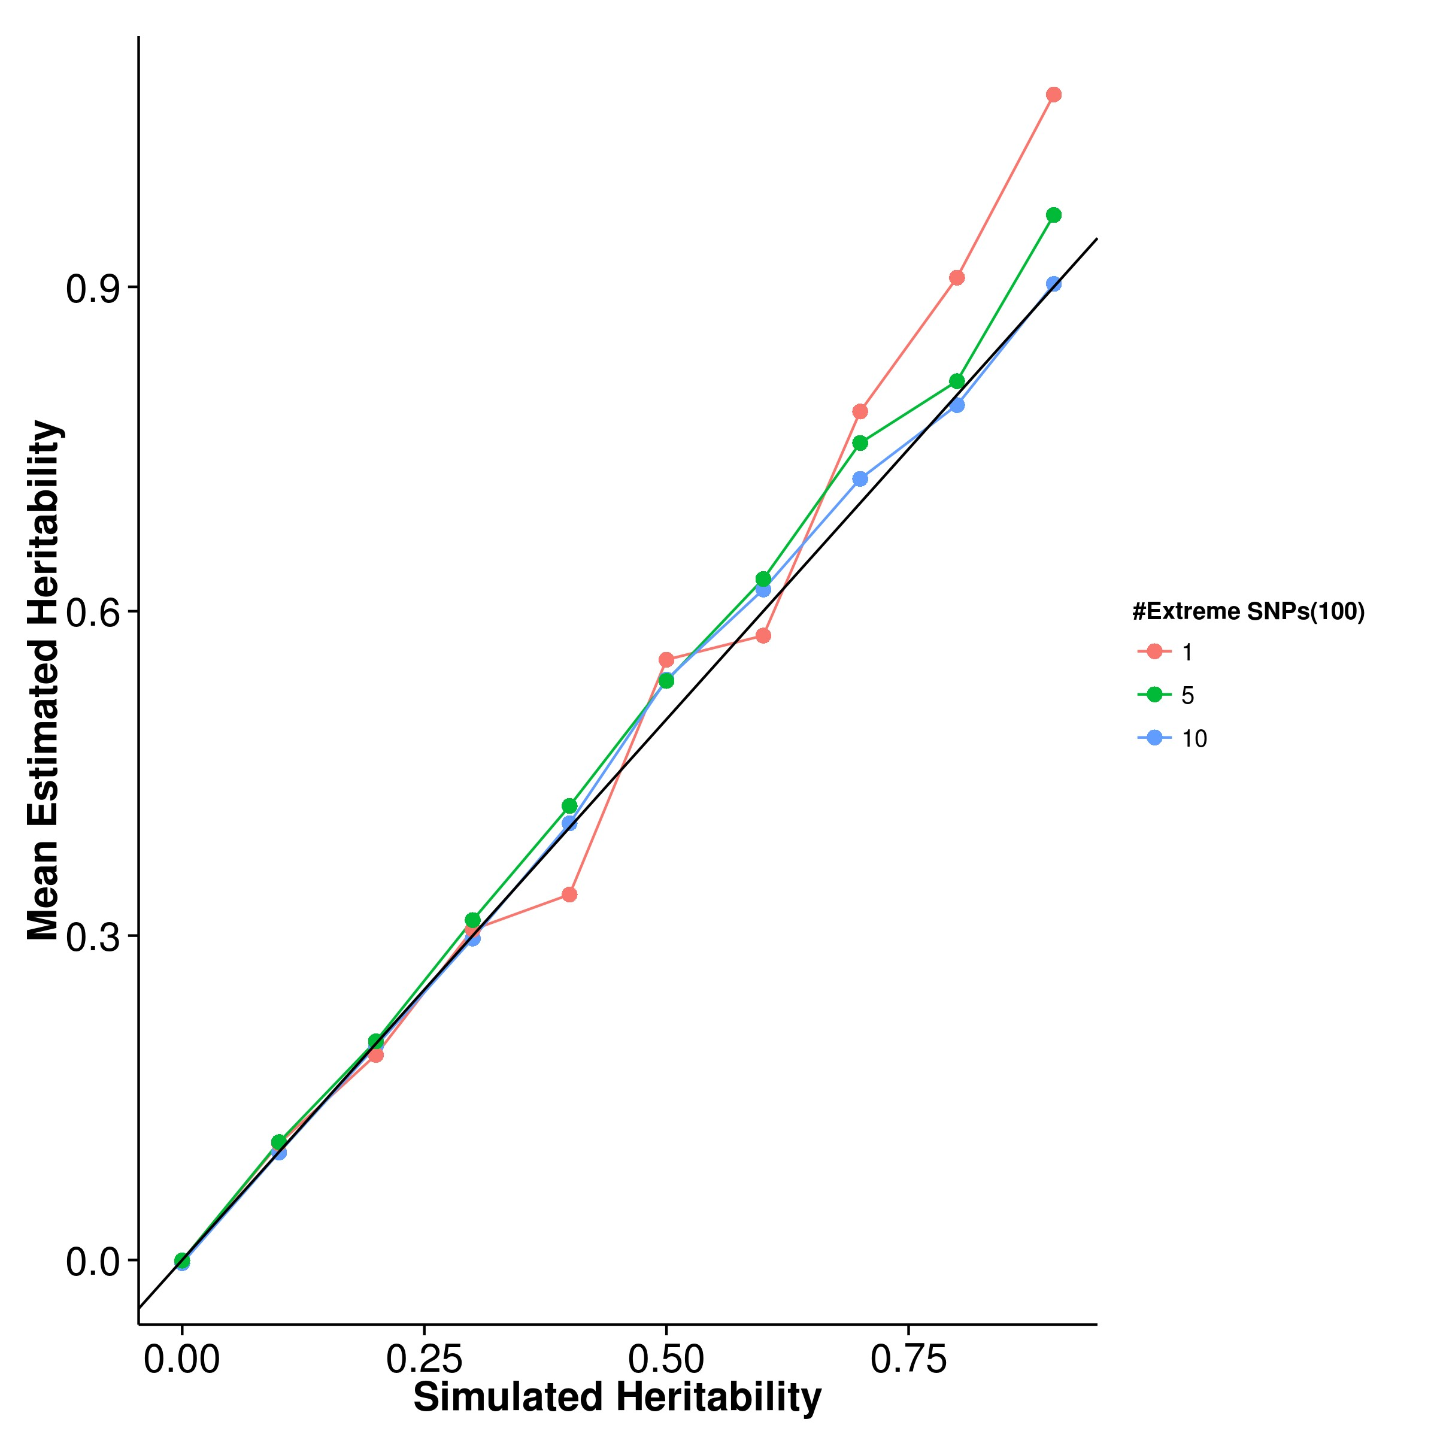

**(c)** LDSC with fix intercept **(d)** LDSC with intercept estimation

**Figure 2.7:** Mean of results from quantitative trait simulation with extreme effect size simulation. It was observed that the mean estimation of heritability of SHREK is not affected by the number of SNP(s) with large effect but with slight upward bias. On the other hand, the mean estimation of LDSC and GCTA seems to fluctuate with respect to the simulated heritability.

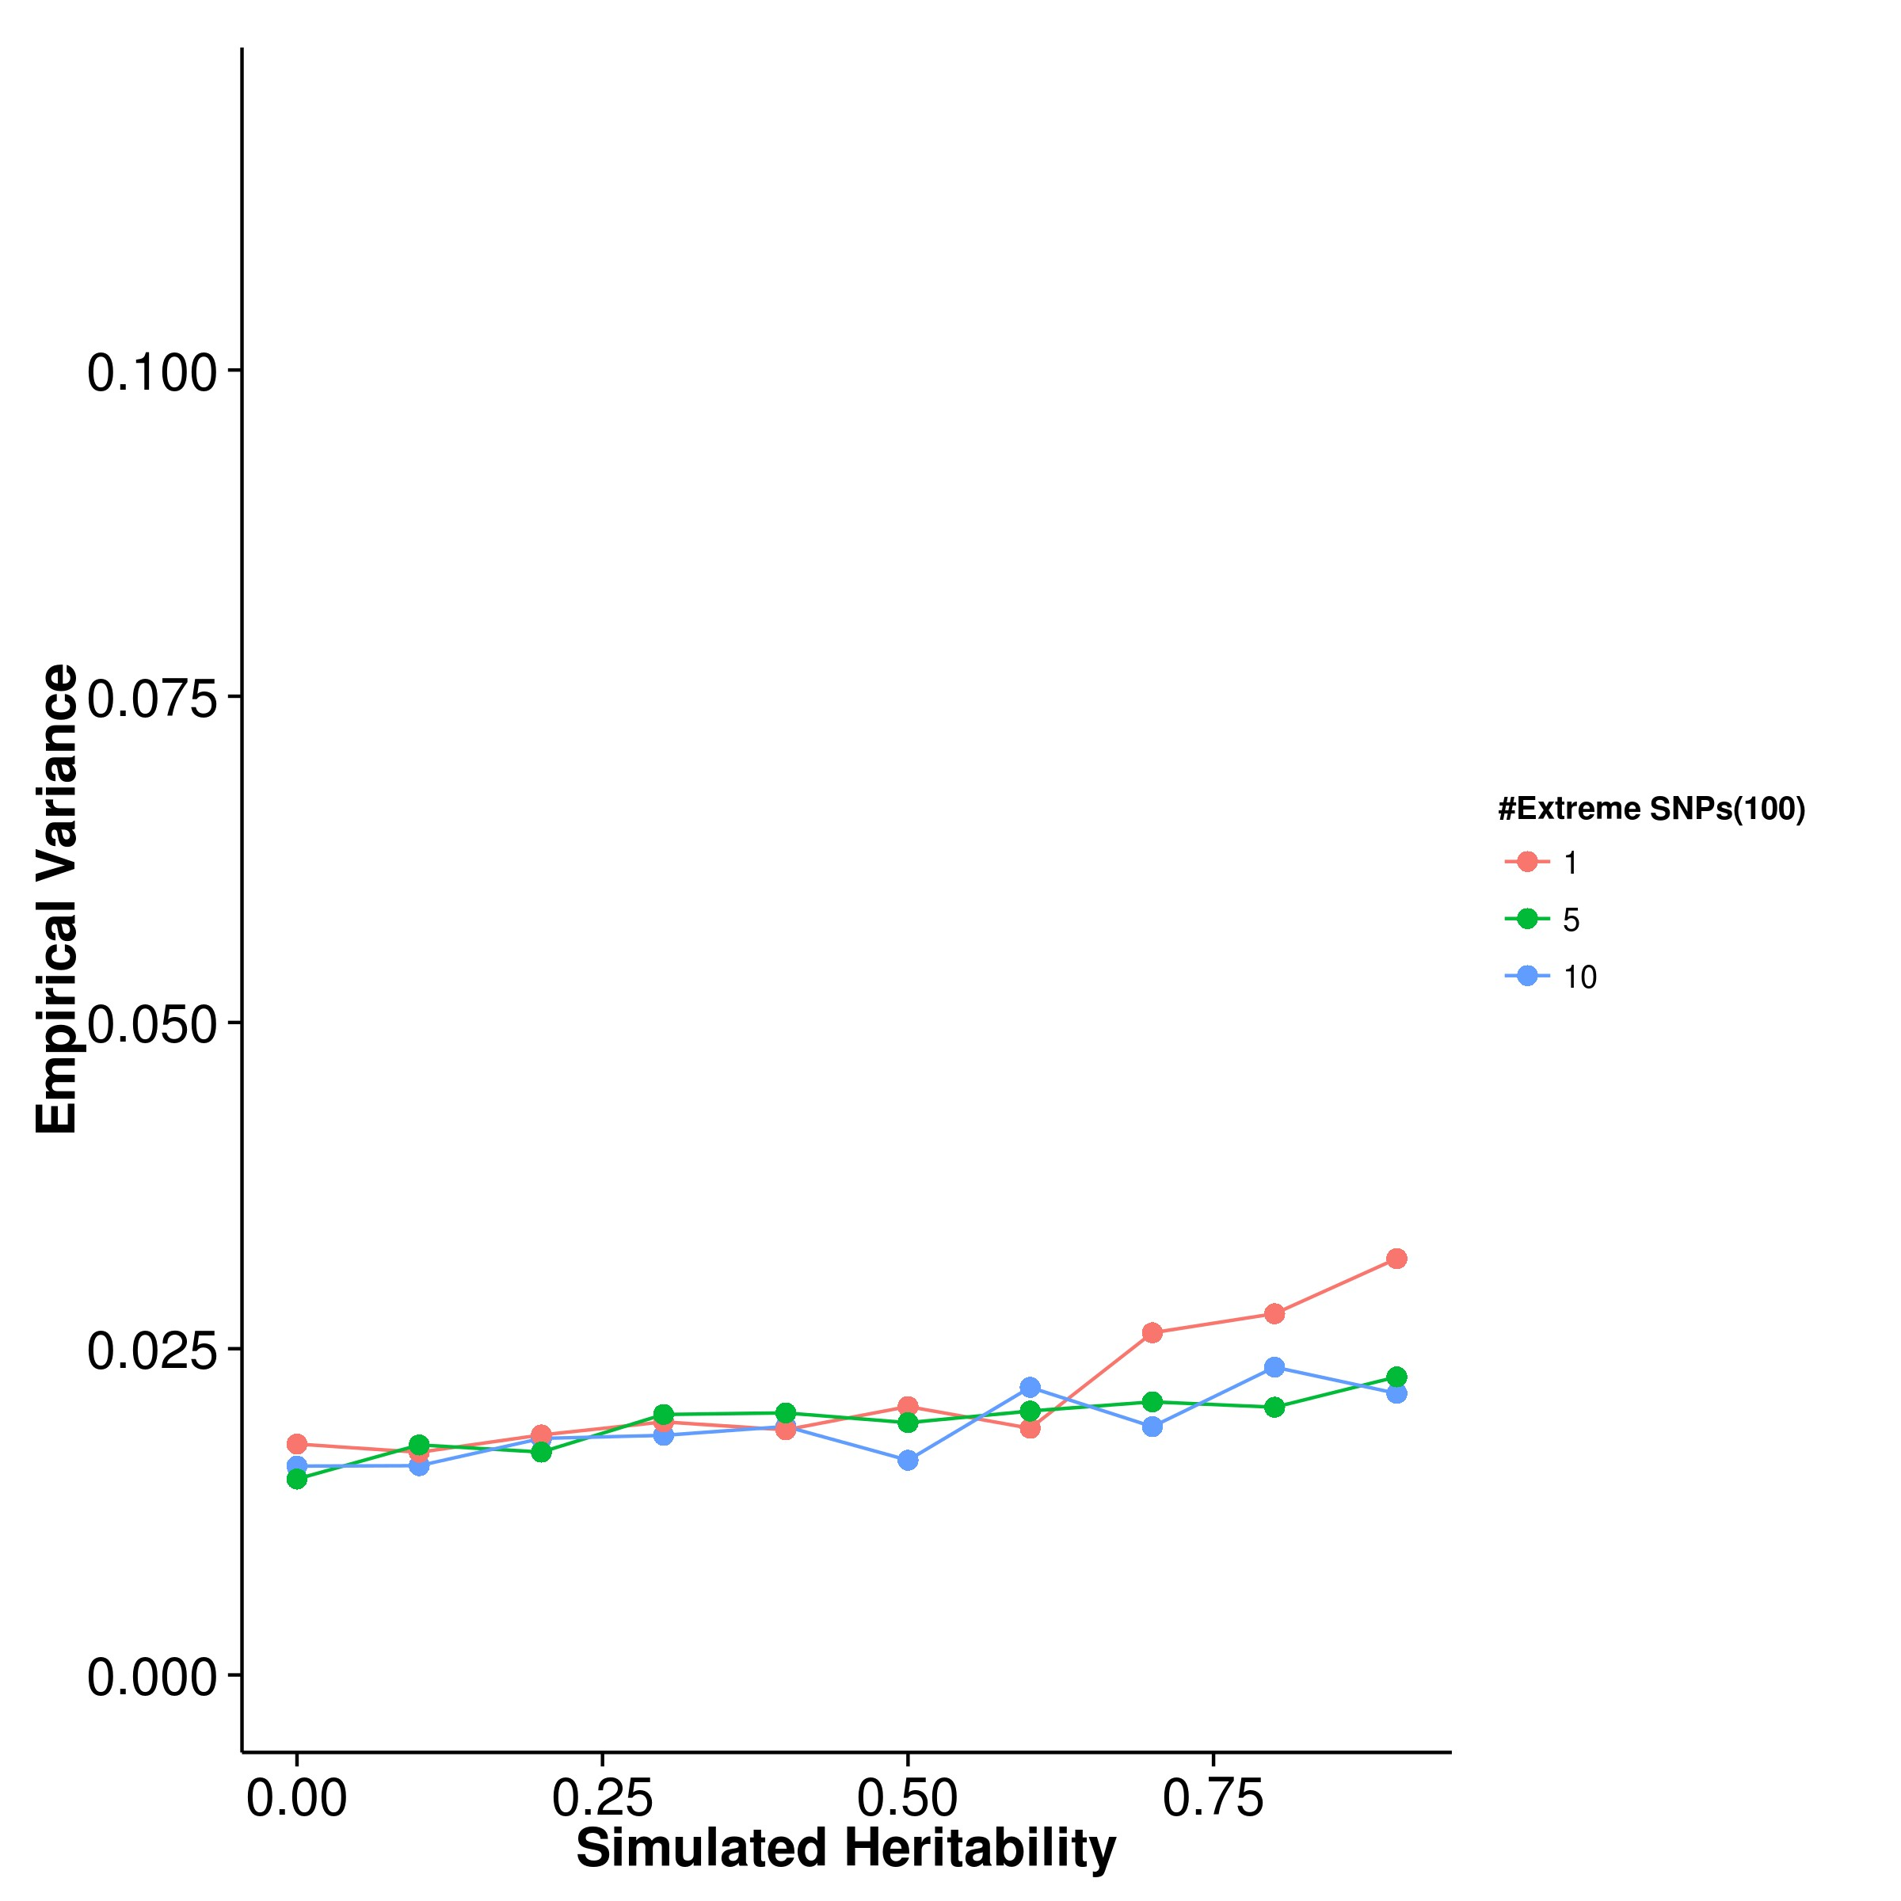

**(a)** SHREK **(b)** GCTA

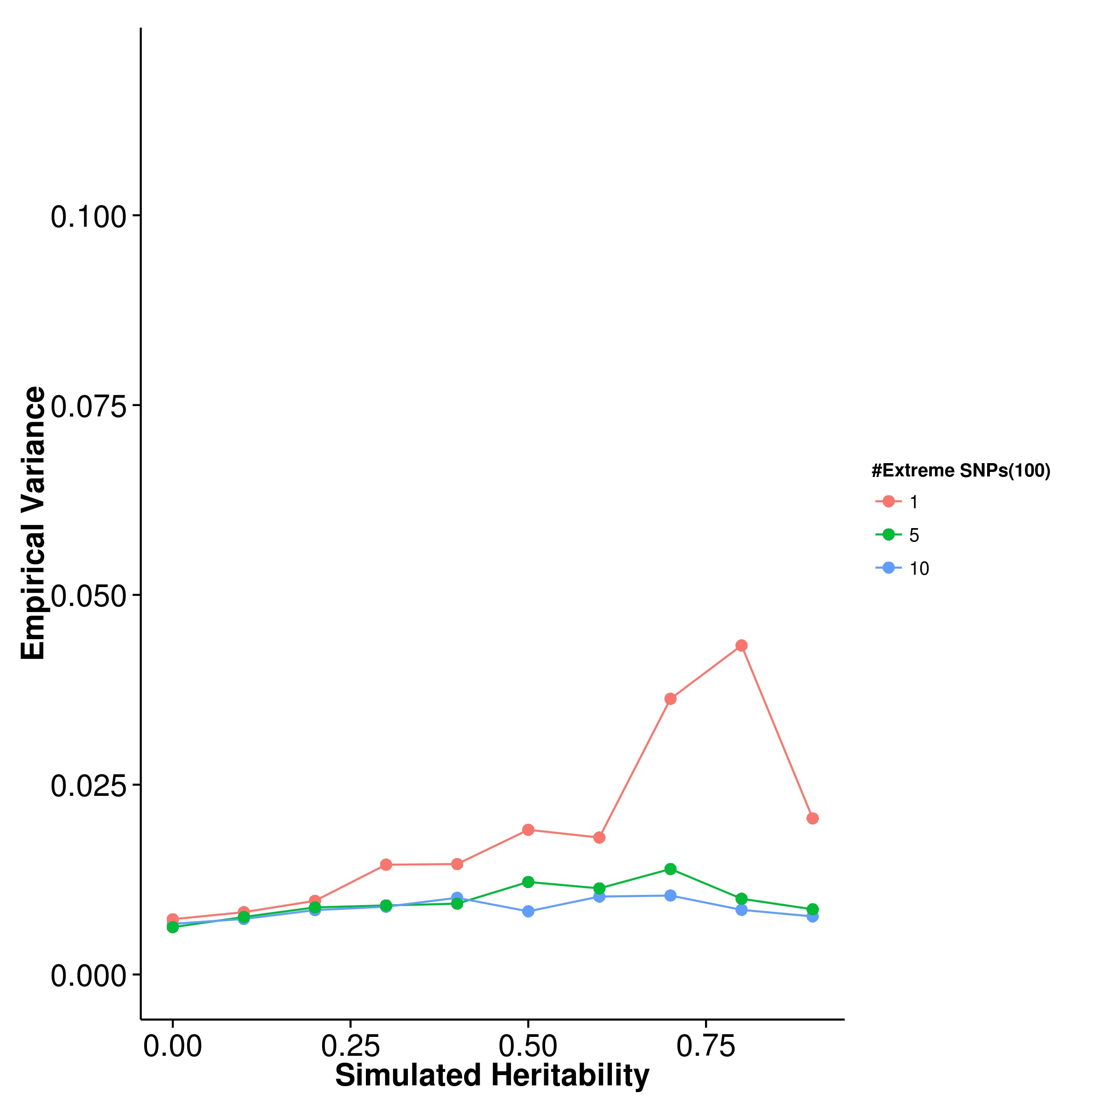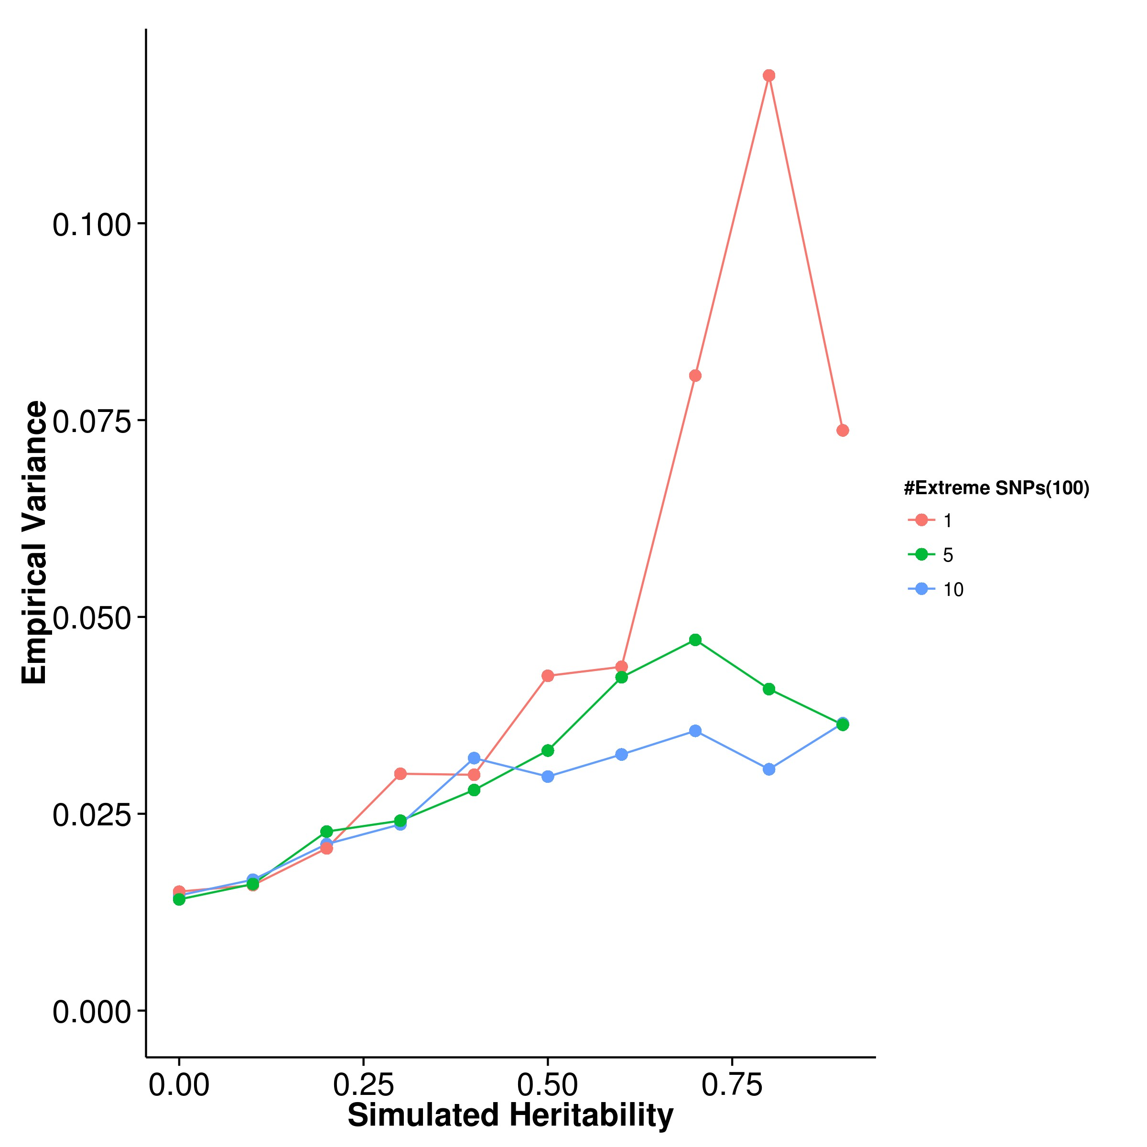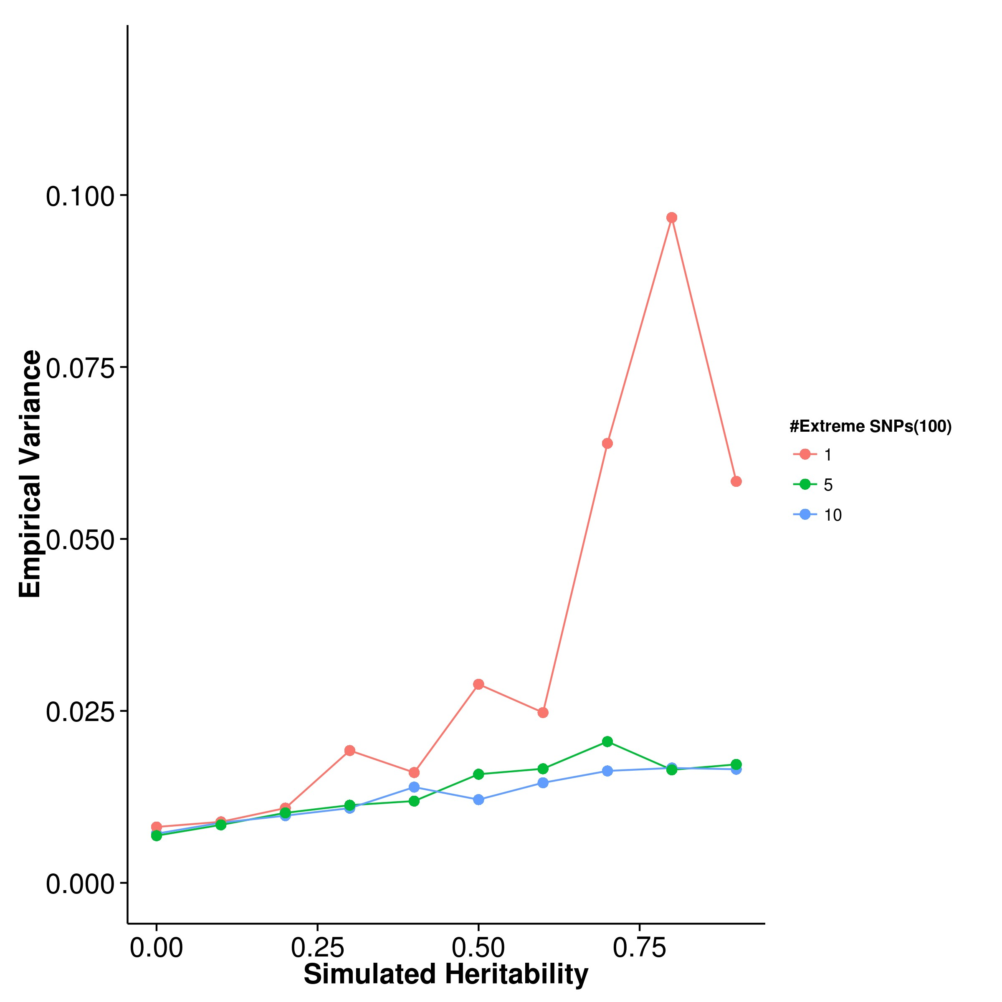

**(c)** LDSC with fix intercept **(d)** LDSC with intercept estimation

**Figure 2.8:** Variance of results from quantitative trait simulation with extreme effect size simulation. 100 causal SNPs were simulated. When only 1 SNP with extreme effect was simulated, the empirical variance of GCTA and LDSC increases and a large fluctuation was observed. Whereas the empirical variance of SHREK only increase slightly when the simulated heritability is large and with only 1 SNP with extreme effect. Suggesting that it is more robust to the change in number of extreme SNP(s).

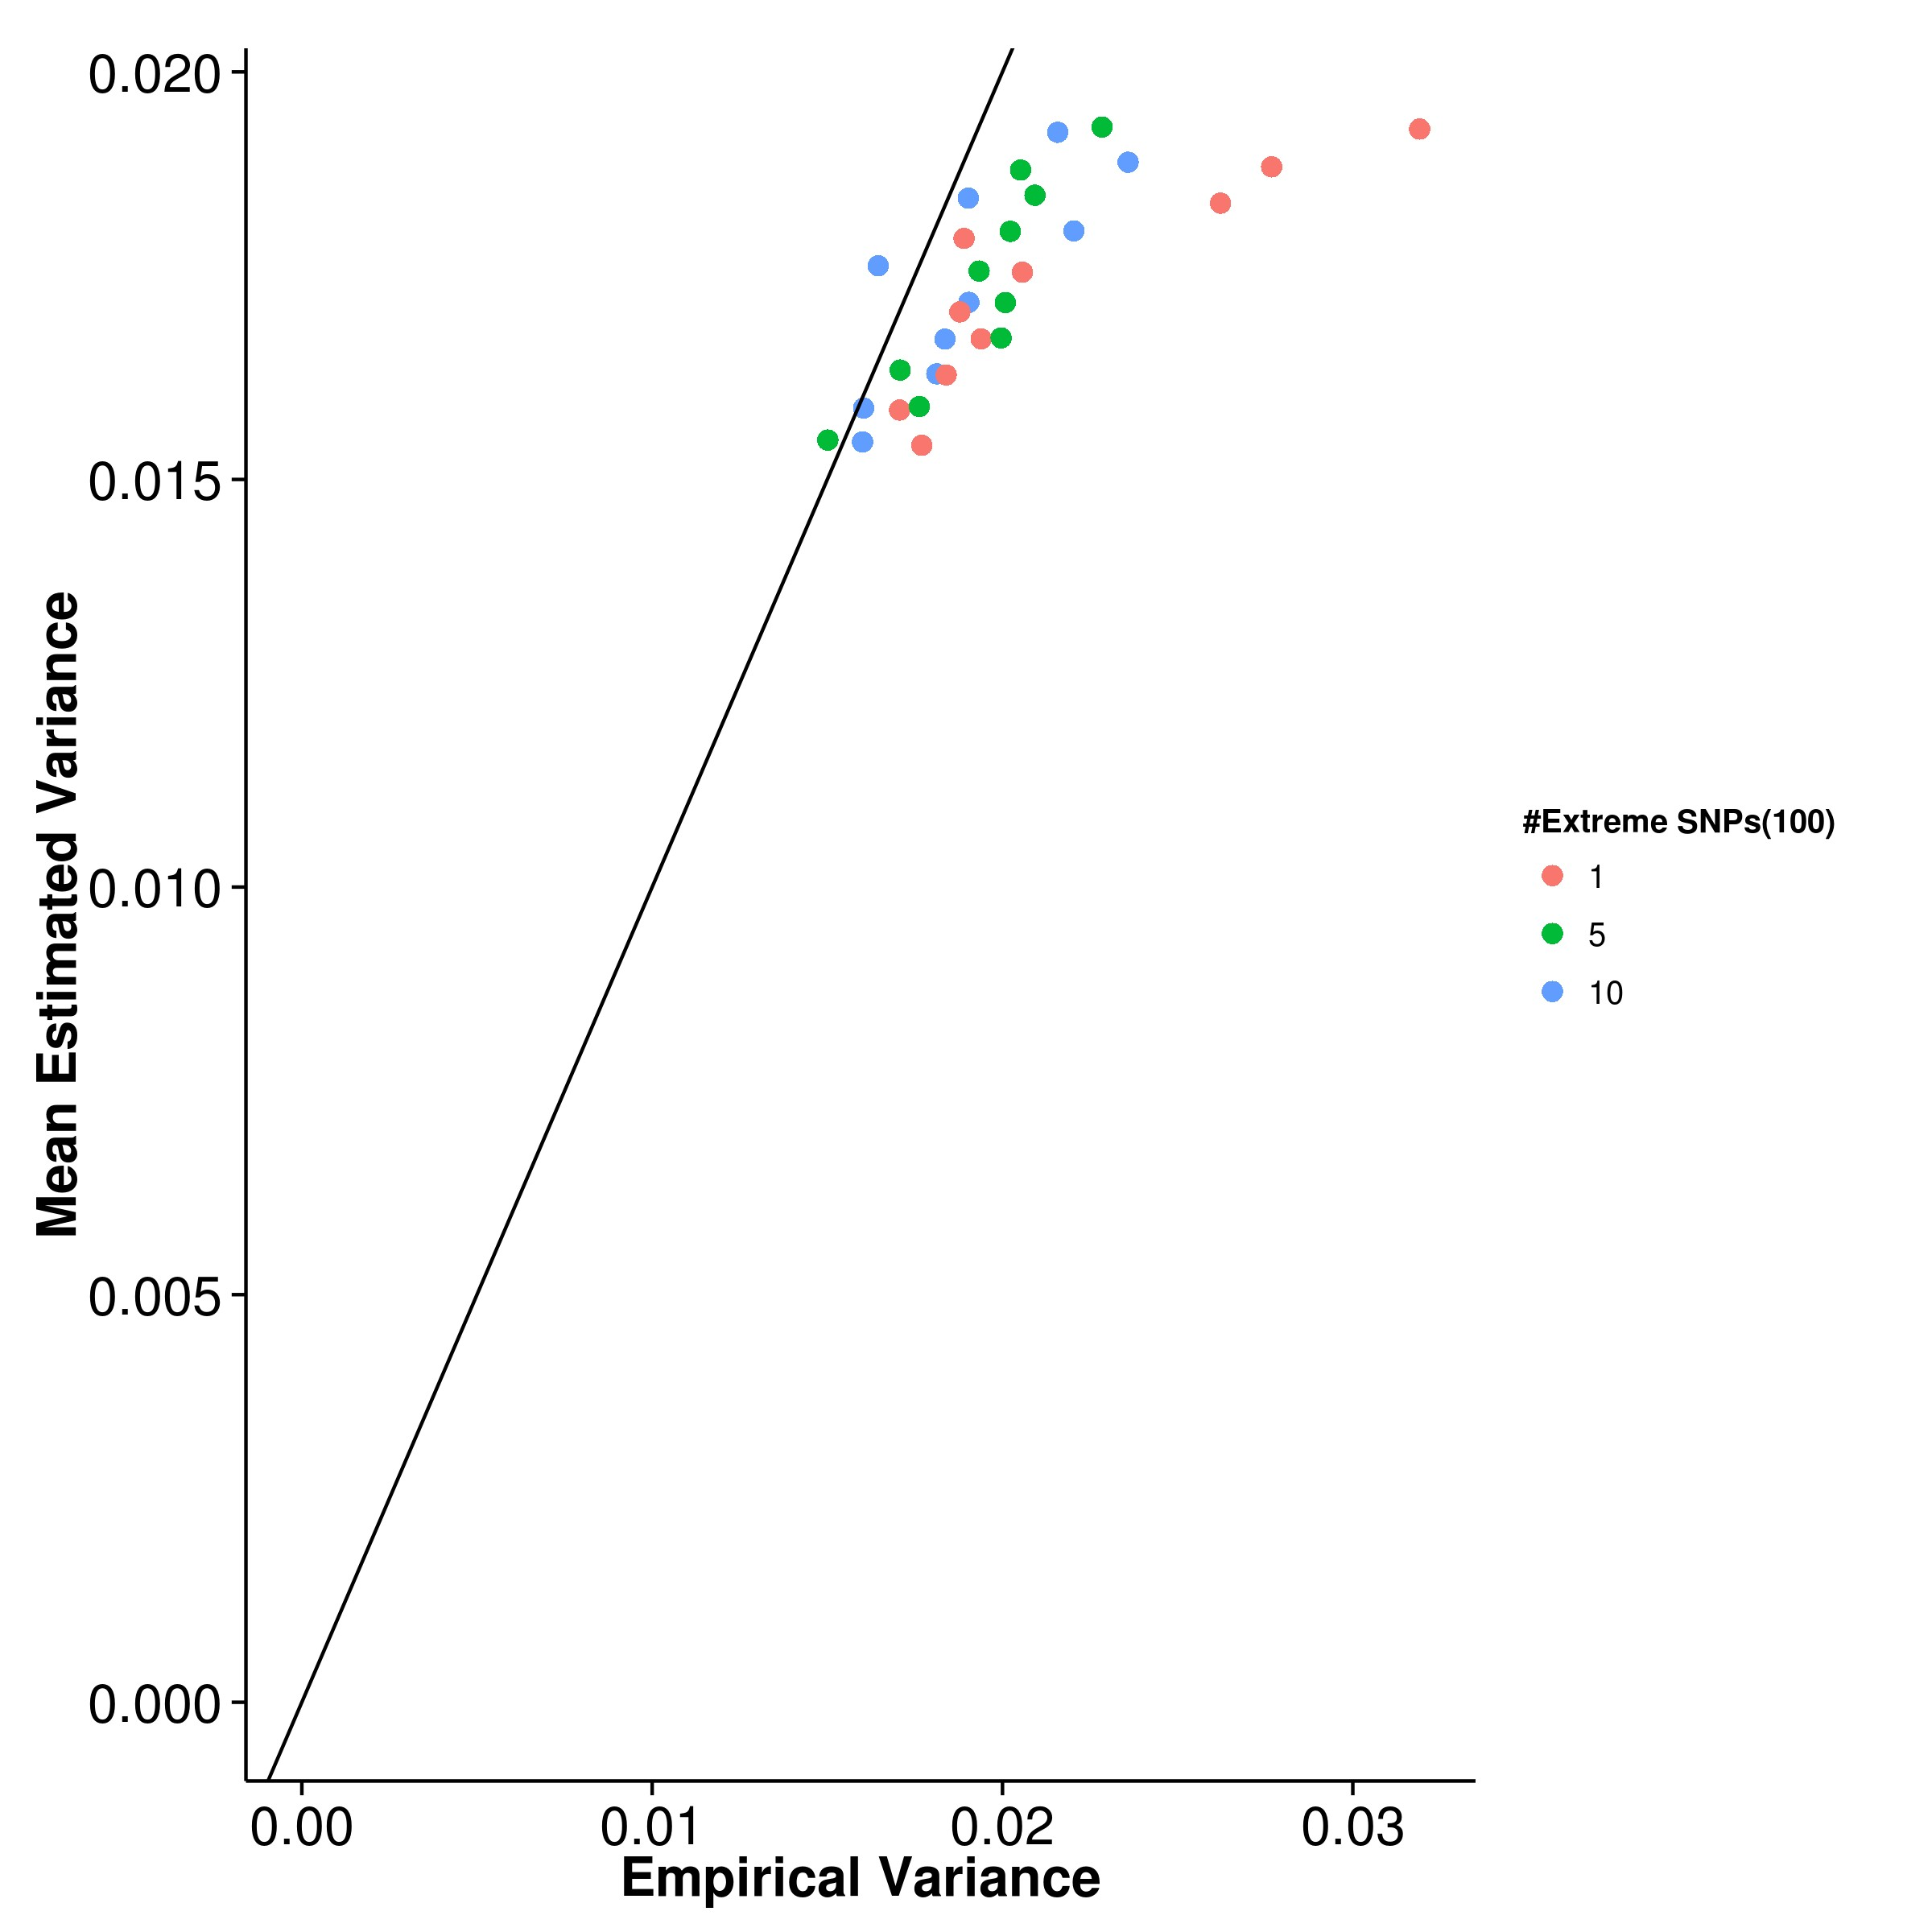

**(a)** SHREK **(b)** GCTA

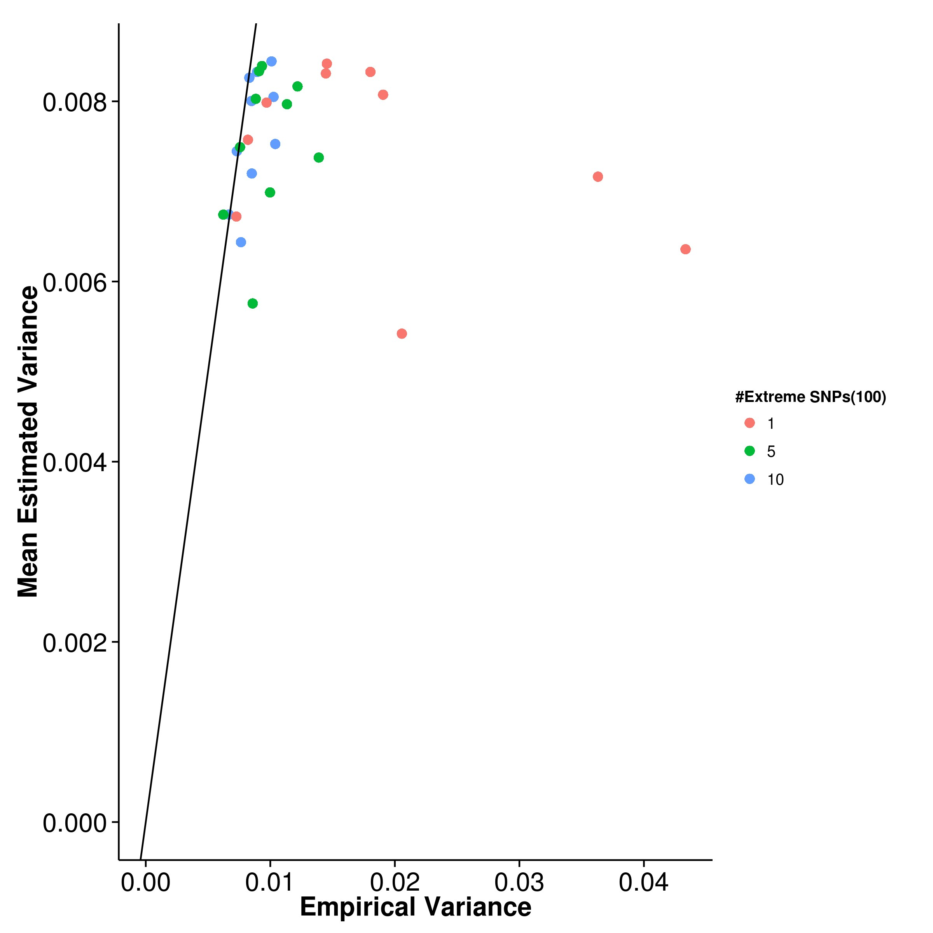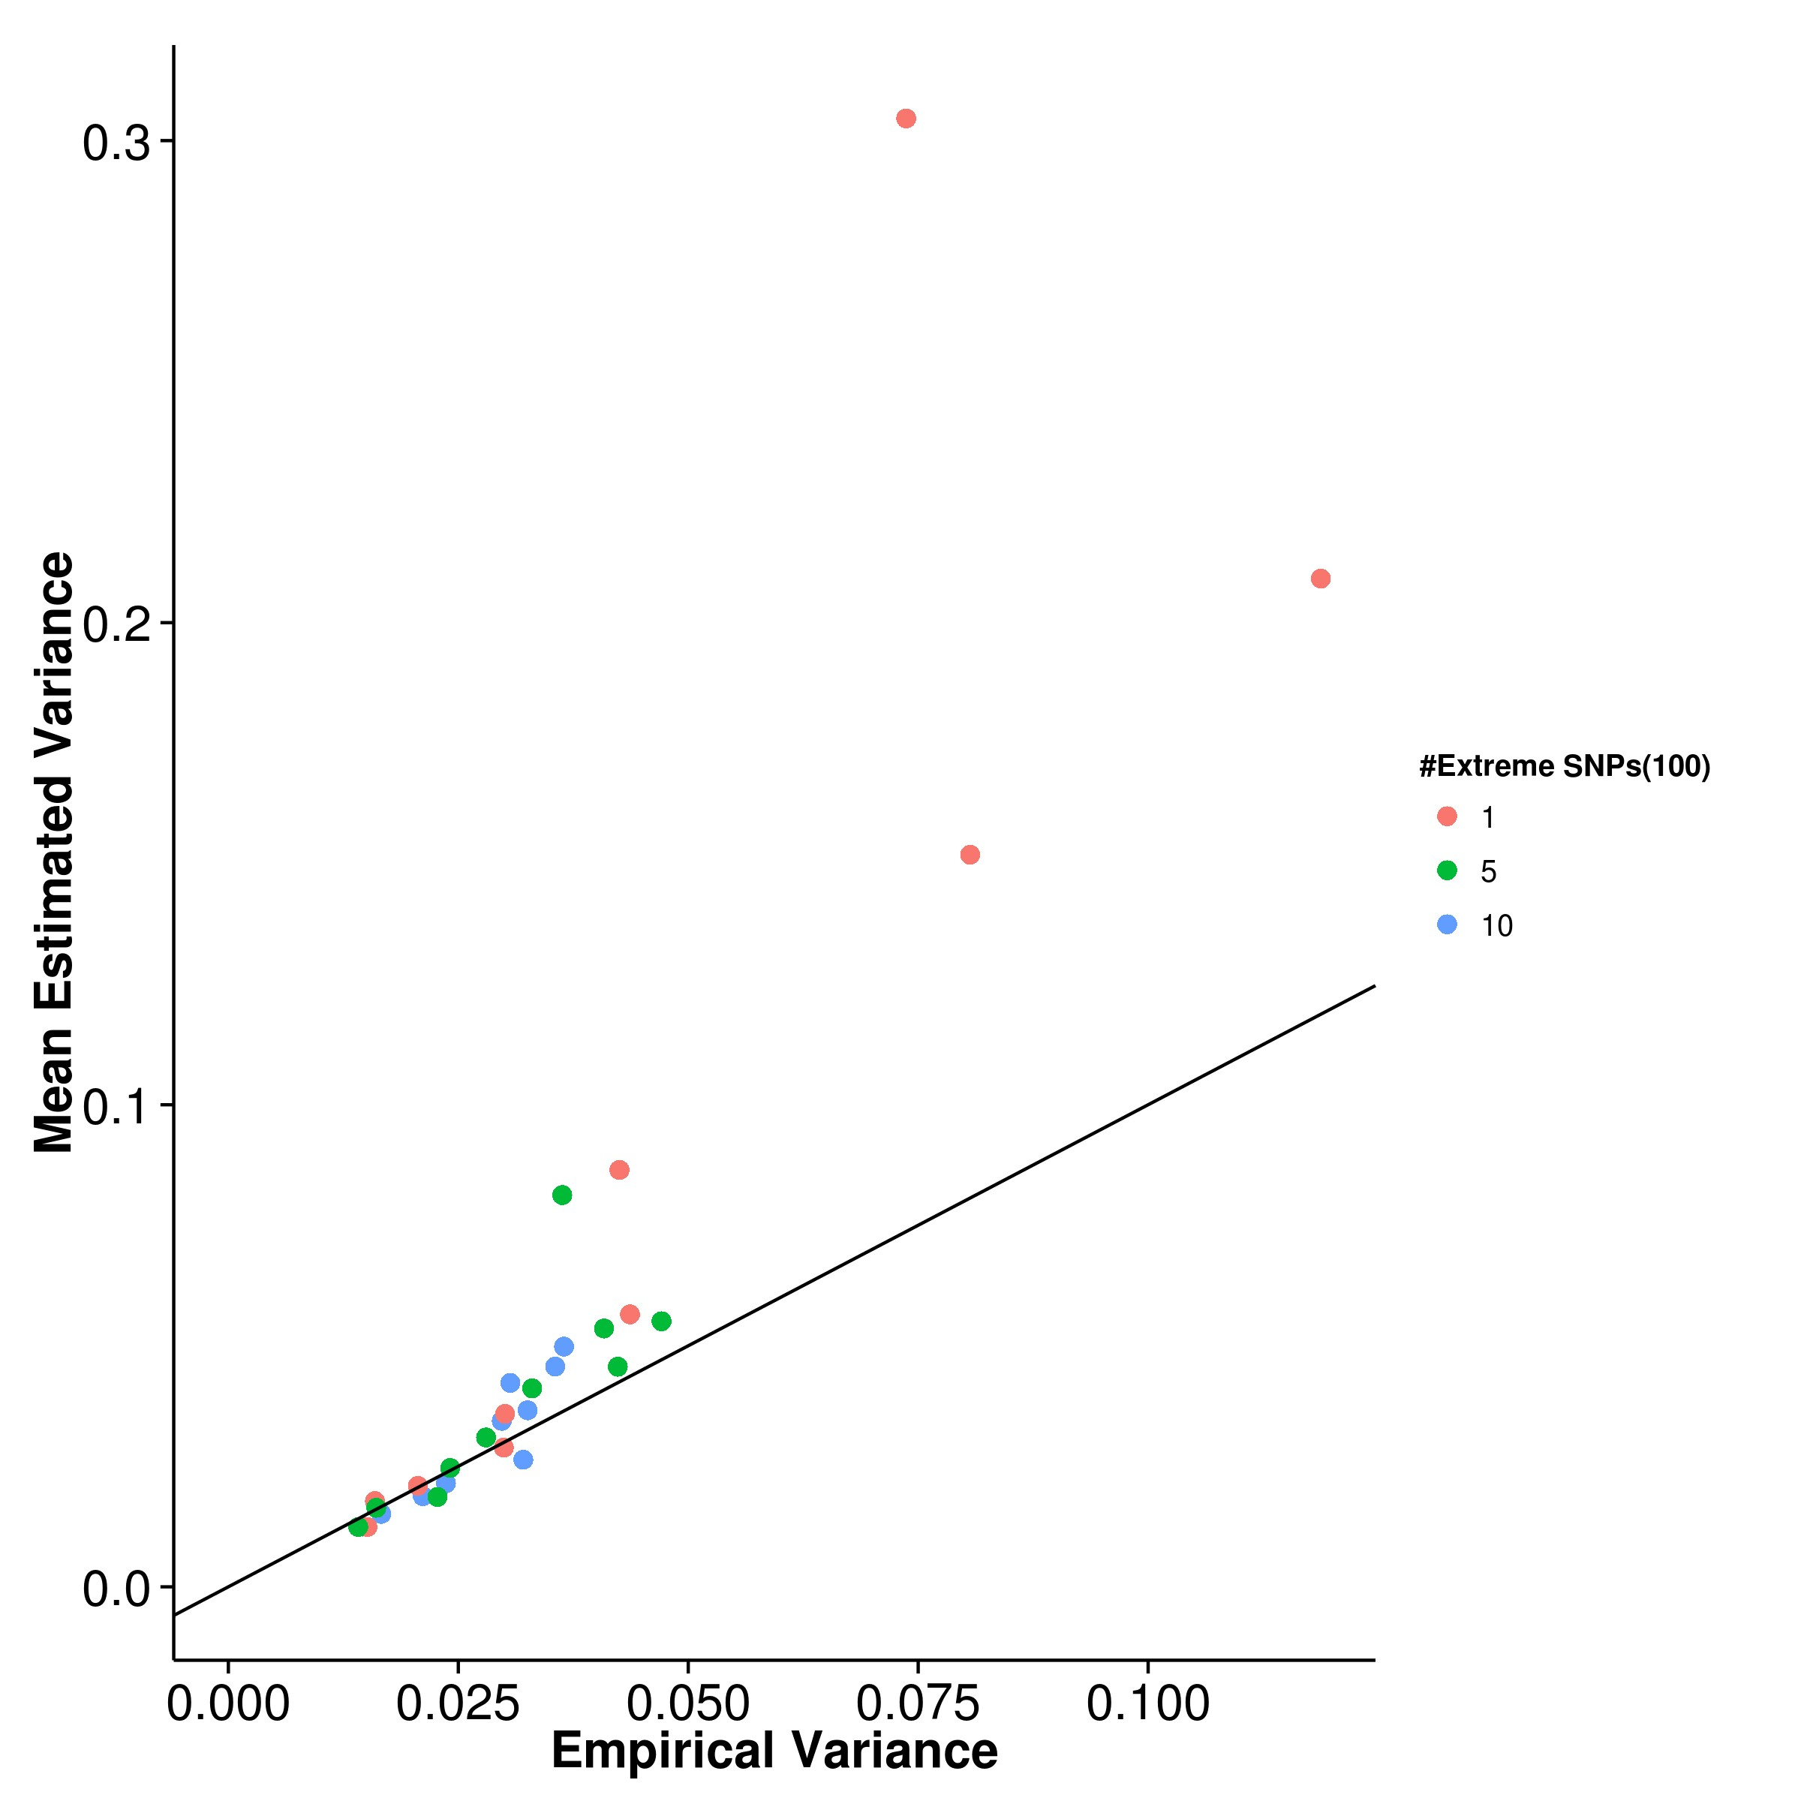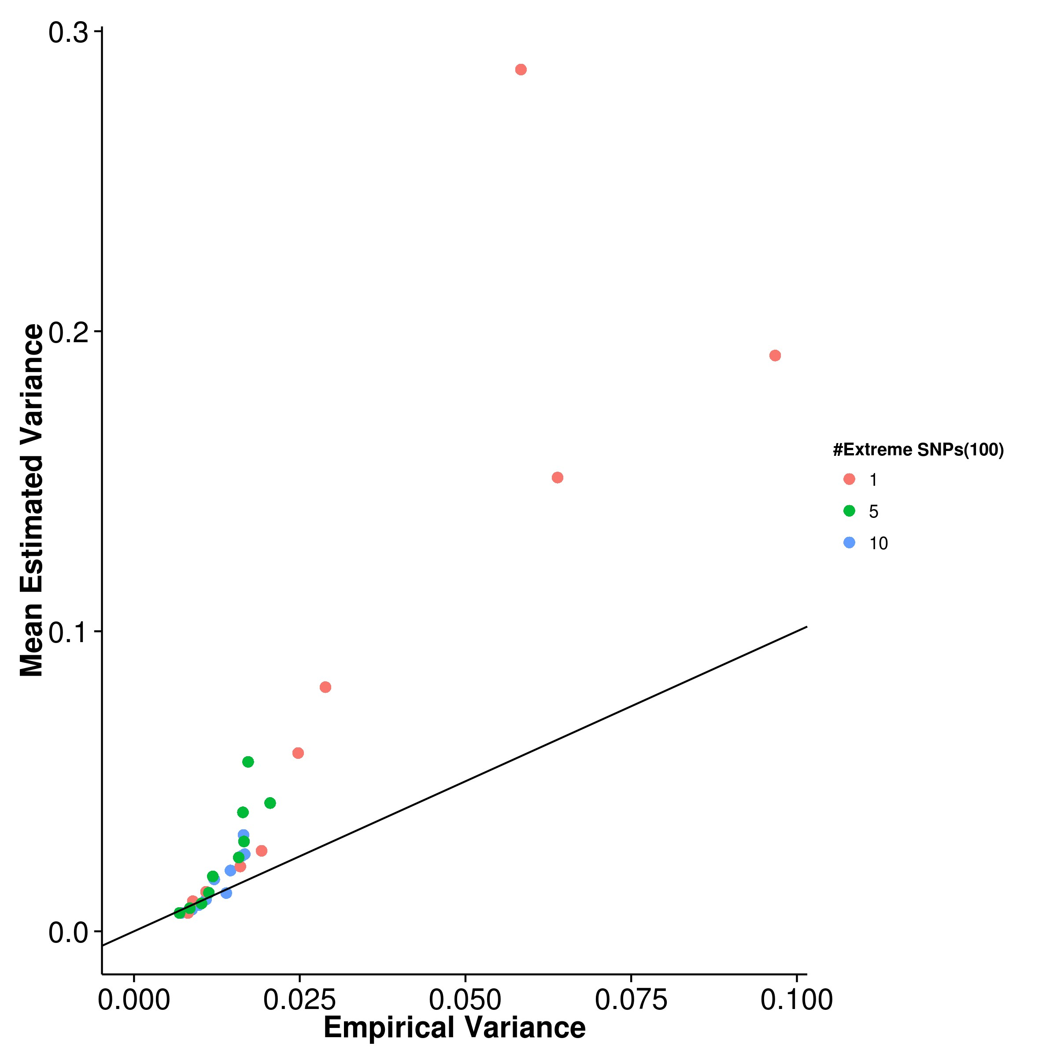

**(c)** LDSC with fix intercept **(d)** LDSC with intercept estimation

**Figure 2.9:** Estimated variance of results from quantitative trait simulation with extreme effect size simulation when compared to the empirical variance. 100 causal SNPs were simulated. SHREK and GCTA generally under-estimate the variance with the magnitude of bias being the highest when there is only 1 SNP with extreme effect. On the other hand, LDSC tends to over-estimate the variance and it can overestimate the variance by more than 3 folds when there is only 1 SNP with extreme effect.

|  |  |  |  |  |
| --- | --- | --- | --- | --- |
| Number of Extreme SNPs | SHREK | LDSC | LDSC-In | GCTA |
| 1 | 0.0227 | 0.0393 | 0.0508 | 0.0206 |
| 5 | 0.0203 | 0.0145 | 0.0316 | 0.00985 |
| 10 | 0.0205 | 0.0129 | 0.0329 | 0.00939 |

**Table 2.2:** MSE of quantitative trait simulation with extreme effect size. Of all the algorithms, GCTA has the lowest MSE in all situations. When comparing the performance of SHREK and LDSC, SHREK only has a better performance when there is one SNP with large effect. For other scenarios, LDSC with fixed intercept has better performance. However, we can observe that the performance of SHREK is very consistent and robust to the change in number of SNPs with extreme effect size.

To conclude, the performance of GCTA is superior to other algorithm (table 2.2). However, if we only consider the algorithms using summary statistic for heritability es- timation, the performance of LDSC is better than SHREK when there are more than 1 SNP with large effect. Again, as no confounding factors were simulated, LDSC with fixed intercept outperforms LDSC with intercept estimation. It was interesting to note that the MSE of SHREK was least affected by the number of SNP(s) with large effect.

**Case Control Simulation**

Nowadays, most of the GWAS are Case Control studies, thus it is important to test the performance of the algorithms when dealing with case control samples. In the case control simulation, we varied the population prevalence and the trait heritability. We also varied the number of causal SNPs to assess the combine effect of these parameters to the performance of the algorithms.

First, we simulated traits with 10 causal SNPs. From the graph, it is clear that the population prevalence has a significant impact to the performance of the algorithms (fig. 2.10). The performance of GCTA was as suggested by Golan, Eric S Lander, and Rosset (2014) where the degree of underestimation increases as the prevalence decreases. On the other hand, the opposite effect was observed for SHREK and LDSC with fixed intercept. Interestingly, when allow the estimate the intercept, the heritability estimated from LDSC becomes underestimated. The magnitude of the bias also decreases, suggesting that the intercept estimation might have corrected for part of the bias of LDSC. The same pattern were also observed when the number of causal SNPs increases (figs. 2.18, 2.21 and 2.24), suggesting that the effect of number of causal SNPs were not the main contributor to the difference in bias.

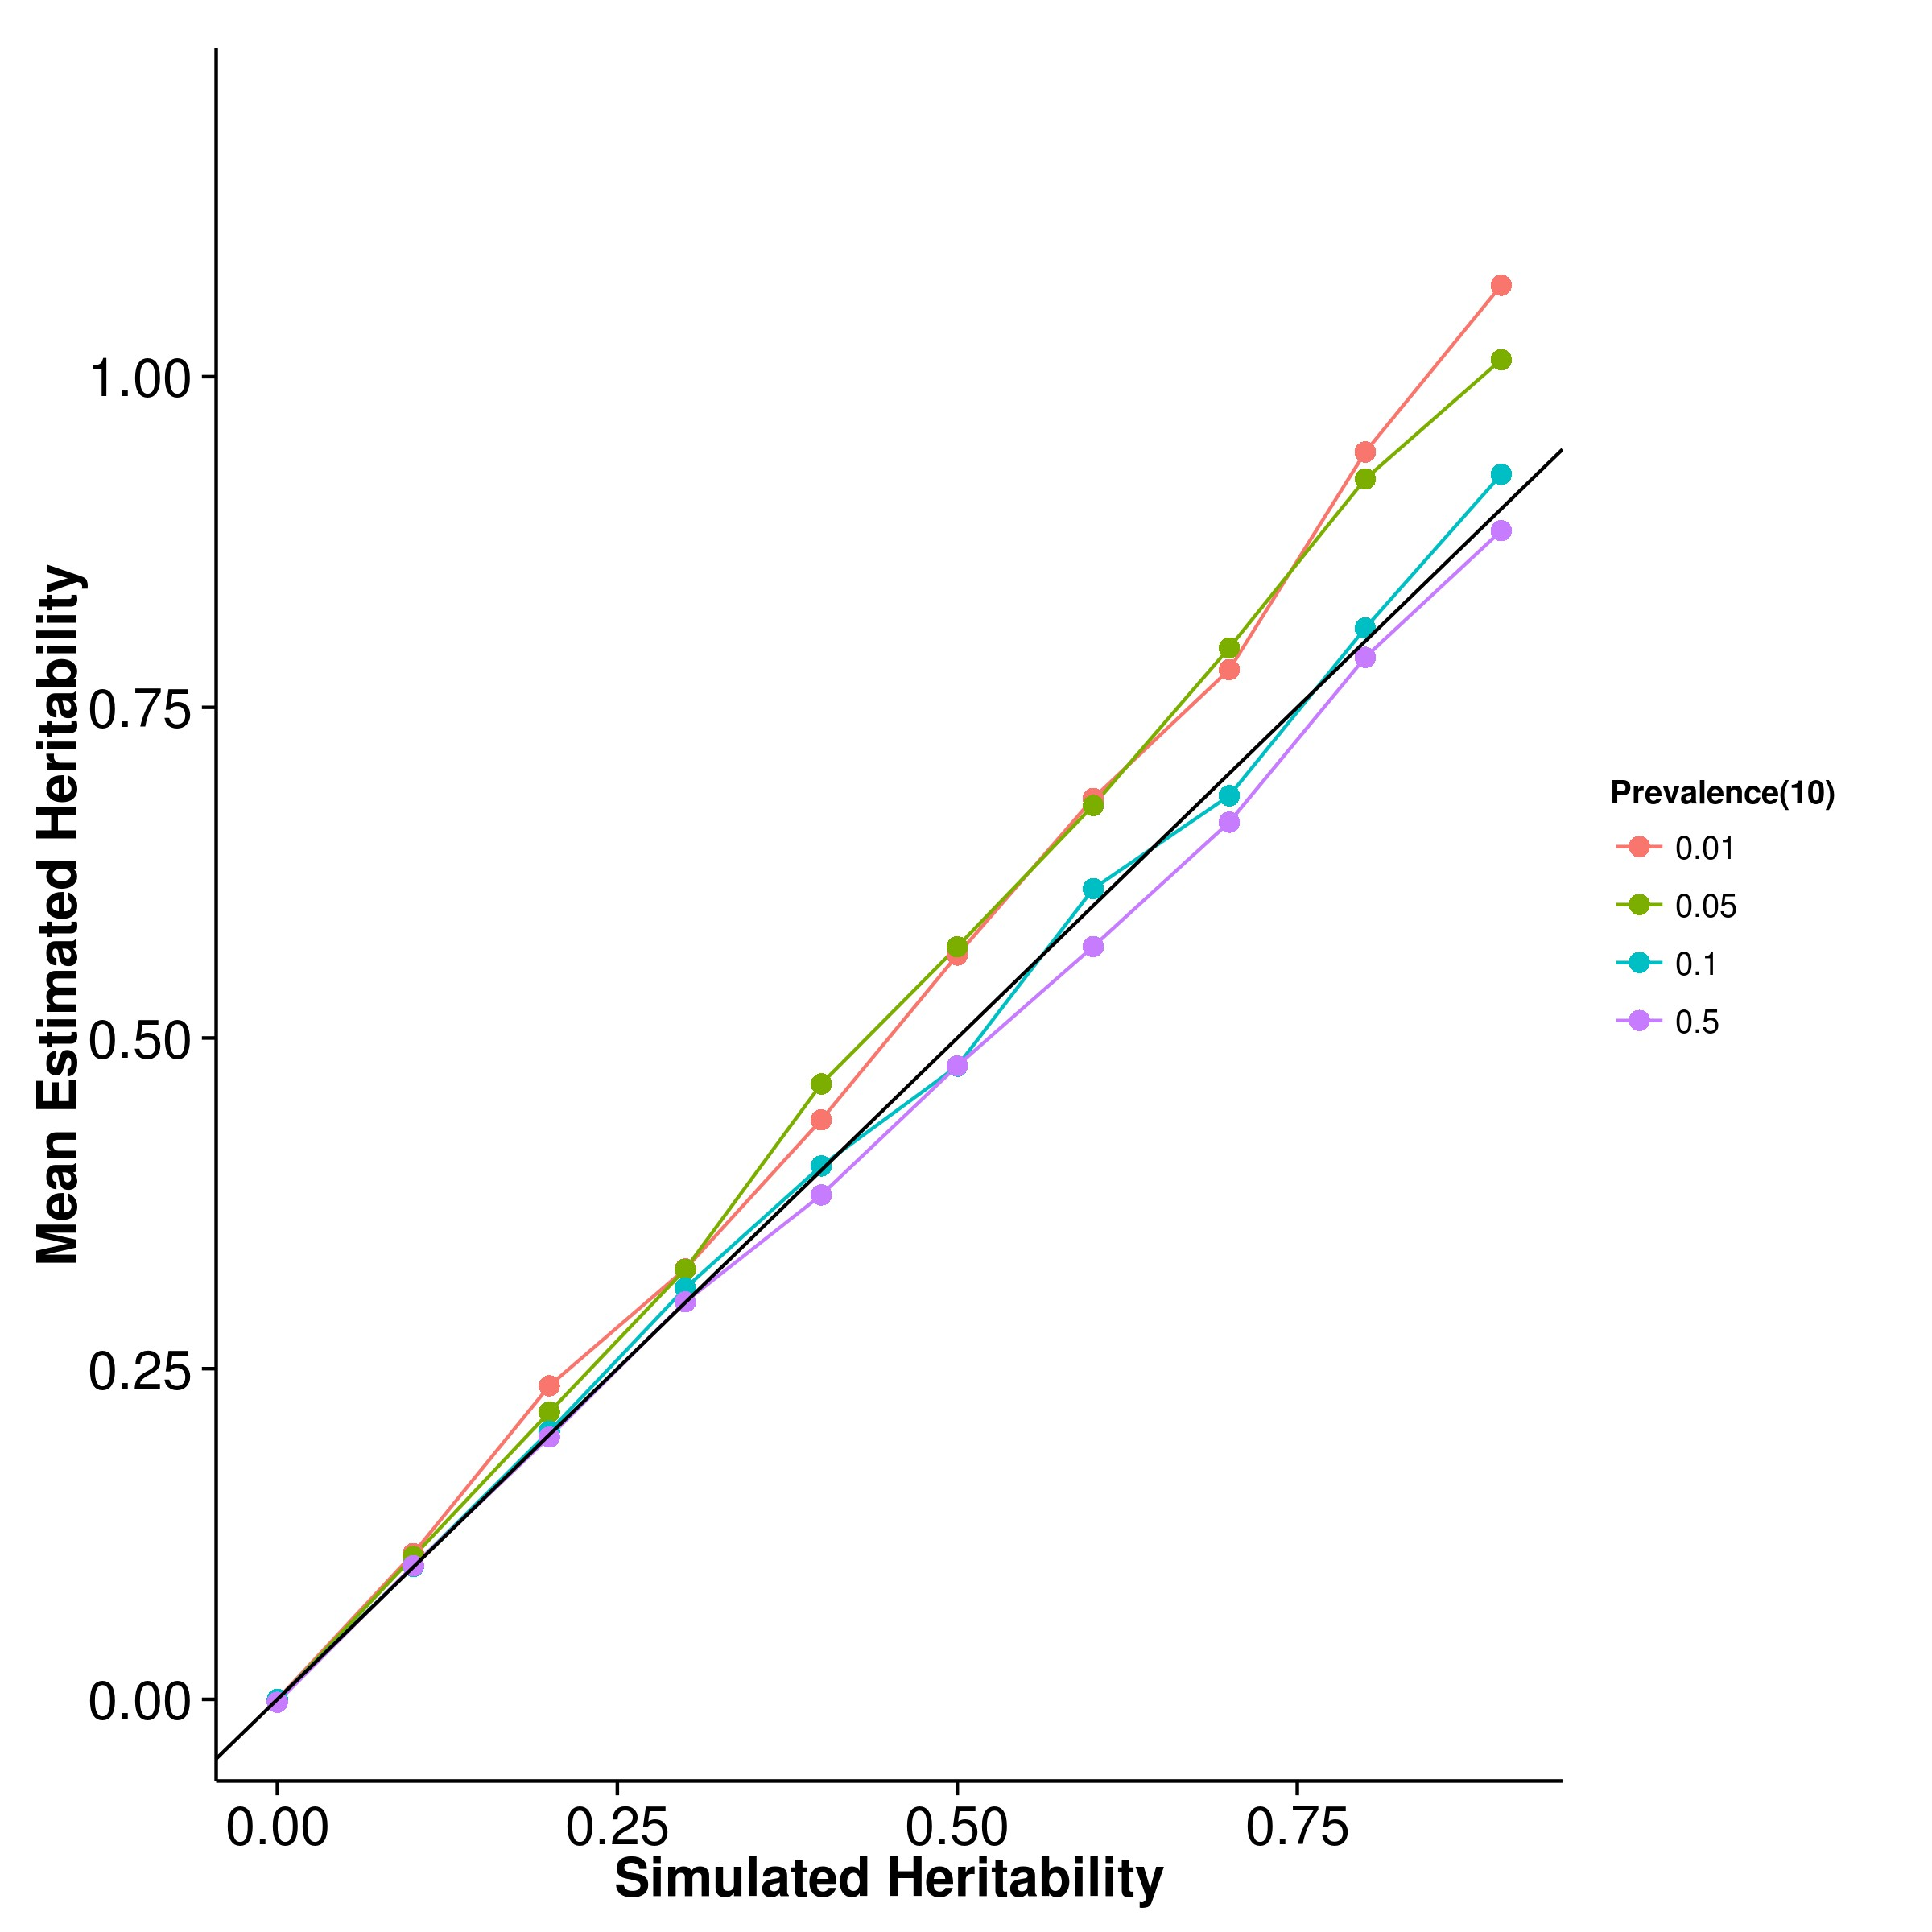

**(a)** SHREK **(b)** GCTA

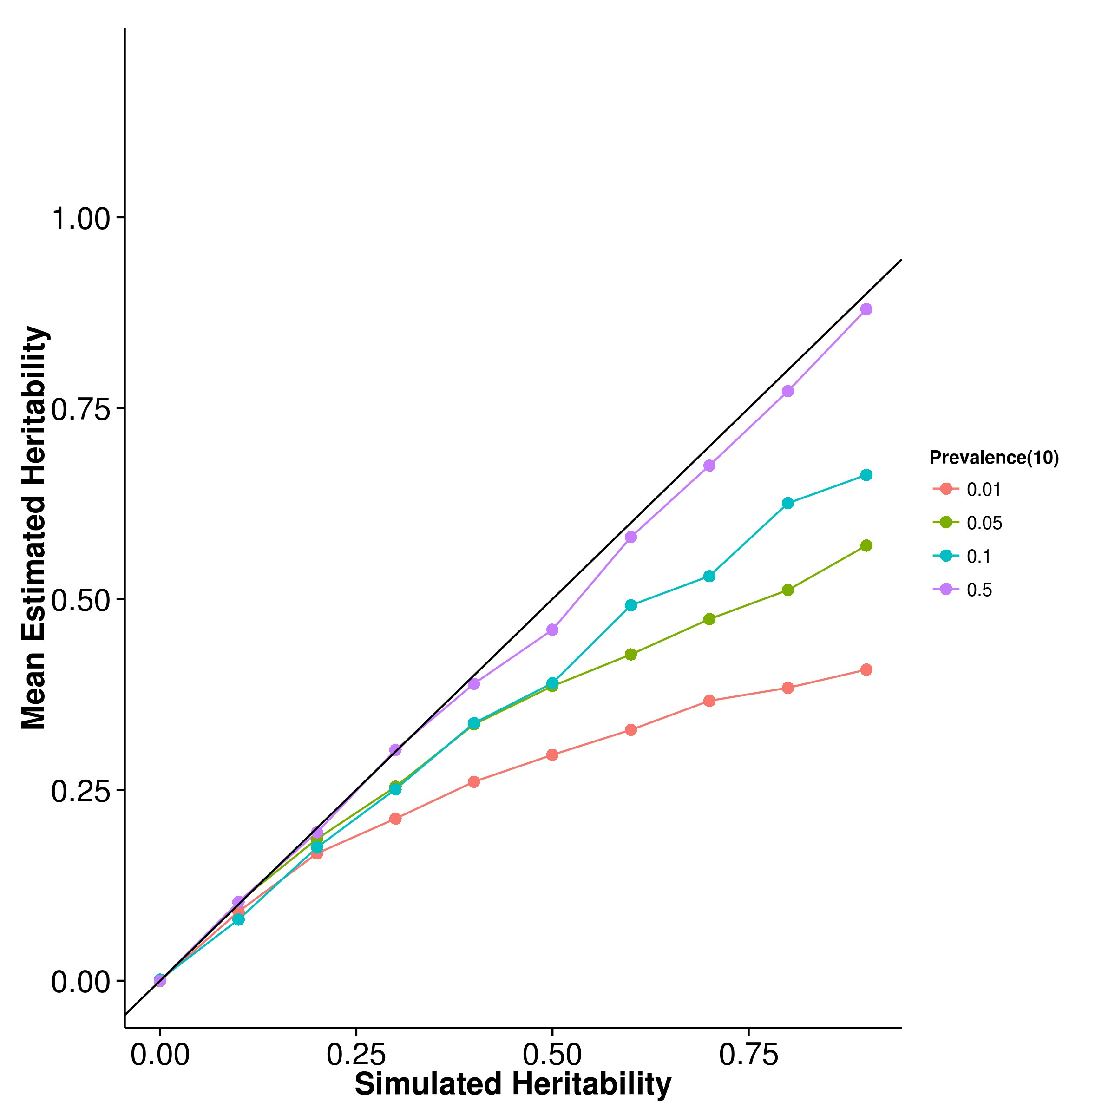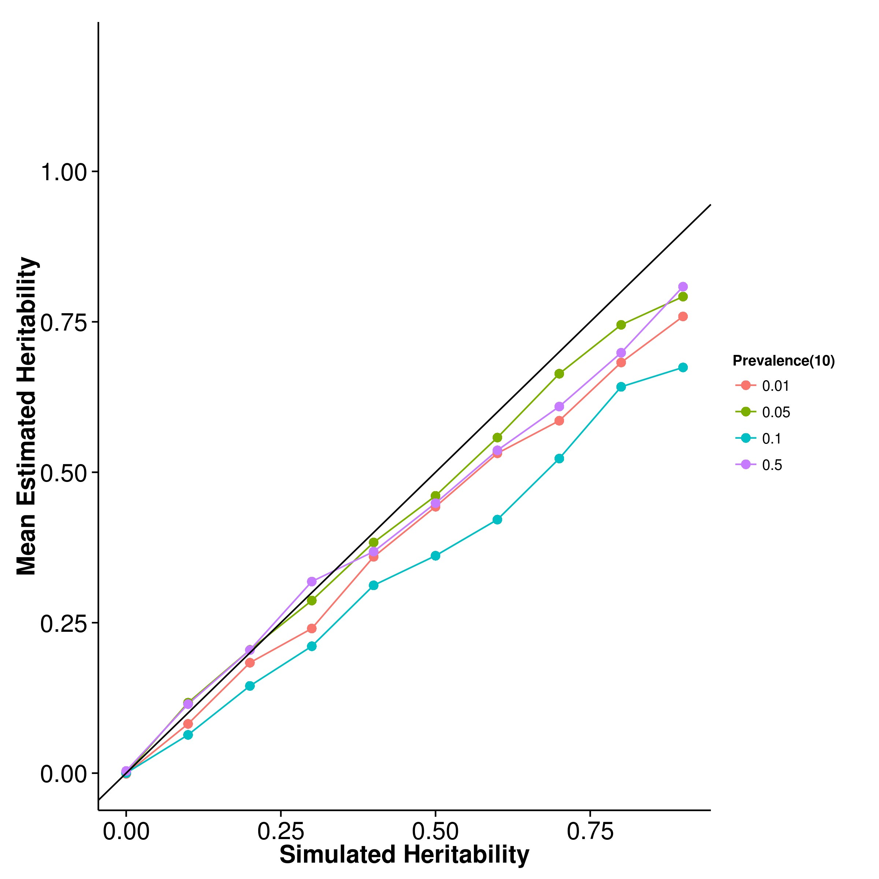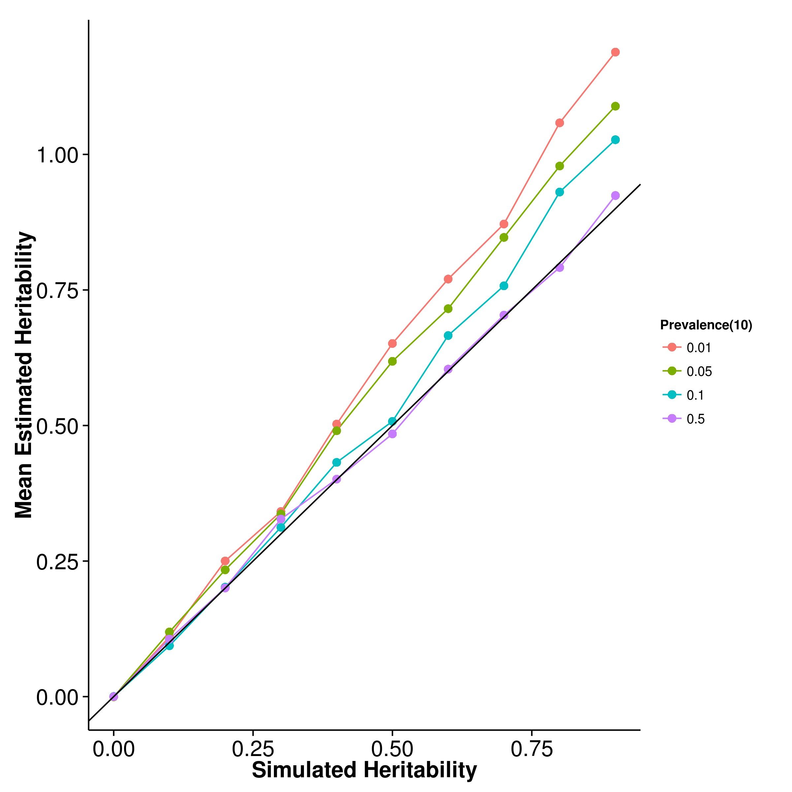

**(c)** LDSC with fix intercept **(d)** LDSC with intercept estimation

**Figure 2.10:** Mean of results from case control simulation with random effect size simulation with 10 causal SNPs. The performance of GCTA was as suggested by Golan, Eric S Lander, and Rosset (2014) where there was an underestimation as prevalence decreases. On the other hand, the upward bias of both LDSC with fixed intercept and SHREK increases as the prevalence decreases whereas LDSC with intercept estimation seems relatively robust to the change in prevalence.

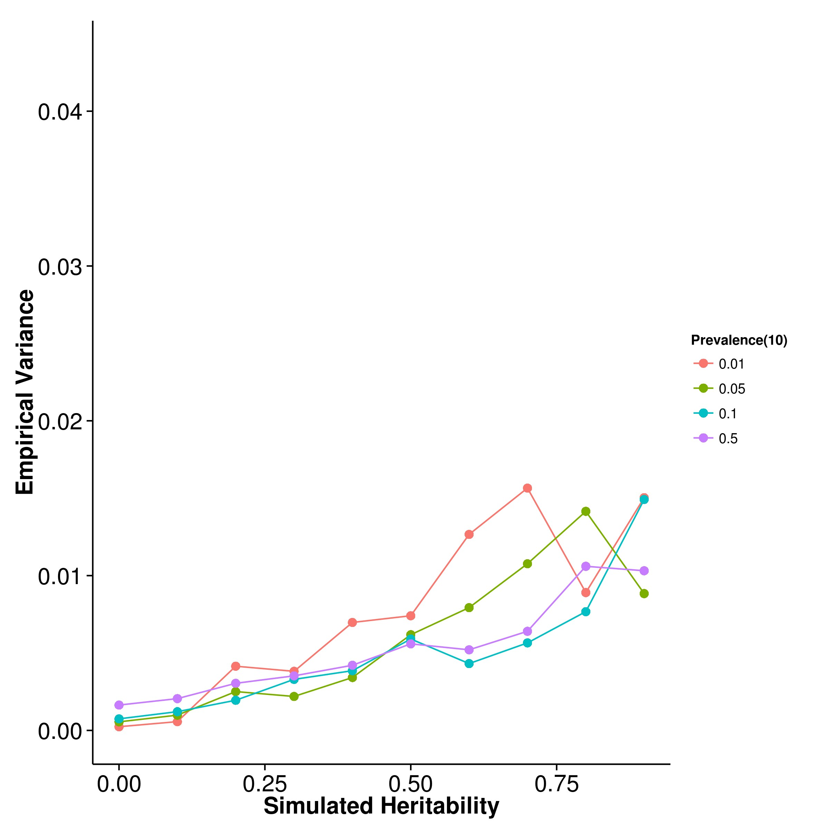

**(a)** SHREK **(b)** GCTA

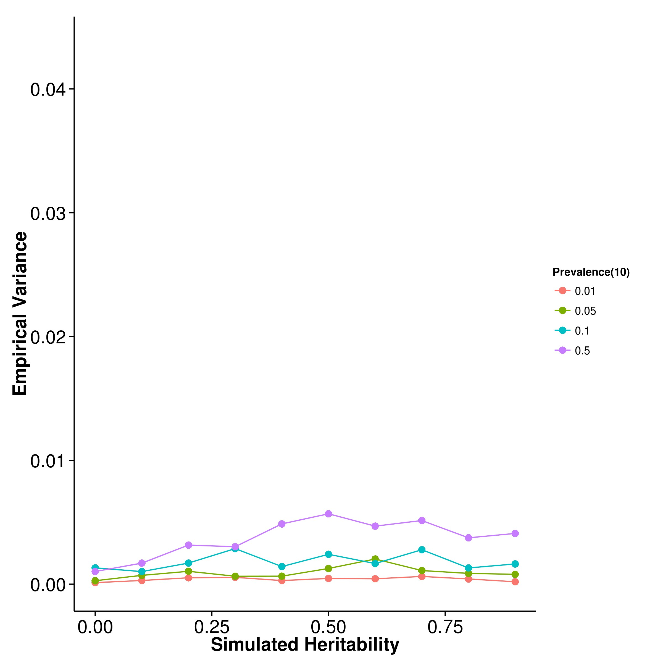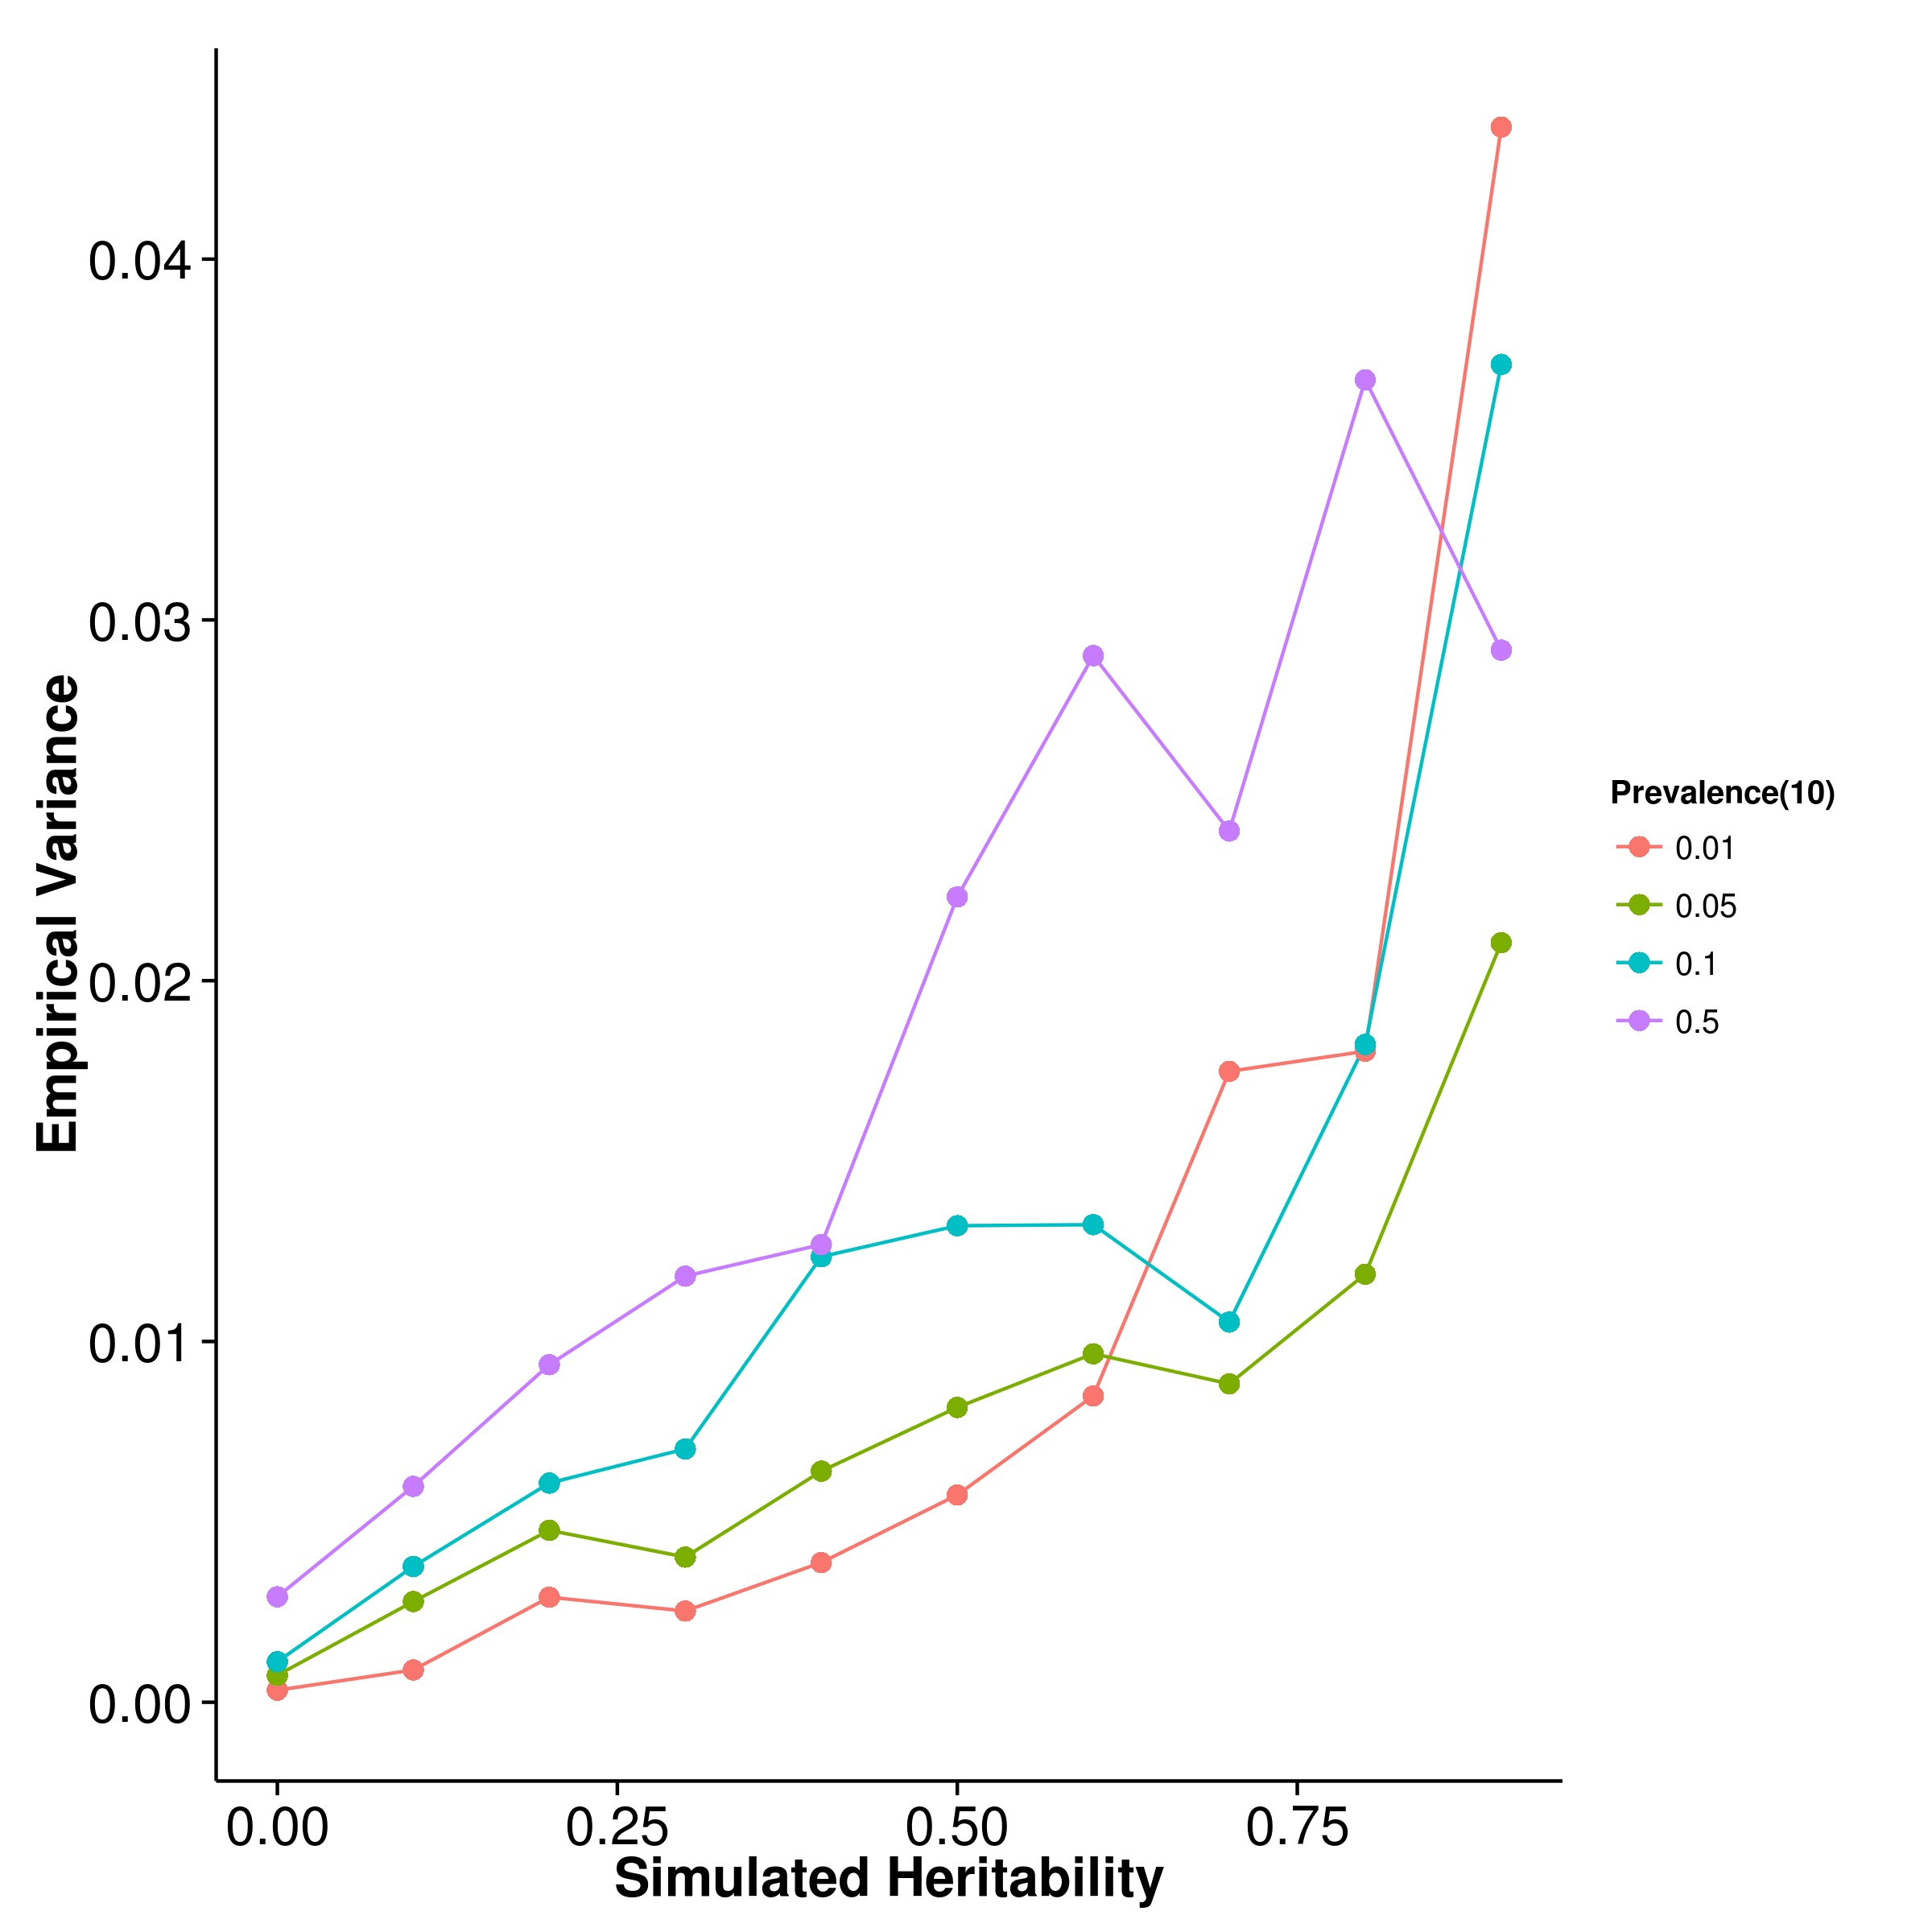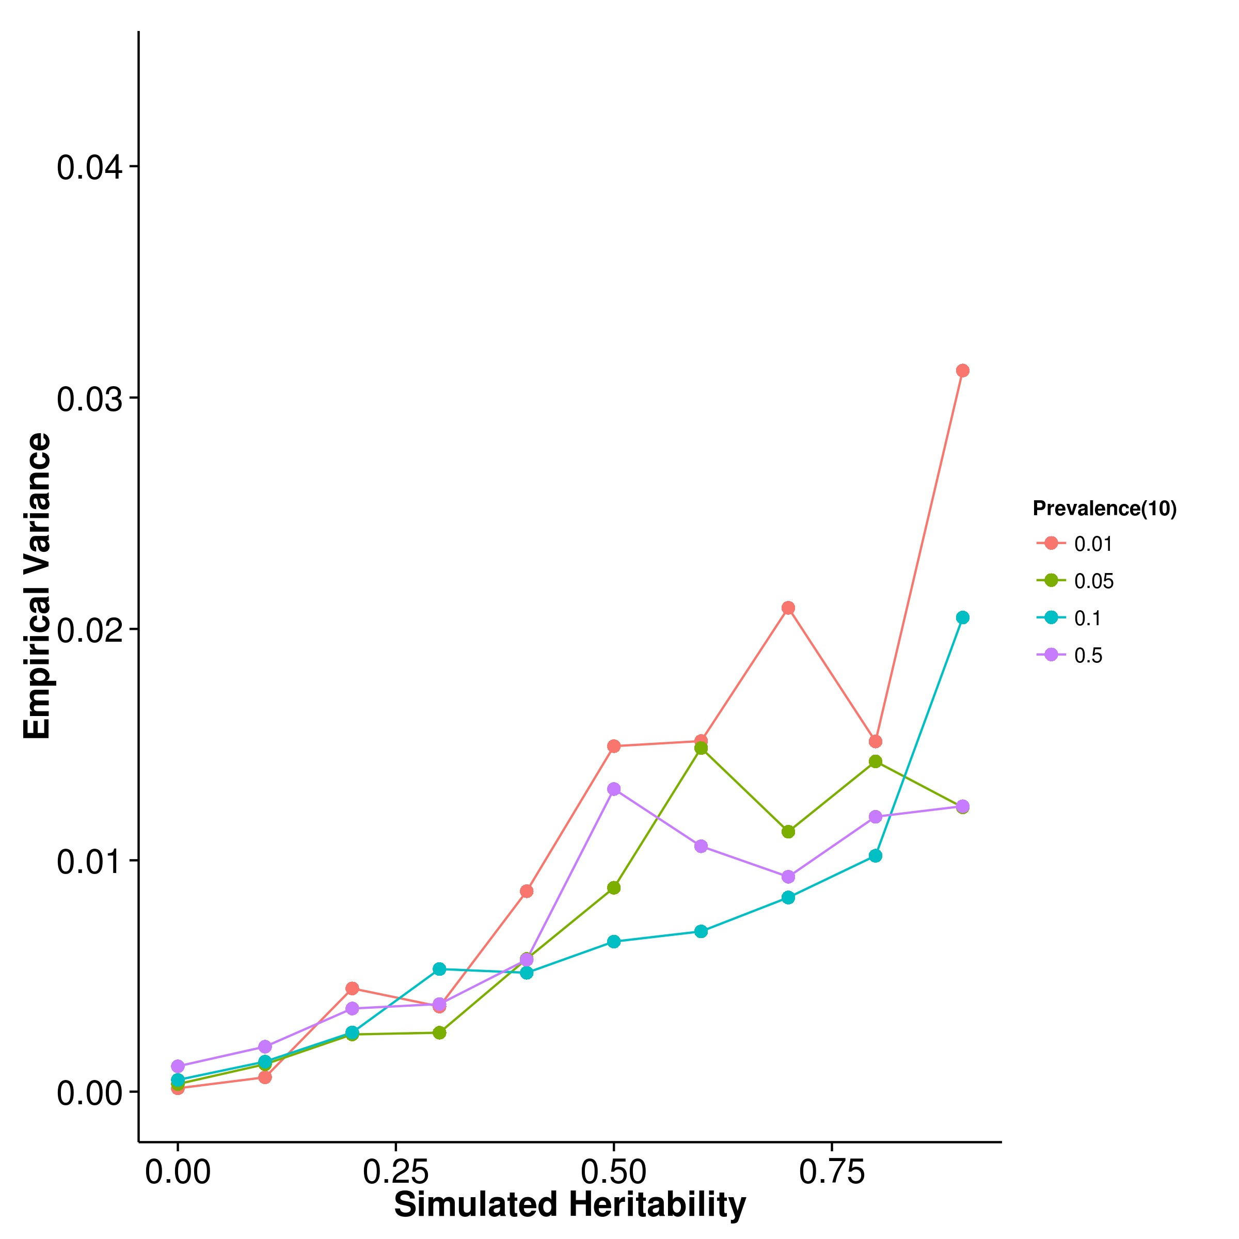

**(c)** LDSC with fix intercept **(d)** LDSC with intercept estimation

**Figure 2.11:** Variance of results from case control simulation with random effect size simulation with 10 causal SNPs. There were no clear pattern as to how the prevalence affect the empirical variance of estimates from SHREK and LDSC. For GCTA, it seems like a larger prevalence tends to result in a larger empirical variance. Again, GCTA has the lowest variance, follow by SHREK and LDSC with fixed intercept. Nonetheless, it was important to remember that in case control simulation, a much smaller amount of SNPs was used, thus the results was not directly comparable to results from the quantitative simulation.

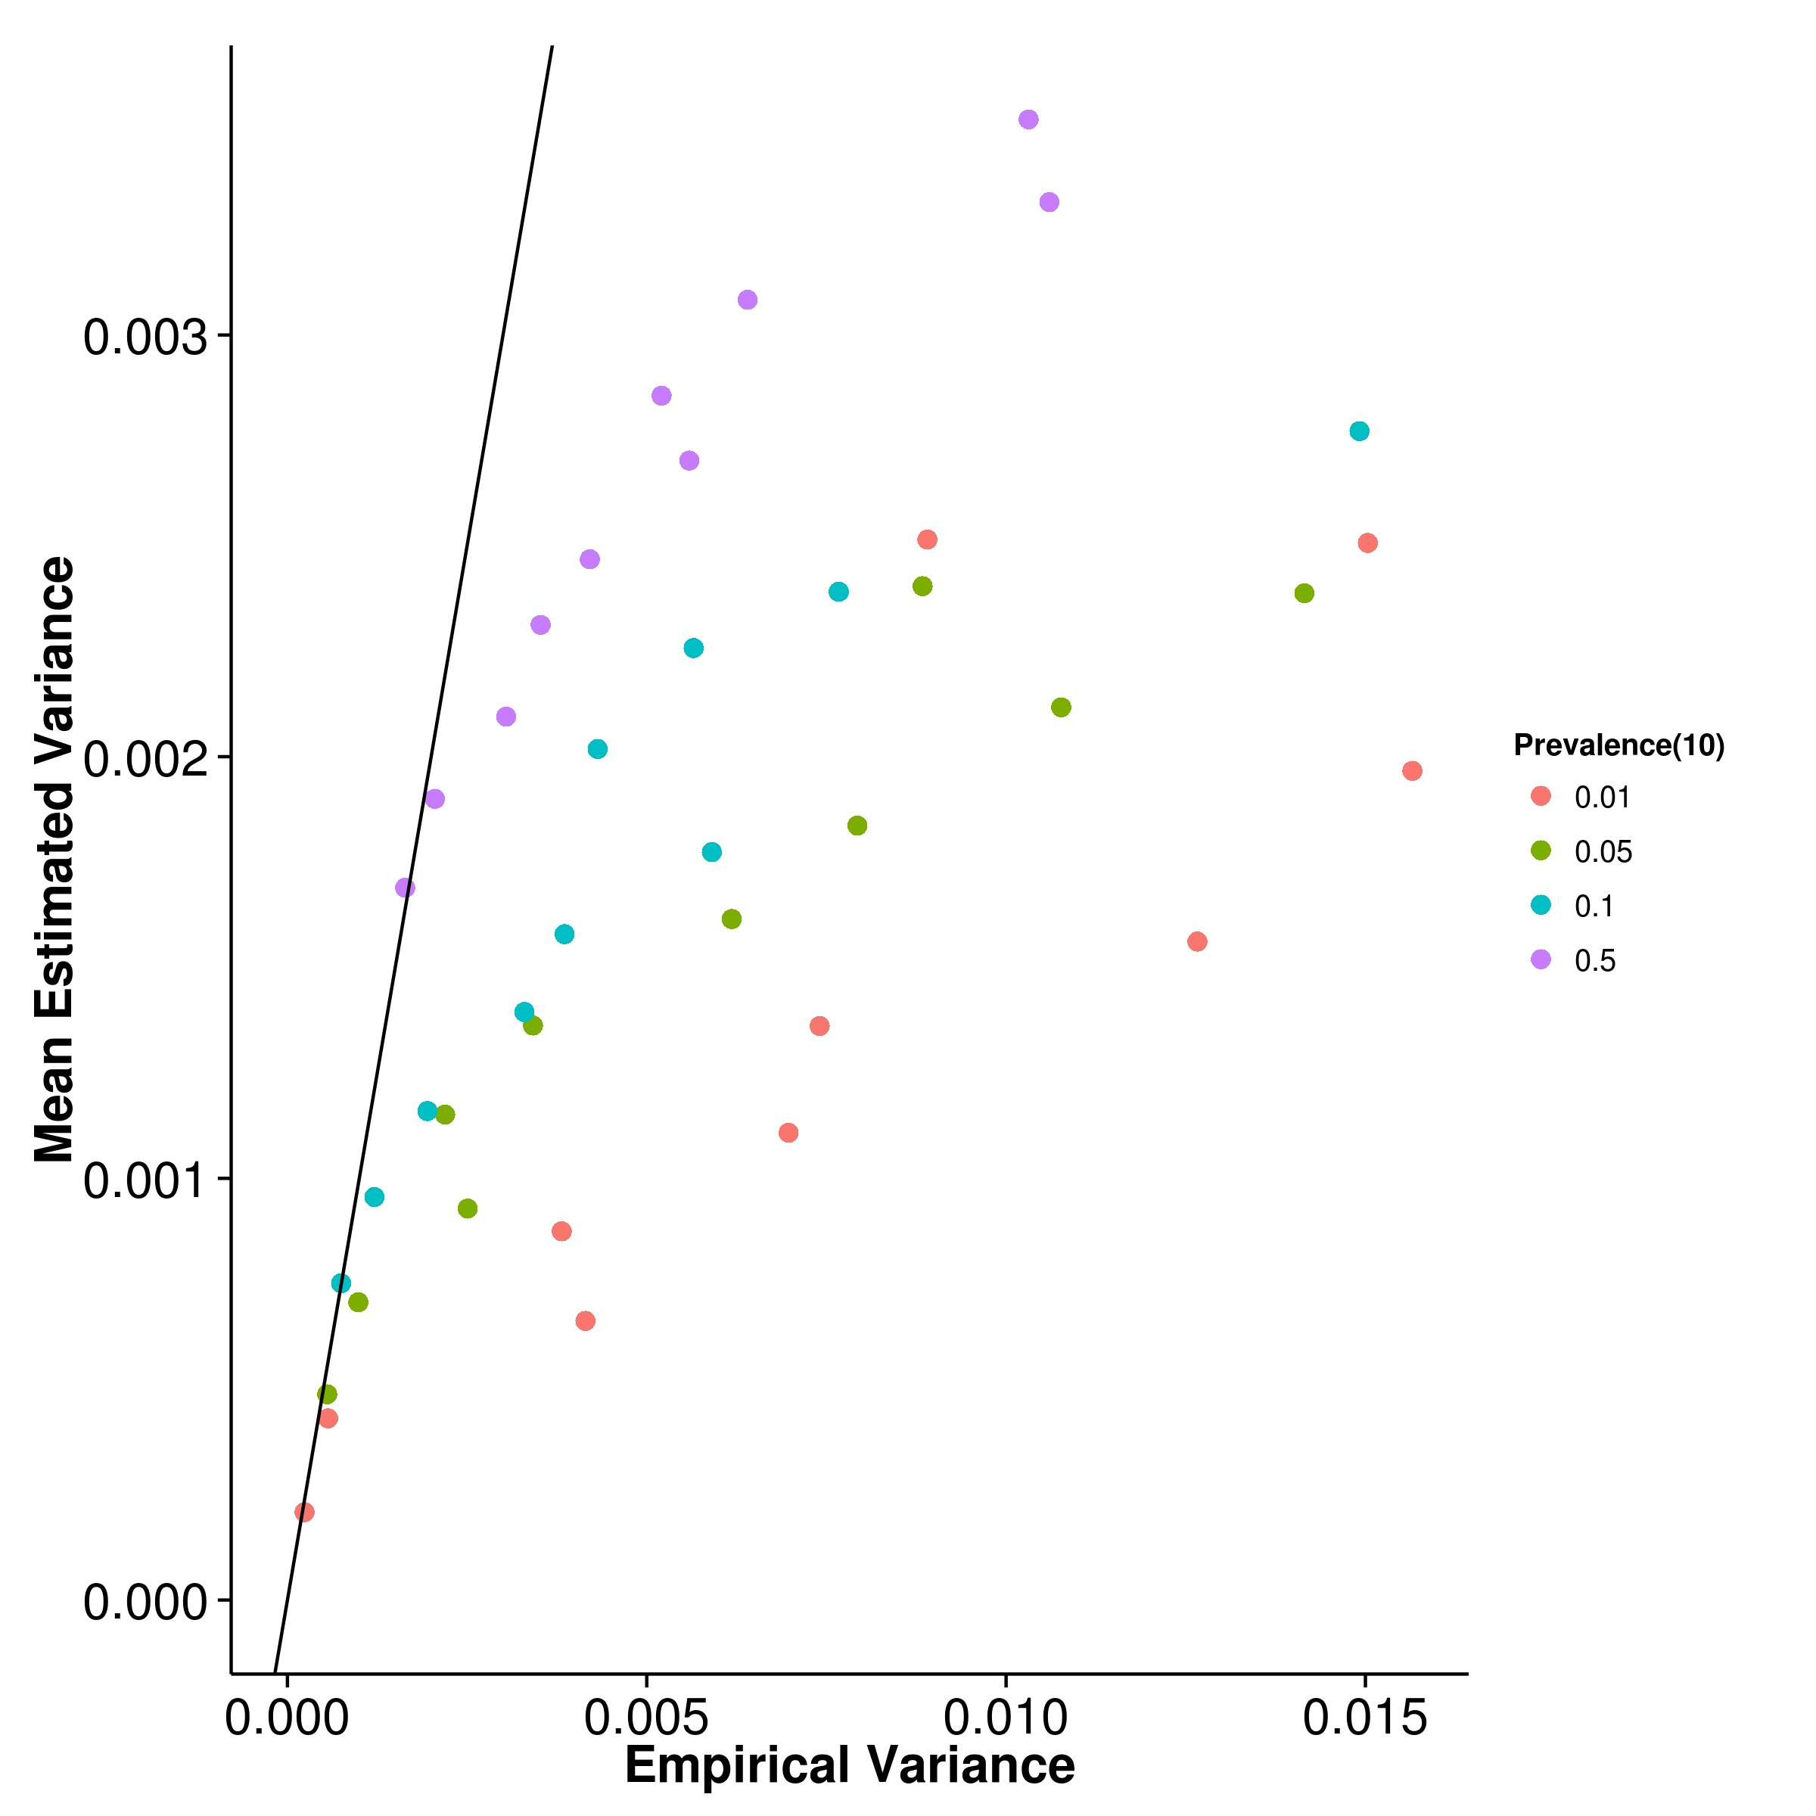

**(a)** SHREK **(b)** GCTA

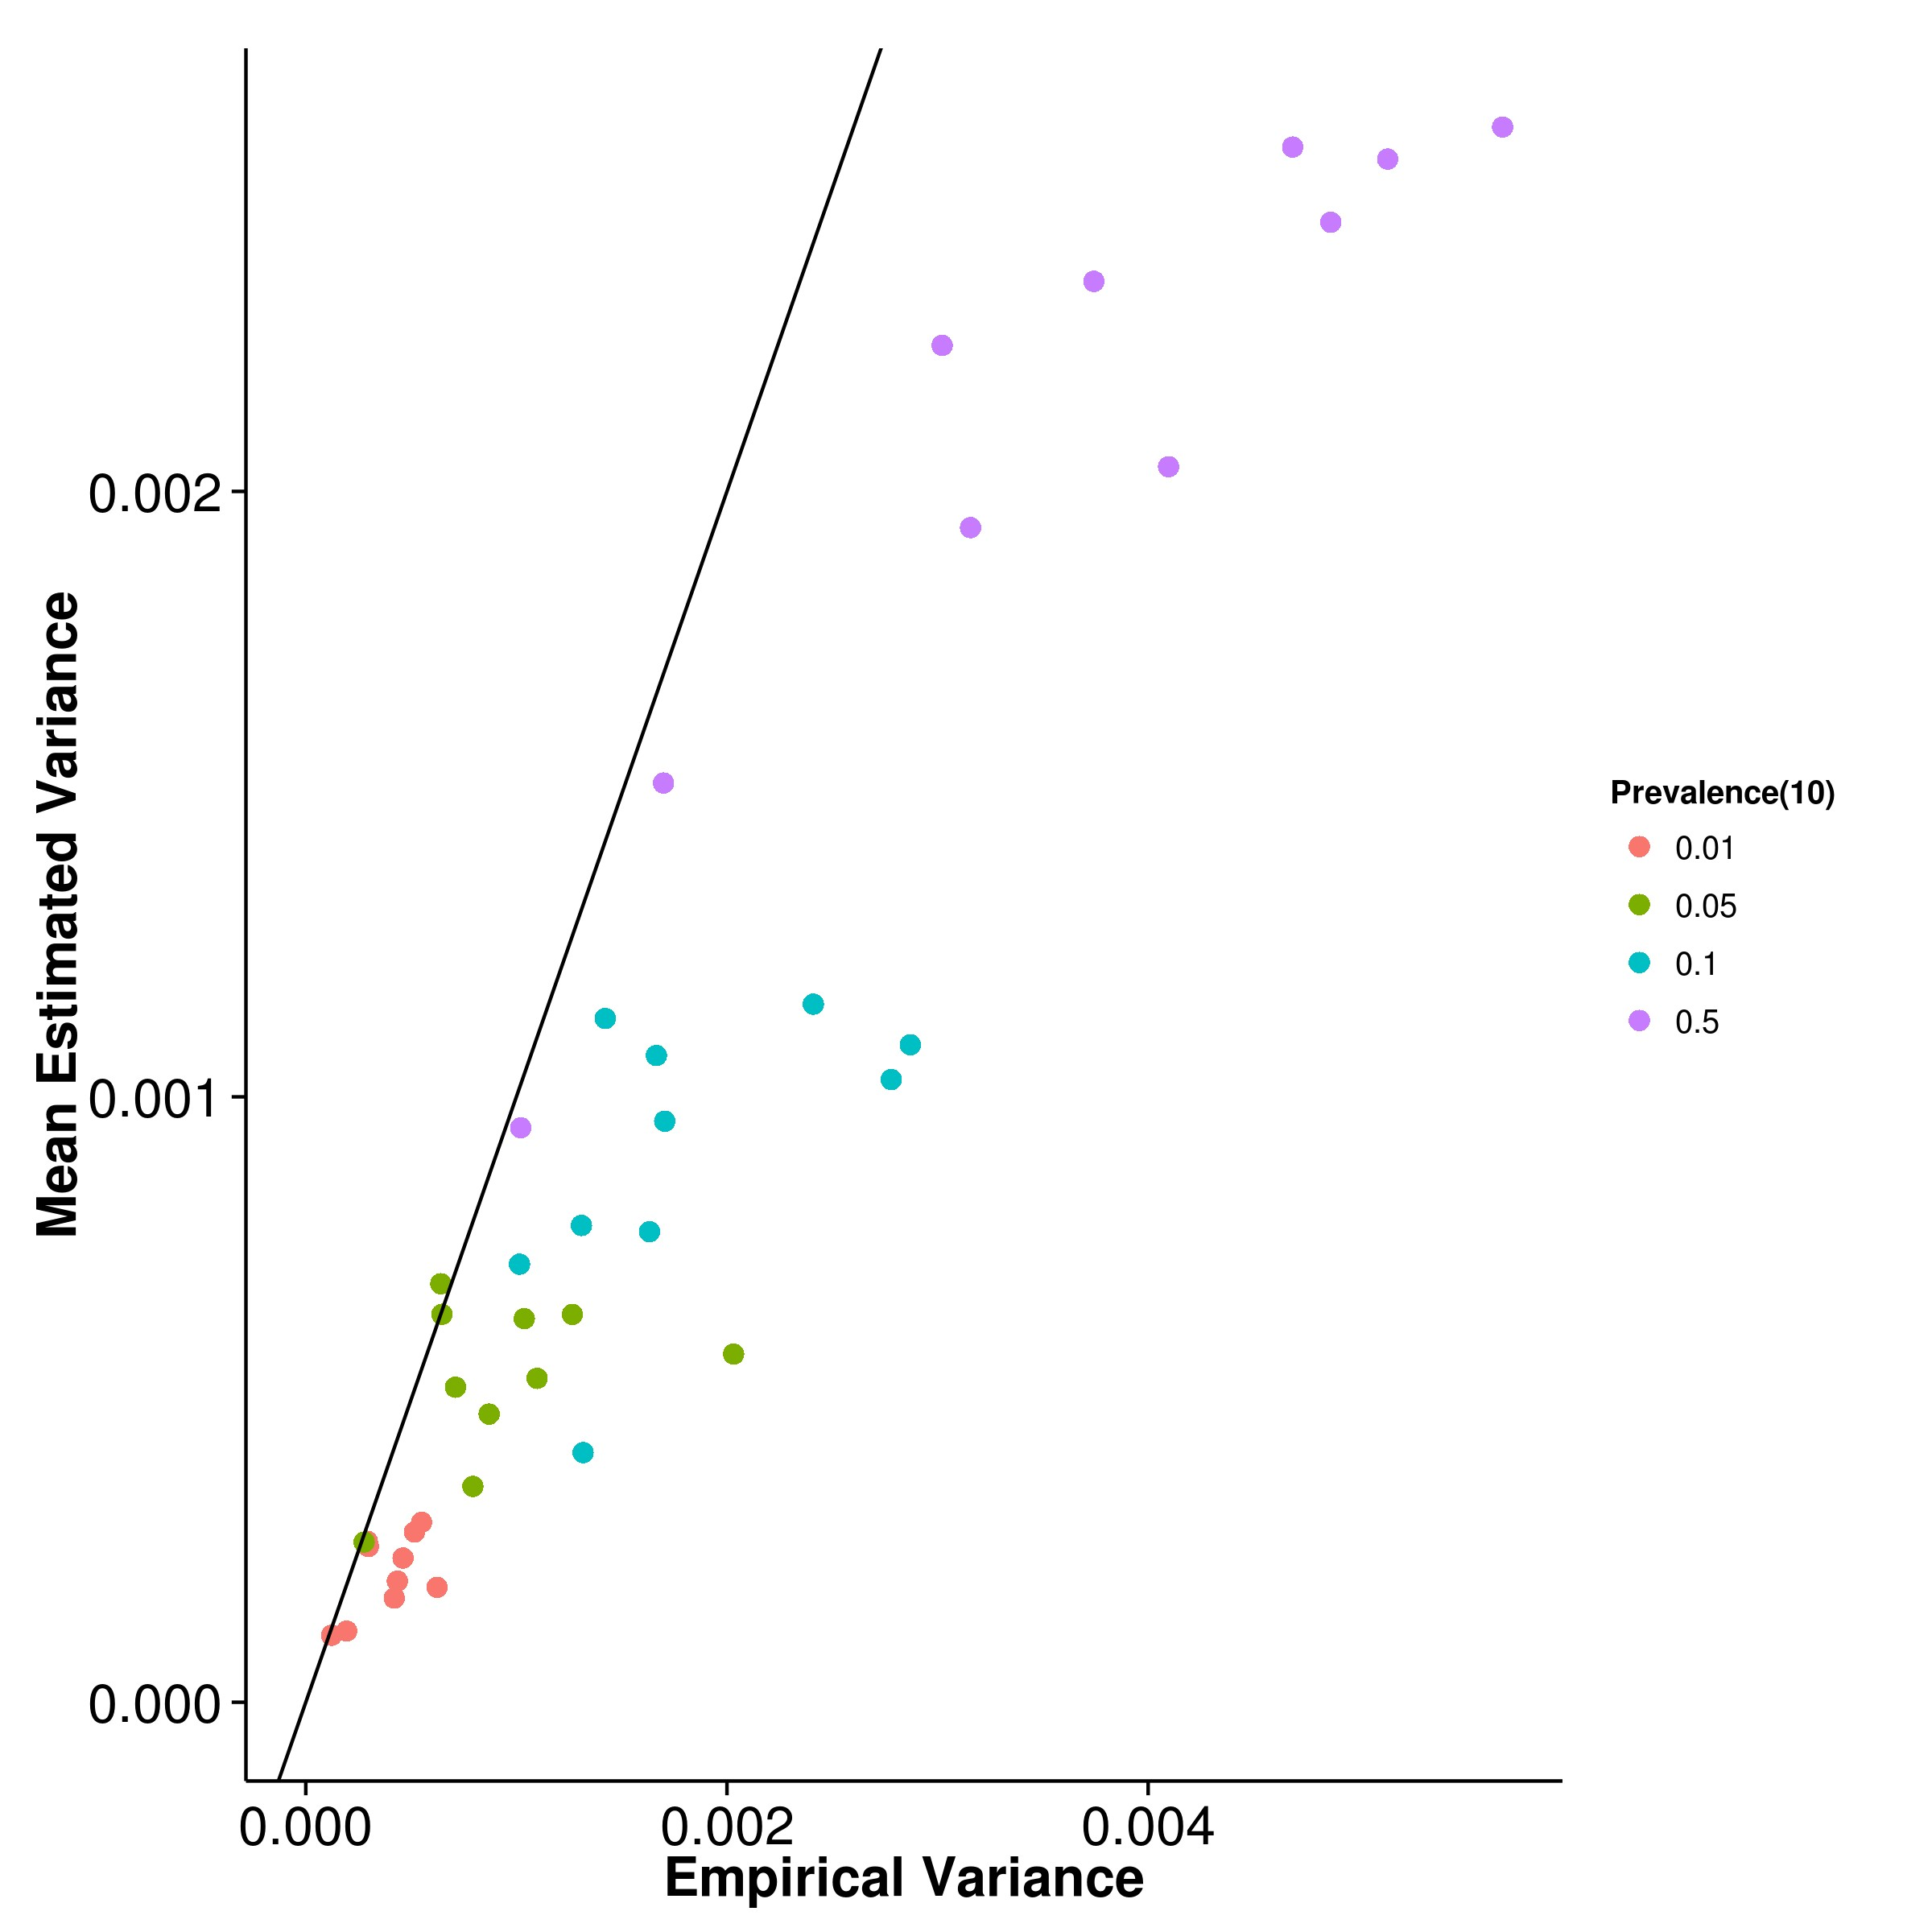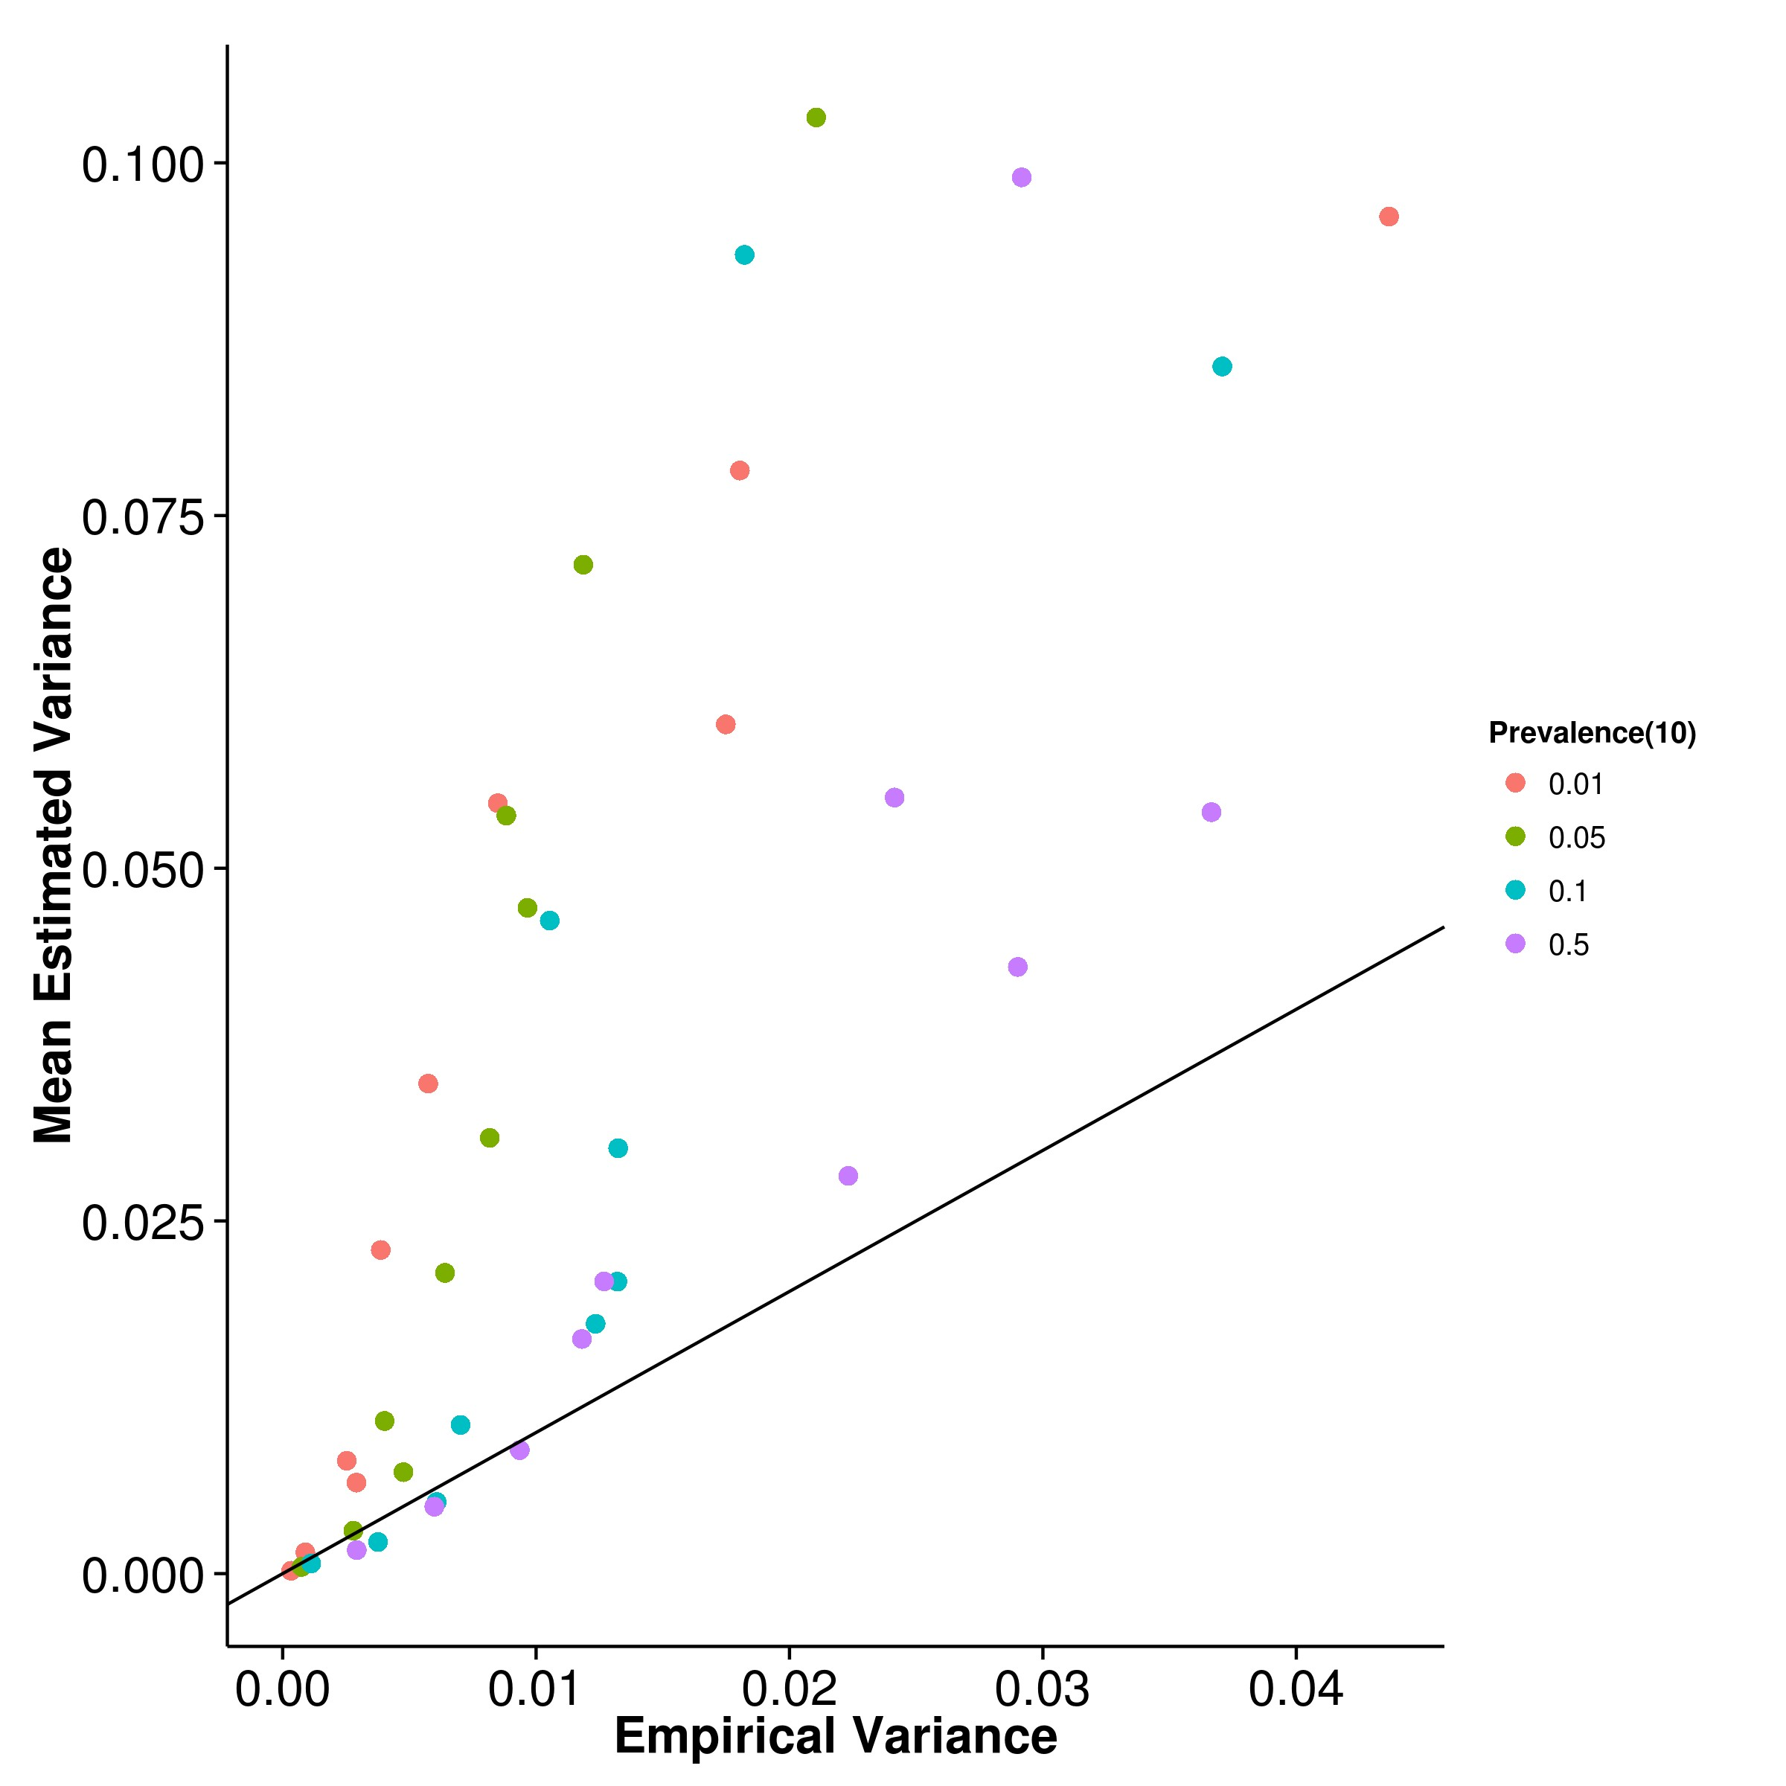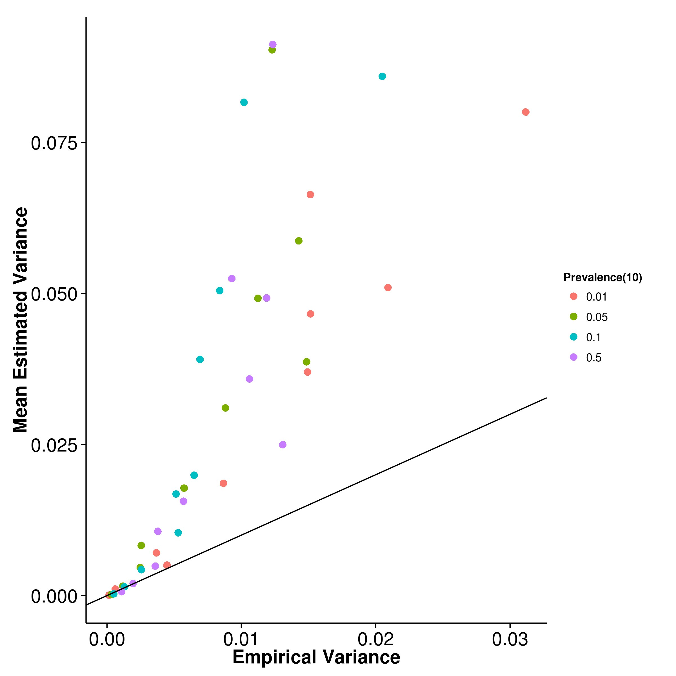

**(c)** LDSC with fix intercept **(d)** LDSC with intercept estimation

**Figure 2.12:** Estimated variance of results from case control simulation with random effect size simulation when compared to empirical variance when 10 causal SNPs was simulated. A general underestimation was observed for SHREK and GCTA whereas a larger upward bias was observed for LDSC.

As one inspect the empirical variance of the algorithms, GCTA clearly has the smallest average empirical variance among the algorithms (fig. 2.11b) where LDSC with intercept estimation has the largest empirical variance (fig. 2.11d). Unlike the quantitative trait simulation, the empirical variance of the estimates from SHREK (fig. 2.11a) seems to be very close to that of LDSC with fixed intercept (fig. 2.11c). When the heritability of the trait is high, the empirical variance of SHREK is even lower than that of LDSC with fixed intercept. As one increases the number of causal SNPs, the empirical variance of all algorithms decreases (figs. 2.19, 2.22 and 2.25) agreeing with the results from the quantitative trait simulation.

On the other hand, both SHREK (fig. 2.12a) and GCTA (fig. 2.12b) under- estimates their empirical variance whereas LDSC overestimates its empirical variance no matter if the intercept estimation was performed (fig. 2.12). As the number of causal SNPs increases (figs. 2.20, 2.23 and 2.26), the bias of variance estimation re- main unchanged for SHREK. However, for LDSC, the magnitude of bias of variance estimation reduces as the number of causal SNPs increases and were able to provide a relatively accurate estimation of its empirical variance when there were 500 causal SNPs (fig. 2.26c).

Taking into account of the bias and variance of the estimations (table 2.3), SHREK has the best average performance of all the algorithm tested. Interestingly, the performance of LDSC with intercept estimation were better than LDSC with fixed intercept when the prevalence is small even-though we did not simulate any confounding factors. In such scenario, one would expect the intercept estimation to be unnecessary and will only increase the SE of the heritability estimation without improving the estimates yet from the simulation results, it was suggested that the intercept estimation might helps correct for some of the bias in the estimates when the prevalence is small.

In general, the effects of the number of causal SNPs in the case control simu- lation agrees with what was observed in the quantitative trait simulations where as the number of causal SNPs increases the MSE tends to decrease for all algorithms, with SHREK least sensitive. Finally, it is important to note that for the case control sim- ulations, a smaller amount of SNPs was simulated when compared to the quantitative trait simulations. The total sample number involved was also larger (2,000 samples with 1,000 cases and 1,000 controls). Thus, the results from case control simulations were not directly comparable to the results from the quantitative trait simulations.

|  |  |  |  |  |  |
| --- | --- | --- | --- | --- | --- |
| Population  Prevalence | Number of  Causal SNPs | SHREK | LDSC | LDSC-In | GCTA |
| 0.01 | 10 | **0.0145** | 0.0361 | 0.0164 | 0.0675 |
| 0.01 | 50 | 0.0135 | 0.0254 | **0.00791** | 0.0702 |
| 0.01 | 100 | 0.0128 | 0.0227 | **0.0102** | 0.0698 |
| 0.01 | 500 | **0.0126** | 0.0214 | 0.0150 | 0.0710 |
| 0.05 | 10 | 0.0110 | 0.0201 | **0.00983** | 0.0302 |
| 0.05 | 50 | **0.00453** | 0.00974 | 0.0115 | 0.0299 |
| 0.05 | 100 | **0.00569** | 0.0113 | 0.00981 | 0.0304 |
| 0.05 | 500 | **0.00540** | 0.00999 | 0.0171 | 0.0305 |
| 0.1 | 10 | **0.00512** | 0.0109 | 0.0301 | 0.0165 |
| 0.1 | 50 | **0.00381** | 0.00824 | 0.0105 | 0.0152 |
| 0.1 | 100 | **0.00418** | 0.00802 | 0.0163 | 0.0148 |
| 0.1 | 500 | **0.00400** | 0.00740 | 0.0141 | 0.0155 |
| 0.5 | 10 | 0.00560 | 0.00749 | 0.0219 | **0.00410** |
| 0.5 | 50 | 0.00362 | 0.00528 | 0.0232 | **0.00244** |
| 0.5 | 100 | 0.00356 | 0.00460 | 0.0208 | **0.00225** |
| 0.5 | 500 | 0.00338 | 0.00365 | 0.0159 | **0.00200** |

**Table 2.3:** MSE of Case Control simulation. Algorithm with the best performance under each condition were bold-ed. When the population prevalence is 0.5, GCTA has the best performance, followed by SHREK. For most other conditions, SHREK has the best performance. Of all the algorithms, SHREK has the lowest average MSE. Also, as the number of causal SNPs increases, the MSE tends to decrease for all algorithms, similar to what was observed in the quantitative simulation.

**2.6.3 Extreme Phenotype Simulation**

Sometimes, when budget is limited, it is not possible to include all samples in the final GWAS. By using appropriate sampling strategy, such as that of extreme phenotype sampling (Peloso et al., 2015), one can increase the power of the association study. Here we perform simulations using extreme phenotype sampling and study the effect of this selection on the performance of heritability estimations. The random sampling procedure were also performed in our simulations such that a clear comparison can be made between the power of extreme phenotype sampling and the traditional random sampling.

From the graph (fig. 2.13), it was observed that performance of SHREK and LDSC were similar to what was observed in the quantitative trait simulation, where when the random sampling strategy were used, higher estimation were usually obtained. Interestingly, GCTA performs poorly when extreme phenotype sampling was performed. As the portion of sample sampled decreases, the bias of the estimates from GCTAincreases (fig. 2.13b).

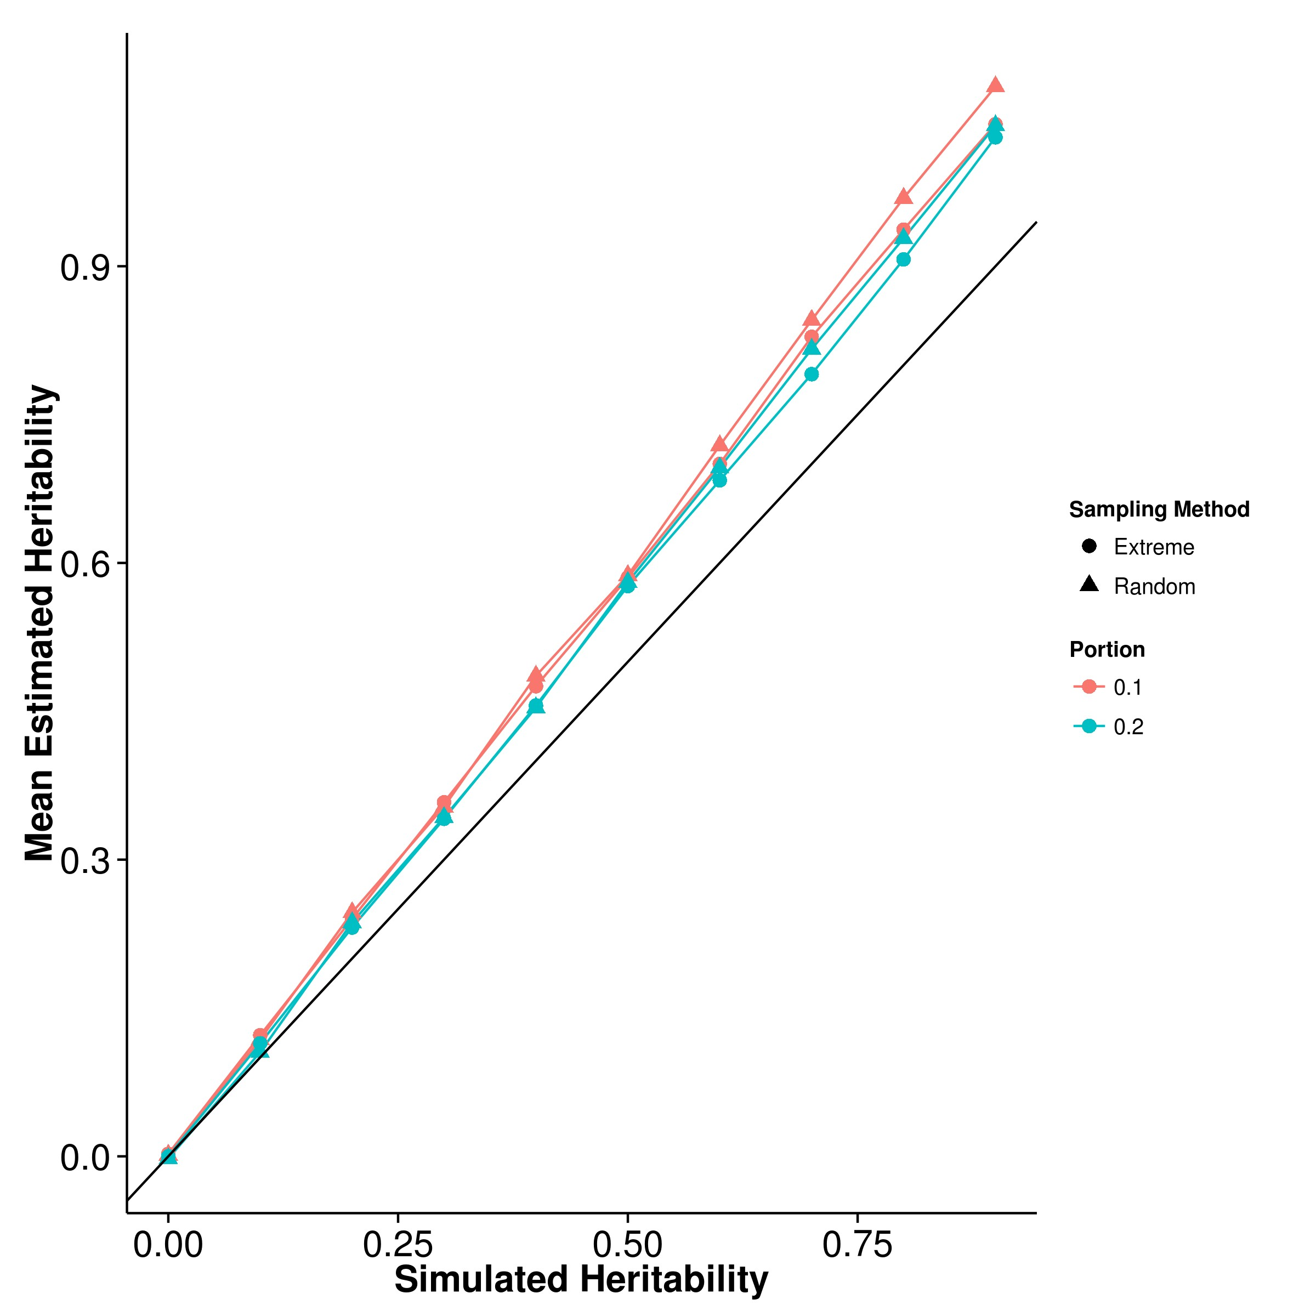

**(a)** SHREK **(b)** GCTA

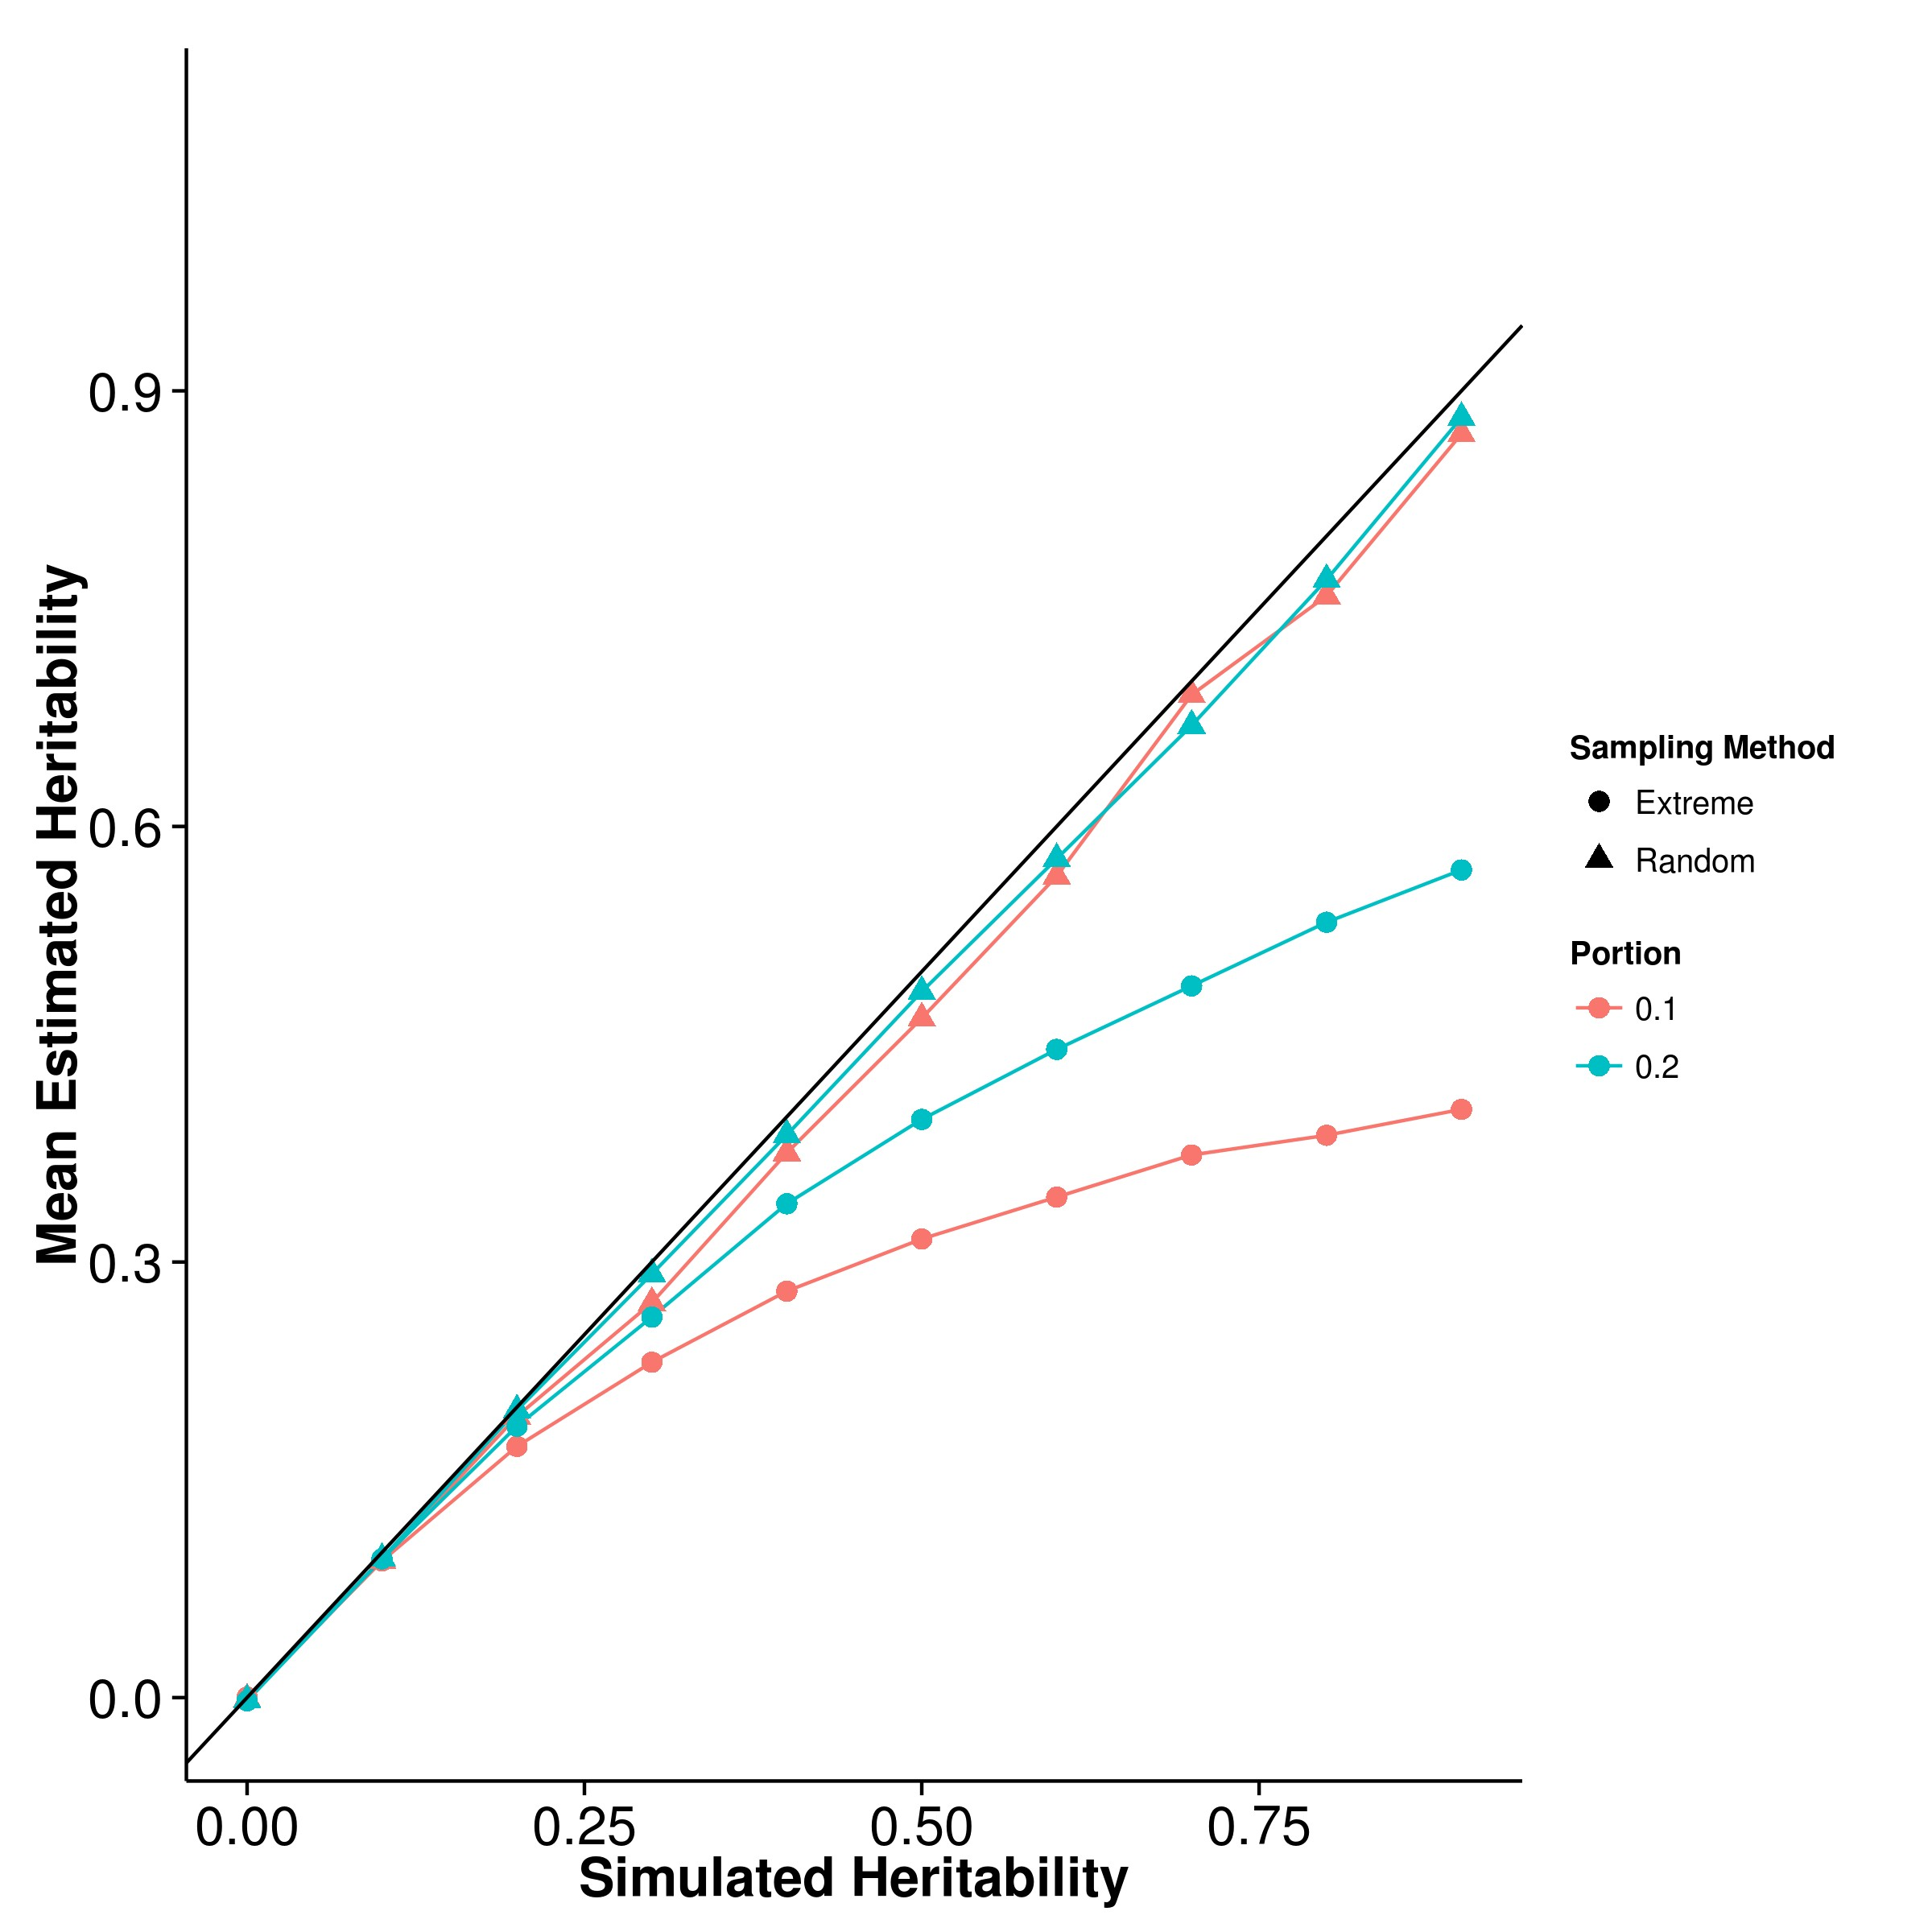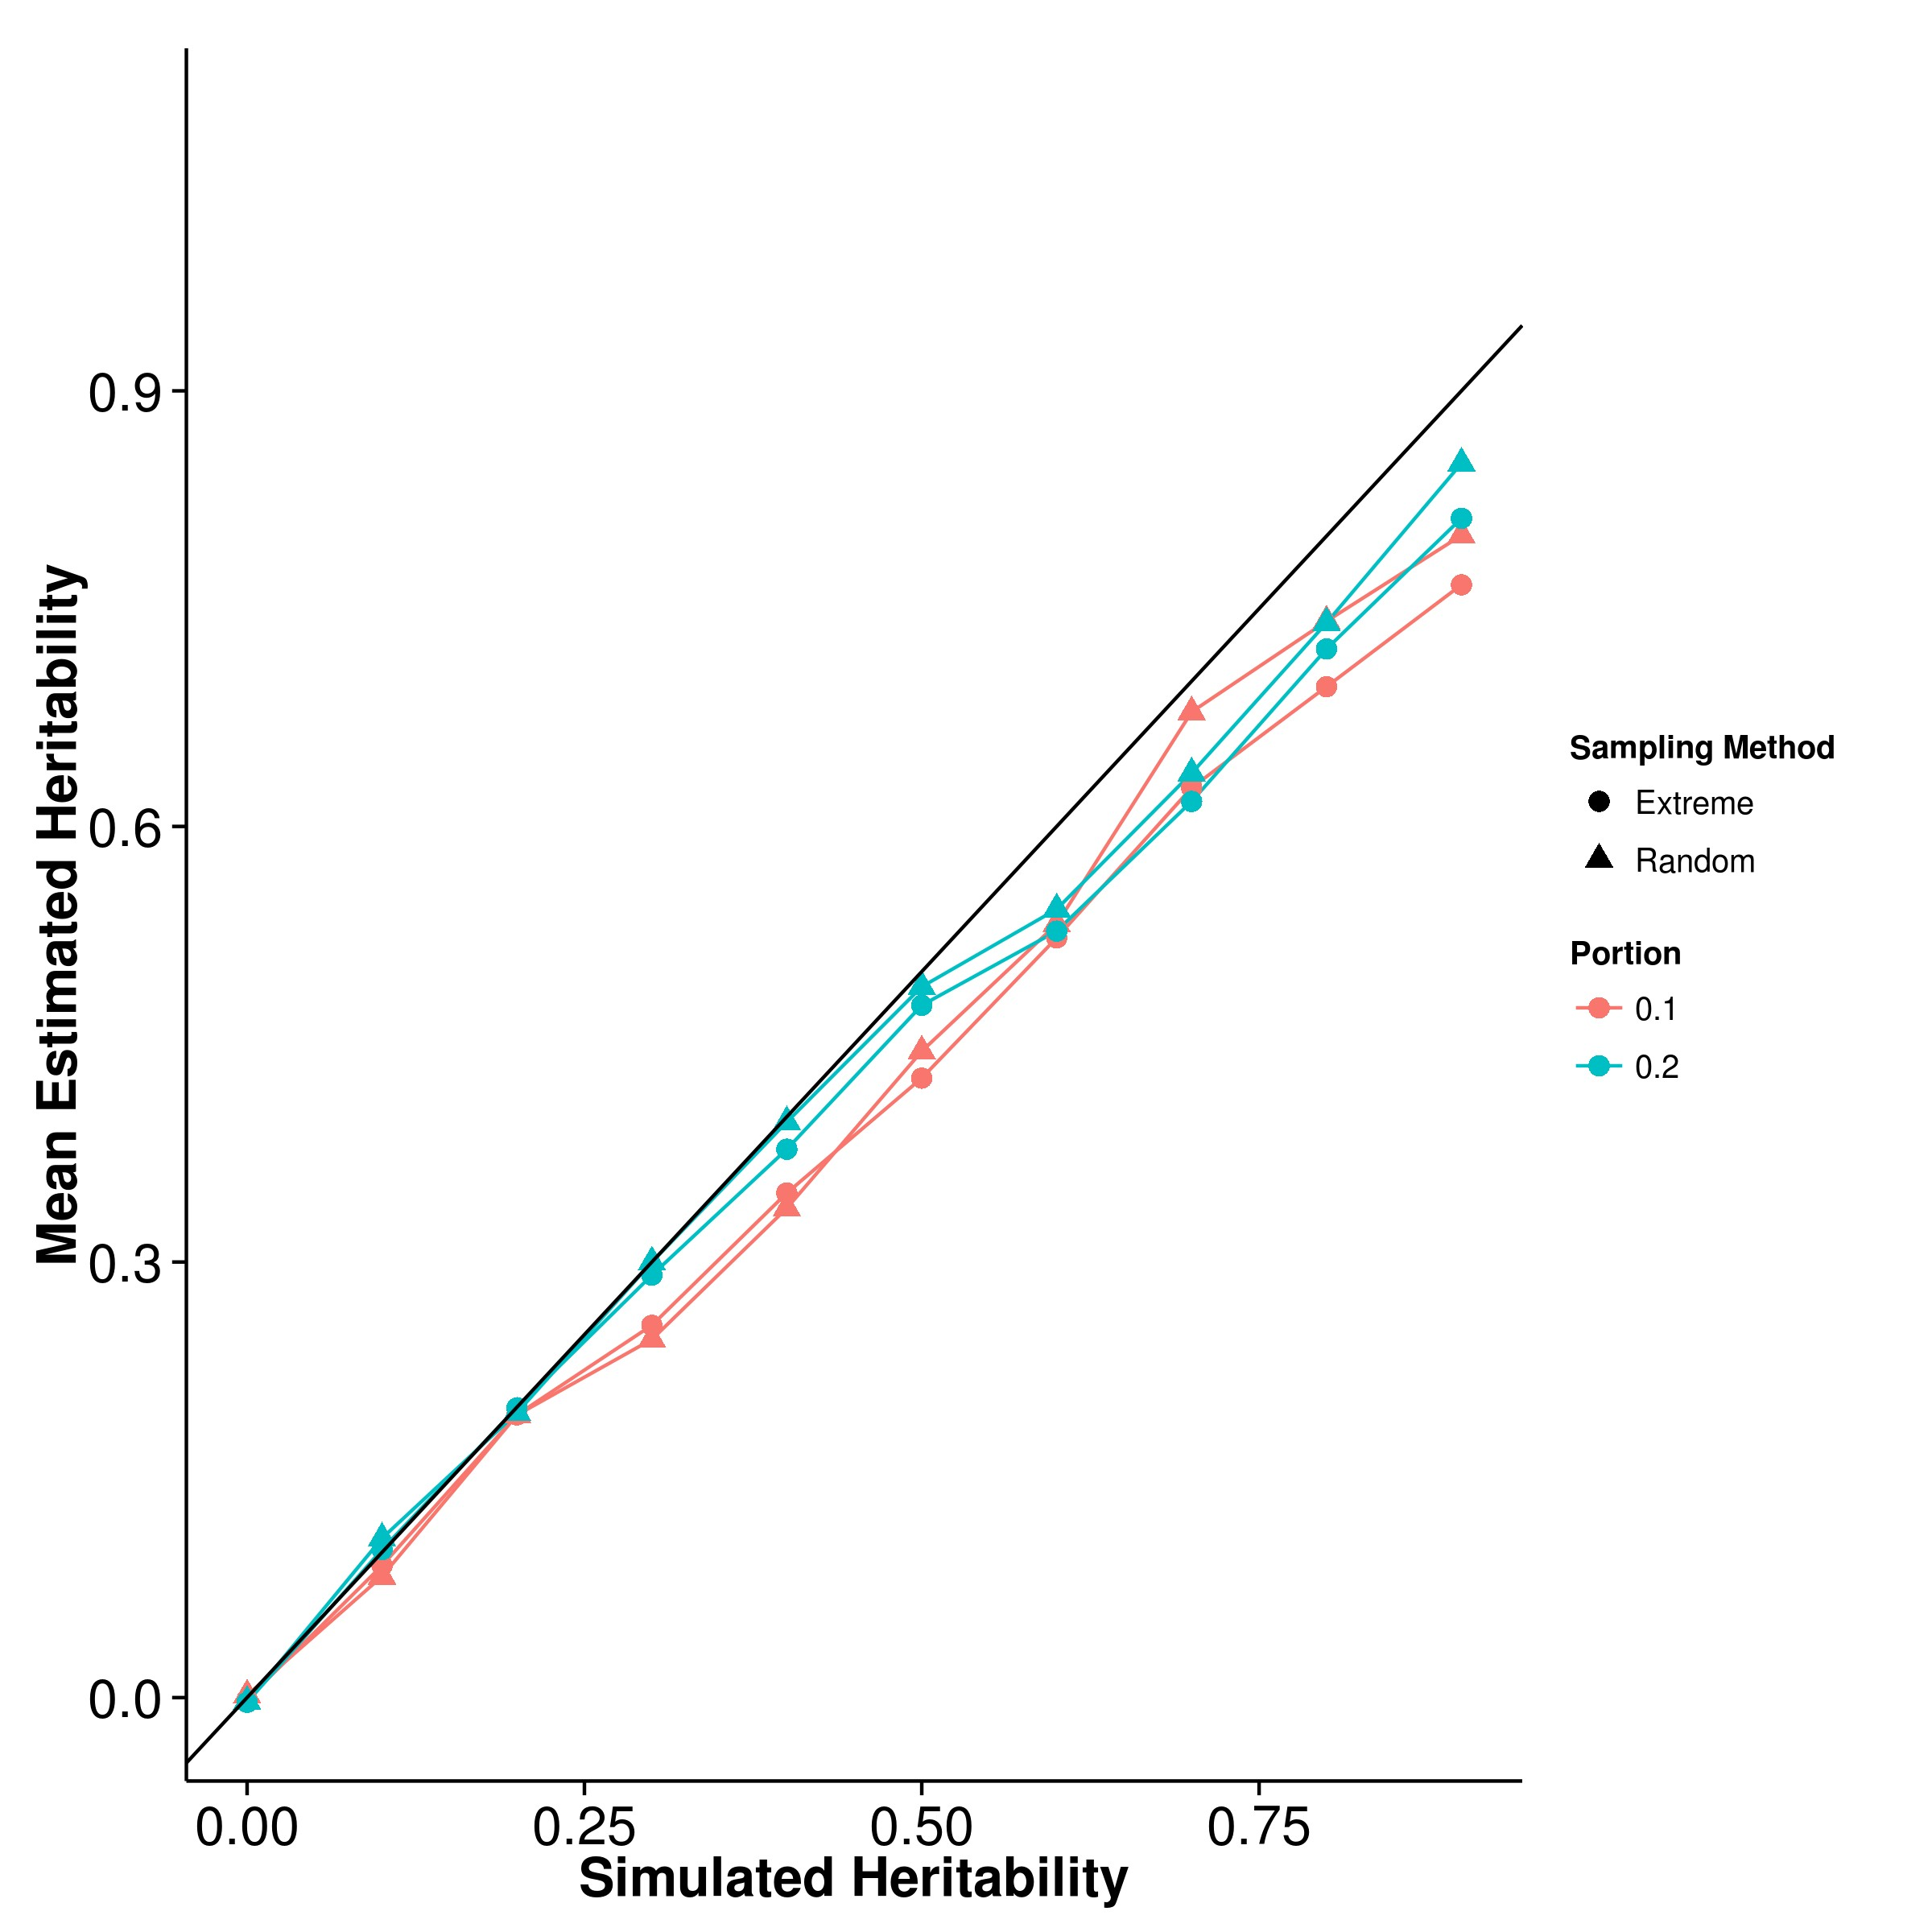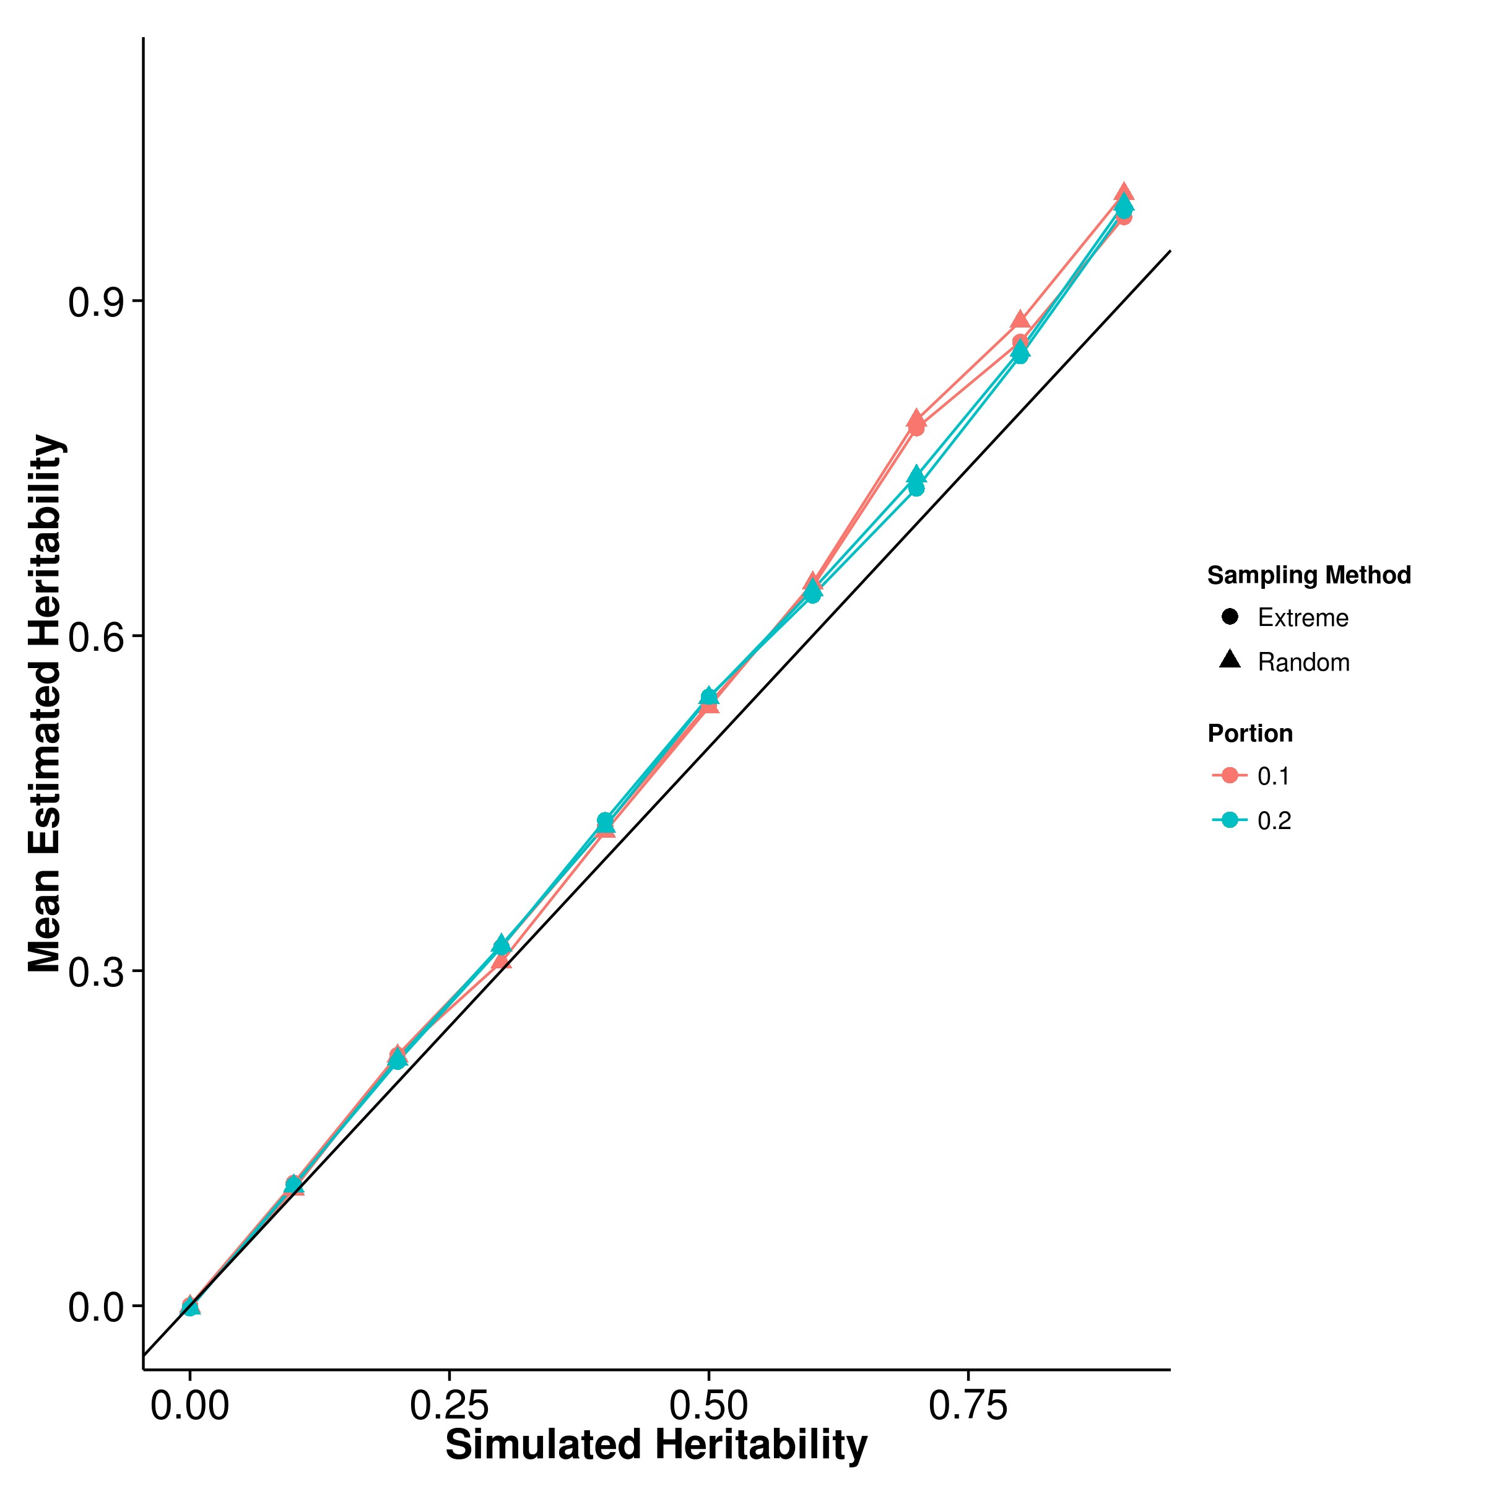

**(c)** LDSC with fix intercept **(d)** LDSC with intercept estimation

**Figure 2.13:** Mean of results from extreme phenotype simulation. The performance of the algorithms when random sampling was performed were similar to what was observed in the quantitative trait simulation. However, when extreme phenotype was performed, a larger under estimation was observed for GCTA and it gets worst when the portion of sample selected decreases. On the other hand, the performance of SHREK and LDSC under the extreme phenotype selection was similar to that from the random samplings.

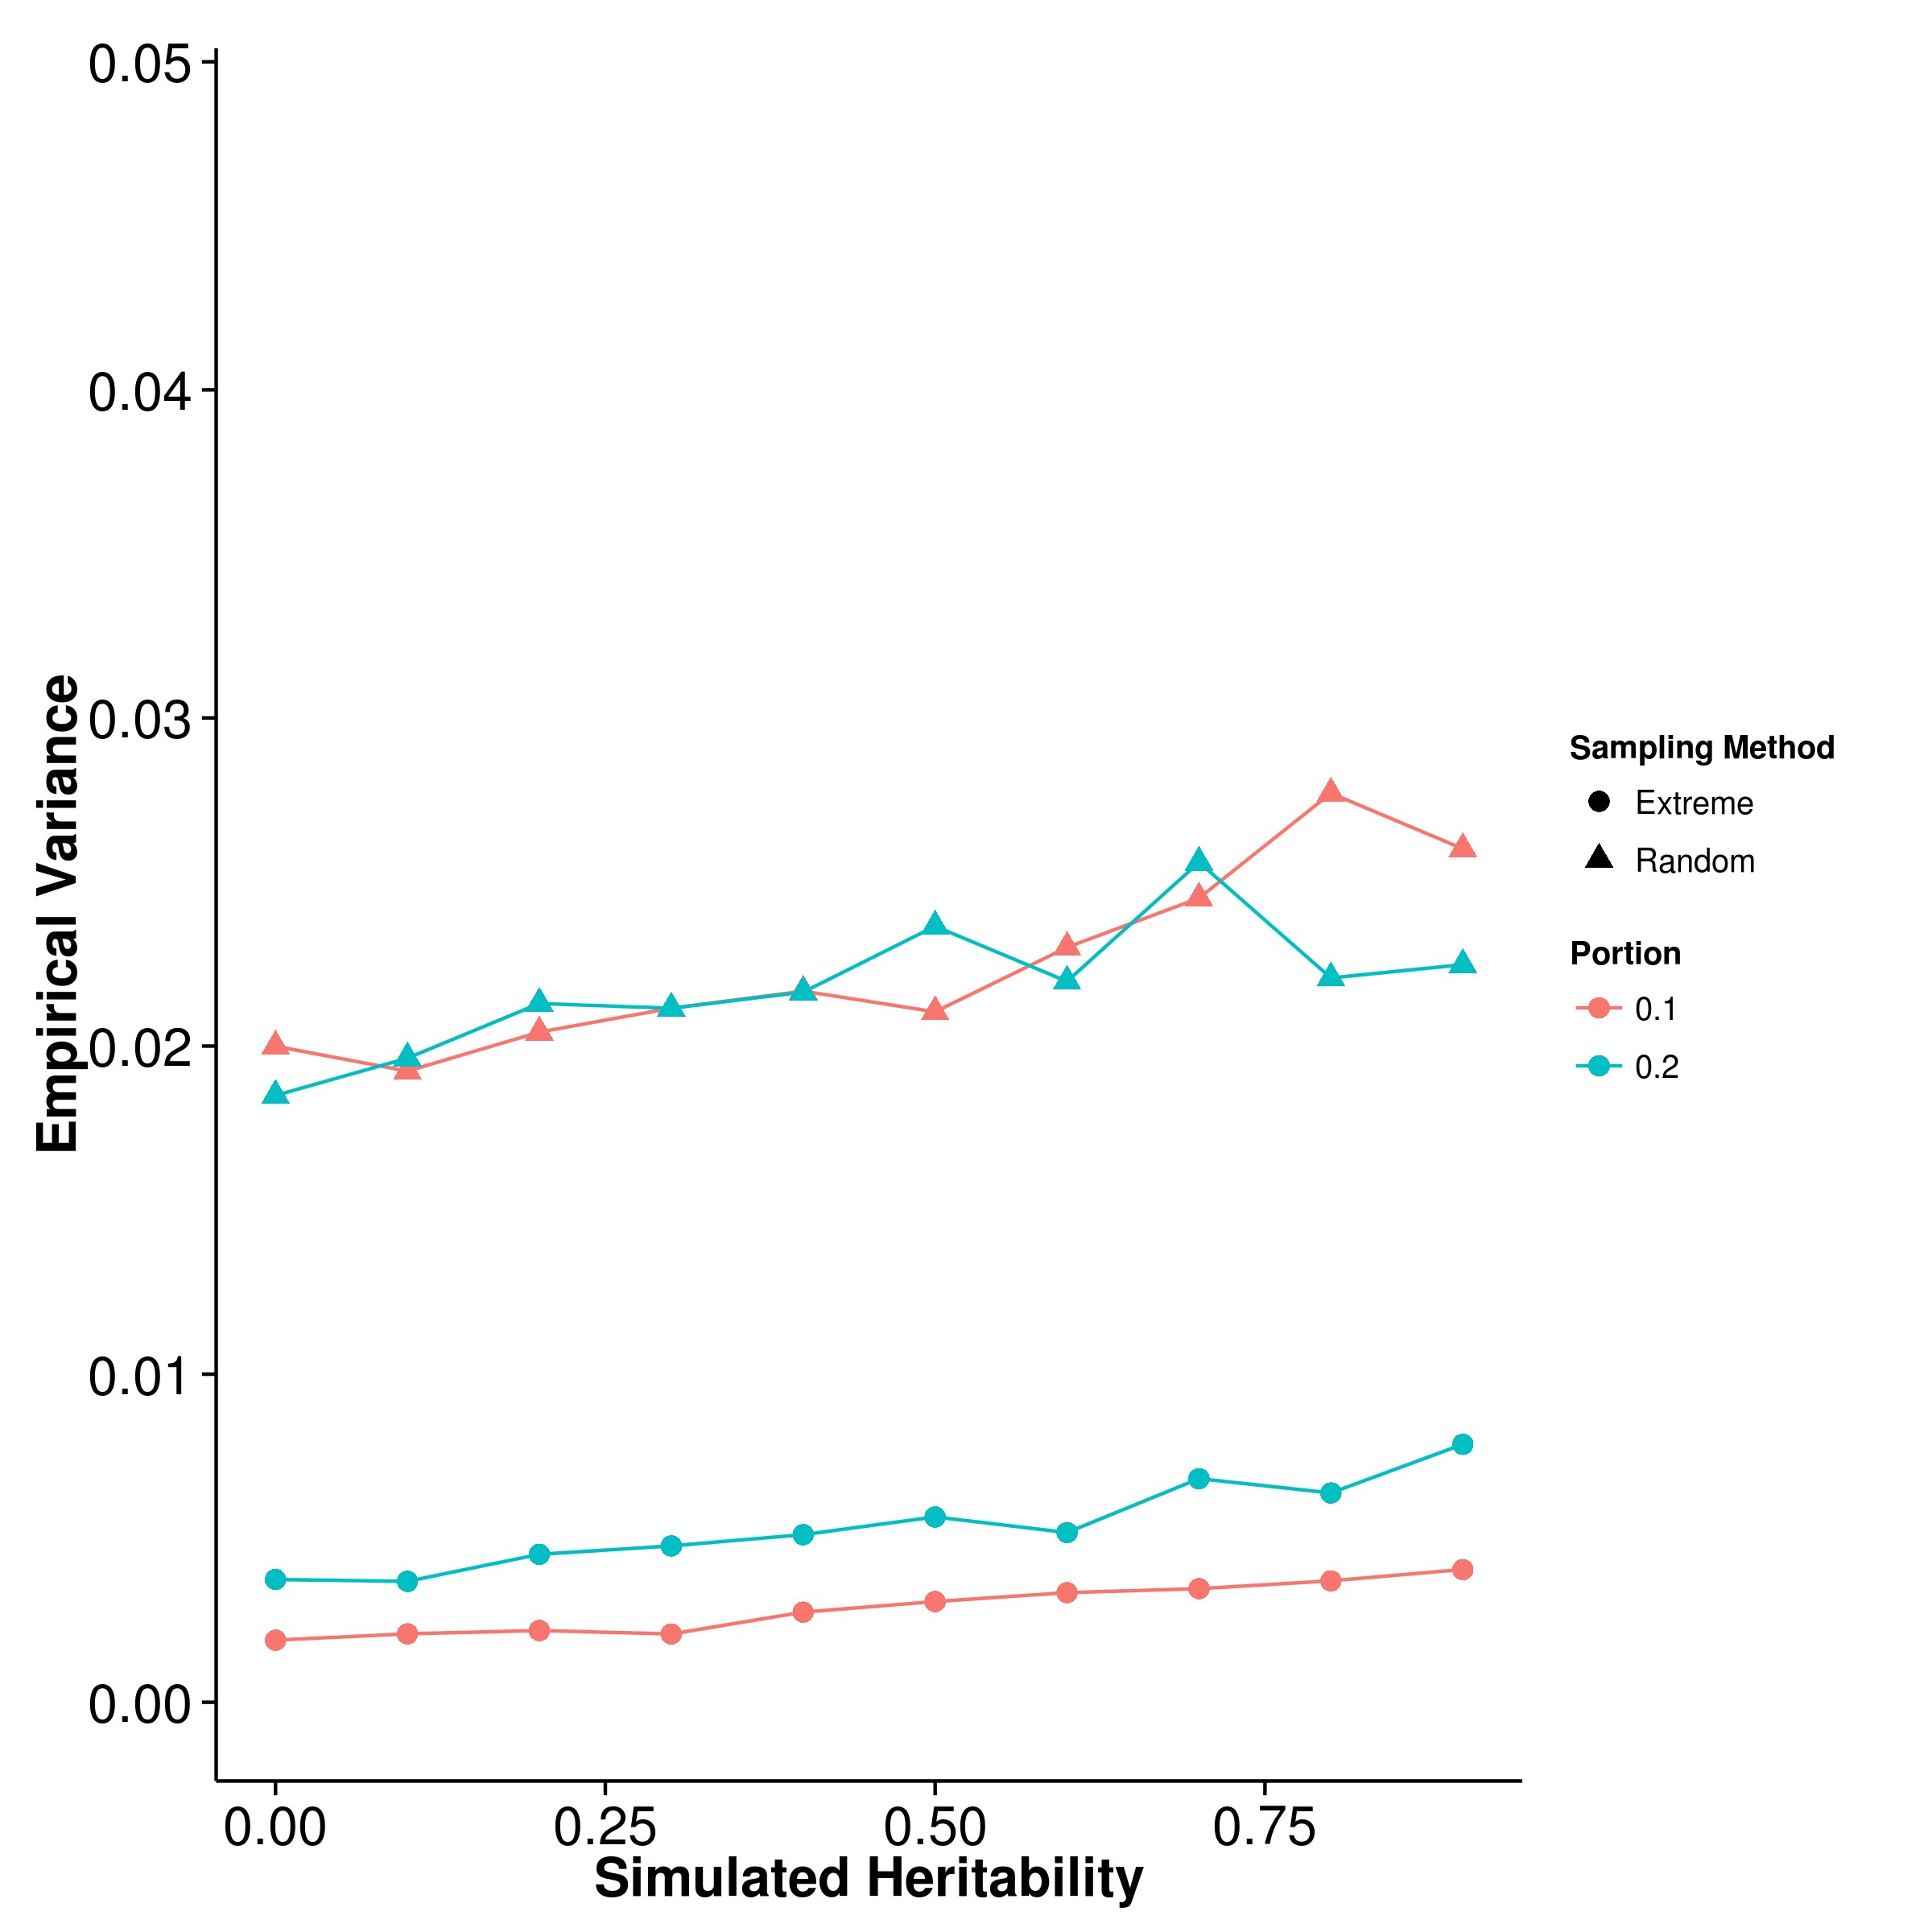

**(a)** SHREK **(b)** GCTA

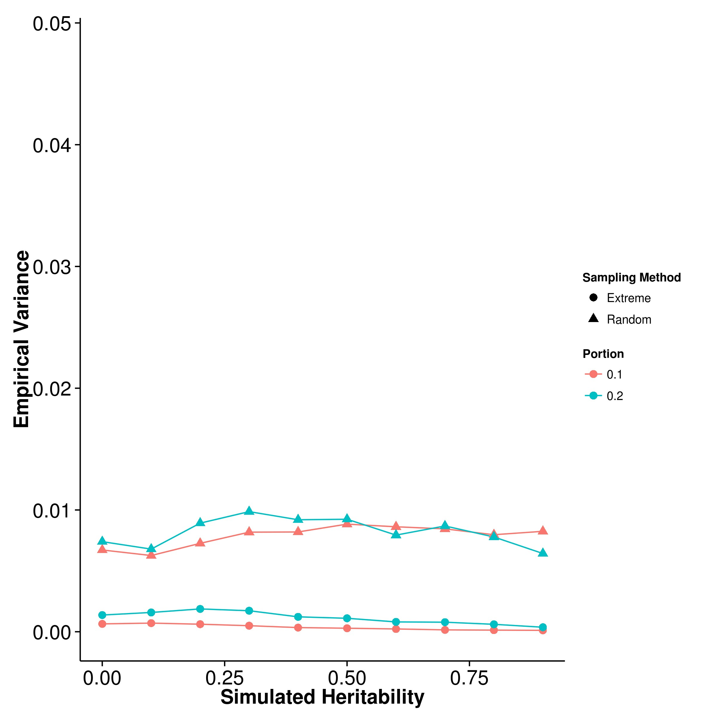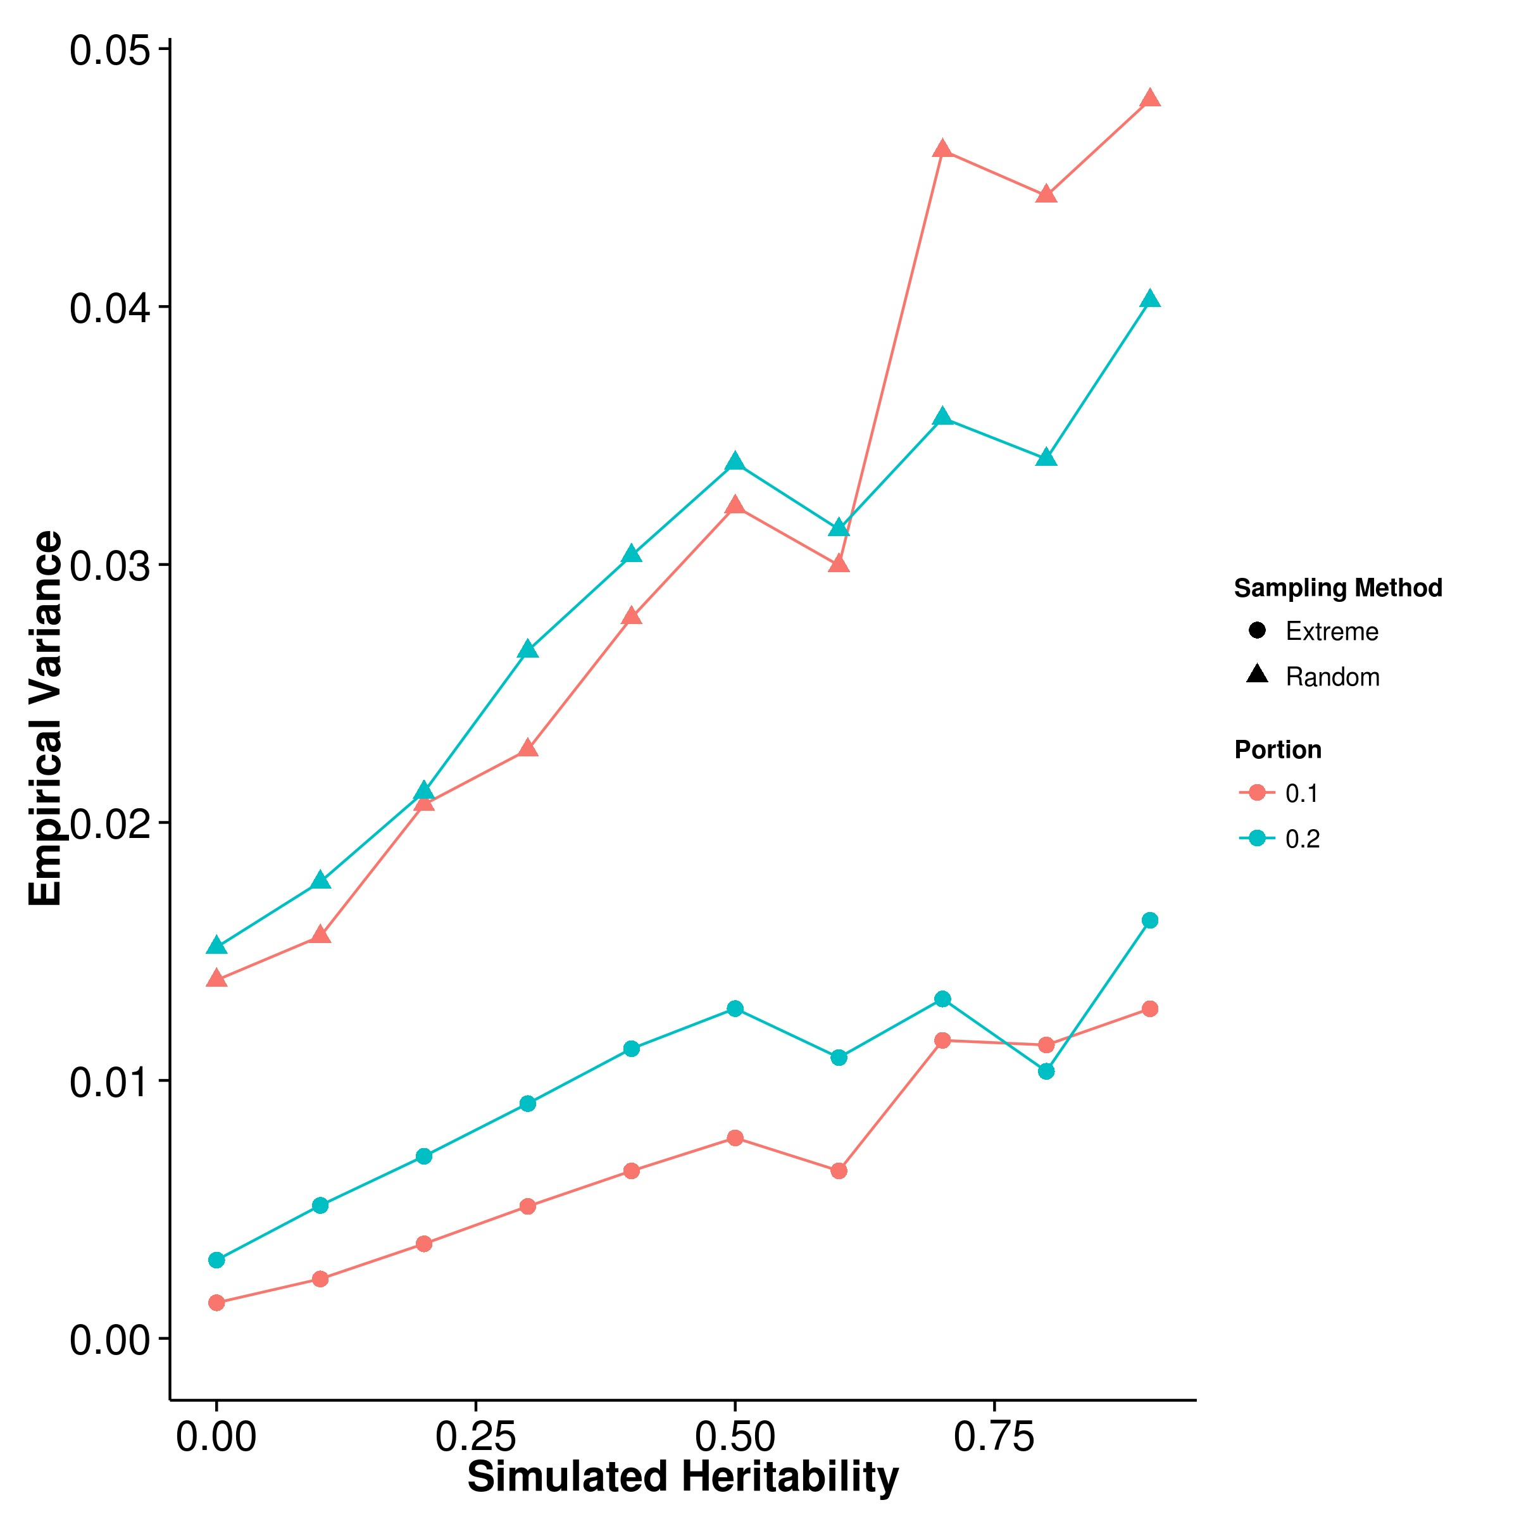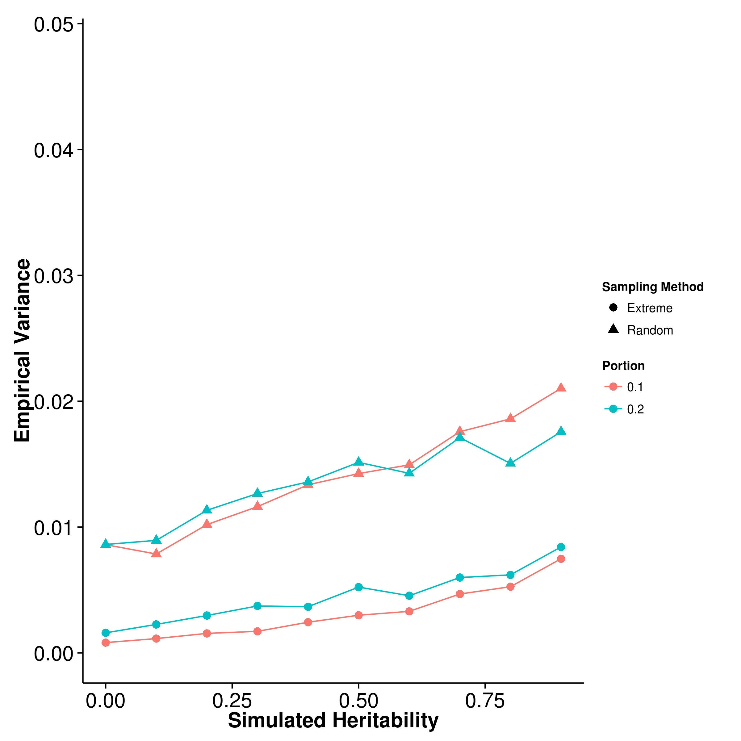

**(c)** LDSC with fix intercept **(d)** LDSC with intercept estimation

**Figure 2.14:** Variance of results from extreme phenotype simulation. It is obvious that when the extreme phenotype selection was performed, the empirical variance of all the algorithm decreases and is much smaller than the empirical variance of the estimation when random sampling was performed. We also compared the empirical variance of random sampling with those from quantitative trait simulation with 100 causal SNPs and they are highly similar.

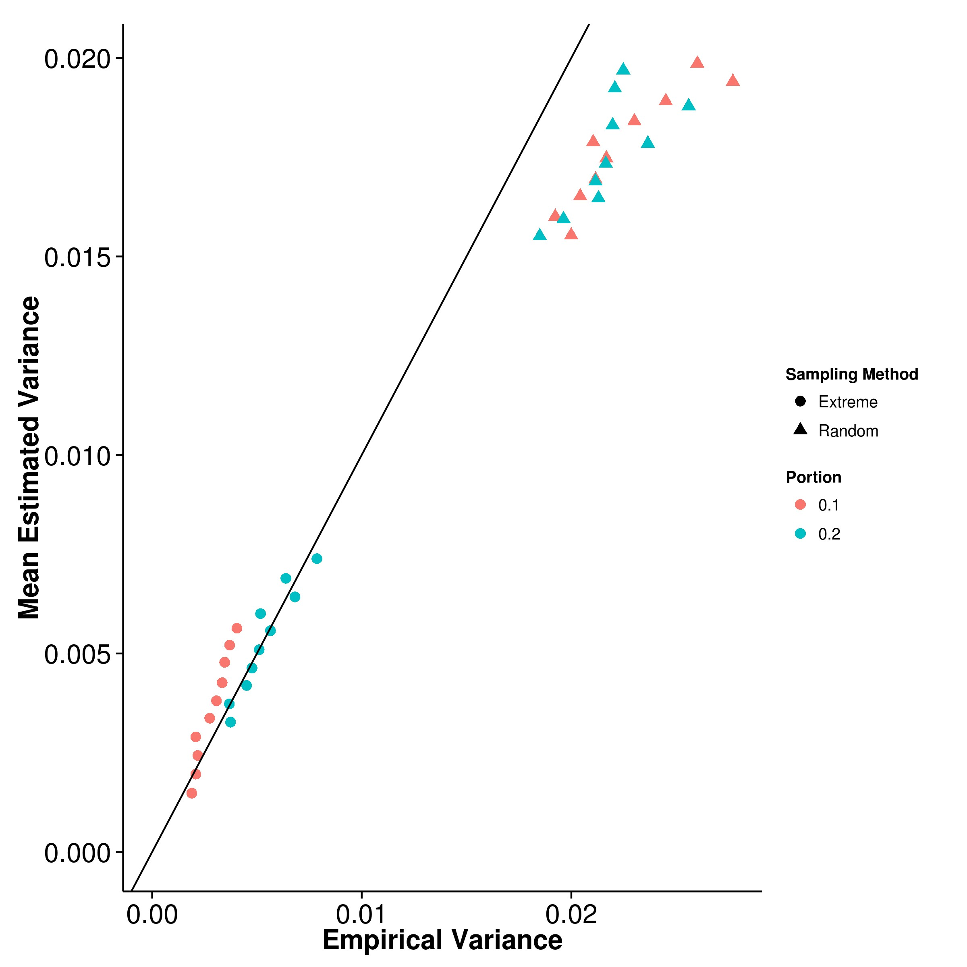

**(a)** SHREK **(b)** GCTA

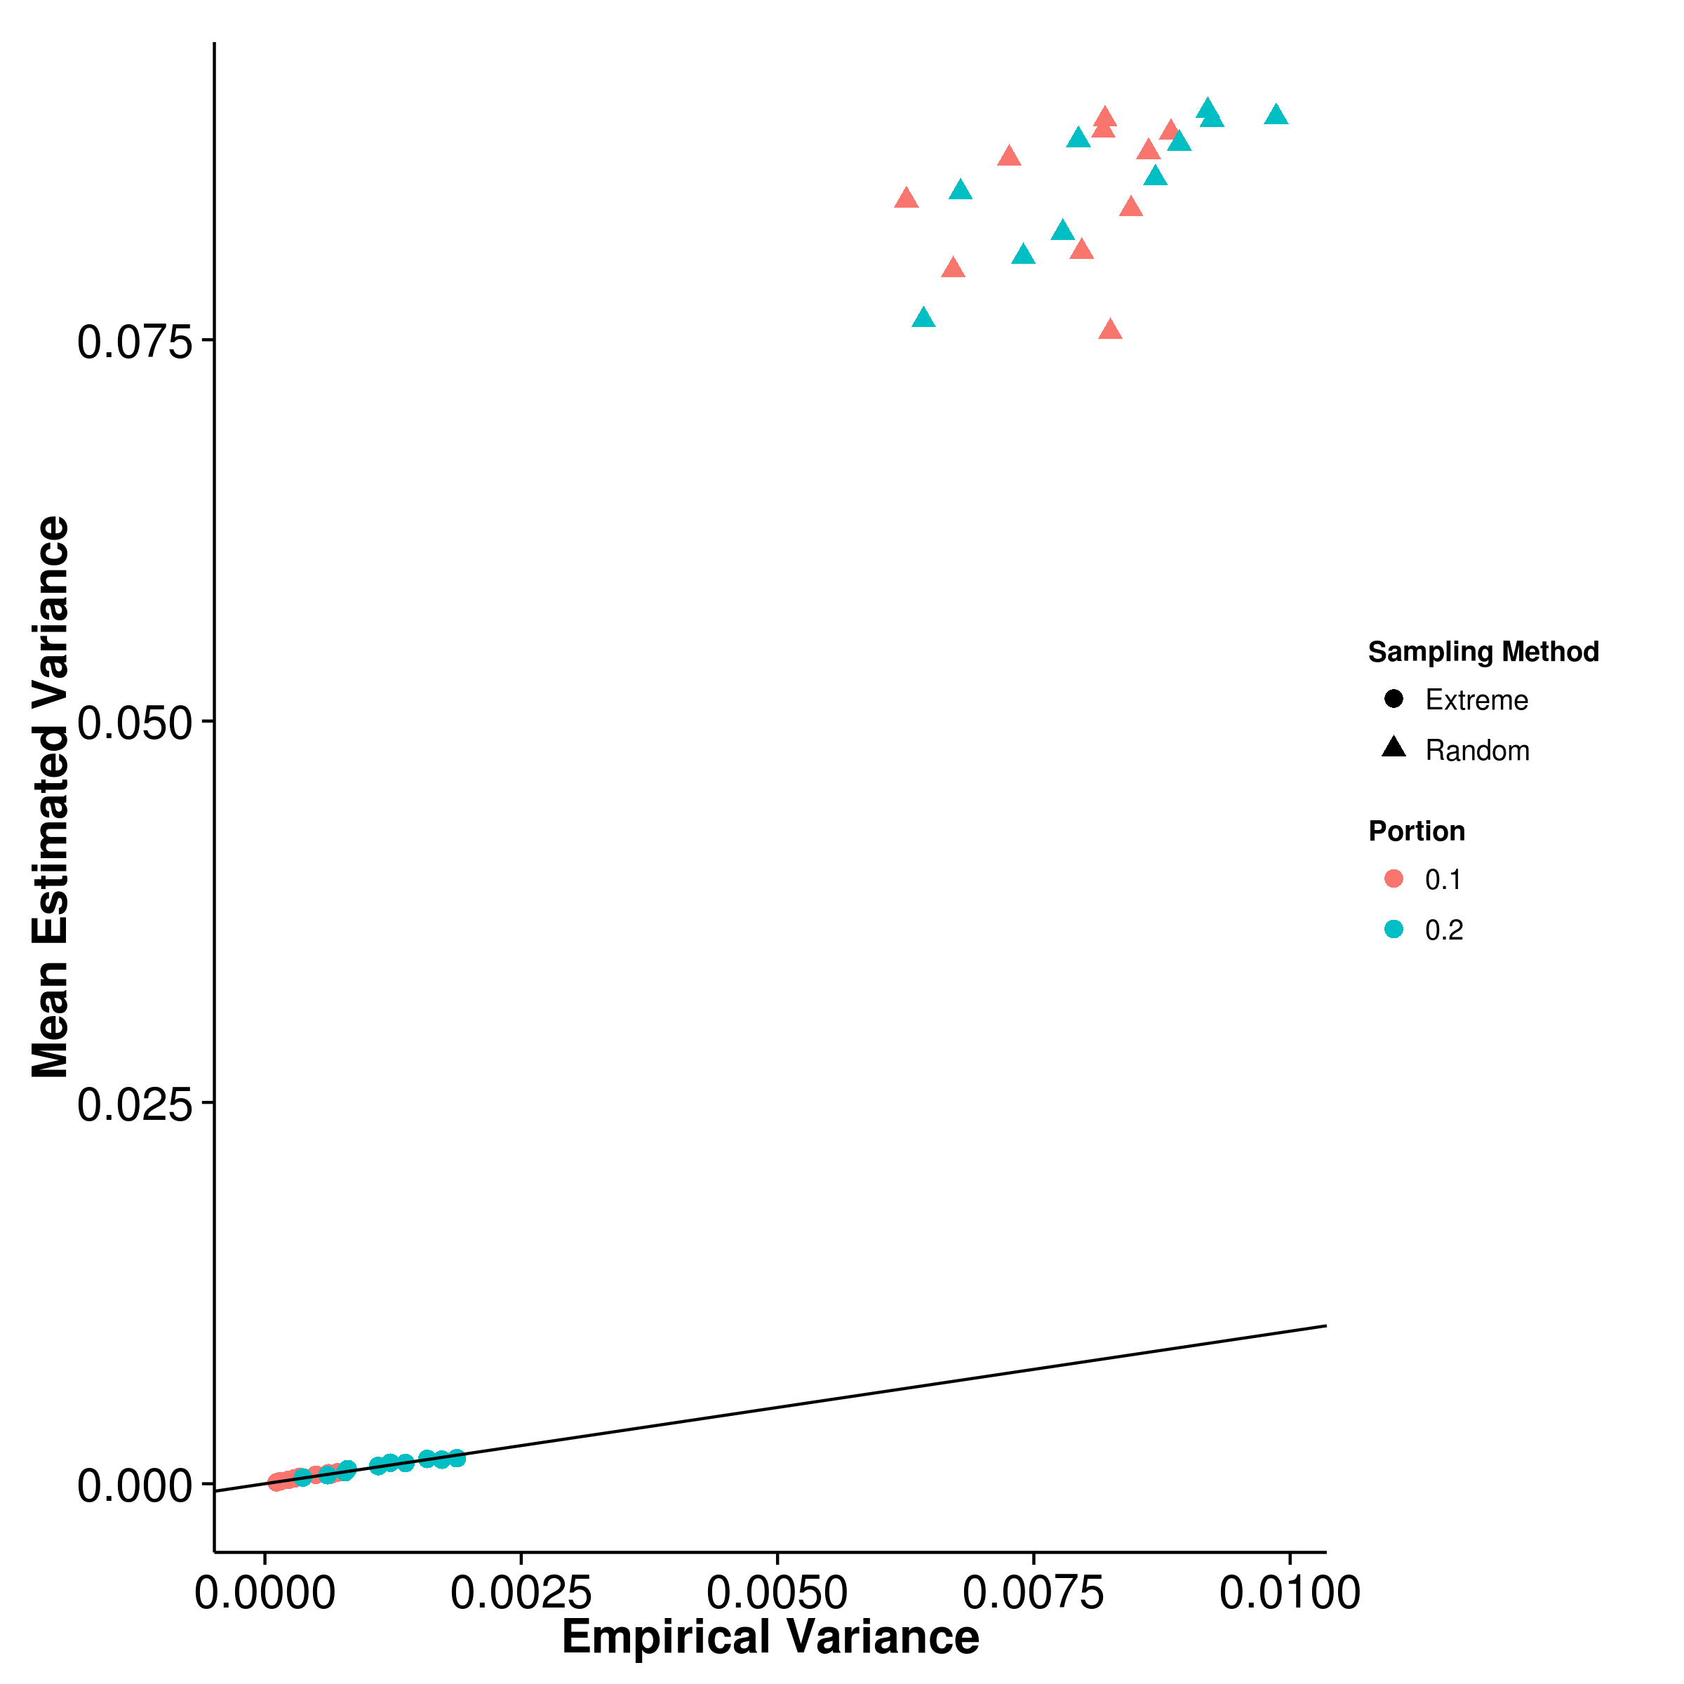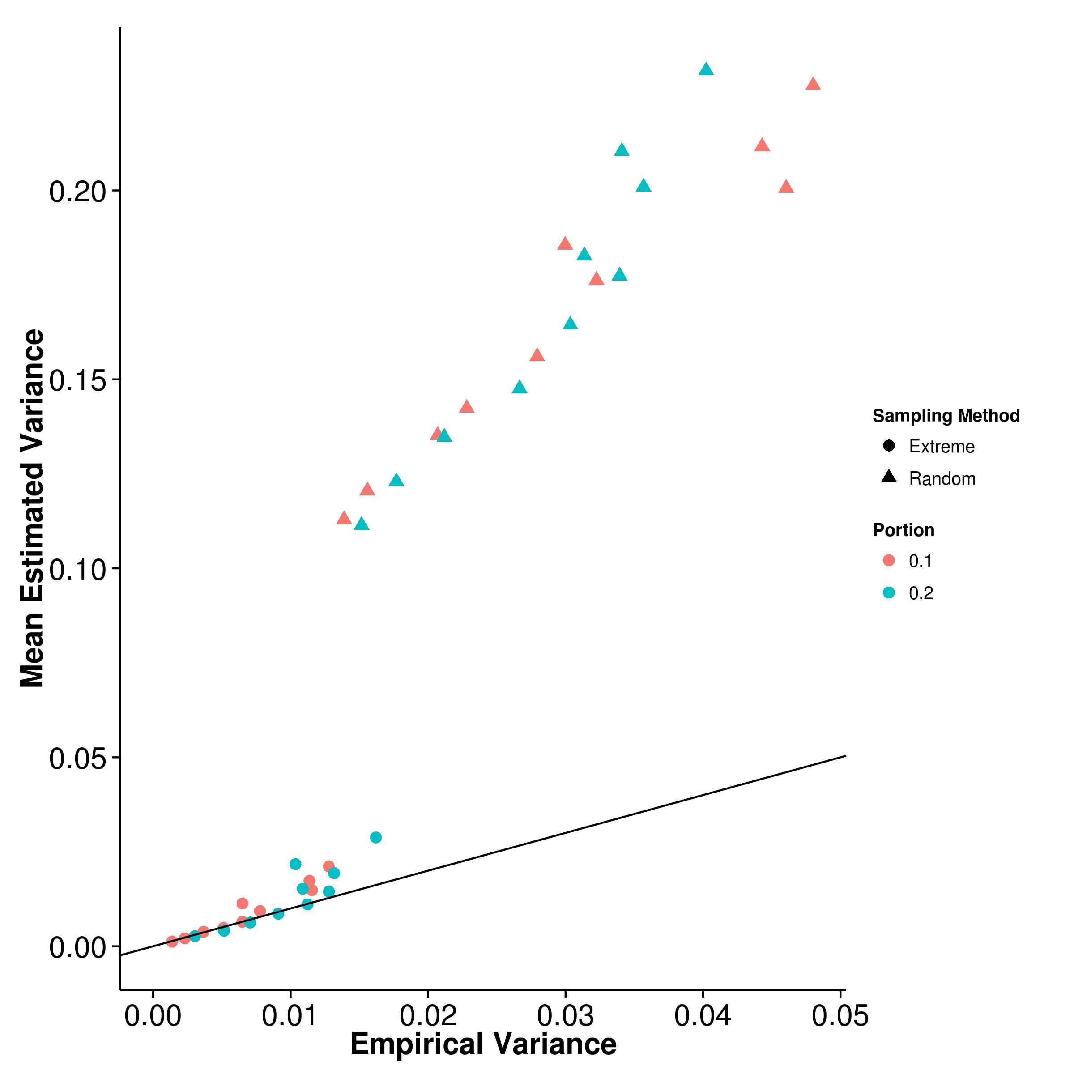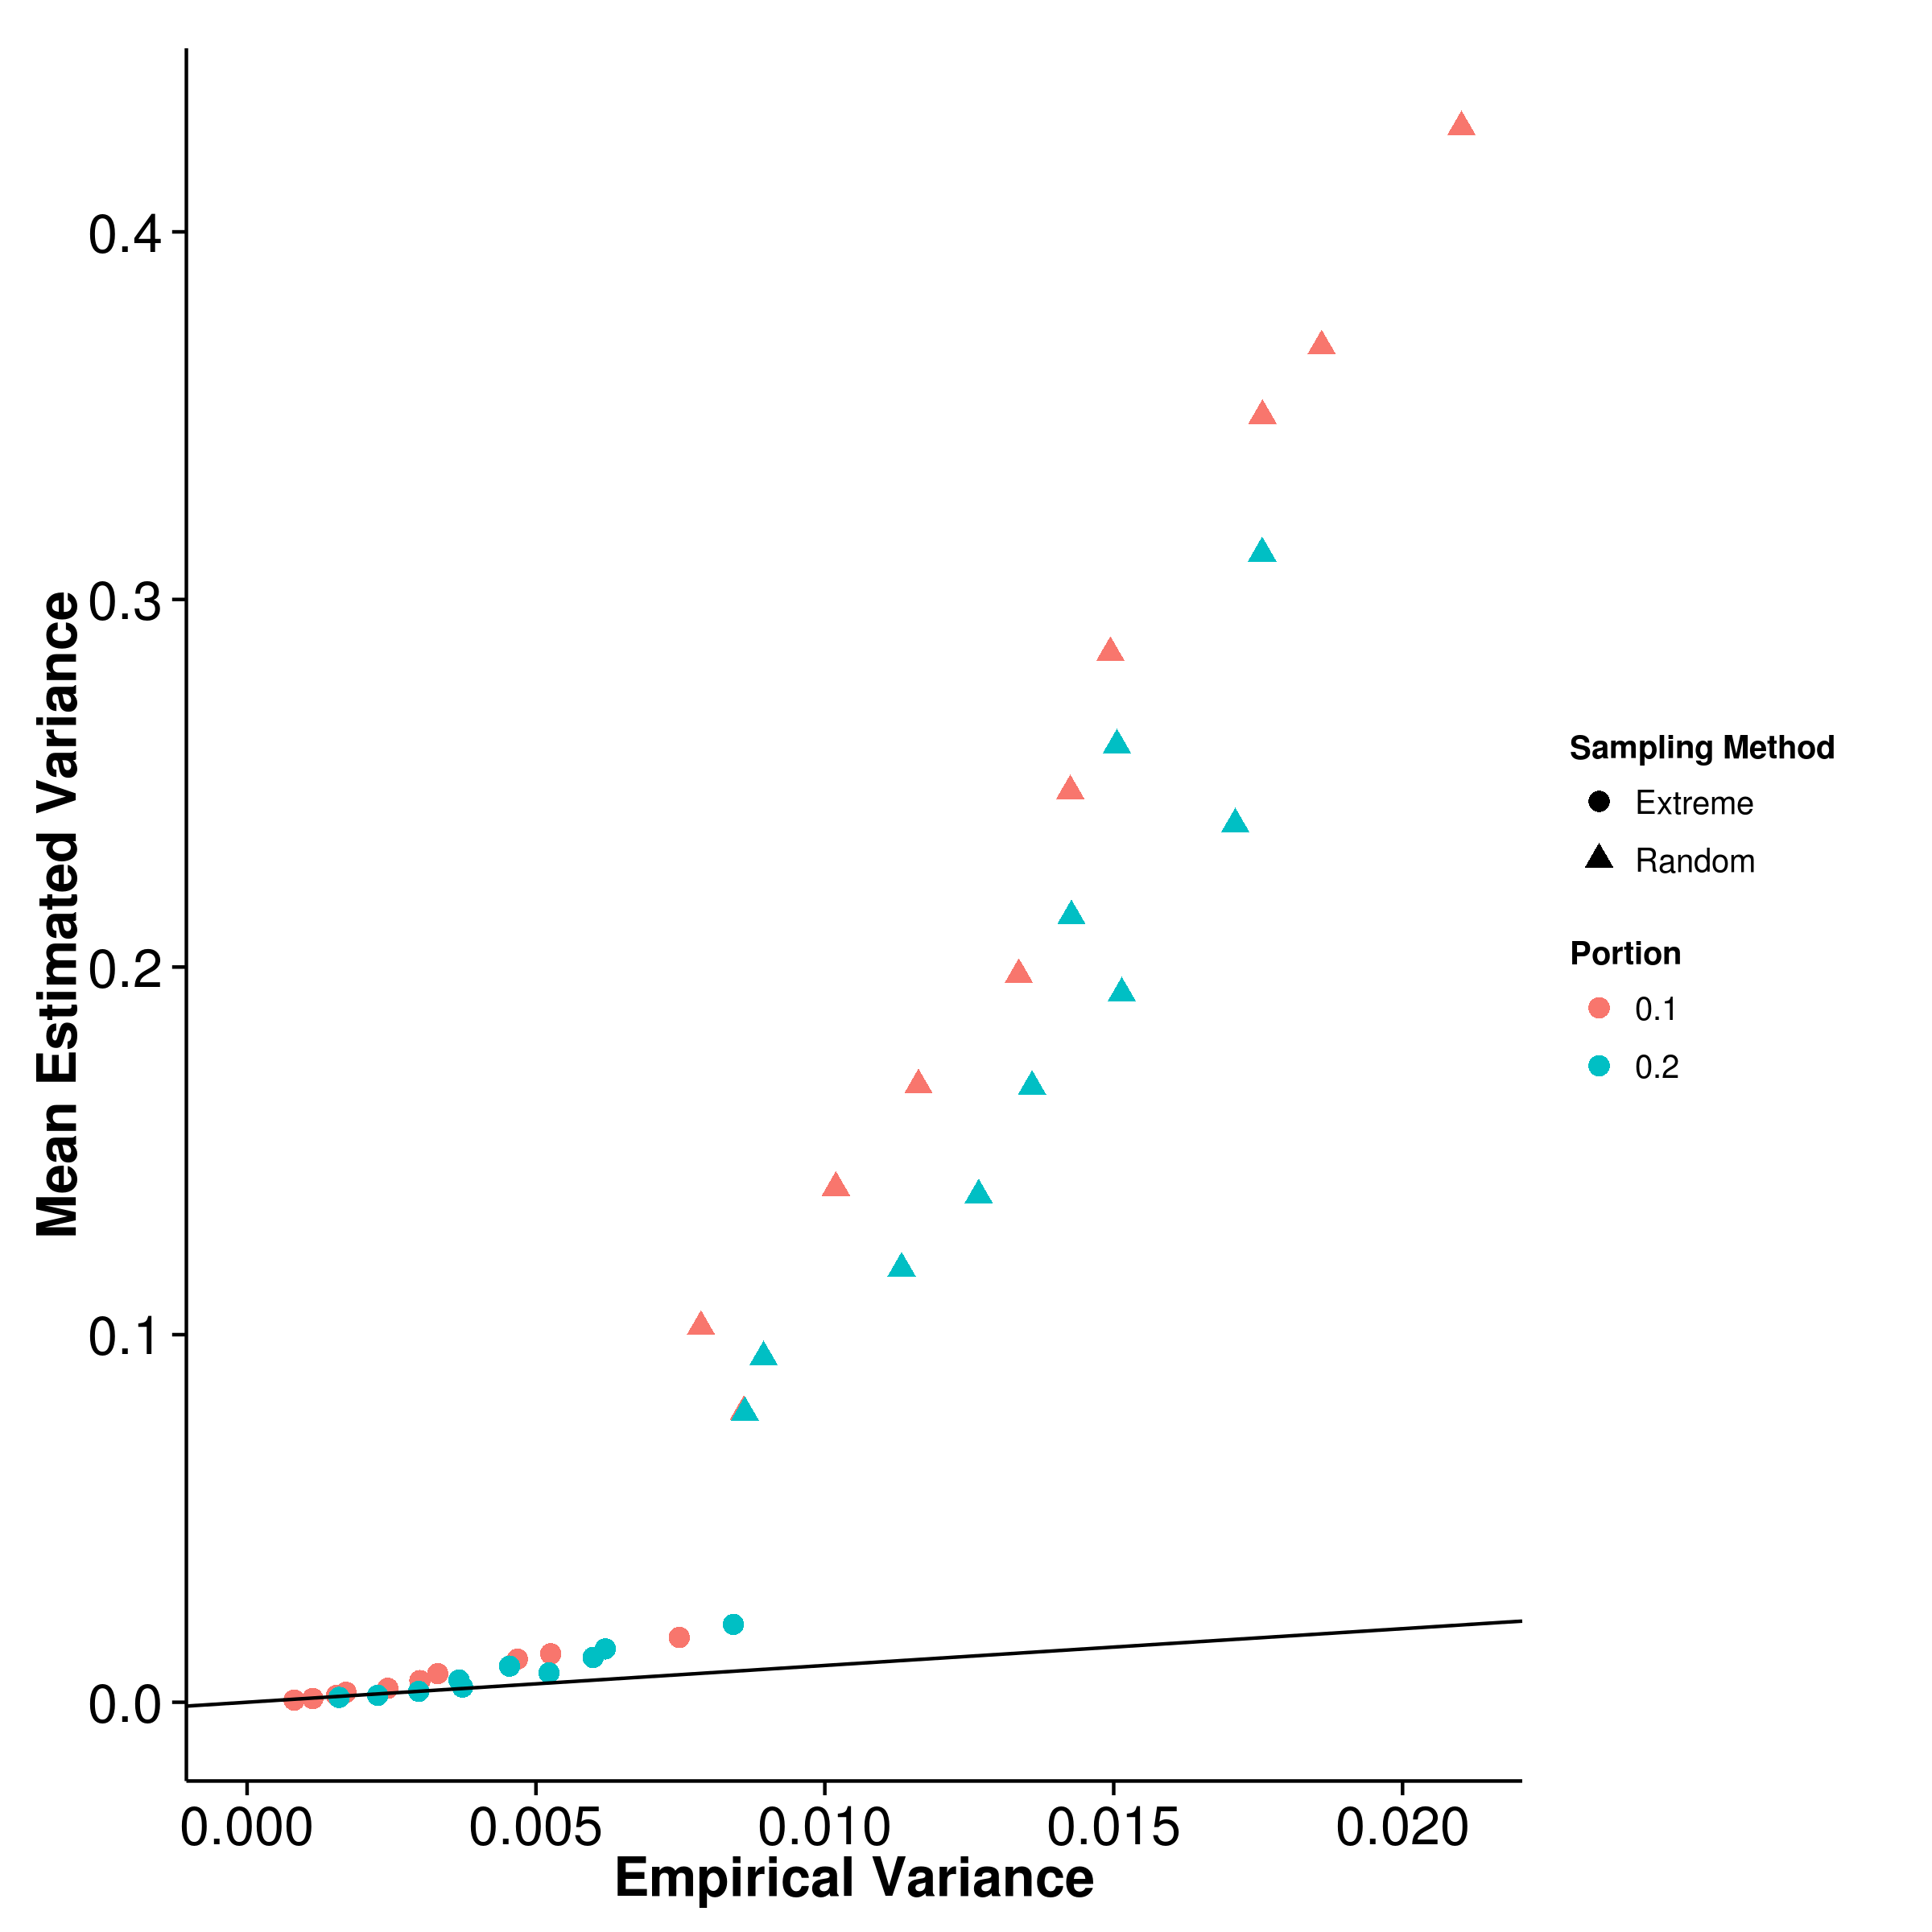

**(c)** LDSC with fix intercept **(d)** LDSC with intercept estimation

**Figure 2.15:** Estimated variance of results from extreme phenotype selection when compared to empirical variance. Surprisingly, except for SHREK, the estimated variance from LDSC and GCTA under the random sampling condition was much higher than the empirical variance. It is much different from the estimated variance from the quantitative trait simulation and further investigations are required to understand this discrepancy.

Portion

Shrek LDSC LDSC-In GCTA Extreme Rand Extreme Rand Extreme Rand Extreme Rand

|  |  |  |  |  |  |  |  |  |
| --- | --- | --- | --- | --- | --- | --- | --- | --- |
| 0.1 | 0.0113 | 0.0341 | 0.00537 | 0.0167 | 0.0119 | 0.0329 | 0.0644 | 0.00849 |
| 0.2 | 0.0109 | 0.0290 | 0.00599 | 0.0152 | 0.0126 | 0.0299 | 0.0274 | 0.00852 |

**Table 2.4:** Here, we compared the MSE of random sampling (Rand) against the MSE of Extreme phenotype sampling (Extreme). With the exception of GCTA, the extreme phenotype selection generally produce a smaller MSE when compared to random sampling. However, for GCTA, because of the large bias introduced by extreme phenotype sampling (fig. 2.13b), the MSE is much higher when extreme phenotype sampling was performed.

When comparing the empirical variance, the random sampling strategy consistently result in larger variance when compared to extreme phenotype sampling strategy (table 2.4). The MSE from extreme phenotype sampling can be as much as 4 fold smaller for SHREK and LDSC when compared to random sampling.

Strangely, although the empirical variance under the random sampling strategy is the same as what was observed in the quantitative trait simulation, there was a large discrepancy in the estimated variance where a tenfold overestimation was observed for LDSC and GCTA (fig. 2.15). More surprisingly, SHREK was unaffected. We are uncertain of the origin of such problem and further investigations are required.

|  |  |  |  |
| --- | --- | --- | --- |
|  | Major Depression Disorder | Bipolar | Schizophrenia |
| SHREK | 0.256 (0.0273) | 0.312 (0.0168) | 0.174 (0.00453) |
| LDSC | 0.161 (0.0317) | 0.185 (0.0211) | 0.133 (0.0071) |

**Table 2.5:** Heritability estimated for Polygenic Risk Score (PGS) data sets. The heritability estimation form SHREK tends to be higher than that from LDSC. One major difference between LDSC and SHREK is that LDSC can remove confounding factors such as population stratifications from their estimation using the intercept estimation function. If there is any confounding factors, they can possibly inflate the estimates from SHREK

**2.6.4 Application to Real Data**

We applied our method and LDSC to the PGC SCZ, major depression disorder, autism and bipolar data sets. To adjust for the confounding factors, intercept estimation were performed for LDSC.

It was estimated that the heritability for major depression disorder is around 0.256 by SHREK and 0.161 by LDSC whereas the heritability of bipolar was estimated to be around 0.312 by SHREK and 0.185 by LDSC (table 2.5). As for schizophrenia, the heritability was estimated to be around 0.133 by LDSC and 0.174 by SHREK. The estimated intercept from LDSC for bipolar and major depression was 1.06 and 1.026 respectively suggesting there is little confounding factors. On the other hand, the estimated intercept was around 1.21 for schizophrenia, suggesting there might be small amount of confounding effect in the estimation. Indeed, in PGC schizophrenia study (Stephan Ripke, B. M. Neale, et al., 2014), a small amount of Asian samples were included. As SHREK doesn’t adjust for the population stratification, caution must be paid when interpreting the results.

**2.7 Discussion**

In order to study complex disorders such as that of schizophrenia, large amount of samples are required and often it is not possible for one single group of researchers to collect sufficient samples. Therefore, collaboration and large scale consortium becomes vital and it make possible for sufficient sample size to be collected. However, due to privacy concerns, the raw genotypes of the participants were usually not shared amount groups or that the genotype is only provided through a tedious and lengthy application process (e.g. dbGaP). Thus these large scale studies relies on the meta analysis and only the summary statistics of the final analysis were provided to the public.

Traditional SNP heritability estimation algorithms for GWAS such as GCTA and Phenotype correlation - genotype correlation regression (PCGC) relies on the genetic relationship matrix which can only be calculated based on the genotypes of the subjects. Not until the development of LDSC and SHREK was there a way to estimates the SNP heritability without the raw genotypes. By being able to estimate the SNP heritability from only the summary statistic from a GWAS, one can now actively compare the difference between the heritability estimated from twin studies and the SNP heritability estimated from GWAS to estimate the relative contribution of SNPs to the disease variance without requiring the raw data.

Despite the promise of LDSC and SHREK, their developments were far from completion. For example, a big issue observed in our simulation was the influence of the sampling bias of the LD which is one of the key element required for LDSC and SHREK.

**2.7.1 LD Correction**

It was known that the LD contains sampling bias and the sample R2 is usually bigger than the true R2. Therefore it is important for one to adjust for the sampling bias before applying them in the estimation of heritability.

When comparing impact of different bias correction algorithm on the performance of SHREK, it was observed that majority of the algorithms, except that of eq. (2.39), inflates the heritability estimated, suggesting that there was an overestimation, whereas when the sampling bias left uncorrected, the estimates were biased downward, as one would expect. The superior performance of eq. (2.39) leads us to use it as our default LD sampling bias correction algorithm.

What was surprising was that in the quantitative trait simulation, an overestimation of heritability was observed despite using eq. (2.39) for LD correction. This overestimation was similar to what was observed in the previous LD correction simulations where 5,000 SNPs on chromosome 22 were simulated. It is possible that despite the superior performance of eq. (2.39), small imprecisions were still introduced to the LD matrix during the bias correction. When the number of SNPs increases, these imprecisions cumulates, thus leads to bias in the final heritability estimates.

Interestingly the same overestimation was not observed in LDSC. When inspecting the algorithm of LDSC, it was observed that LDSC also correct for the sampling bias in R2 using:



which was not tested in our previous LD correction simulation.

An interesting analysis will be to test the performance of the LD correction algorithm when the number of SNPs is higher (e.g 50,000 SNPs on chromosome 1) and whether if eq. (2.43) produce a better results. We therefore repeated the LD correction simulation by increasing the number of simulated SNPs to 50,000 on chromosome 1. To reduce the run time of the simulation, we only compared the performance of SHREK when eq. (2.43), eq. (2.39) and eq. (2.37) were used for the LD correction.

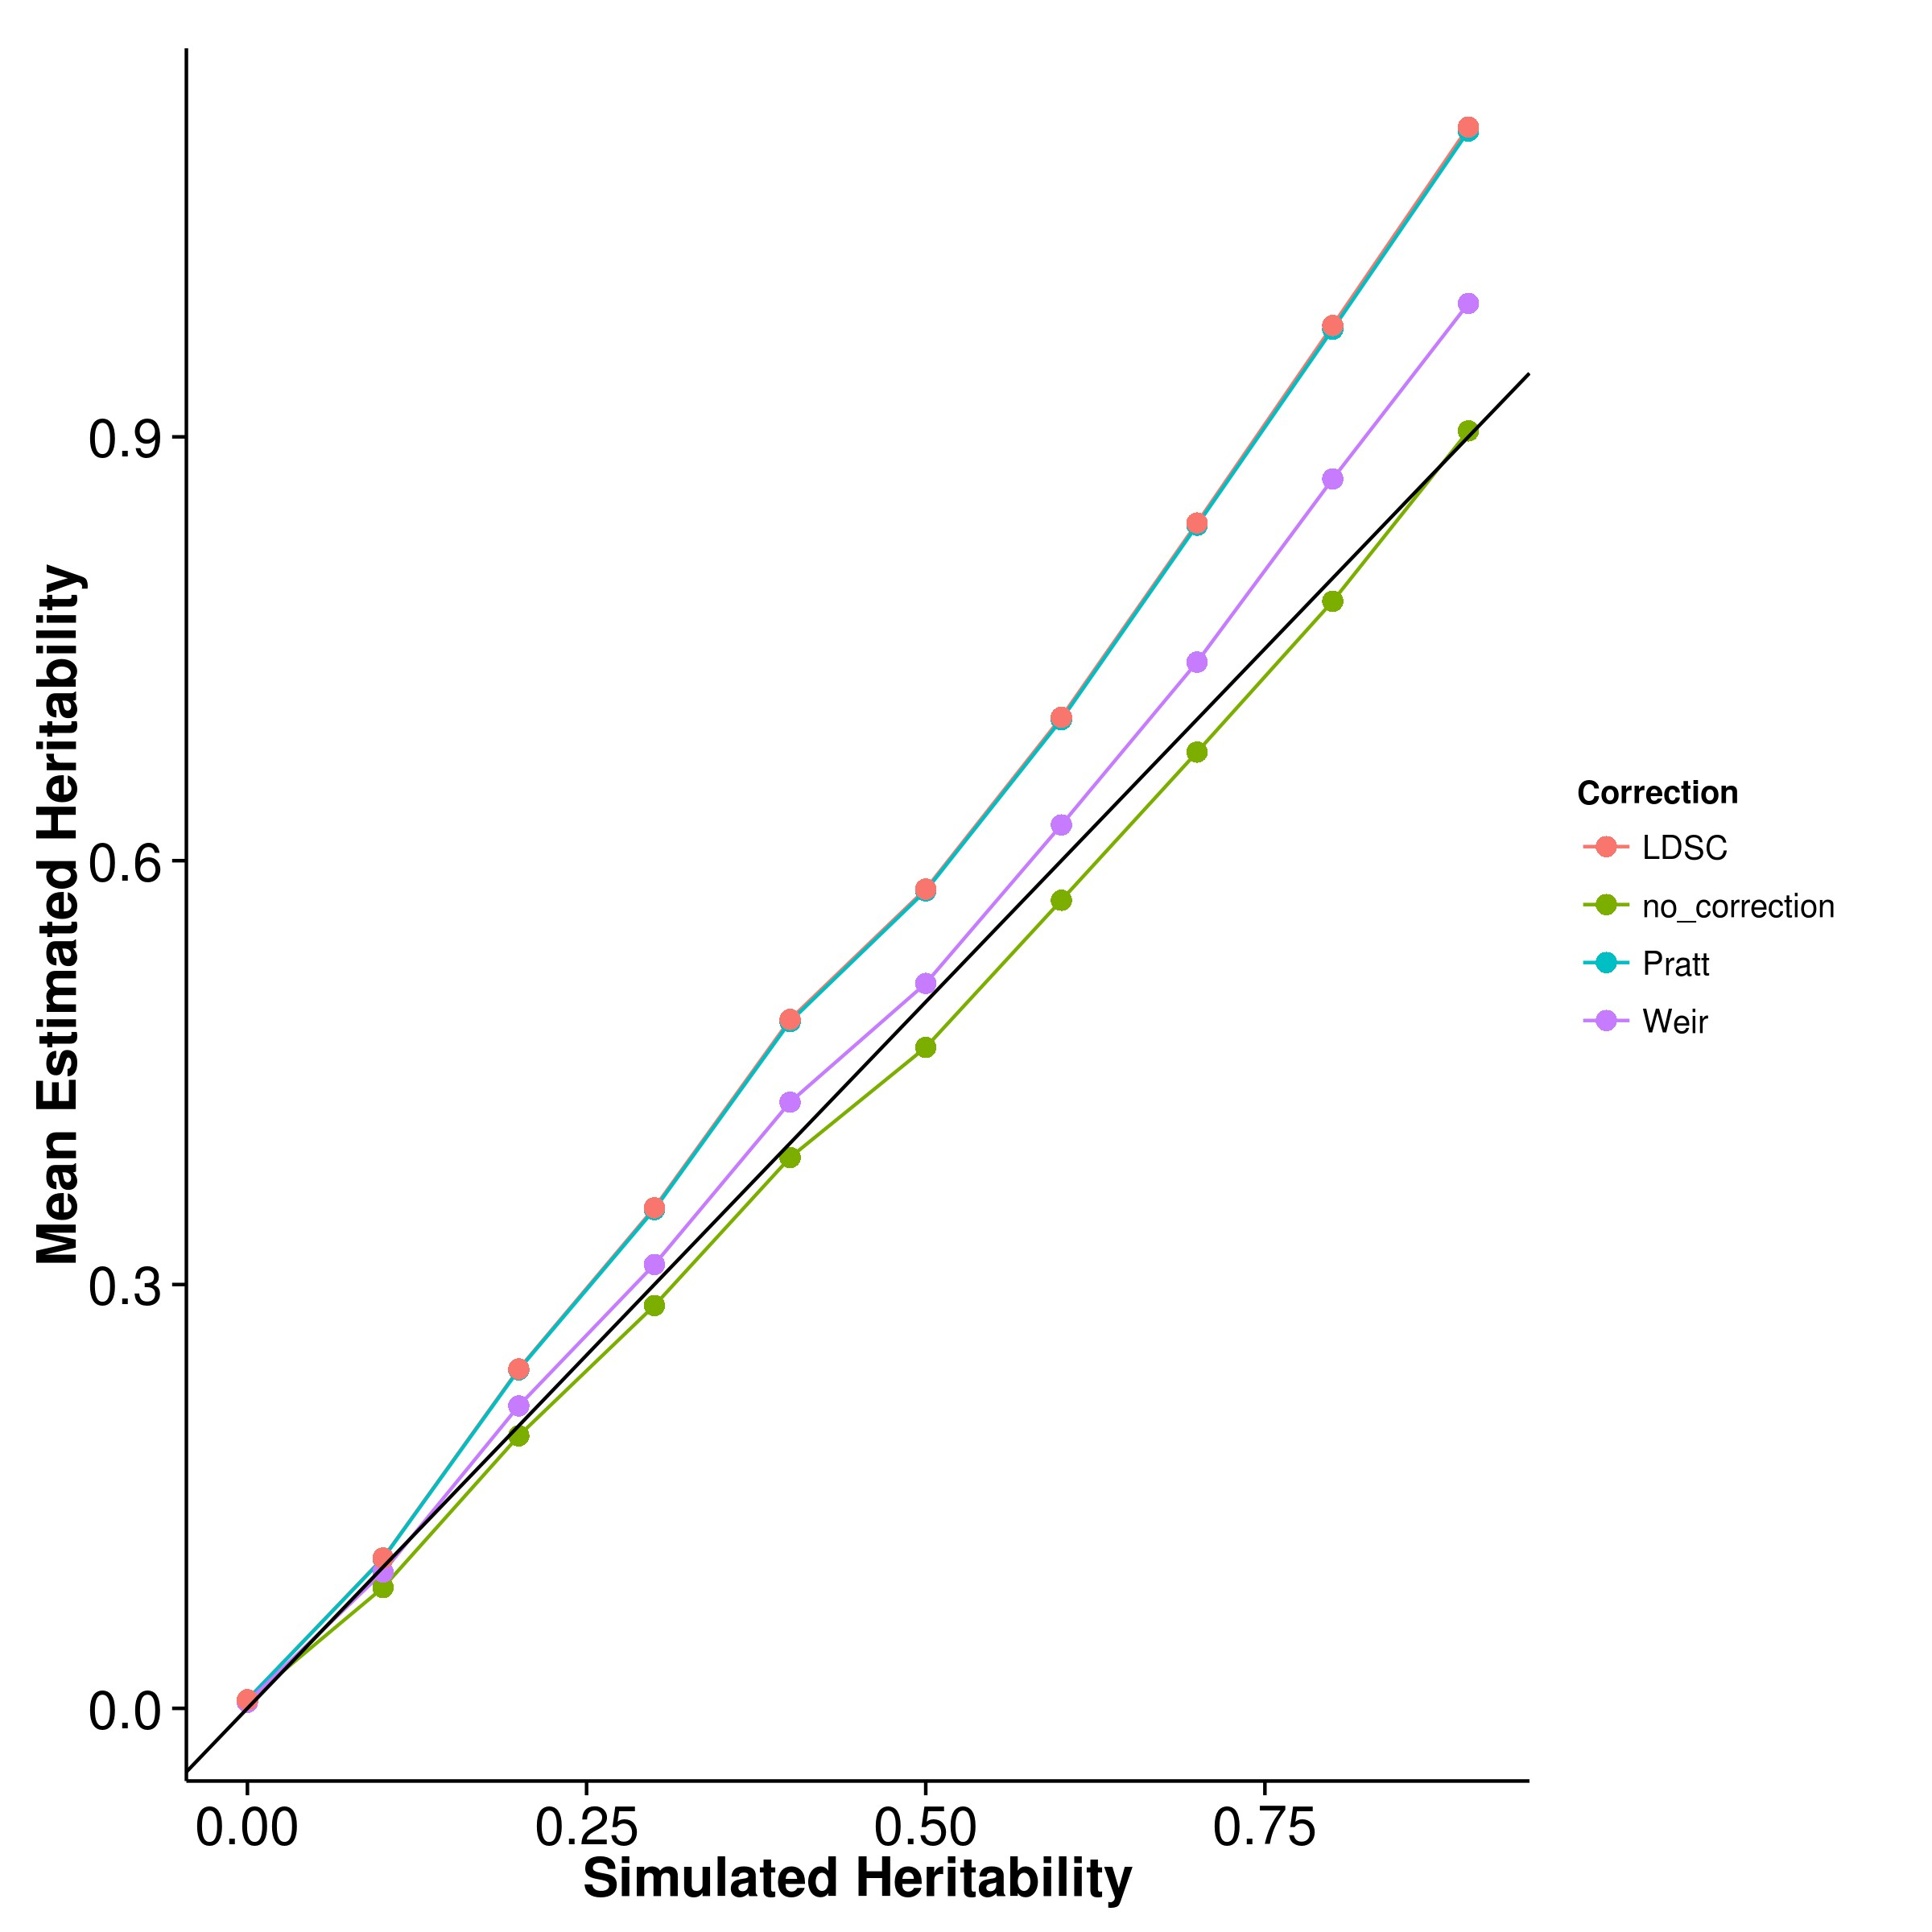

**(a)** Mean Estimation **(b)** Empirical Variance

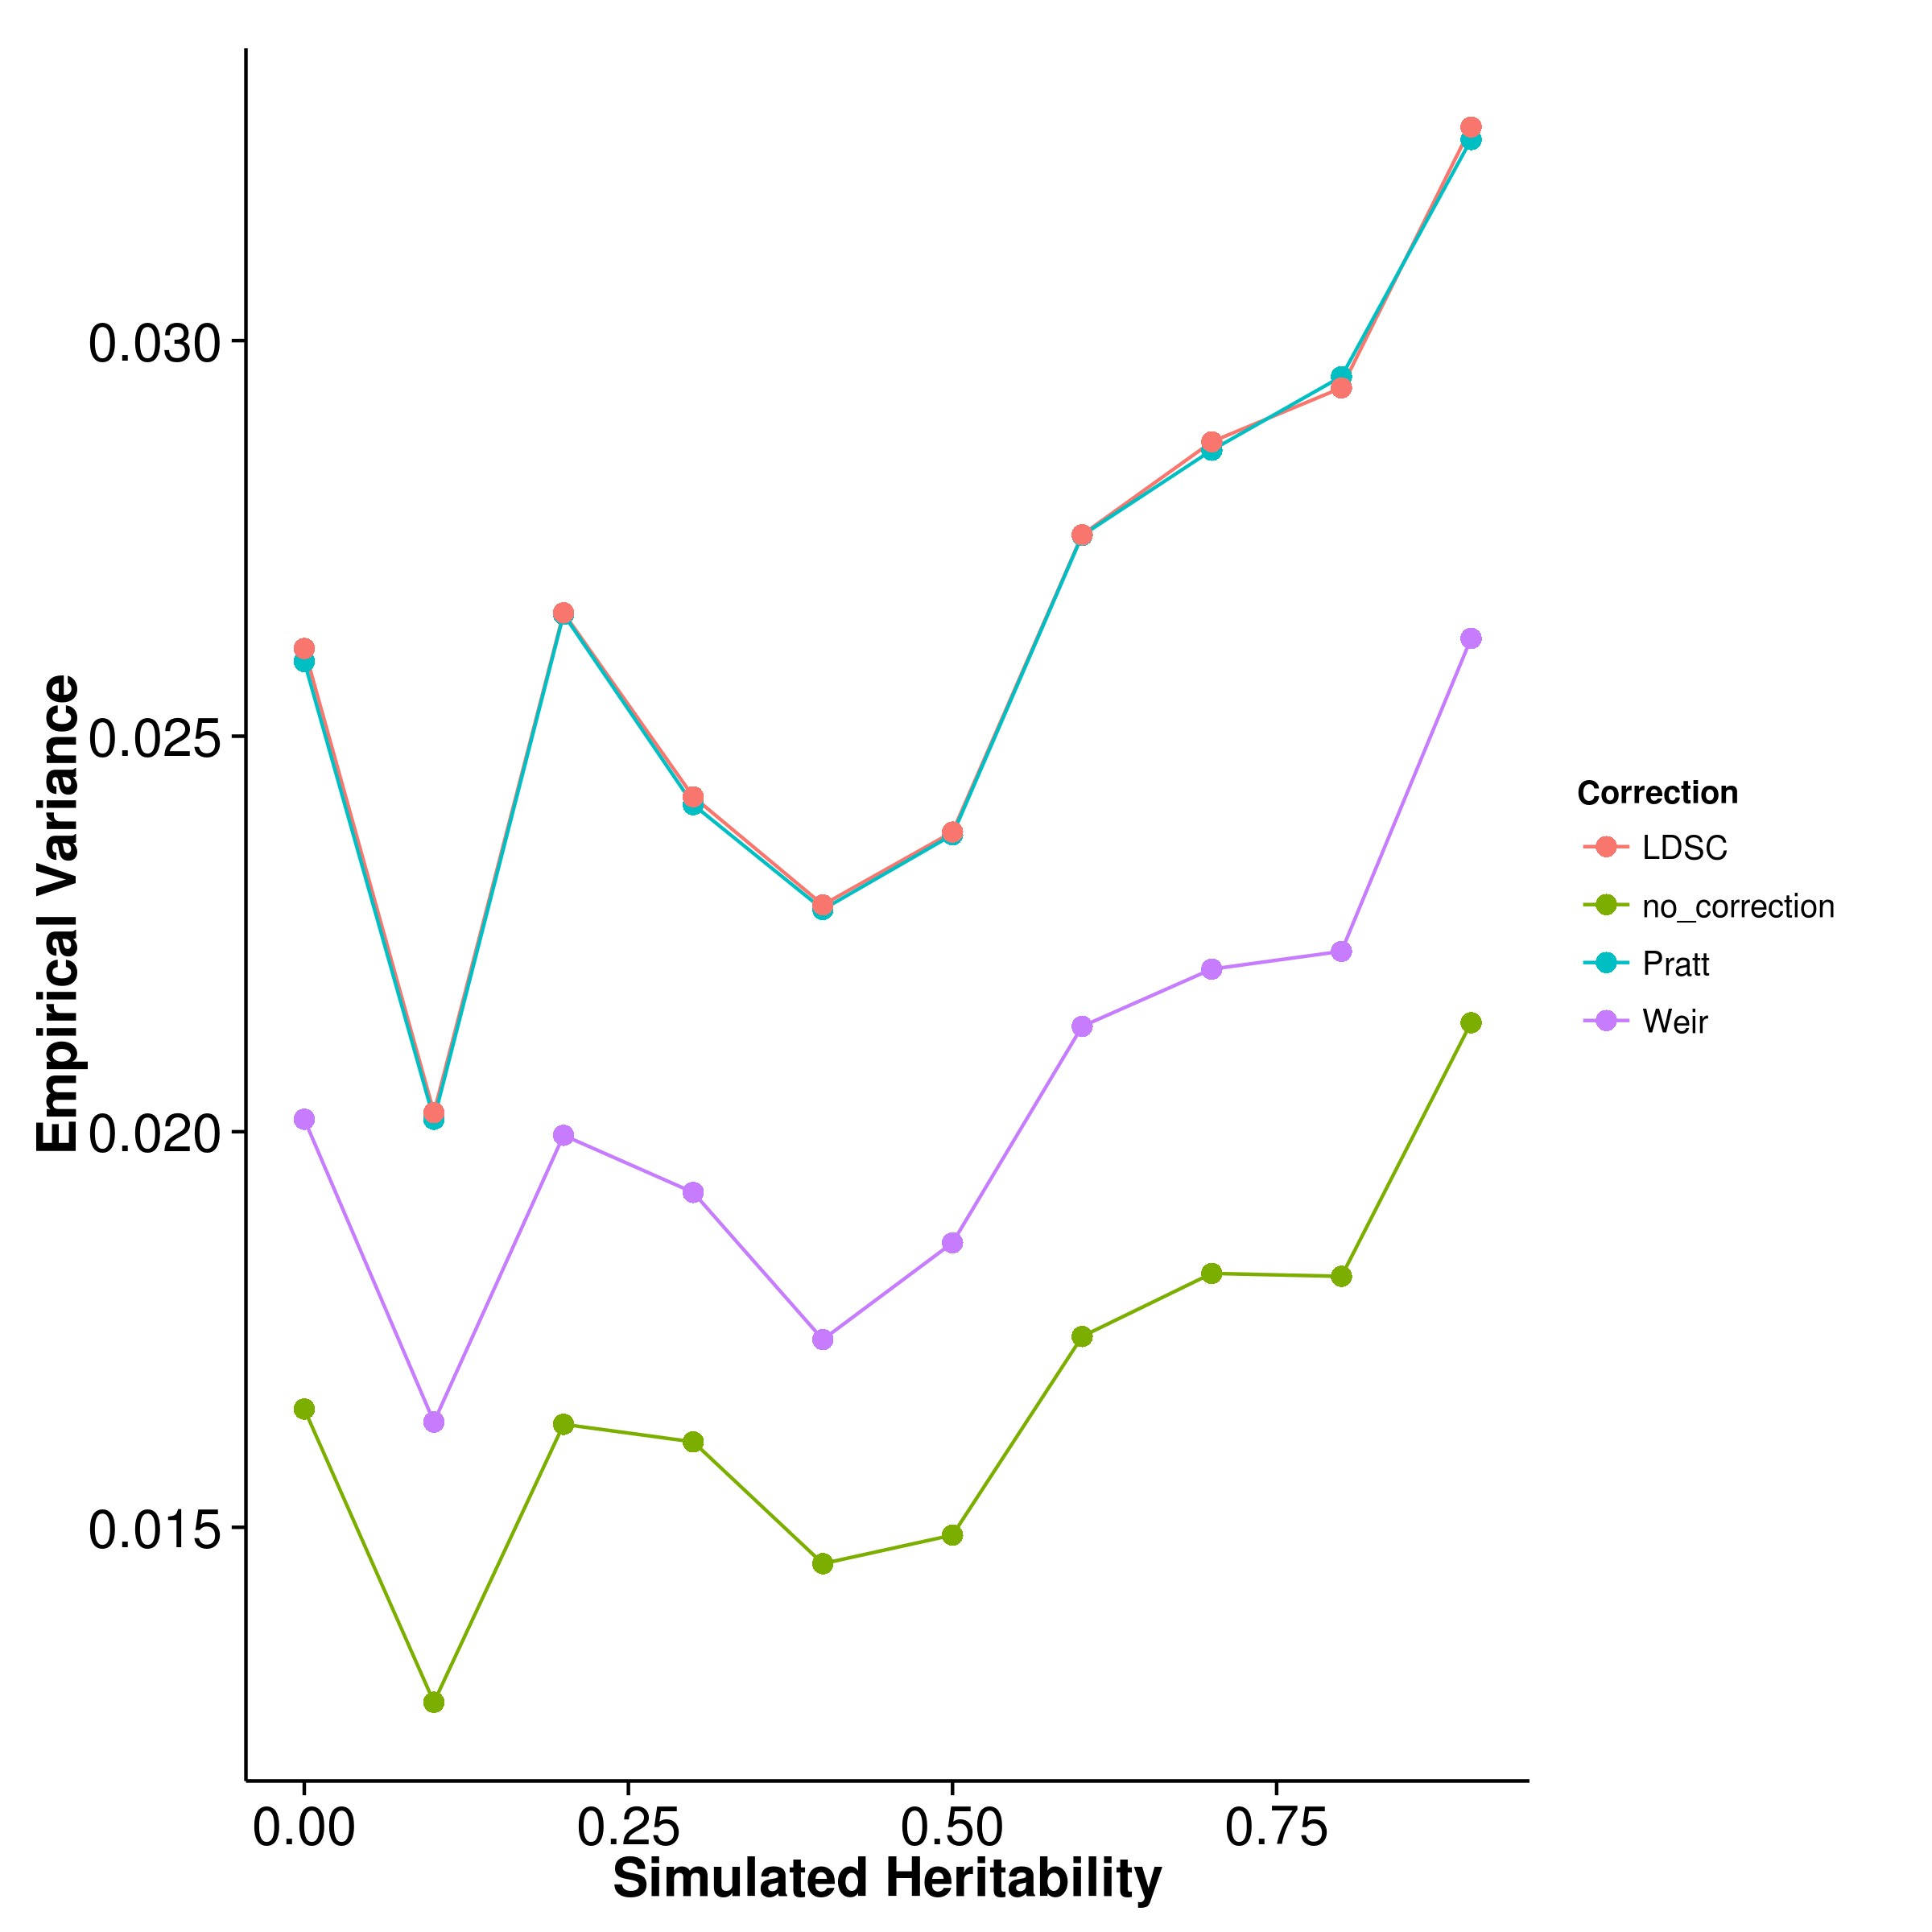

**Figure 2.16:** Effect of LD correction to Heritability Estimation when 50,000 SNPs were simulated. As an overestimation was observed in the quantitative trait simulation, we performed a short simulation to assess the impact of LD correction to the heritability of SHREK when the there is a larger number of SNPs. From the graph, it was observed that all LD correction algorithms inflate the heritability estimation when large number of SNPs were simulated. In fact, the bias was the smallest when no LD correction was performed.

From the results (fig. 2.16), it was clear that all LD correction algorithms inflates the heritability estimation from SHREK in oppose to the underestimation observed when no LD correction was performed. The underestimation was as expected because the positive sampling bias in R2 will lead to an “over correction” of the collinearity, thus result in lower estimates. As mentioned, it is possible that eq. (2.39) does introduce small imprecision (e.g. overcorrection) to the LD matrix which accumulates as the number of SNPs increases, leading to overestimation of the heritability. Our simulation results do support that as one of the possible explanation. What was interesting though is that the MSE is the lowest when no LD correction was performed, suggesting that when the number of SNPs increases, these LD correction algorithms actually has a negative impact to the performance of SHREK.

It was noted that most LD correction algorithm assumes the correlation was calculated on normally distributed data. However, genomic data follows a binomial distribution, which might violates the assumption, leading to a biased correction. This will be an important area for further research. Without a good bias correction algo- rithm, the estimates from SHREK will most likely be biased downward, especially when the reference panel is small. Meanwhile, we allow users the freedom to disable the LD correction in SHREK.

Another important observation was the overestimation observed when we use the LD correction algorithm from LDSC on SHREK. Using the same algorithm, the estimates from SHREK were biased upward whereas the same bias was not observed in LDSC. This observation suggests that SHREK might be more sensitive to the errors in the LD matrix when compared to LDSC. Indeed, SHREK requires the inverse of the LD matrix and considering the large condition number of the LD matrix, any errors can be multiplied during the inversion. On the other hand, LDSC does not compute the inverse of LD matrix. Instead, they only require the sum of R2 for the regression model. By avoiding the inverse of the matrix, the algorithm will then be less sensitive to the imprecision in the LD, thus result in a better estimates. However, it will still be interesting to see whether if the application of a better LD correction algorithm can help to improve the estimates from LDSC.

**2.7.2 Simulation Results**

To understand how the performance of the heritability estimation algorithm was influenced by different genetic architectures, we performed a series of simulations.

**Quantitative Trait Simulation**

In the quantitative trait simulation, it was clear that for most situation, GCTA has the best performance. By using the genetic relationship matrix, the estimation from GCTA were more accurate when compared to LDSC and SHREK. However, when the sample genotypes are unavailable, it is not possible to calculate the genetic relationship matrix required by GCTA. Thus one can only rely on LDSC and SHREK.

When the trait is polygenic, it is observed that the estimates of LDSC with fixed intercept were more accurate than the estimates from SHREK. However, under the oligogenic condition (e.g with only 5 or 10 causal SNPs), the variance of LDSC increases, thus increasing the MSE. On the other hand, the estimates of SHREK were relatively insensitive to the number of causal SNPs. As a result of that, under the oligogenic condition, SHREK has a better performance when compared to LDSC.

An important factor to remember is that in our simulation, we did not simulate any confounding factors, therefore the intercept estimation in LDSC was expected to only increase the variance without any gain in estimation power. The results from the simulation agrees with the hypothesis and demonstrated that the intercept estimation does increase the variance of the estimates, leading to a higher MSE.

It will be interesting to assess the performance of these algorithms when there is confounding effects such that one can test the importance of the intercept estimation function in the correction of confounding effects. However, the simulation of population and, especially cryptic relationship, is nontrivial. For example, although one can pro- vide haplotype from different population to HAPGEN2, there is a lot of uncertainties in the simulation of the individual phenotypes: Should one standardize the genotype of the two population independently in the calculation of phenotype? Should the two population have the same causal SNPs? If not, should we limit the causal SNPs within the same biological pathway / function?

Moreover, heritability is dependent on the environment and genotype fre- quency. Theoretically, it is possible for different population to have a different her- itability for a particular trait. The possible combinations and the complexity of the problem is beyond the scope of this thesis but we do acknowledge that it is an important subject and further research is required.

Overall, when compared to LDSC, the only advantage of SHREK is its rela- tive robustness to change in genetic architecture of the trait. Under extreme scenarios such the oligogenic condition, or when there is one SNP with extreme effect size, the performance of SHREK remain relatively unaffected when compared to LDSC which usually result in a larger variance under the extremes. Whereas under polygenic con- dition LDSC outperforms SHREK. It is important to note that the bias of SHREK is mainly due to the LD correction algorithm, if LD correction was not performed, the MSE of the estimates form SHREK will be reduced (e.g. from 0.0217 to 0.0166 in the LD correction simulation), reducing the difference in performance between LDSC. Nonetheless, the sensitive to errors in the LD matrix remains to be one of the biggest weakness of SHREK.

**Case Control Simulation**

More often than not, researchers are interested in case control studies where “affected” and “normal” samples were compared. This is particular useful for the studies of disease traits such as schizophrenia. However, the heritability estimation is not as straight forward and requires the adaptation of the liability threshold model. It was known that GCTA, the most widely adopted algorithm for heritability estimation in GWAS was unable to provide accurate estimates in case control scenarios and its estimates are affected by the population prevalence and sample size of the studies (Golan, Eric S Lander, and Rosset, 2014). Our simulation results agree with the observation of Golan, Eric S Lander, and Rosset (2014), suggesting that as the population prevalence decreases, the magnitude of bias in the estimates of GCTA increases.

According to Golan, Eric S Lander, and Rosset (2014), in case control studies there is an oversampling of the cases relative to their prevalence in the population. The case control sampling induced a positive correlation between the genetic and environmental effects for the samples in the study even when there is no true genetic and environmental interaction in the population (Golan, Eric S Lander, and Rosset, 2014). This leads to heritability estimates from GCTA to be strongly downward biased where the magnitude of bias increases as the population prevalence decreases, heritability increases and when the proportion of cases is closer to half.

The question then is whether if this artificial correlation will affect the performance of SHREK and LDSC. First, it was observed that as the population prevalence decreases, the magnitude of bias for both LDSC with fixed intercept and SHREK in- creases suggesting that the population prevalence and the sampling bias might indeed be influential to the estimates of LDSC and GCTA. However, the direction of bias was opposed to what was observed in GCTA where a smaller population prevalence leads to a larger overestimation in the heritability. Considering that for SHREK, we adjust the estimates by multiplying eq. (2.23) to the estimates. An overestimation might suggest that we have an under correction of the bias. Of course the bias introduced by the LD correction is another factor to be considered, but considering that only 5,000 SNPs were simulated, the bias introduced by LD sampling bias should be relatively small as suggested by our LD correction simulation. To understand the effect of LD correction in case control scenario, we will need to increase the number of SNPs simulated yet that is only possible when additional computation resources are made available.

What was most surprising in the case control simulation is the performance of LDSC with intercept estimation. As we did not simulate any confounding factors, we would expect the performance of LDSC with intercept estimation would be worst compared to LDSC with fixed intercept because of the unnecessary additional degree of freedom in the estimation. However, it was observed that unlike SHREK and LDSC with fixed intercept, the bias of LDSC with intercept estimation was robust to the change in population prevalence (figs. 2.10, 2.18, 2.21 and 2.24), thus when the population prevalence is small, the bias of LDSC with intercept estimation is relatively smaller when compared to LDSC with fixed intercept.

Taking into consideration of the empirical variance and the bias of the estimates, SHREK has better average performance when compared to LDSC. It is important to remember that the case control simulation is not comparable to the results from the quantitative trait simulation, not only because the addition of the liability model, but also that in the case control simulation, we only simulated 5,000 SNPs on chromosome 22. Based on the LD correction simulation, it was observed that bias from the LD correction algorithms was smaller when less SNPs were simulated. On top of that, the total amount of samples included in the simulation was doubled that from the quantitative trait simulation, with 1,000 cases and 1,000 controls whereas we only simulated 1,000 total samples in the quantitative trait scenario. Nonetheless, our case control simulation does highlights the effect of population prevalence on the performance of the heritability estimation algorithms. It will be an important topic to develop better algorithm for adjusting the attenuation bias introduced by case control sampling when the population prevalence of the disease is small.

Finally, it was noted that in order to provide an accurate estimation of the heritability, one needs to know the population prevalence of the disease beforehand. Without the information of the population prevalence, it will be difficult for one to estimates the heritability from GWAS with case control design. Therefore once should always be cautious with the heritability estimations from a case control designs.

**Extreme Phenotype Sampling**

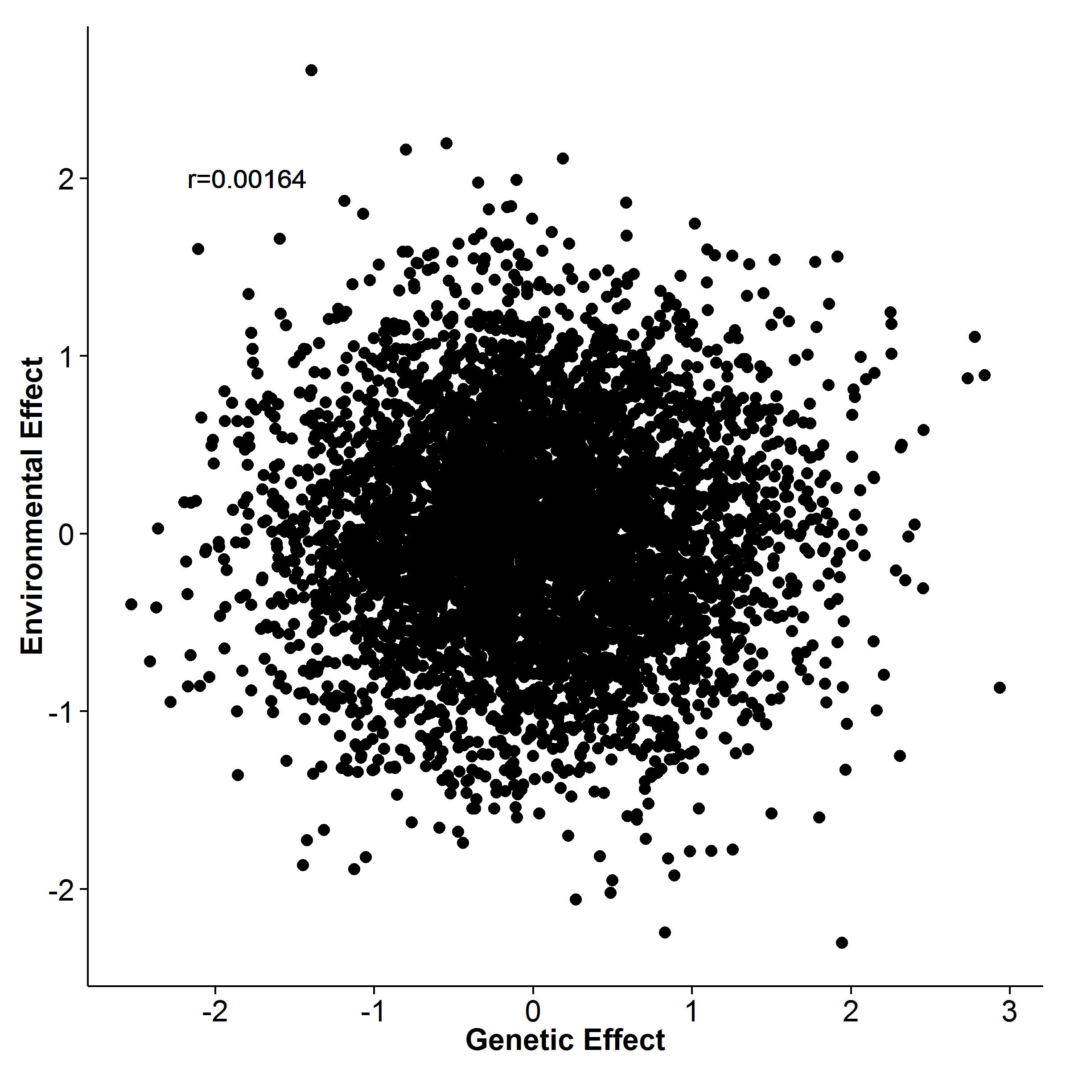

**(a)** No Extreme sampling **(b)** Extreme Sampling

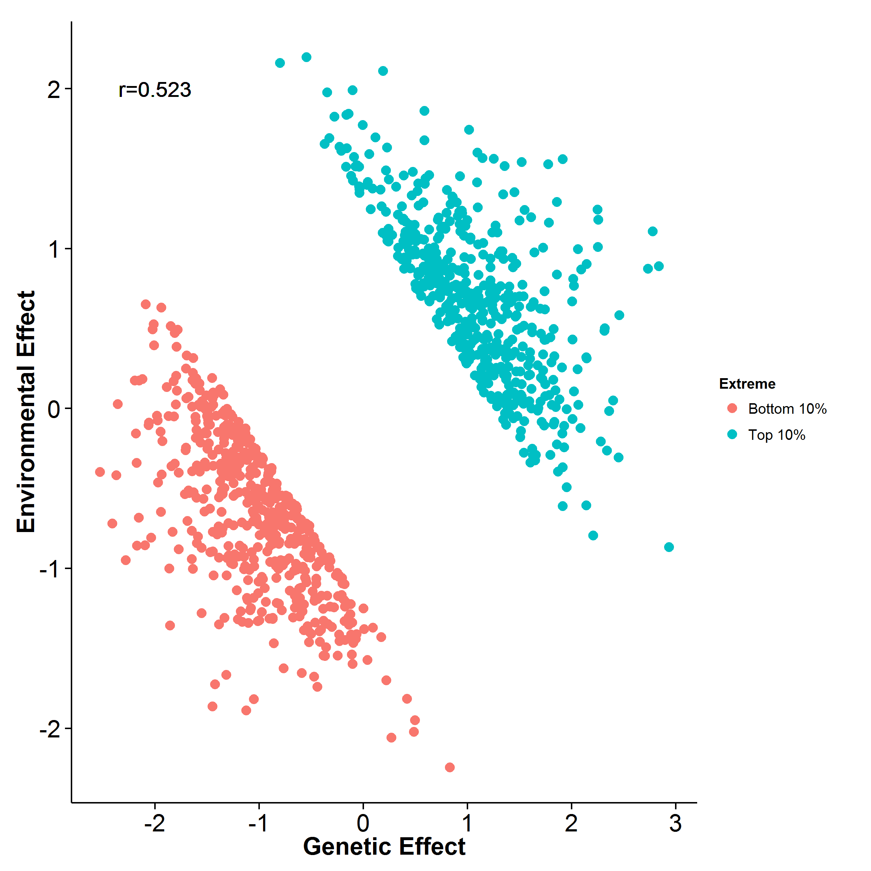

**Figure 2.17:** Effect of extreme sampling design. Here we simulated the genetic and environmental effect independently. When no extreme sampling was performed, there is no correlation between the environmental effect and genetic effect as expected. How- ever, when extreme sampling was performed, an artificial correlation was observed. This might be the main reason why the estimates from GCTA are downward biased.

Other than the case control study design, extreme phenotype sampling is another common experimental design for it can helps to increase the power of an association studies given the same amount samples. Compared with the same number of randomly selected individuals, the extreme selection design can increase the power by a factor of V’/V where V’ is variance of the trait of the selected sample and V is the trait variance of the general population. So for example, if one only include the samples from the top 5% and bottom 5% of the phenotype distribution, one can achieve the same power as a study with random sampling design that has 4 times the sample size (Pak C Sham and Shaun M Purcell, 2014).

Herein, we simulated the situation where an extreme selection design was performed to assess the performance of the heritability estimation algorithms. We are also interested in comparing the performance between extreme phenotype sampling and random sampling strategy. First, it was observed that when extreme phenotype sampling was performed, the estimates from GCTA were biased downward. This observation was similar to what was observed in the case control simulation. It was noted that although we were simulating independent environmental and genetic effects, the extreme phenotype sampling strategy does introduced an artificial correlation between the two effects, similar to what was observed in case control scenario (fig. 2.17). This might therefore affect the performance of GCTA where as the portion of sample selected decreases, the magnitude of bias increases, similar to the change of population prevalence in case control studies.

On the other hand, an upward bias was observed in the estimates from SHREK and LDSC. Although the same bias can be observed in the random sampling scenario, the bias is slightly high when a smaller portion of samples were selected. This level of bias concurs with the biased observed when a trait has a smaller population prevalence suggesting that the sampling method might introduce bias in the SNP heritability estimate. Studies are therefore required to identify a better algorithm for the correction of the attenuation bias. Overall, the performance of SHREK and LDSC were more than 3 fold better when extreme selection was performed, suggesting that the extreme selection does help to improve the power in estimation even though the same amount of samples were used.

However, although the empirical variance observed in the random sampling for all the algorithm was the same as what was observed in the quantitative trait simulation with 100 causal SNPs, the estimated variance for GCTA and LDSC was much worst. A larger upward bias was observed in the estimates from LDSC with fixed intercept, suggesting there might be some difference between the simulation of random sampling and the simulation of quantitative trait, even though most of the parameter for simulation are the same. The only difference in the two simulation was the standardization of genotype when calculating the phenotype. For the quantitative trait simulation, the genotype was standardized based on the genotype of 1,000 samples of which all were included in the analysis. However, in the simulation of the random sampling design, 5,000 samples were used to standardize the genotype, of which only 1,000 out of 5,000 were included in the final analysis. It was uncertain how this affects the performance of the algorithm and further analysis might be required.

Nonetheless, in this simulation, we first simulated the individuals and their phenotype then we perform the sampling. The only difference between the two sets of data is the sampling performed. Thus it is safe to conclude that the extreme phenotype sample does provide more power than the random sampling in heritability estimation.

Finally, we only tested the performance of the algorithms when the trait is polygenic (e.g. 100 causal SNPs). Further simulation should be performed to test the effect of extreme phenotype selection on traits with different genetic architecture.

**2.7.3 Application to Real Data**

Our main question of interest is to understand what is the true contribution of common genetic variants, such as SNP, to the variance of schizophrenia. Although B. Bulik- Sullivan (2015) estimated that the SNP heritability of schizophrenia is around 0.555, it is still interesting to see if the same results can be calculated when different method was used. In order to make sure our analysis is correct and that the concordance between estimates from different tools were not merely by chance, we also estimated the heritability for bipolar disorder and major depression disorder as a reference point.

What was most surprisingly was that the LDSC estimated heritability was much smaller than the estimates from the supplementary materials of B. K. Bulik- Sullivan et al. (2015) (e.g. for schizophrenia, 0.555 compared to 0.133). From B. K. Bulik-Sullivan et al. (2015), the formula of LDSC is



where *lj* is the LD score of variant *j*, *N* is the sample size, *a* is the contribution of confounding biases, *h2* is the heritability and *M* is the number of SNPs. When contact the author about the discrepancy of the estimation between our run of LDSC and the estimates shown in the supplementary table, B. Bulik-Sullivan (2015) replied that the estimated from the supplementary table define M as the total number of SNPs in the reference panel used to estimated LD score whereas the current version of LDSC defines M as the number of SNPs with maf> 5% in the reference panel used to estimate LD score which they deem more appropriate based on new data they observed after their original paper was published. Based on the caption of their supplementary, they stated that “. . . if the average rare SNP explains less phenotypic variance than the average common SNP, then a smllaer value of M would be more appropriate, and the estimates in the supplementary table will be biased upwards.” This explain the smaller estimates from our run.

|  |  |  |  |
| --- | --- | --- | --- |
|  | Major Depression Disorder | Bipolar | Schizophrenia |
| SHREK | 0.256 (0.0273) | 0.312 (0.0168) | 0.174 (0.00453) |
| LDSC | 0.235 (0.0241) | 0.267 (0.0147) | 0.197 (0.0058) |

**Table 2.6:** Heritability estimated for PGS data sets without Intercept Estimation.

Indeed, when the intercept estimation was not performed, the estimates from LDSC was very close to that of SHREK.

Another interesting observation from the estimates in real data was that SHREK consistently return a higher estimates when compared to LDSC Considering the fact that SHREK cannot account for confounding effects such as cryptic relationship and population stratification, it is likely that the estimates was inflated by these confounding factors. A straight forward test was to perform LDSC without the intercept estimation and compare the estimates with that from SHREK such that it is clear whether if the difference of the estimates was due to the ability of estimating the intercept by LDSC. Indeed, when the intercept estimation was not performed, the estimates from the two algorithms converges (table 2.6). Therefore, it is likely that the difference in table 2.5 is a direct result of the estimation of the intercept.

However, it is very important for one to remember that it is difficult to tell which estimates is the “correct” estimate. For example, in the case control simulation, it was observed that SHREK and LDSC with fixed intercept will overestimates the heritability when the prevalence is less than 0.5 whereas within the same range of population prevalence, LDSC with intercept estimation will underestimate the heritability. The problem of our simulation was that no confounding factors were simulated, thus it is uncertain whether if the same pattern can be observed when there is confounding factors. Nonetheless, as the confounding effects most likely will inflate the test statistic of the association, the estimates of the heritability will likely to be biased upward. Moreover applying SHREK to the real data, we performed the LD correction. As there is a large amount of SNPs in the real data, the LD correction will inflate the estimates thus ensuring all biases were in the same direction (e.g. inflates our estimates). Because of the uni-directional bias, we can safely hypothesize that the estimates from SHREK in tables 2.5 and 2.6 is an upper-bound for the true “detectable” SNP heritability in the current GWAS studies.

Based on our estimation, the PGC schizophrenia GWAS can at most account for ∼ 20% of the heritability of SCZ despite the amount of samples included. When compared to the heritability estimated from twin studies, there are around 40% ∼ 60% of missing heritability unaccounted for. It is important to note that we were only estimating the contribution of common SNP to the variance of schizophrenia. Thus, it is likely that rare variants or other factors (e.g. CNV) that were not captured by the GWAS can account for the remaining heritability of schizophrenia.

If one would like to estimates the contribution of rare variants to SCZ, new algorithms might be required. This is mainly because the LD estimates form the rare variants usually have a large variability and might not be reliable, thus leading to unreliable estimates from SHREK and LDSC. Thus special care are required if one would like to include the rare variants in the estimation process. Also, it was noted that we only performed the estimation on the autosomal chromosomes. The main reason behind was that there are large difference between male and female on the sex chromosomes (e.g. 2 X for female and XY for male). The proportion of male and female were usually not given. This leads to difficulties in eq. (2.14) where the sample size is an important factors. Special consideration might therefore be required if one would like to estimates the contribution of variants on the sex chromosome to schizophrenia.

It is important to remember that although the PGC schizophrenia GWAS has a large sample size it was unable to capture any epigenetic changes. Considering that the risk of having schizophrenia of individual with a schizophrenic mother or schizophrenic father differs, it is possible that epigenetic or the mitochondrion which were mainly contributed by the mother also have their role in the heritability of schizophrenia. One might therefore want to consider also the epigenetic when estimating the heritability.

Overall, the development of SHREK and LDSC marks a new era in SNP heritability estimation and hopefully, with the continuous advancement of the method- ology, one can transits from the estimation of heritability into accurate risk prediction. Meanwhile, the problem in LD correction, the liability adjustment are all important research topics to improve SHREK and LDSC.

**2.7.4 Limitations and Improvements**

One of the biggest disadvantage of SHREK is its speed when compared to LDSC. To estimate the heritability, SHREK requires the calculation of the inverse of the LD matrix, which is an O(n3) operation. Although the use of sliding window has significantly reduce the time requirement, the run time will still increase substantially as the density of the SNPs increases. For example, it can take more than 2 days to process one chromosome of the PGC schizophrenia data set, where there can be more than 5,000 SNPs per window. When applying SHREK to the real data, the computation resources required to estimates heritability of the PGC SCZ GWAS was too high, forcing us to reduce the window size for the analysis. To make the use of SHREK feasible, further development might be required to improve the speed of SHREK. An obvious choice might be to use the Armadillo library (Sanderson, 2010) together with the OpenBLAS library which can be more than 3 times faster when compared to the EIGEN C++ library (Ho, 2011).

On the other hand, the inverse of the LD matrix proves to be one of the biggest challenge for SHREK not only because of the time required to invert the matrix, but also the accuracy of the inverse. Due to the inherently high collinearity of the LD matrix, the condition number of the matrix is very high, meaning that small imprecisions in the matrix can be amplified during the analysis. This makes SHREK very sensitive to errors in the LD matrix. The use of tSVD does help to alleviate some of this problem yet it is still possible for it to break. A possible method to reduce the problem of the LD matrix is to remove any SNPs in perfect LD with each other and we are going to implement this feature in SHREK in future release and hopefully an improve in performance can be obtained.

Finally, we do acknowledge that we have not exhaust all possible combinations of genetic architectures in our simulation. For example, one can also test the performance of the algorithms when the observed prevalence was different (e.g. not 50%). It is also possible for one to investigate the effect of number of causal SNPs on the performance of the algorithms when extreme phenotype sampling was performed. However, we do argue that we have performed a substantial amount of simulations and should be able to provide a general concept as to how the performance of SHREK, LDSC and GCTA are affected in the general scenarios.

**2.8 Supplementary**

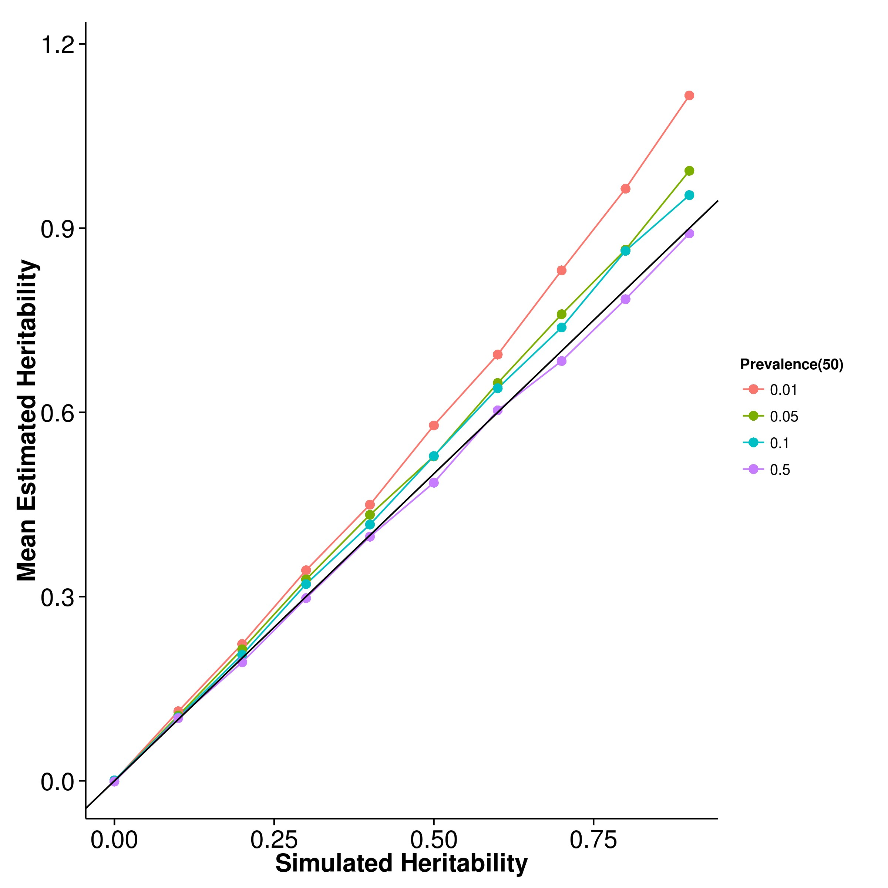

**(a)** SHREK **(b)** GCTA

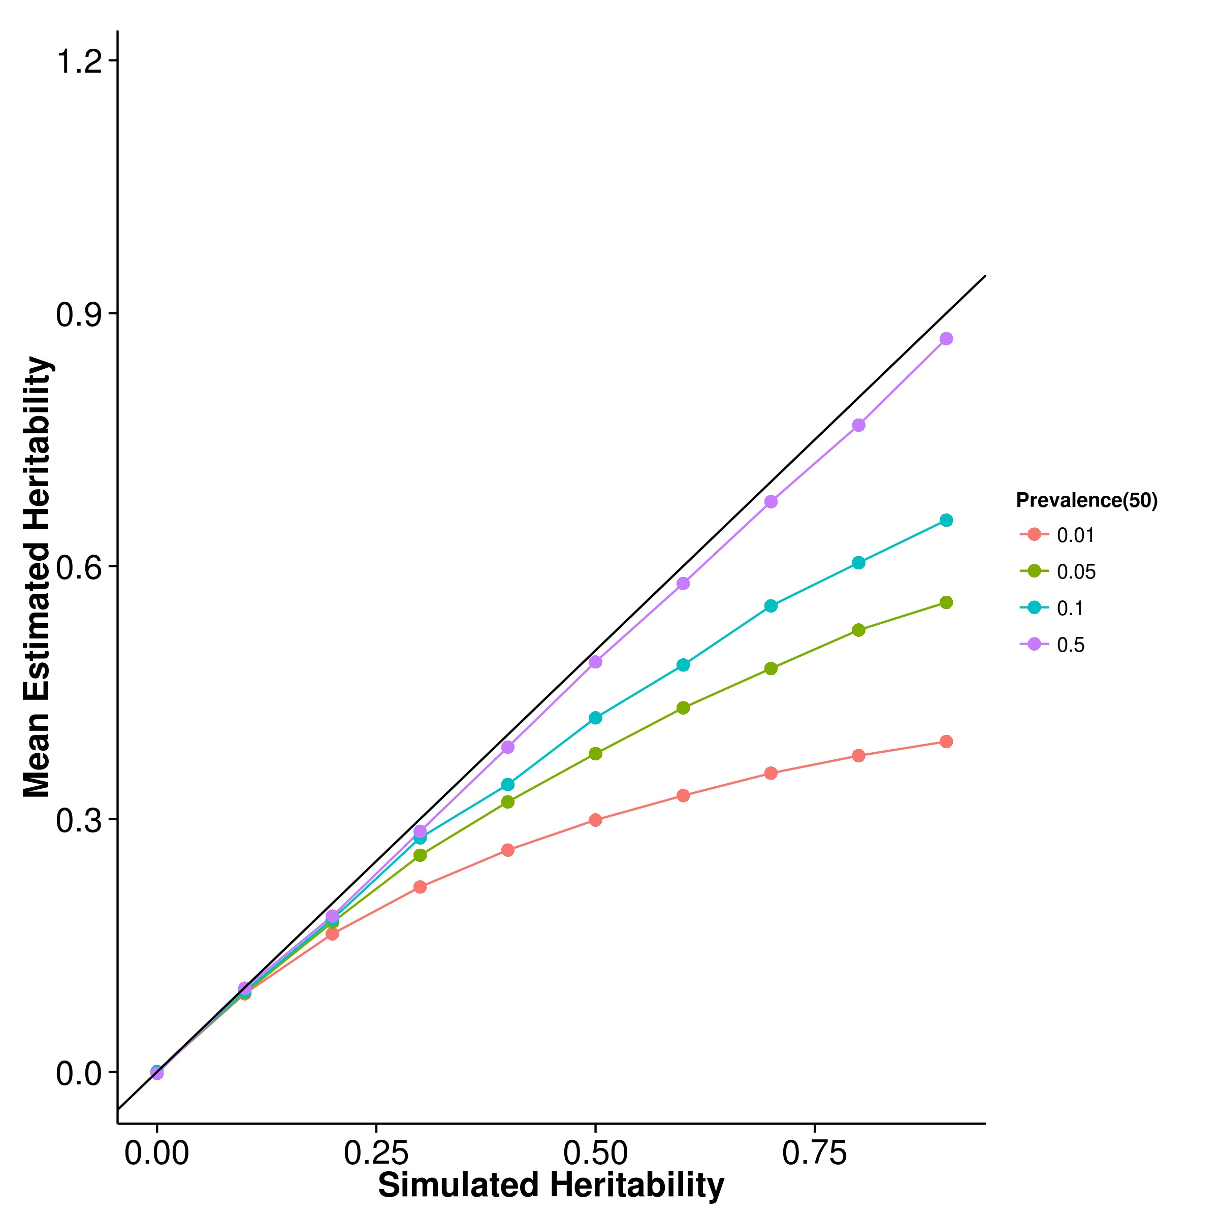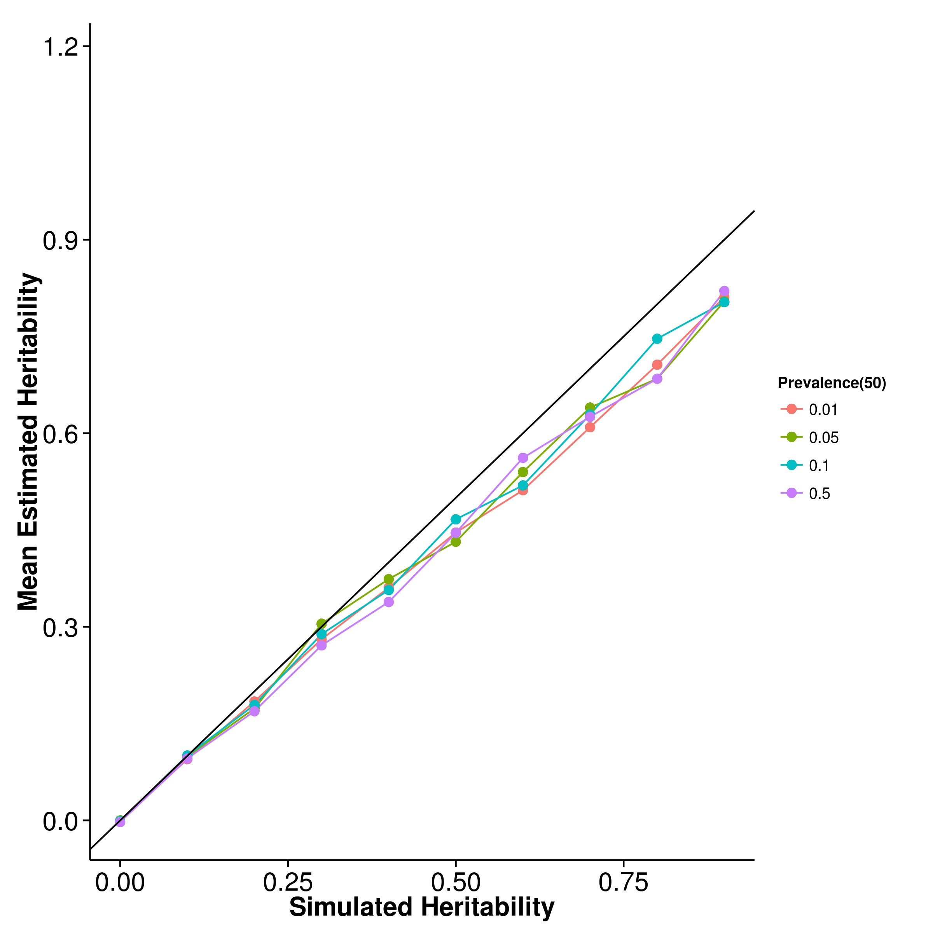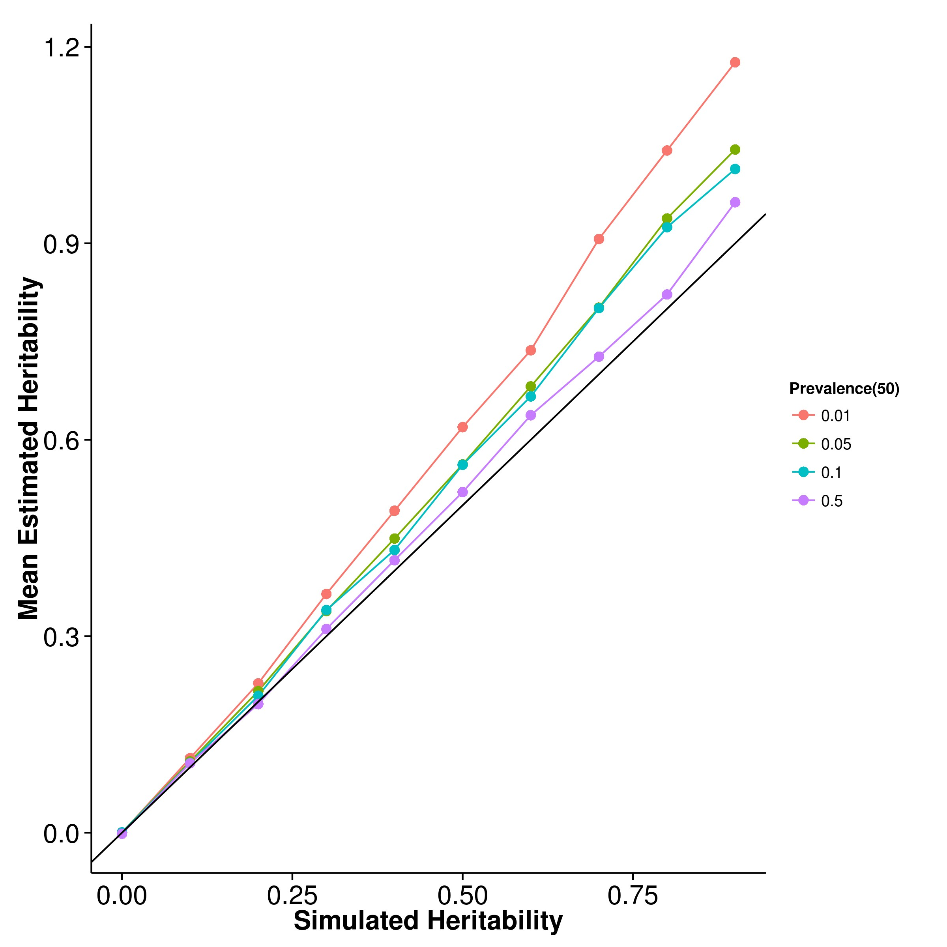

**(c)** LDSC with fix intercept **(d)** LDSC with intercept estimation

**Figure 2.18:** Mean of results from case control simulation with random effect size simulation with 50 causal SNPs. In general, the results were similar to the scenario with 10 causal SNPs with the only exception that the estimates from LDSC with intercept estimates seems to be less affected by the change in prevalence of the trait.

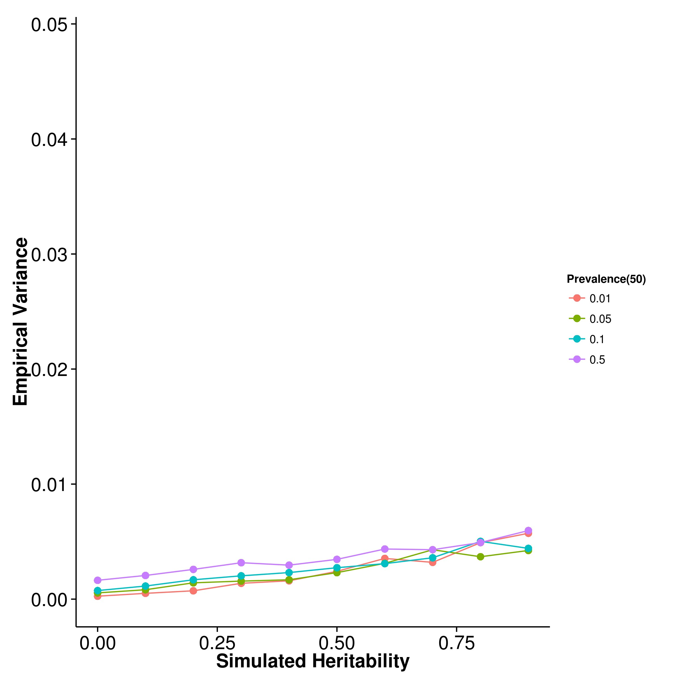

**(a)** SHREK **(b)** GCTA

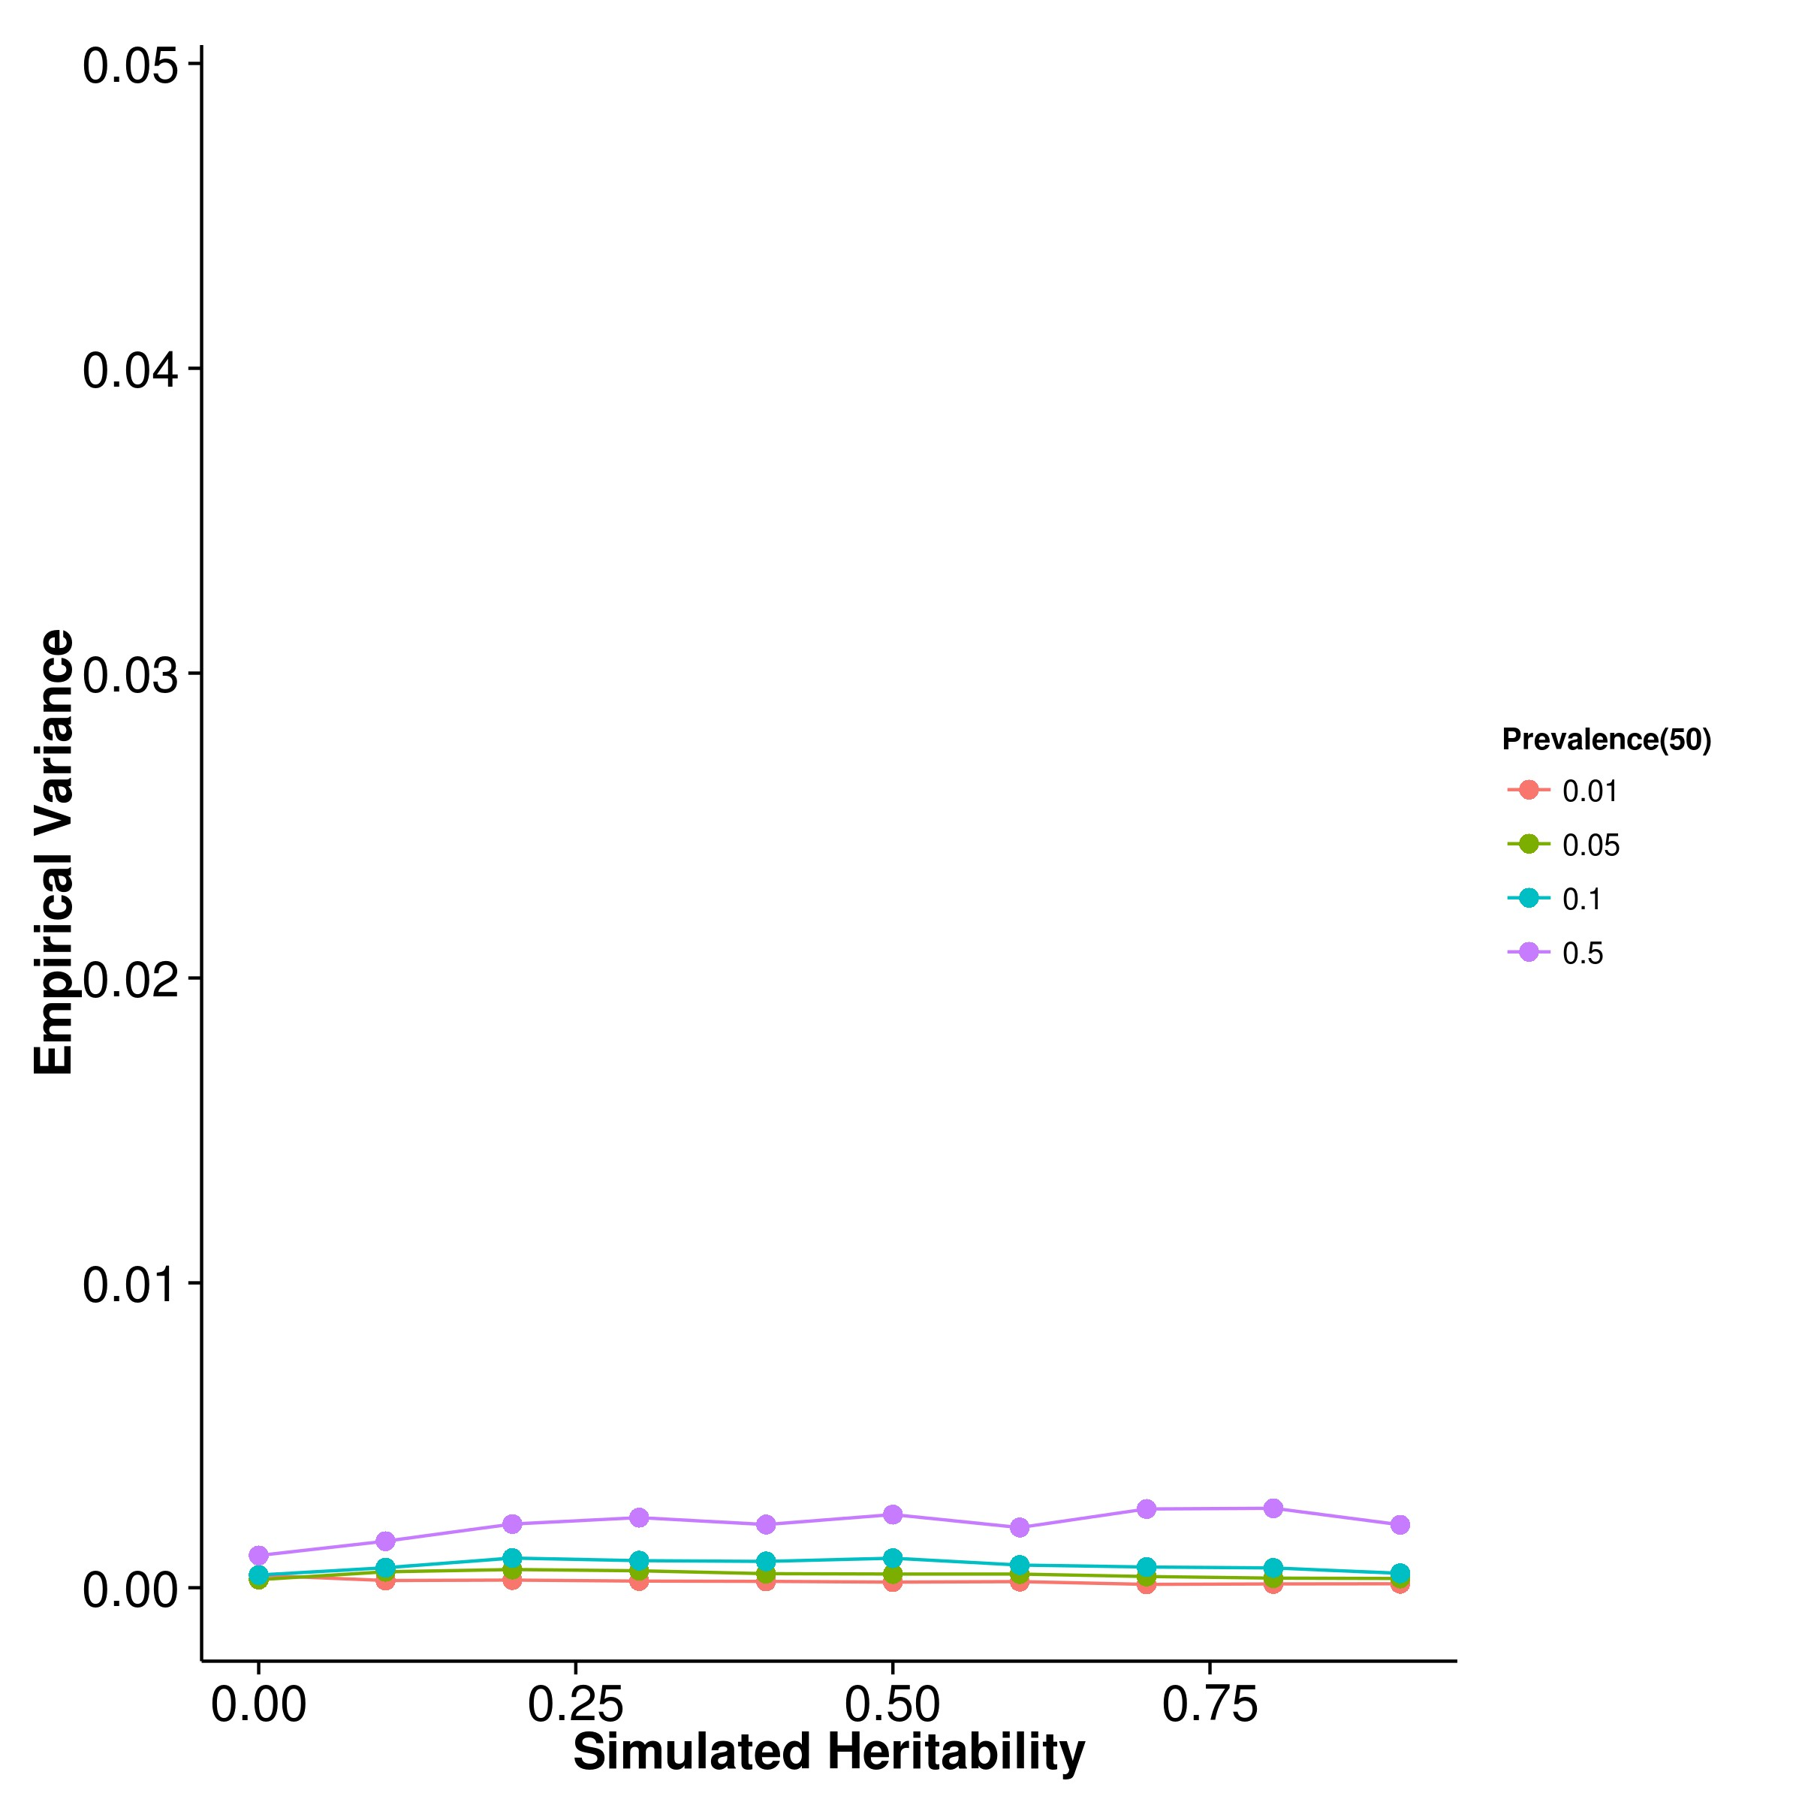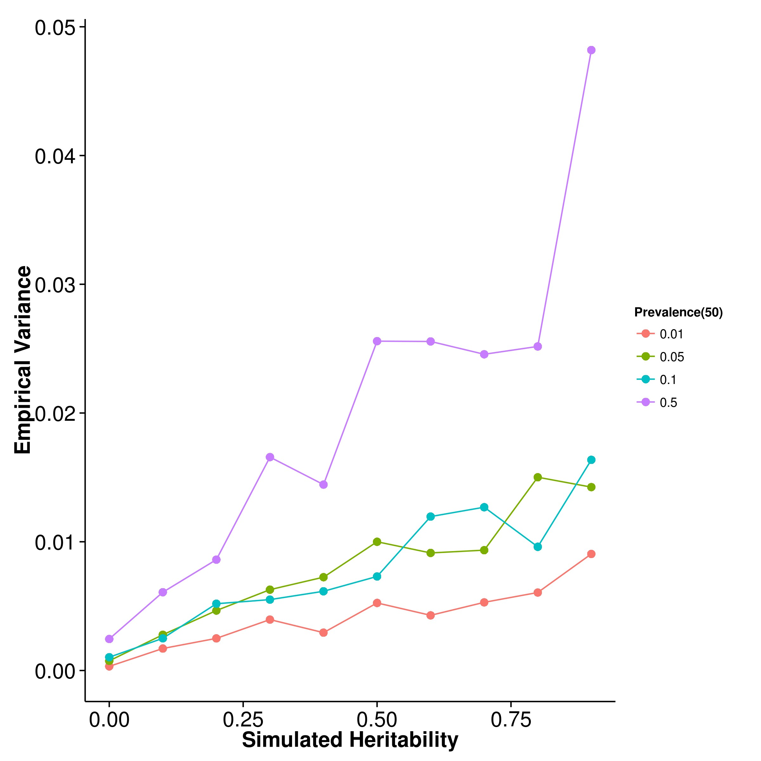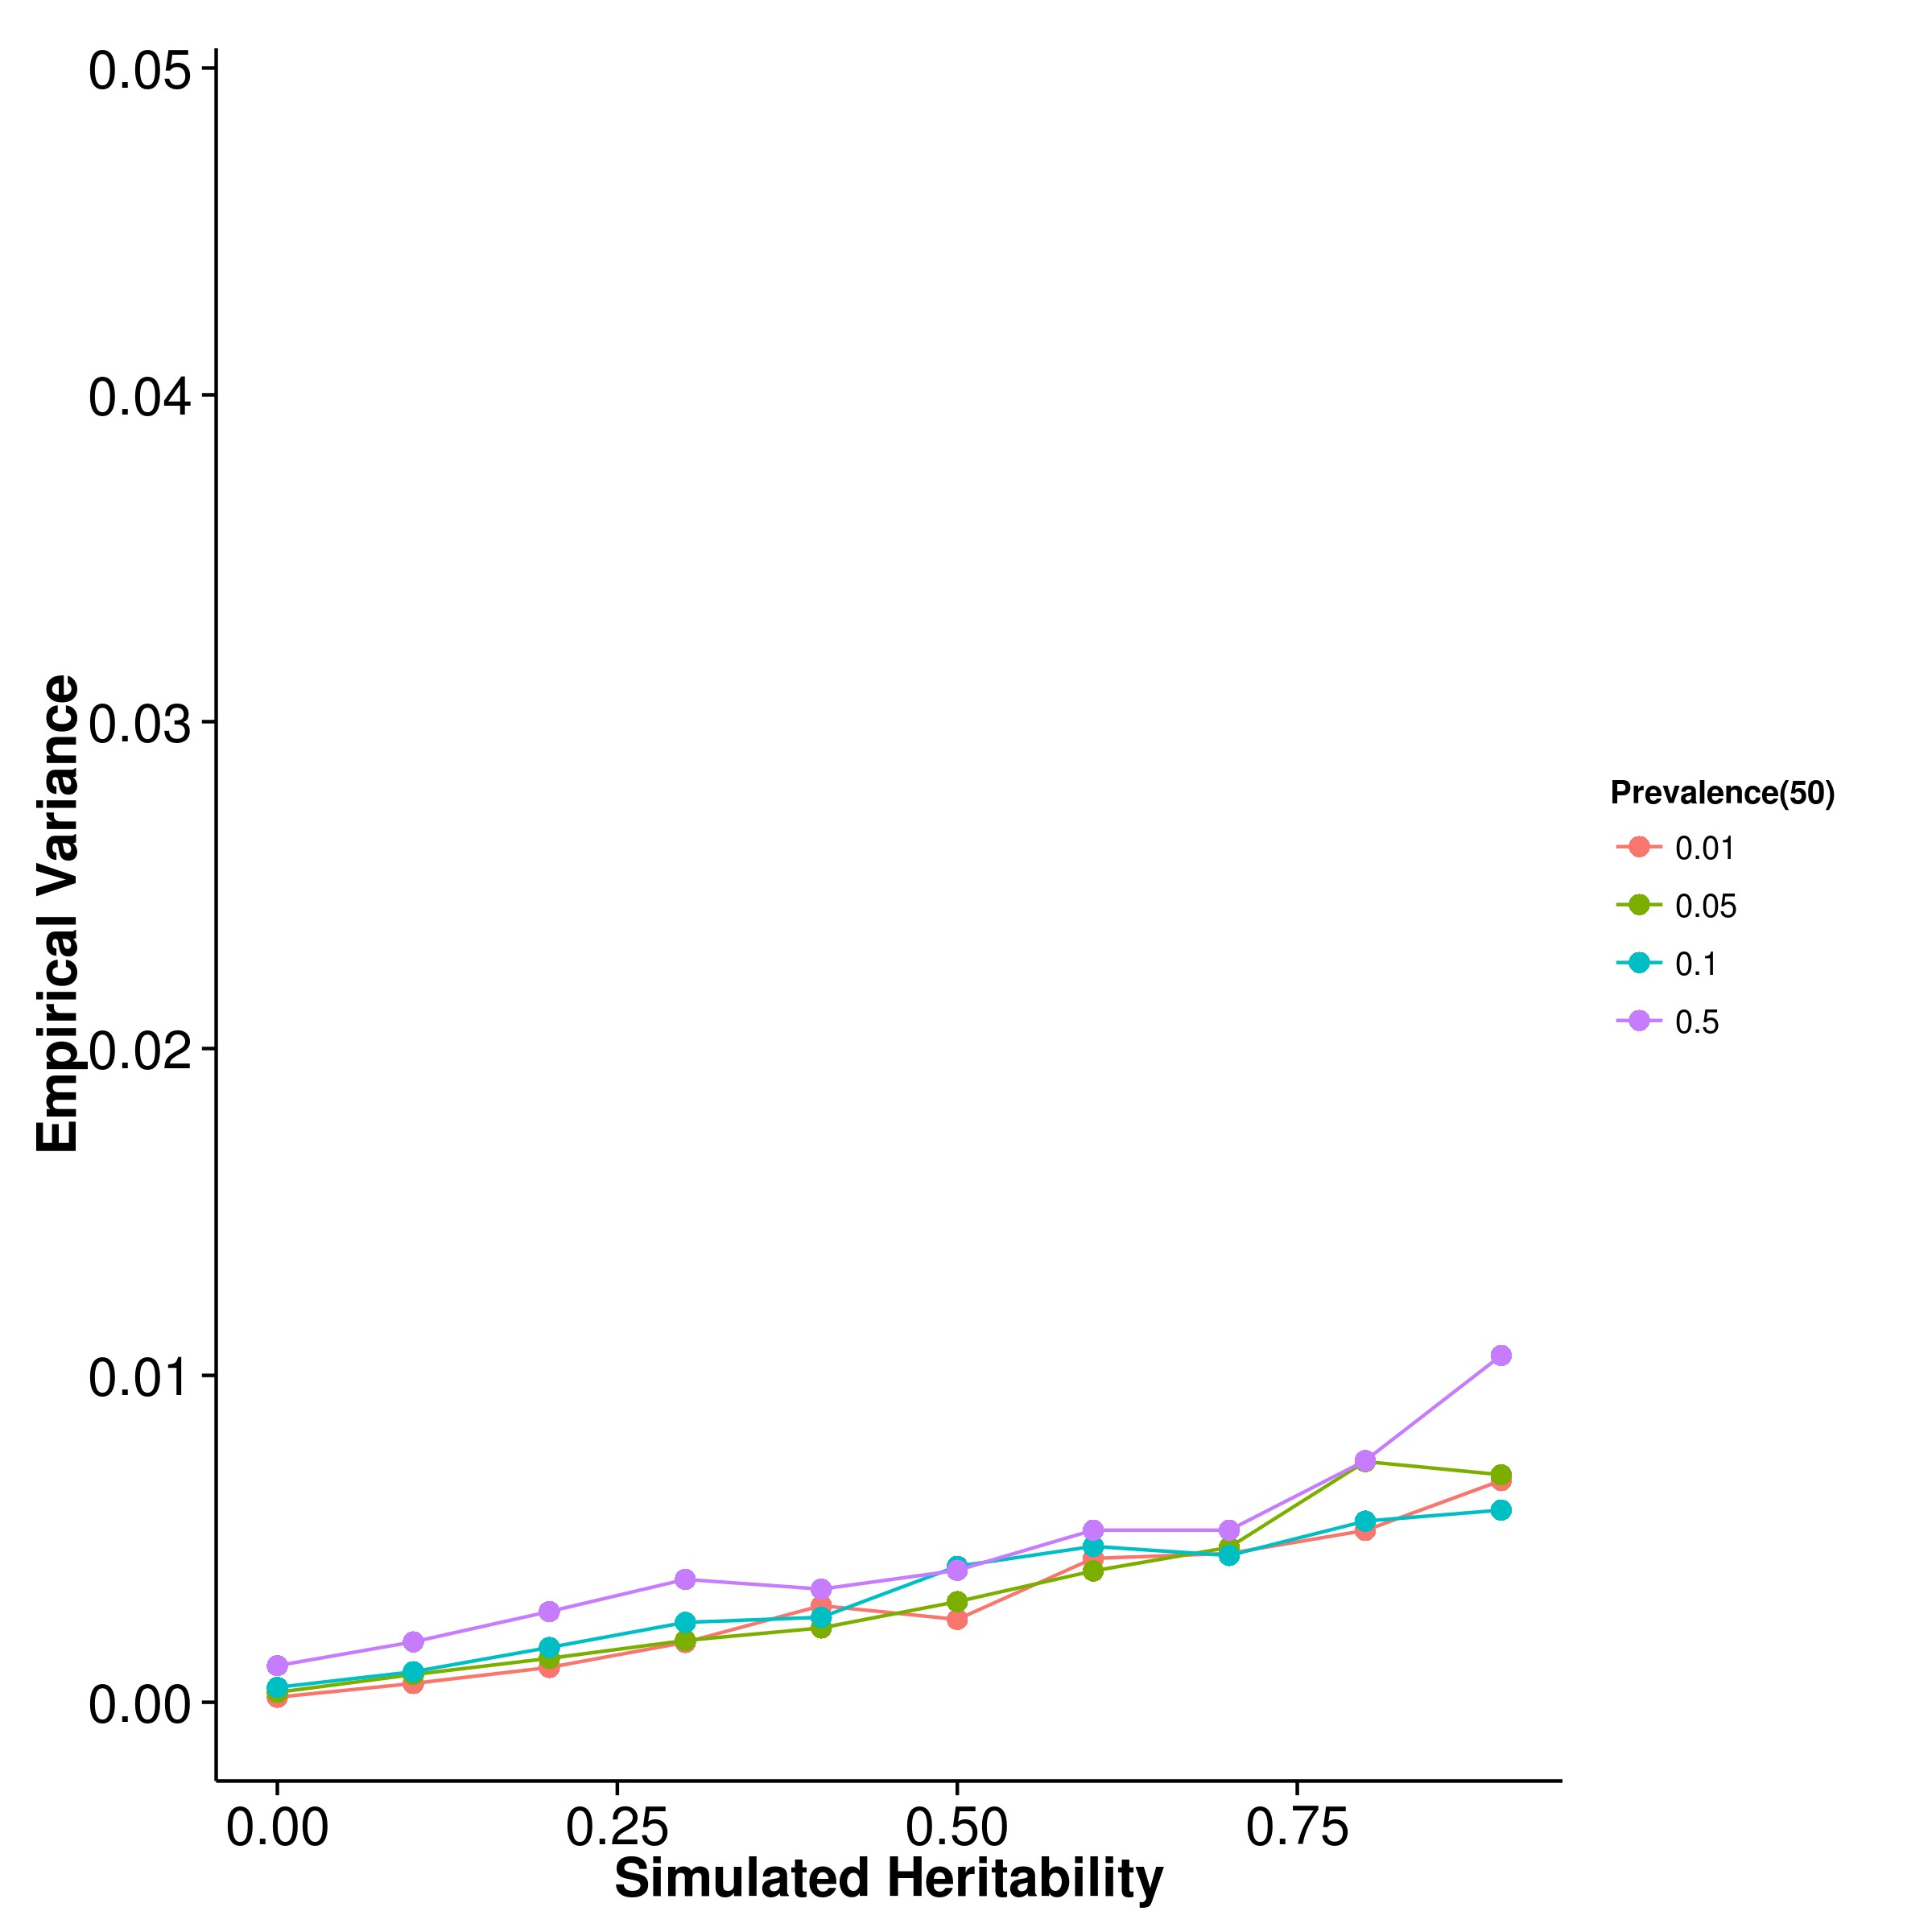

**(c)** LDSC with fix intercept **(d)** LDSC with intercept estimation

**Figure 2.19:** Variance of results from case control simulation with random effect size simulation with 50 causal SNPs. For most algorithm except that of LDSC with fixed intercept, the empirical variance of the estimates increases as the population prevalence of the trait increases, with the estimations from LDSC with intercept estimation display the largest variance.

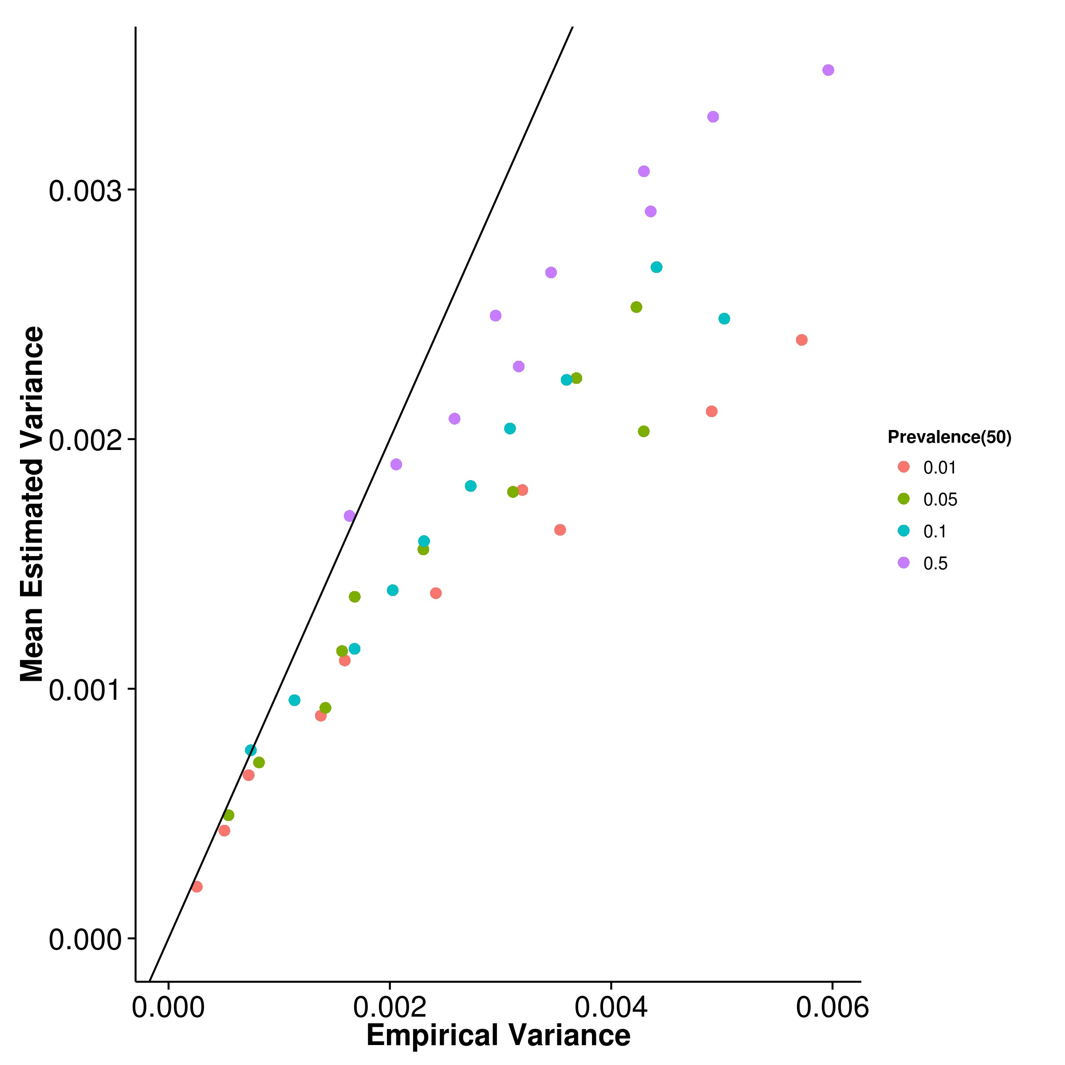

**(a)** SHREK **(b)** GCTA

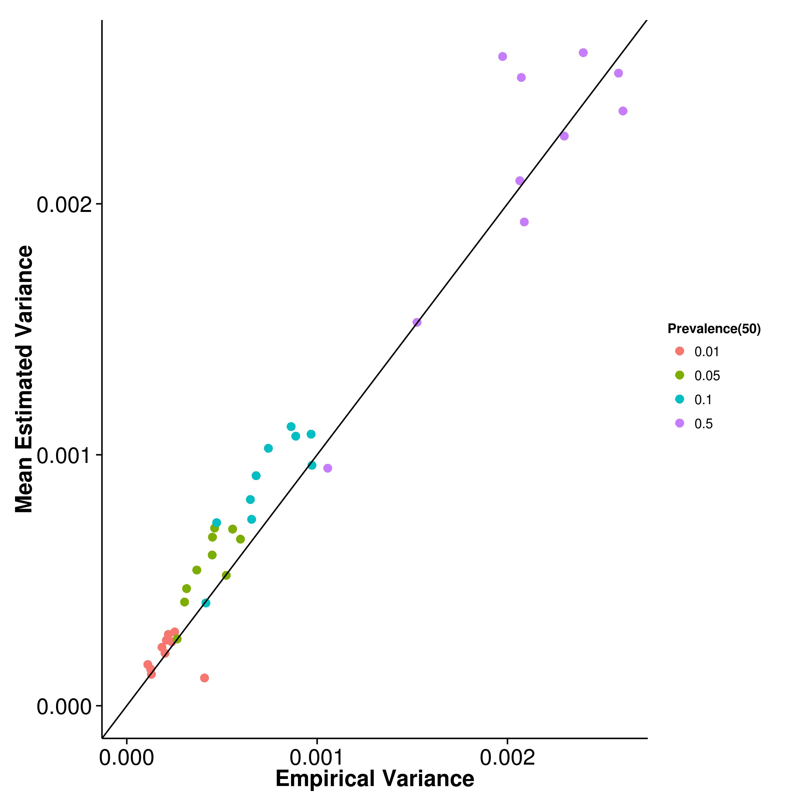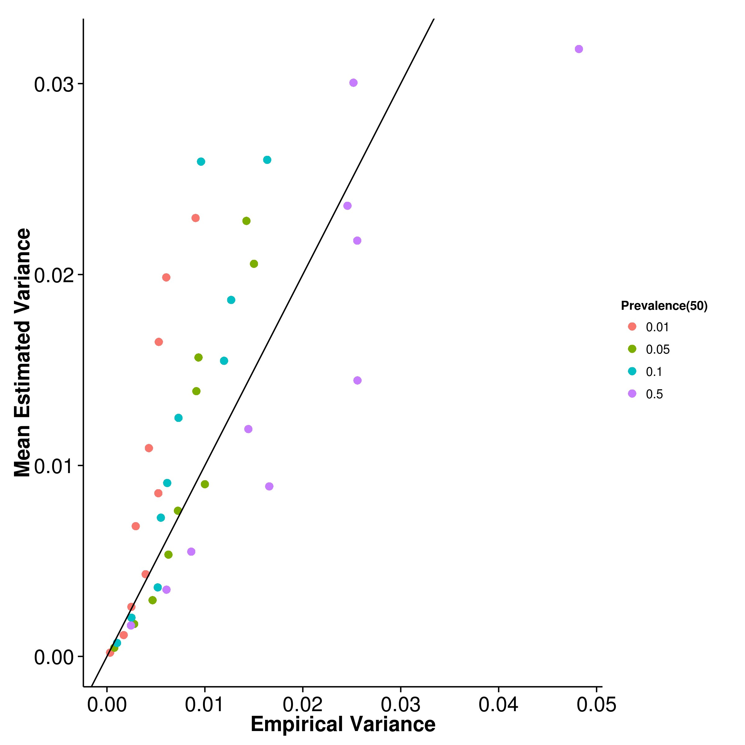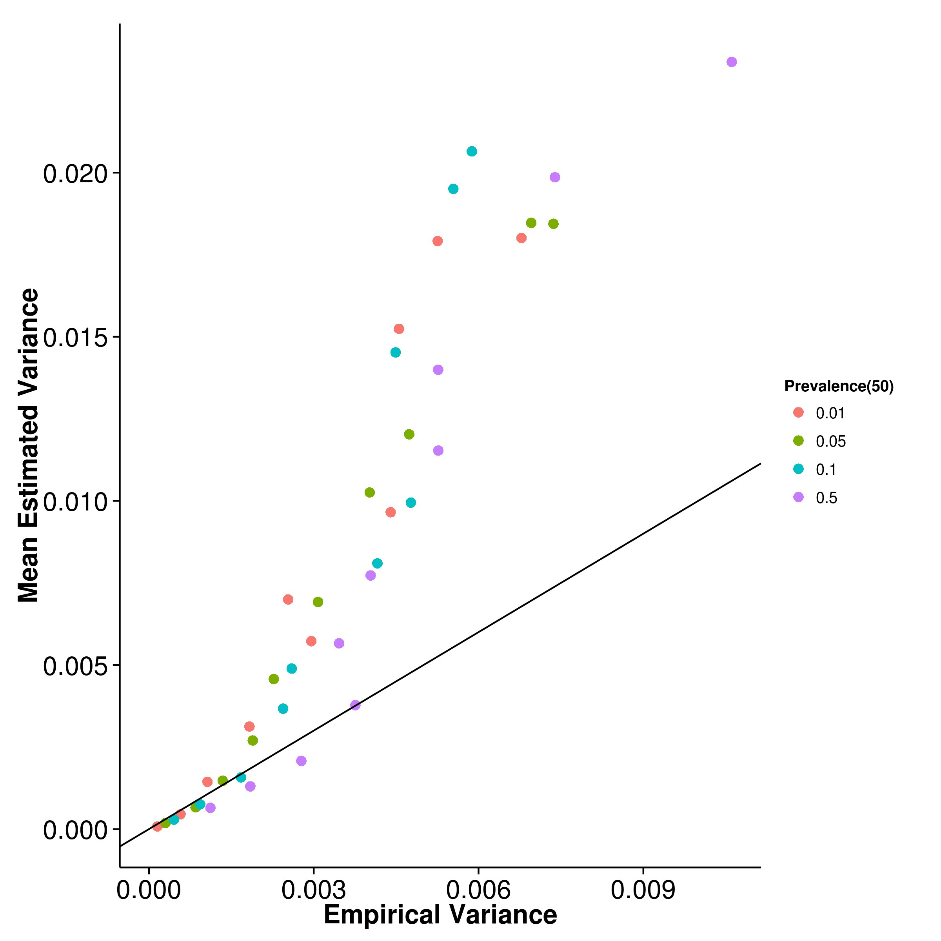

**(c)** LDSC with fix intercept **(d)** LDSC with intercept estimation

**Figure 2.20:** Estimated variance of results from case control simulation with random effect size simulation when compared to empirical variance when 50 causal SNPs was simulated. Again, the estimation of variance from SHREK tends to be downwardly biased and LDSC with fixed intercept tends to be upwardly biased. However, when intercept estimation was performed, the estimation of variance of LDSC improved.

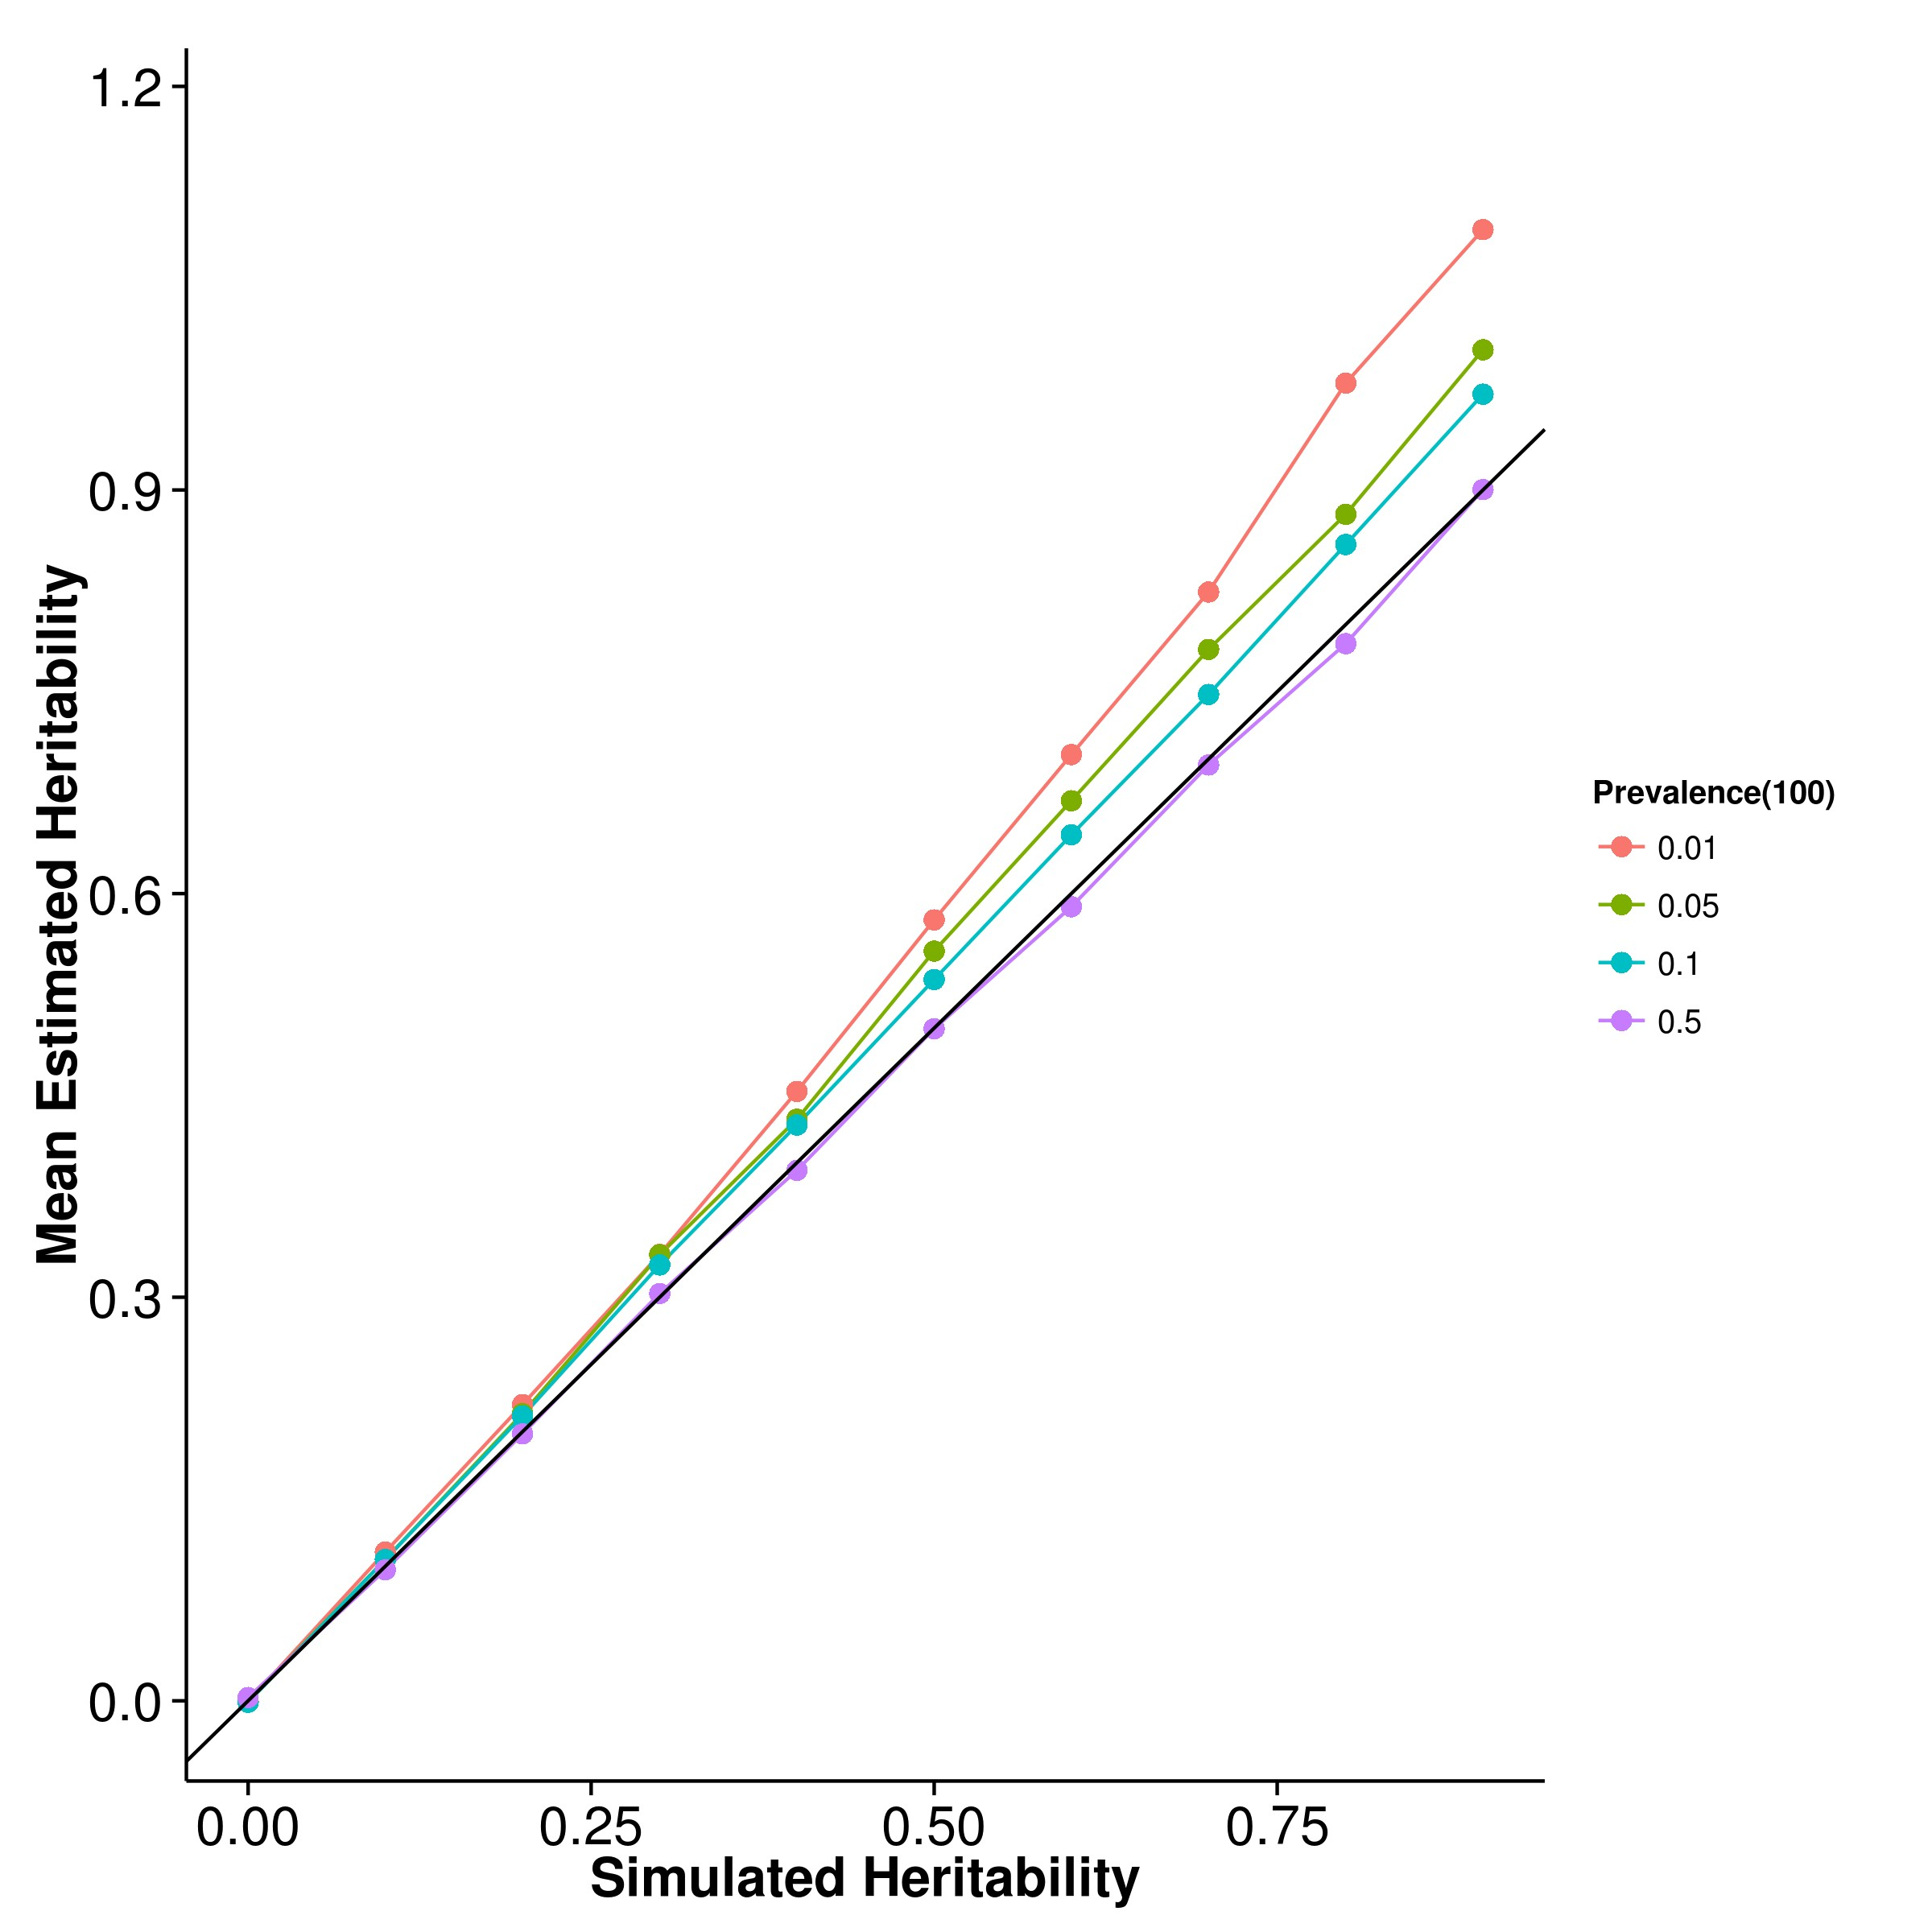

**(a)** SHREK **(b)** GCTA

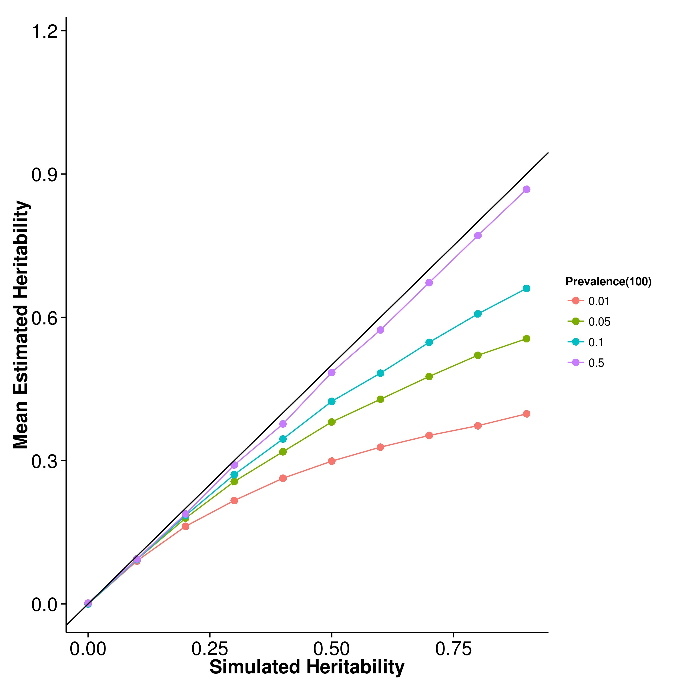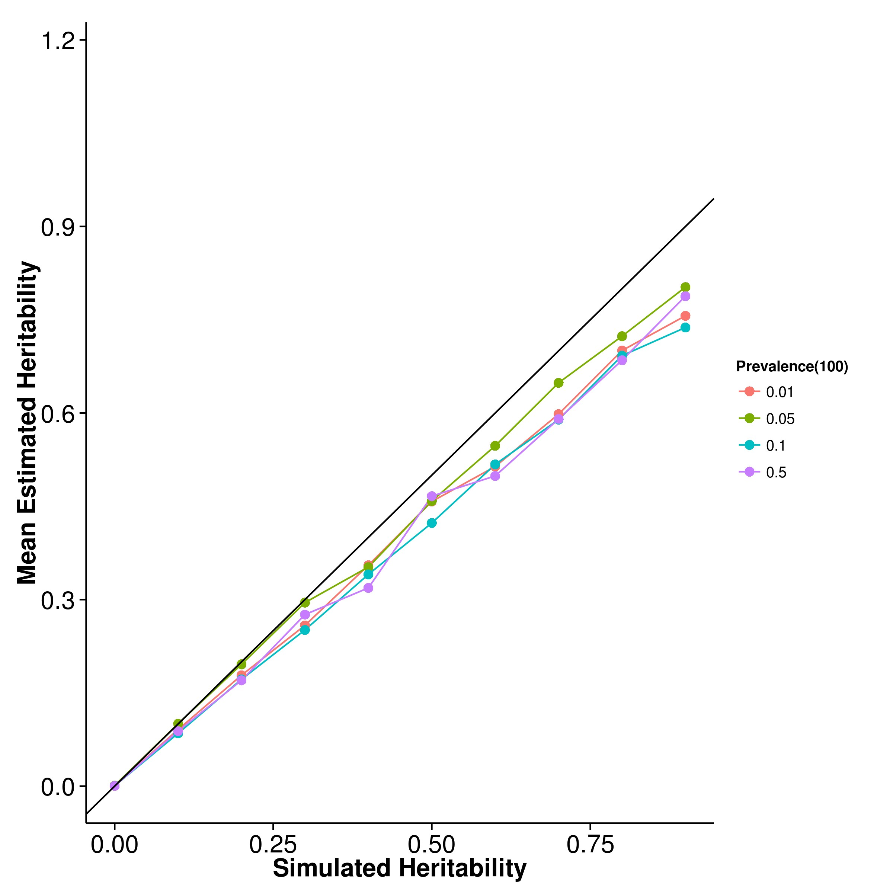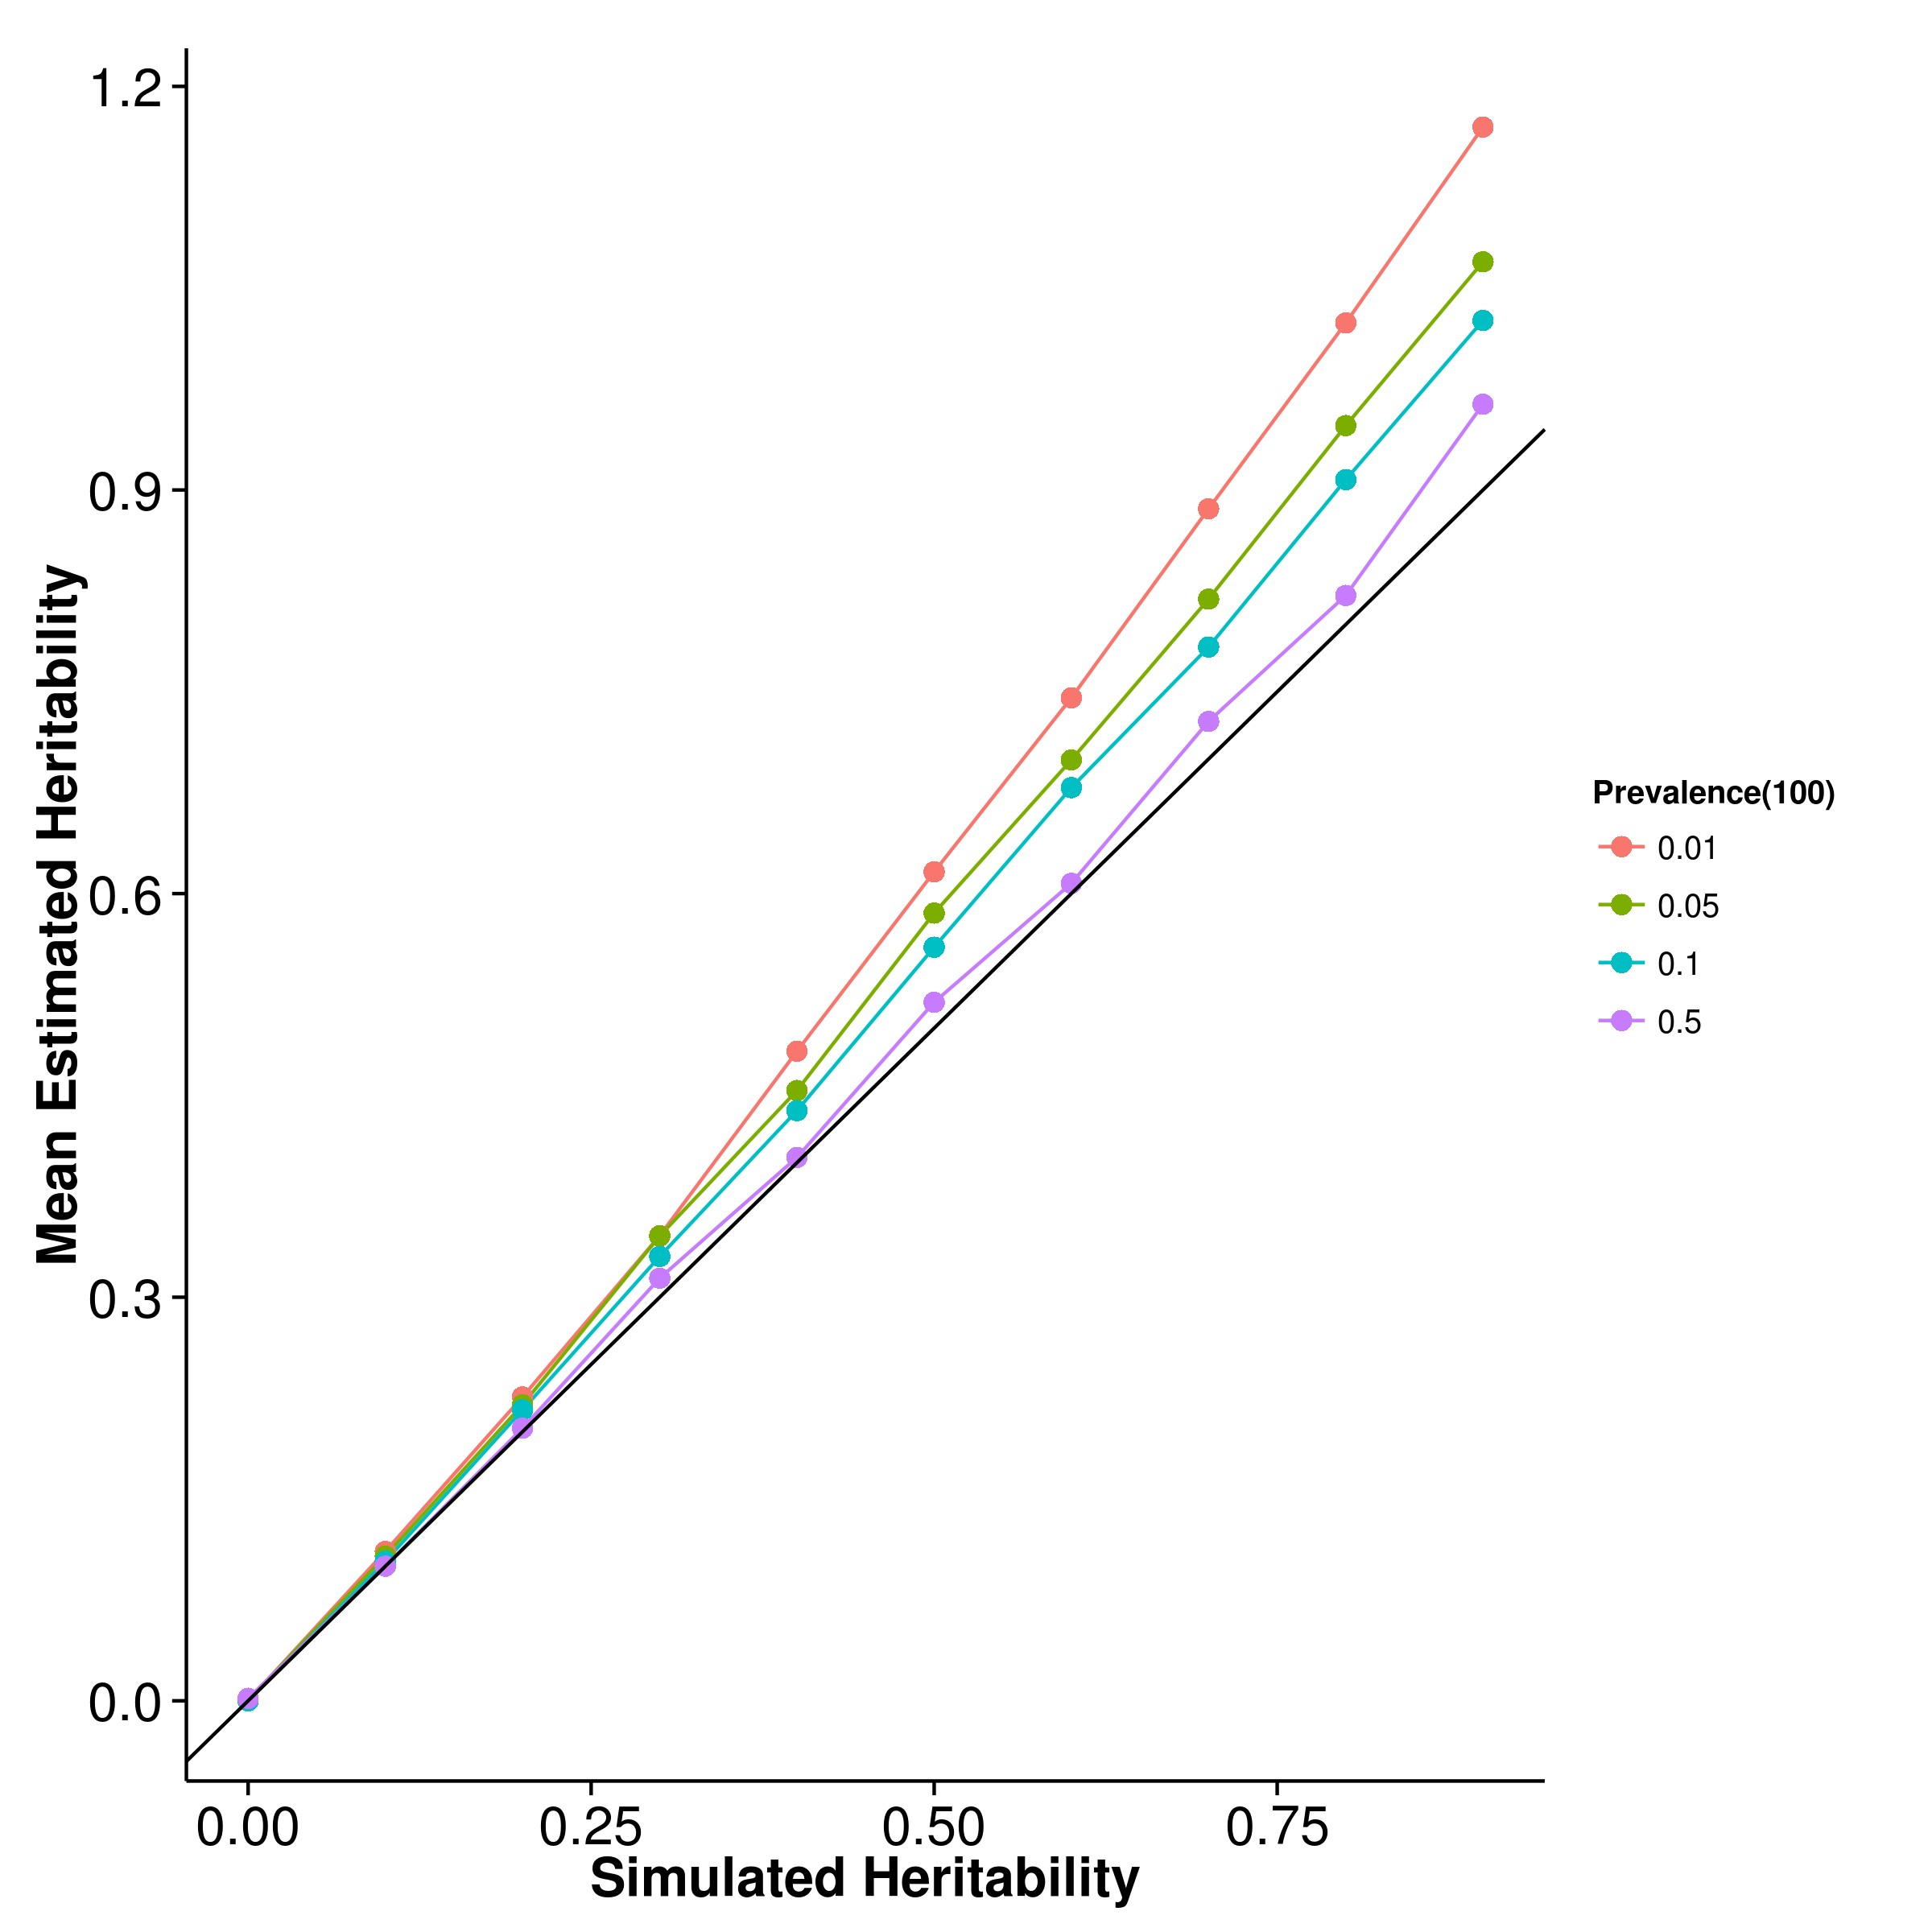

**(c)** LDSC with fix intercept **(d)** LDSC with intercept estimation

**Figure 2.21:** Mean of results from case control simulation with random effect size simulation with 100 causal SNPs. The bias seems to be unaffected by the number of causal SNPs and were the same as what was observed when there were 10 or 50 causal SNPs.

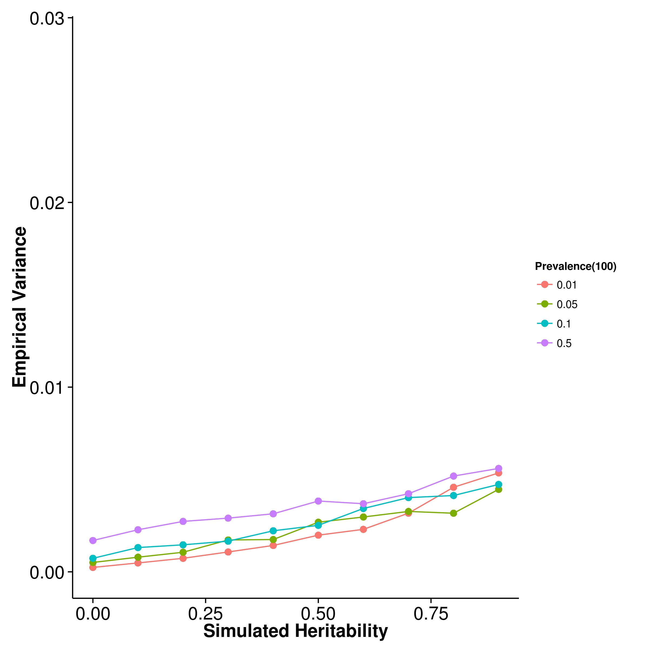

**(a)** SHREK **(b)** GCTA

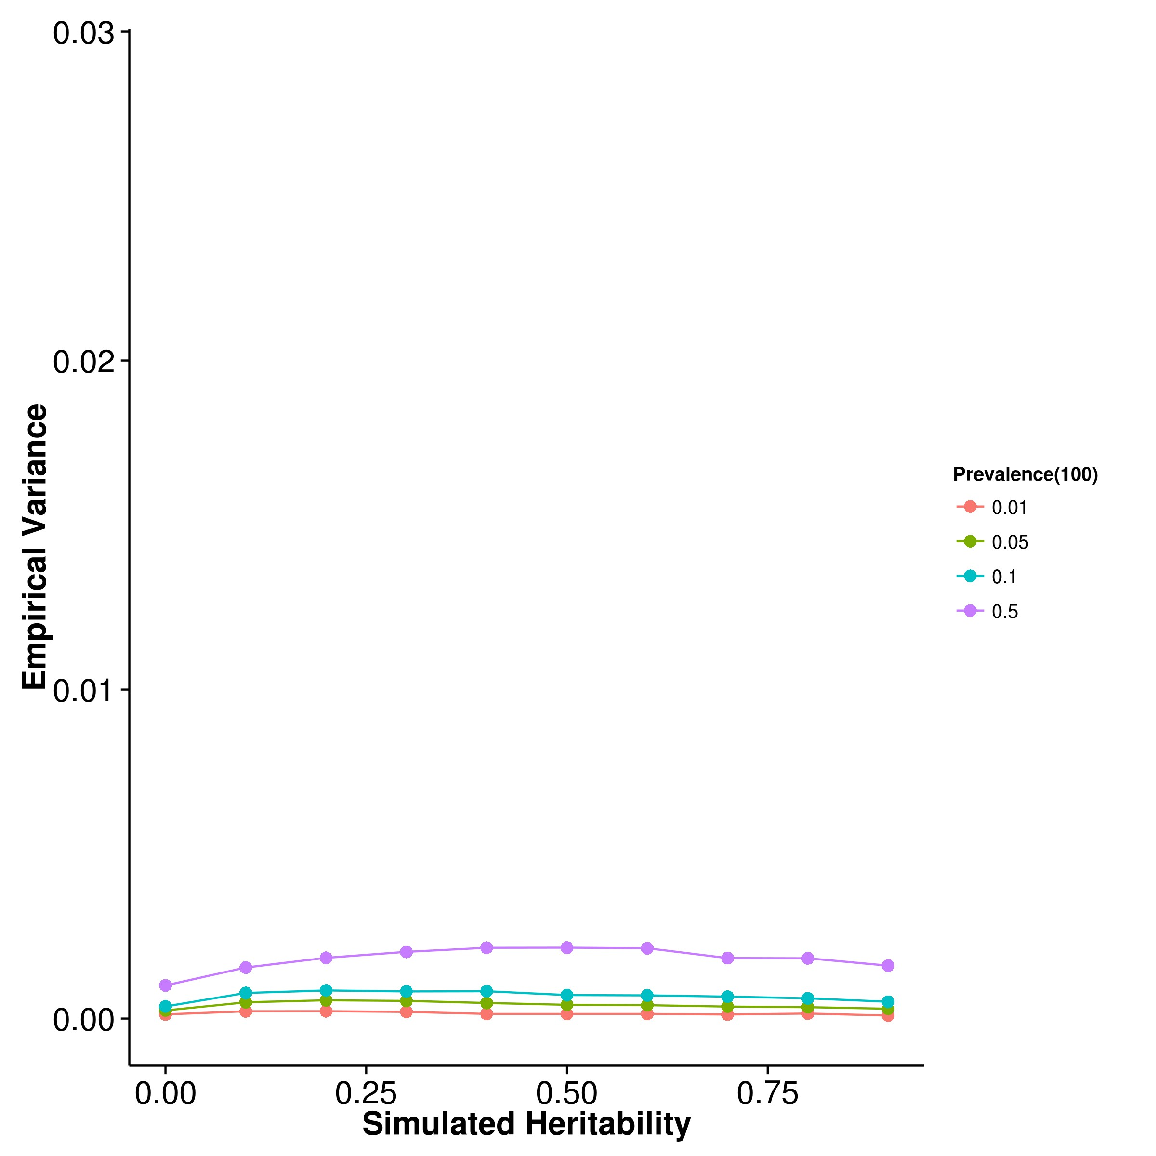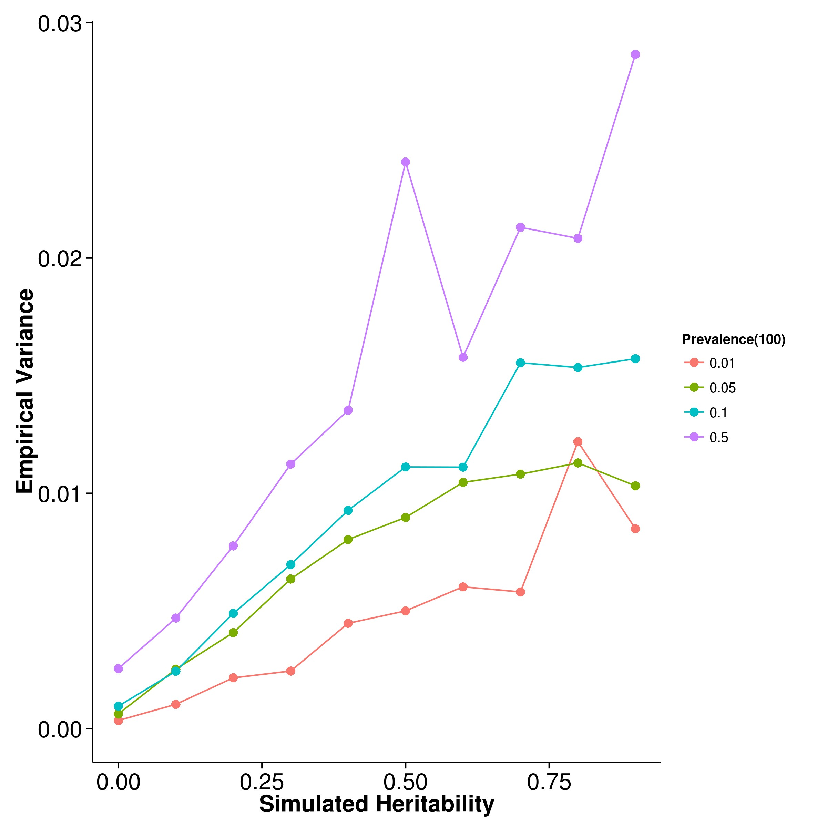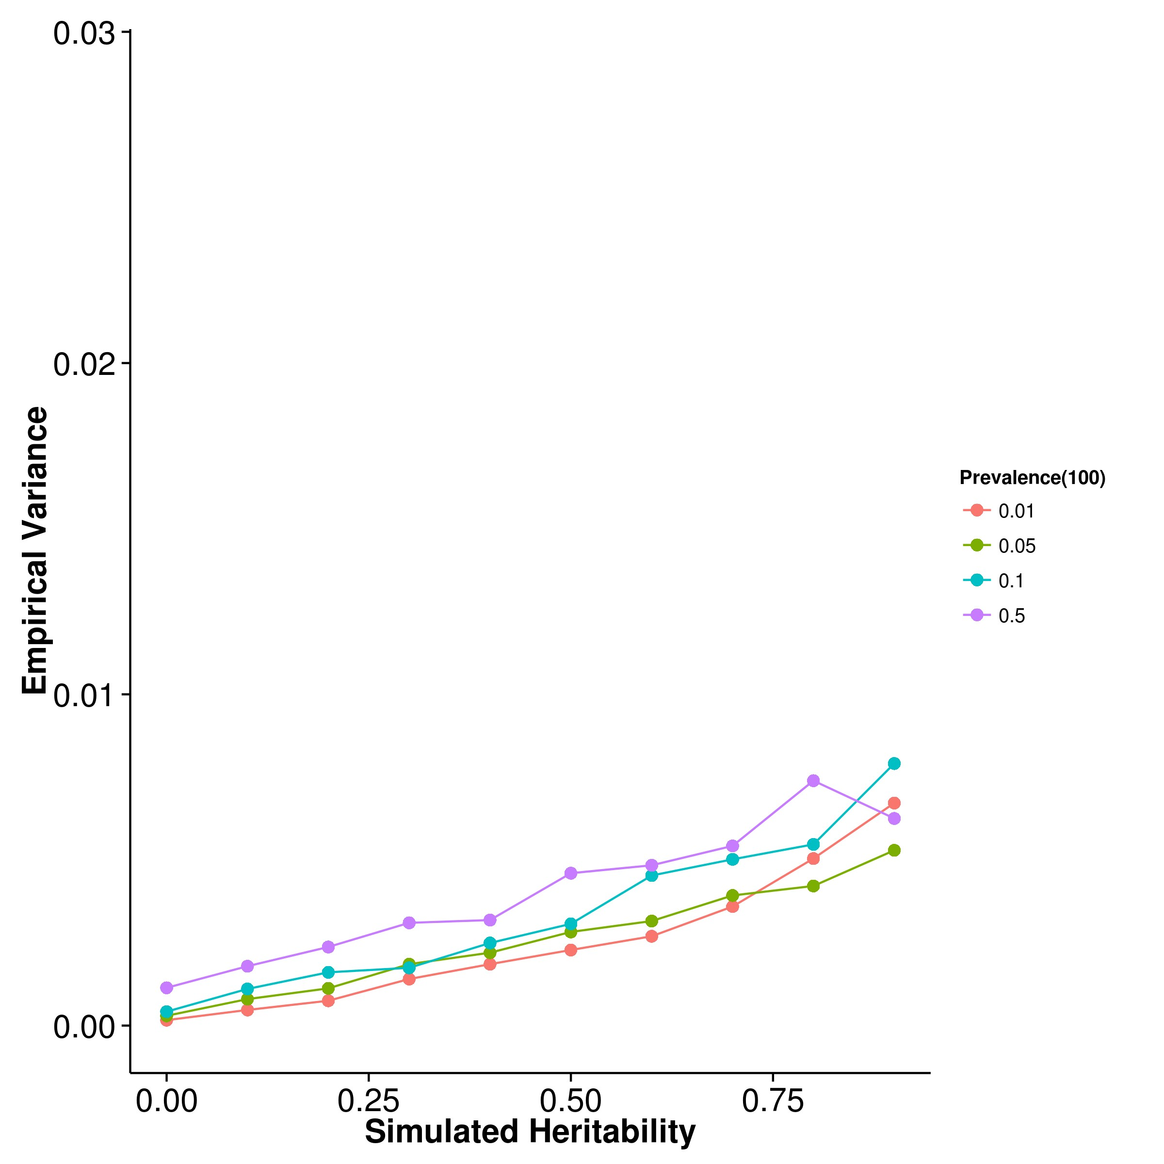

**(c)** LDSC with fix intercept **(d)** LDSC with intercept estimation

**Figure 2.22:** Variance of results from case control simulation with random effect size simulation with 100 causal SNPs. As the number of causal SNPs increased to 100, the relationship between the population prevalence and the empirical variance of the algorithms become clear where as the population prevalence increases, the empirical variance of all algorithm increases. Again, LDSC with intercept estimation has the largest variation of all the algorithms and the empirical variance of LDSC with fix intercept is only slightly higher than that of SHREK.

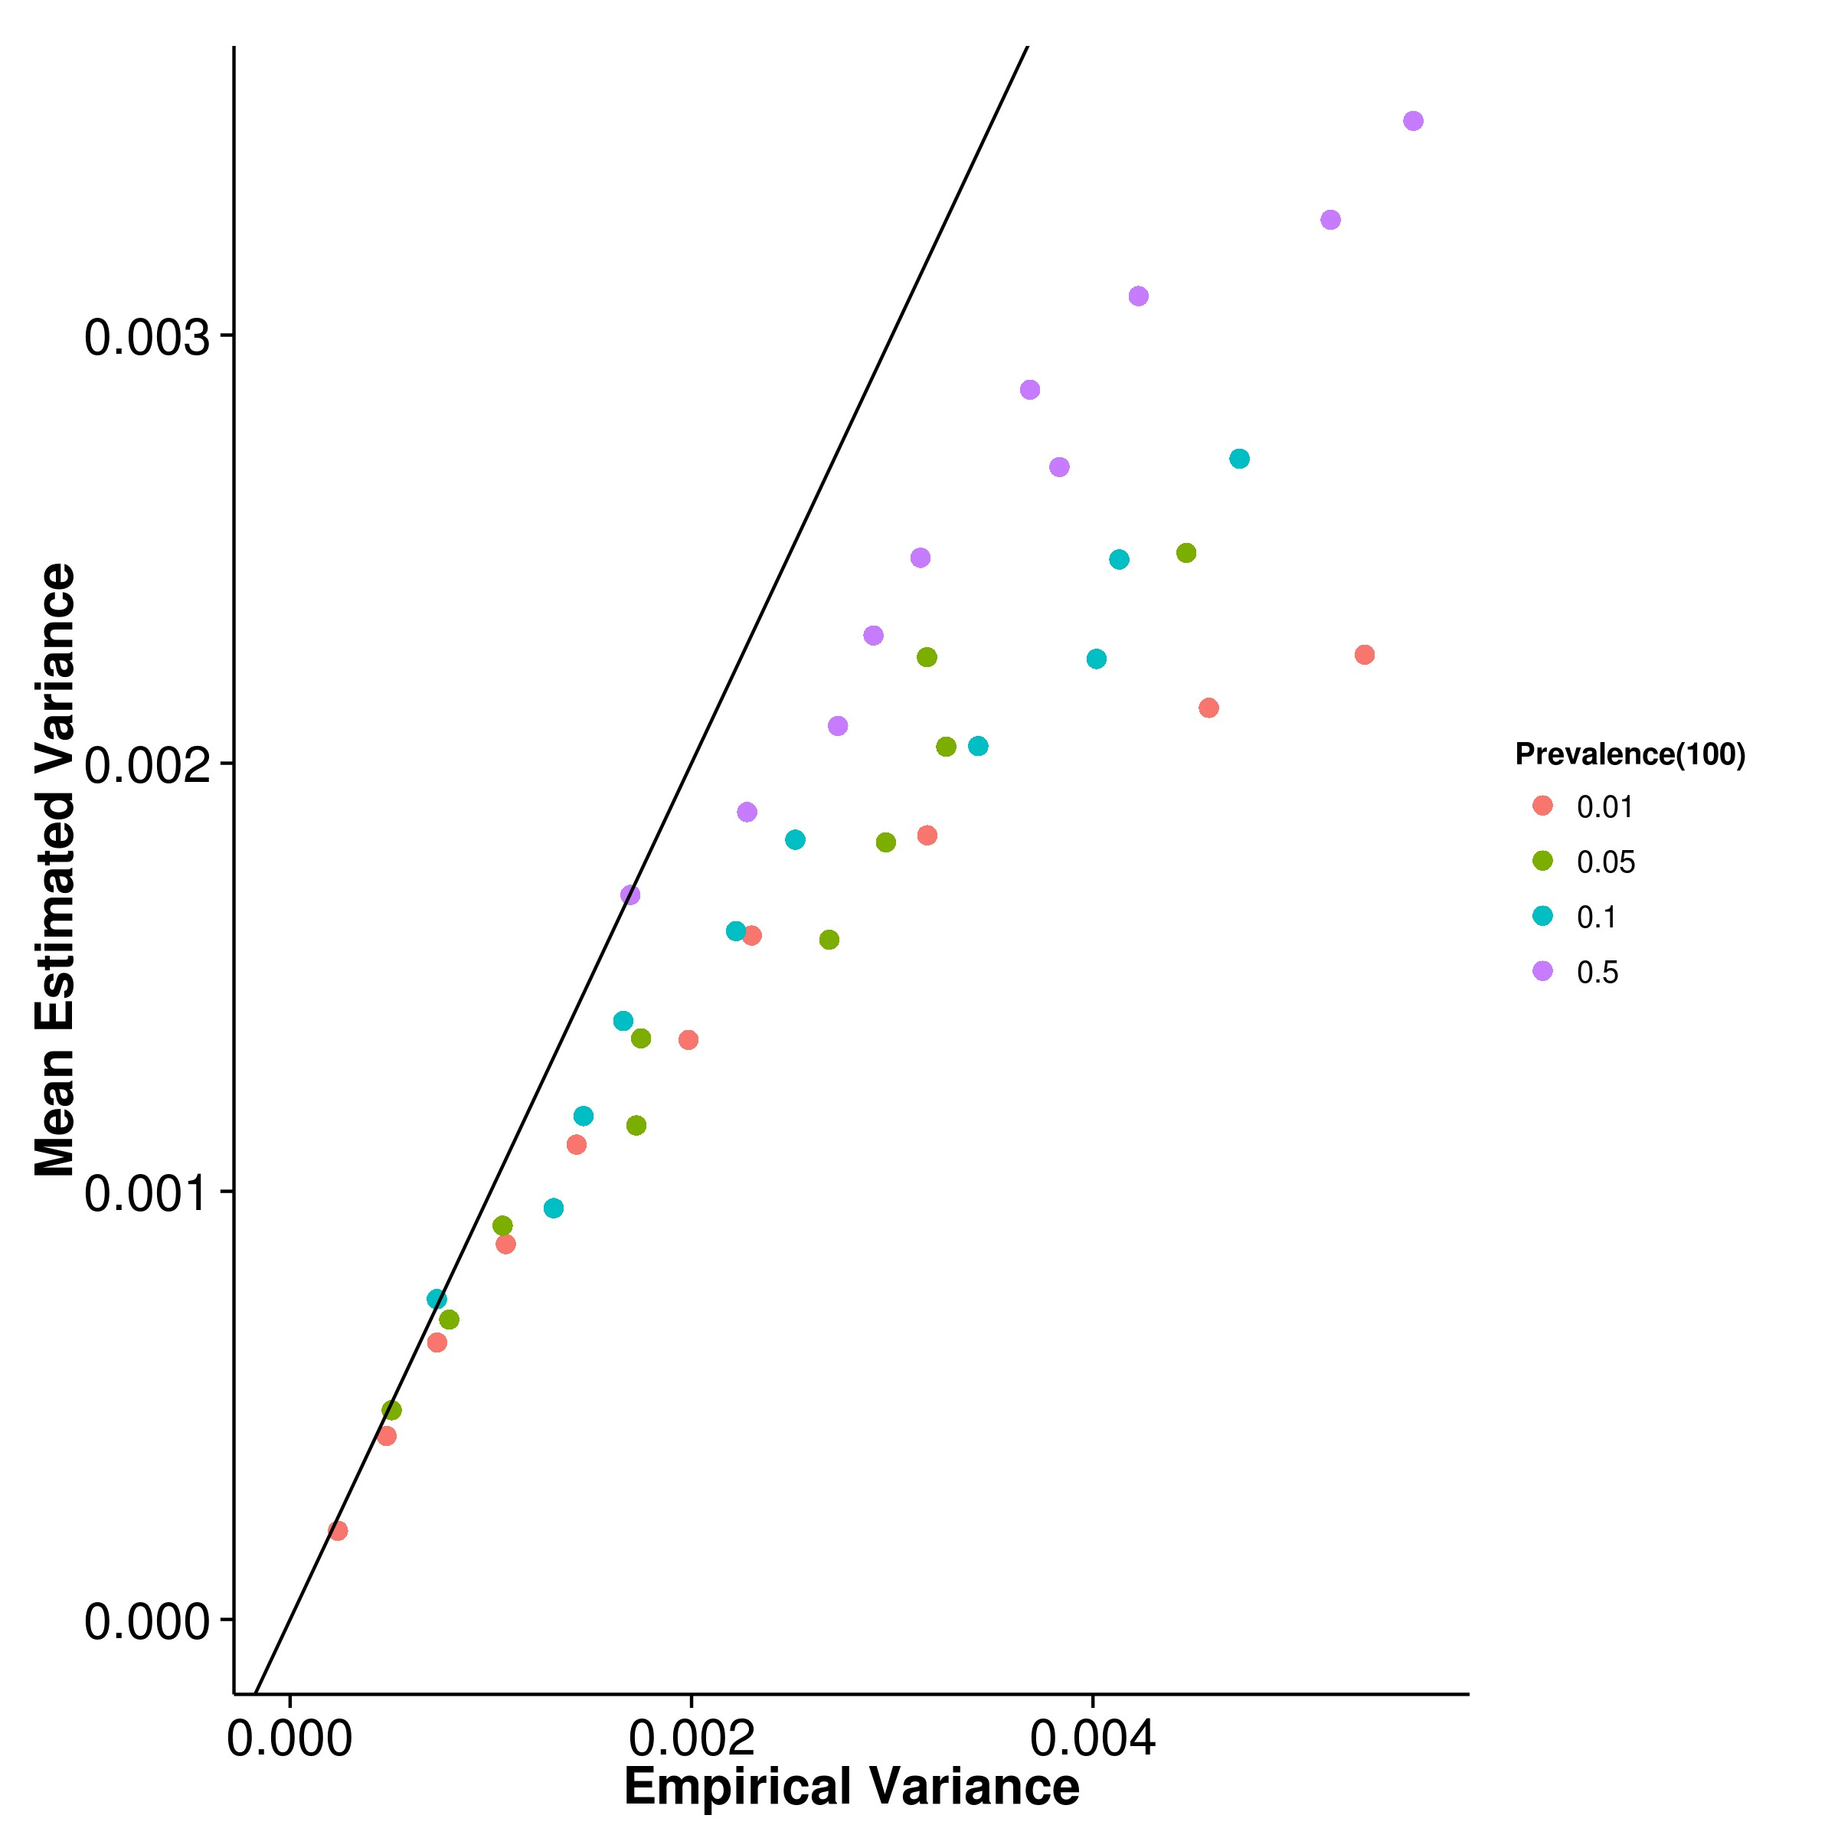

**(a)** SHREK **(b)** GCTA

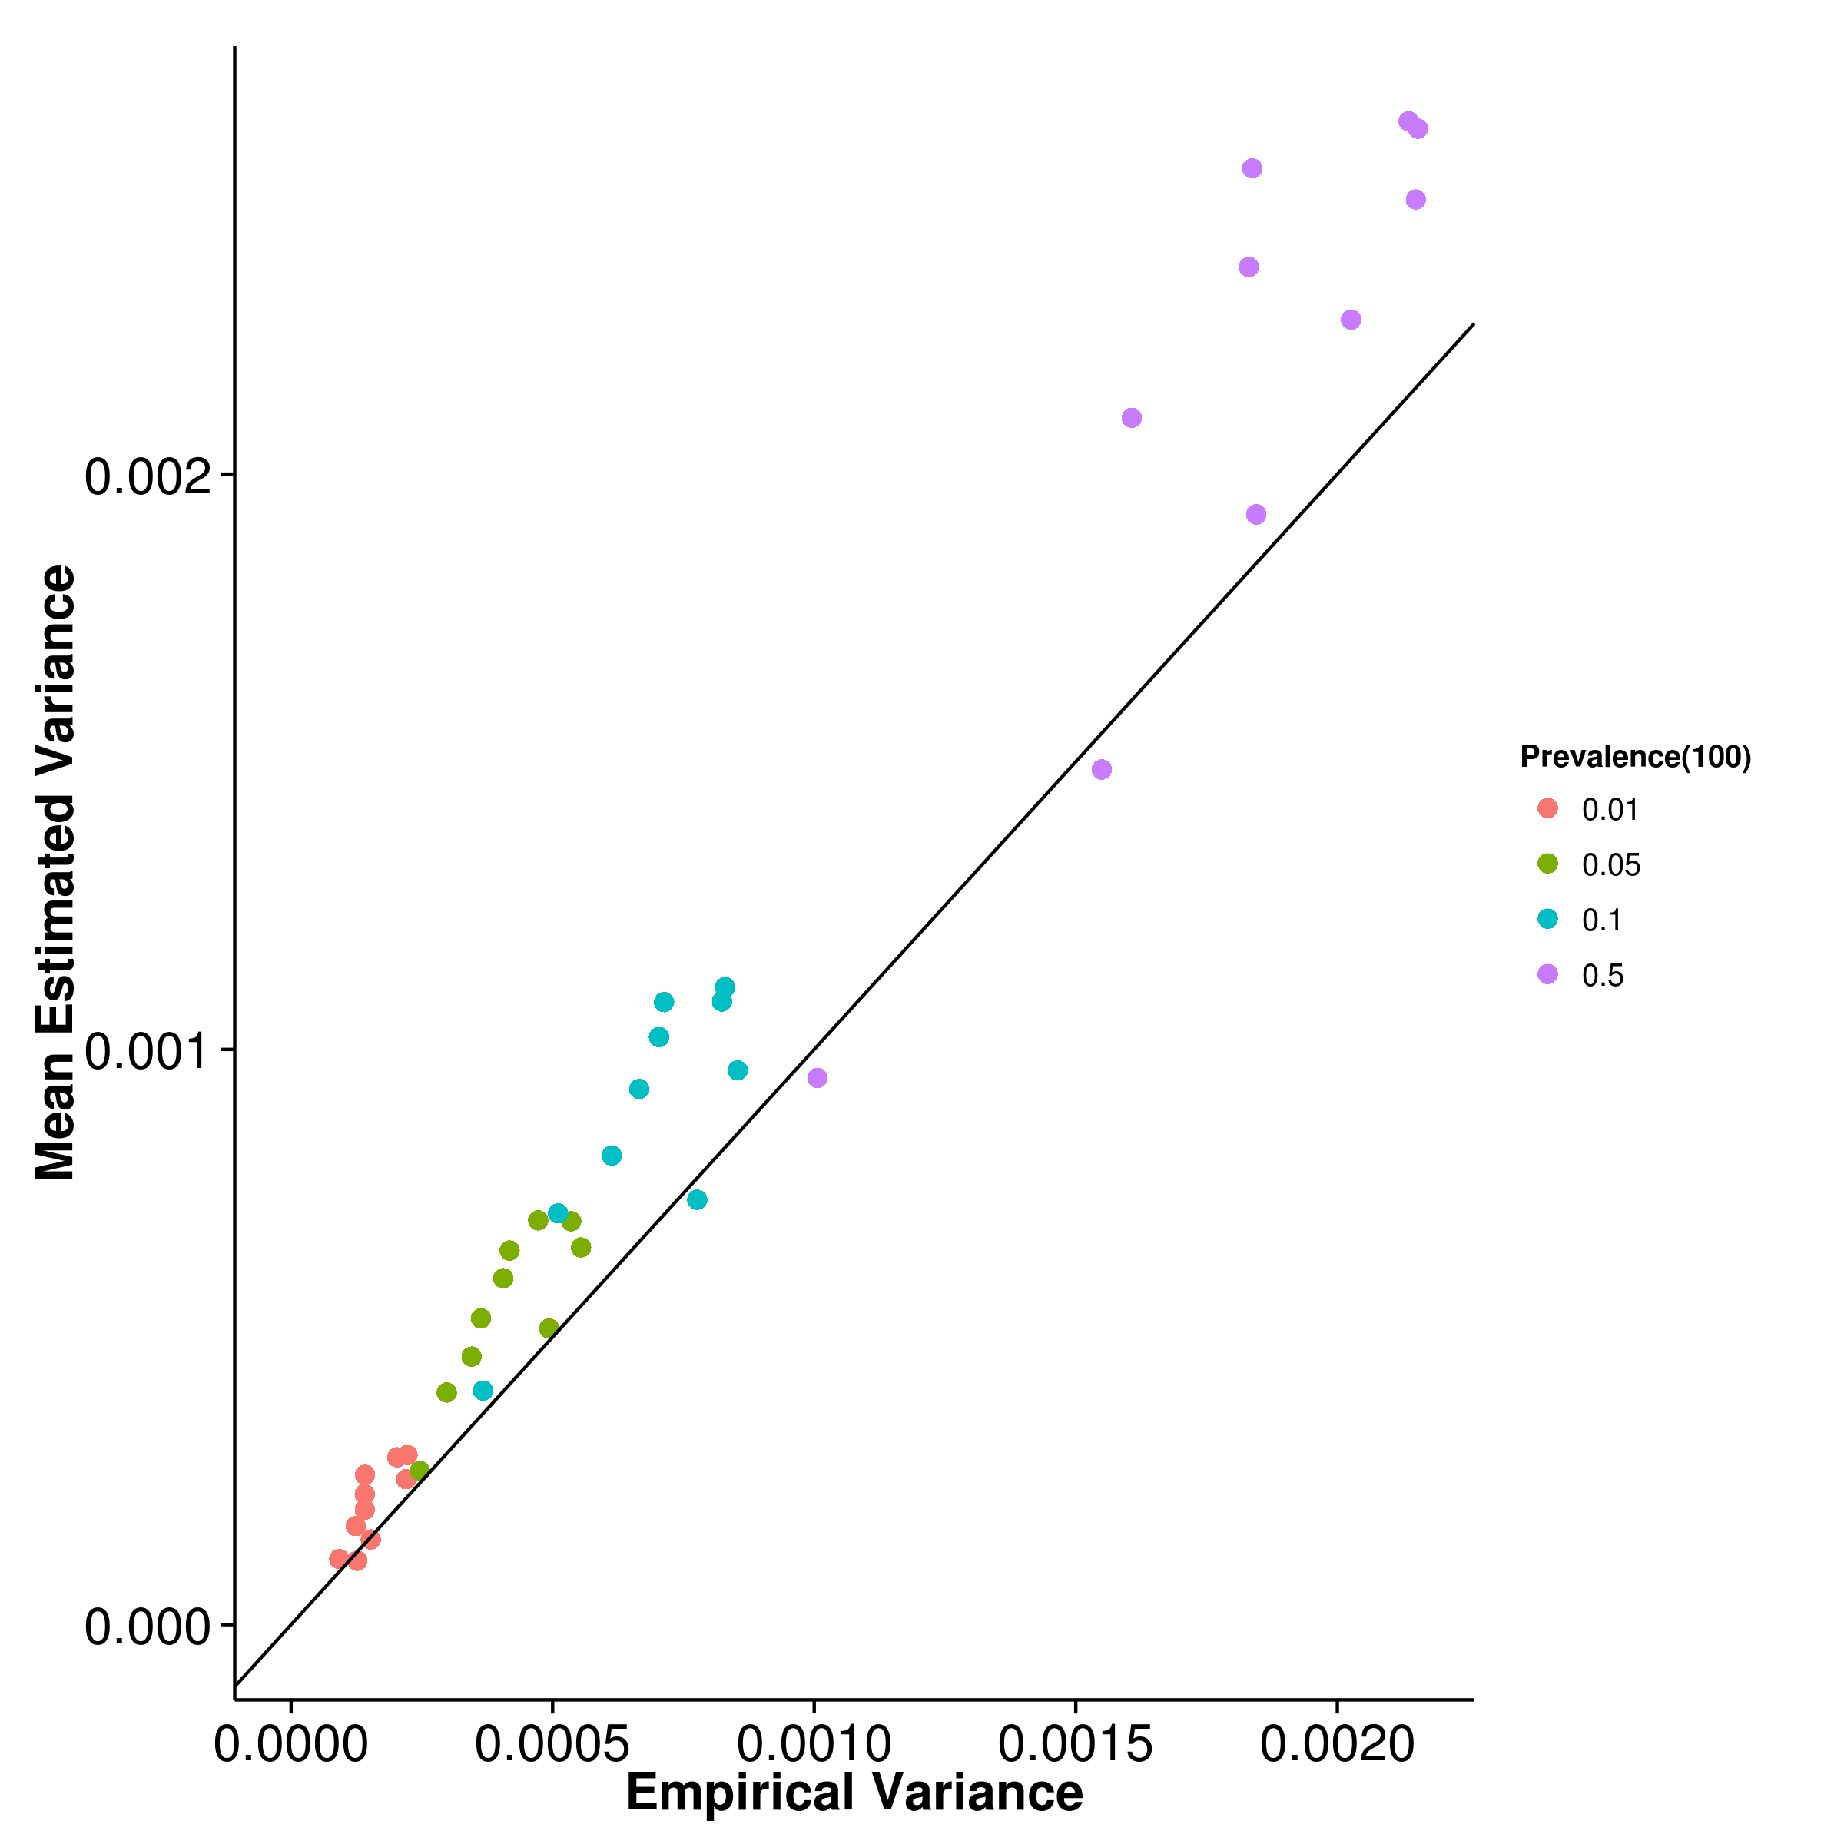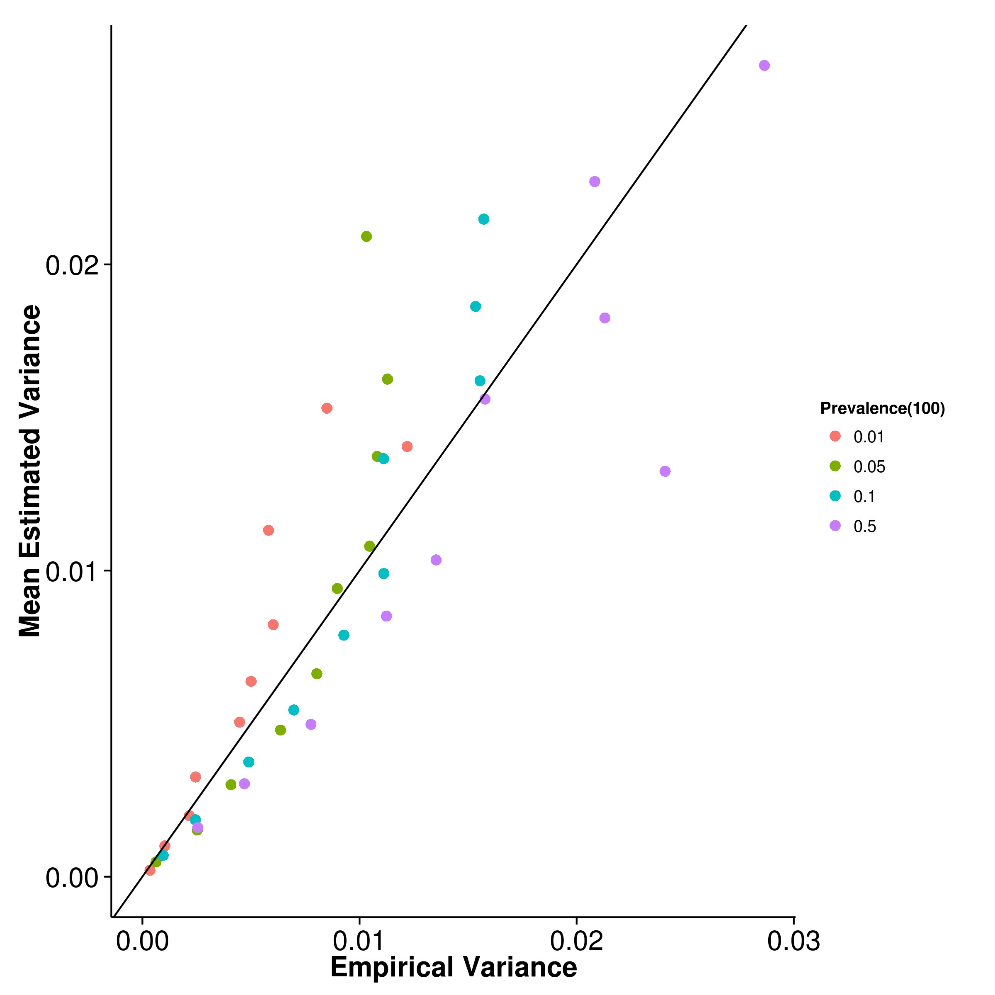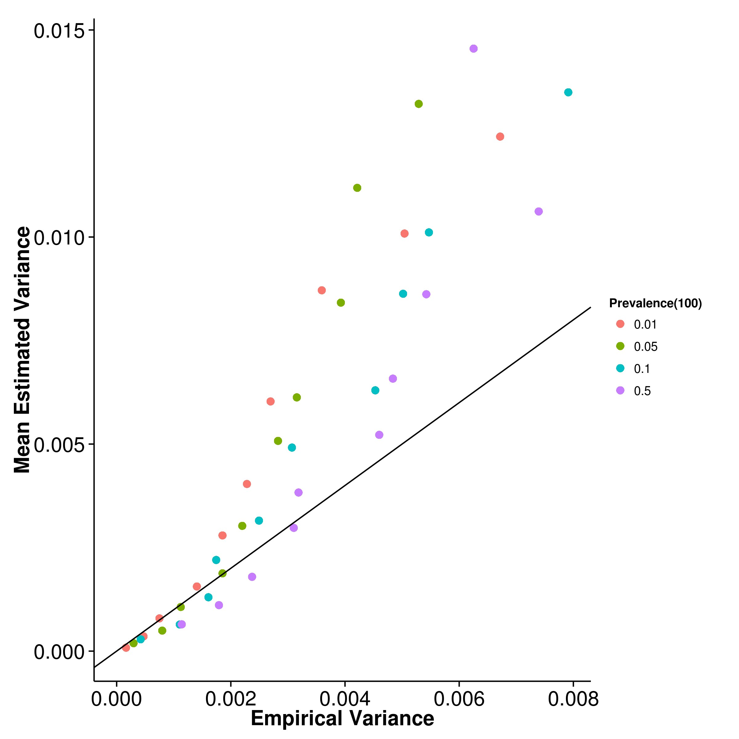

**(c)** LDSC with fix intercept **(d)** LDSC with intercept estimation

**Figure 2.23:** Estimated variance of results from case control simulation with random effect size simulation when compared to empirical variance when 100 causal SNPs was simulated. Once again, SHREK underestimated its empirical variance and LDSC with fixed intercept overestimates its empirical variance. However, the magnitude of overestimation of LDSC with fixed intercept decreased when compared to previous conditions.

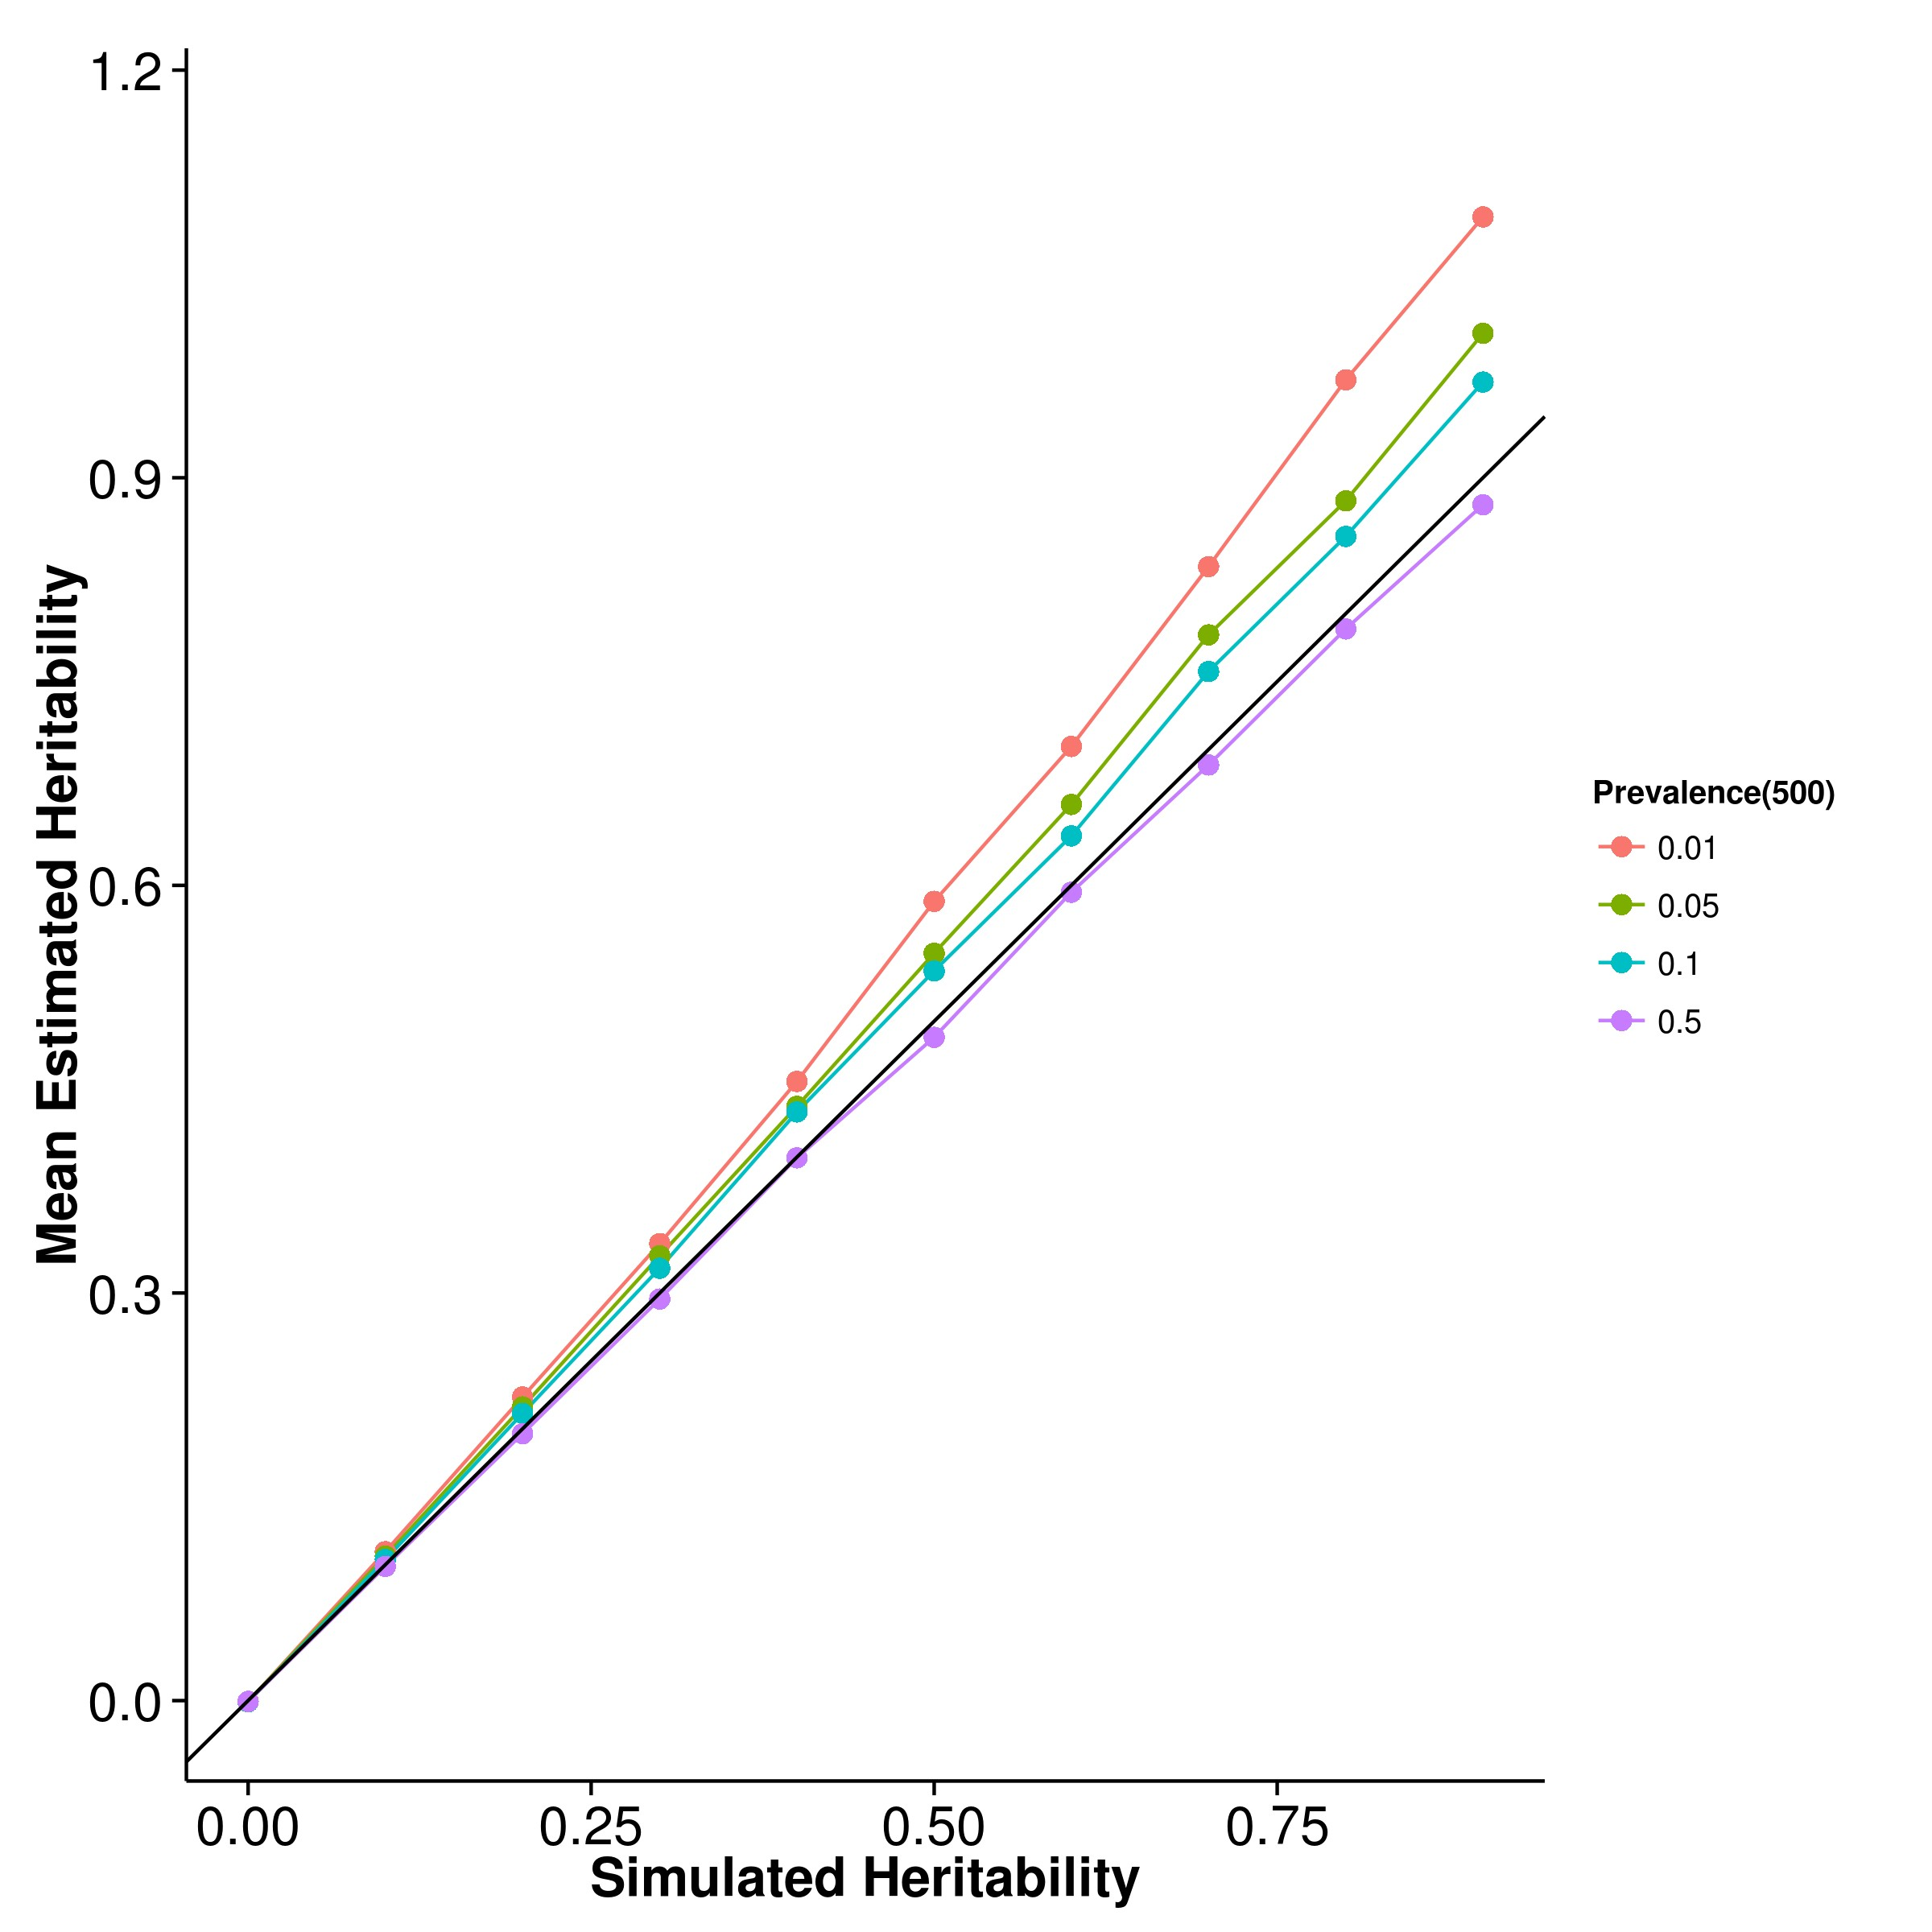

**(a)** SHREK **(b)** GCTA

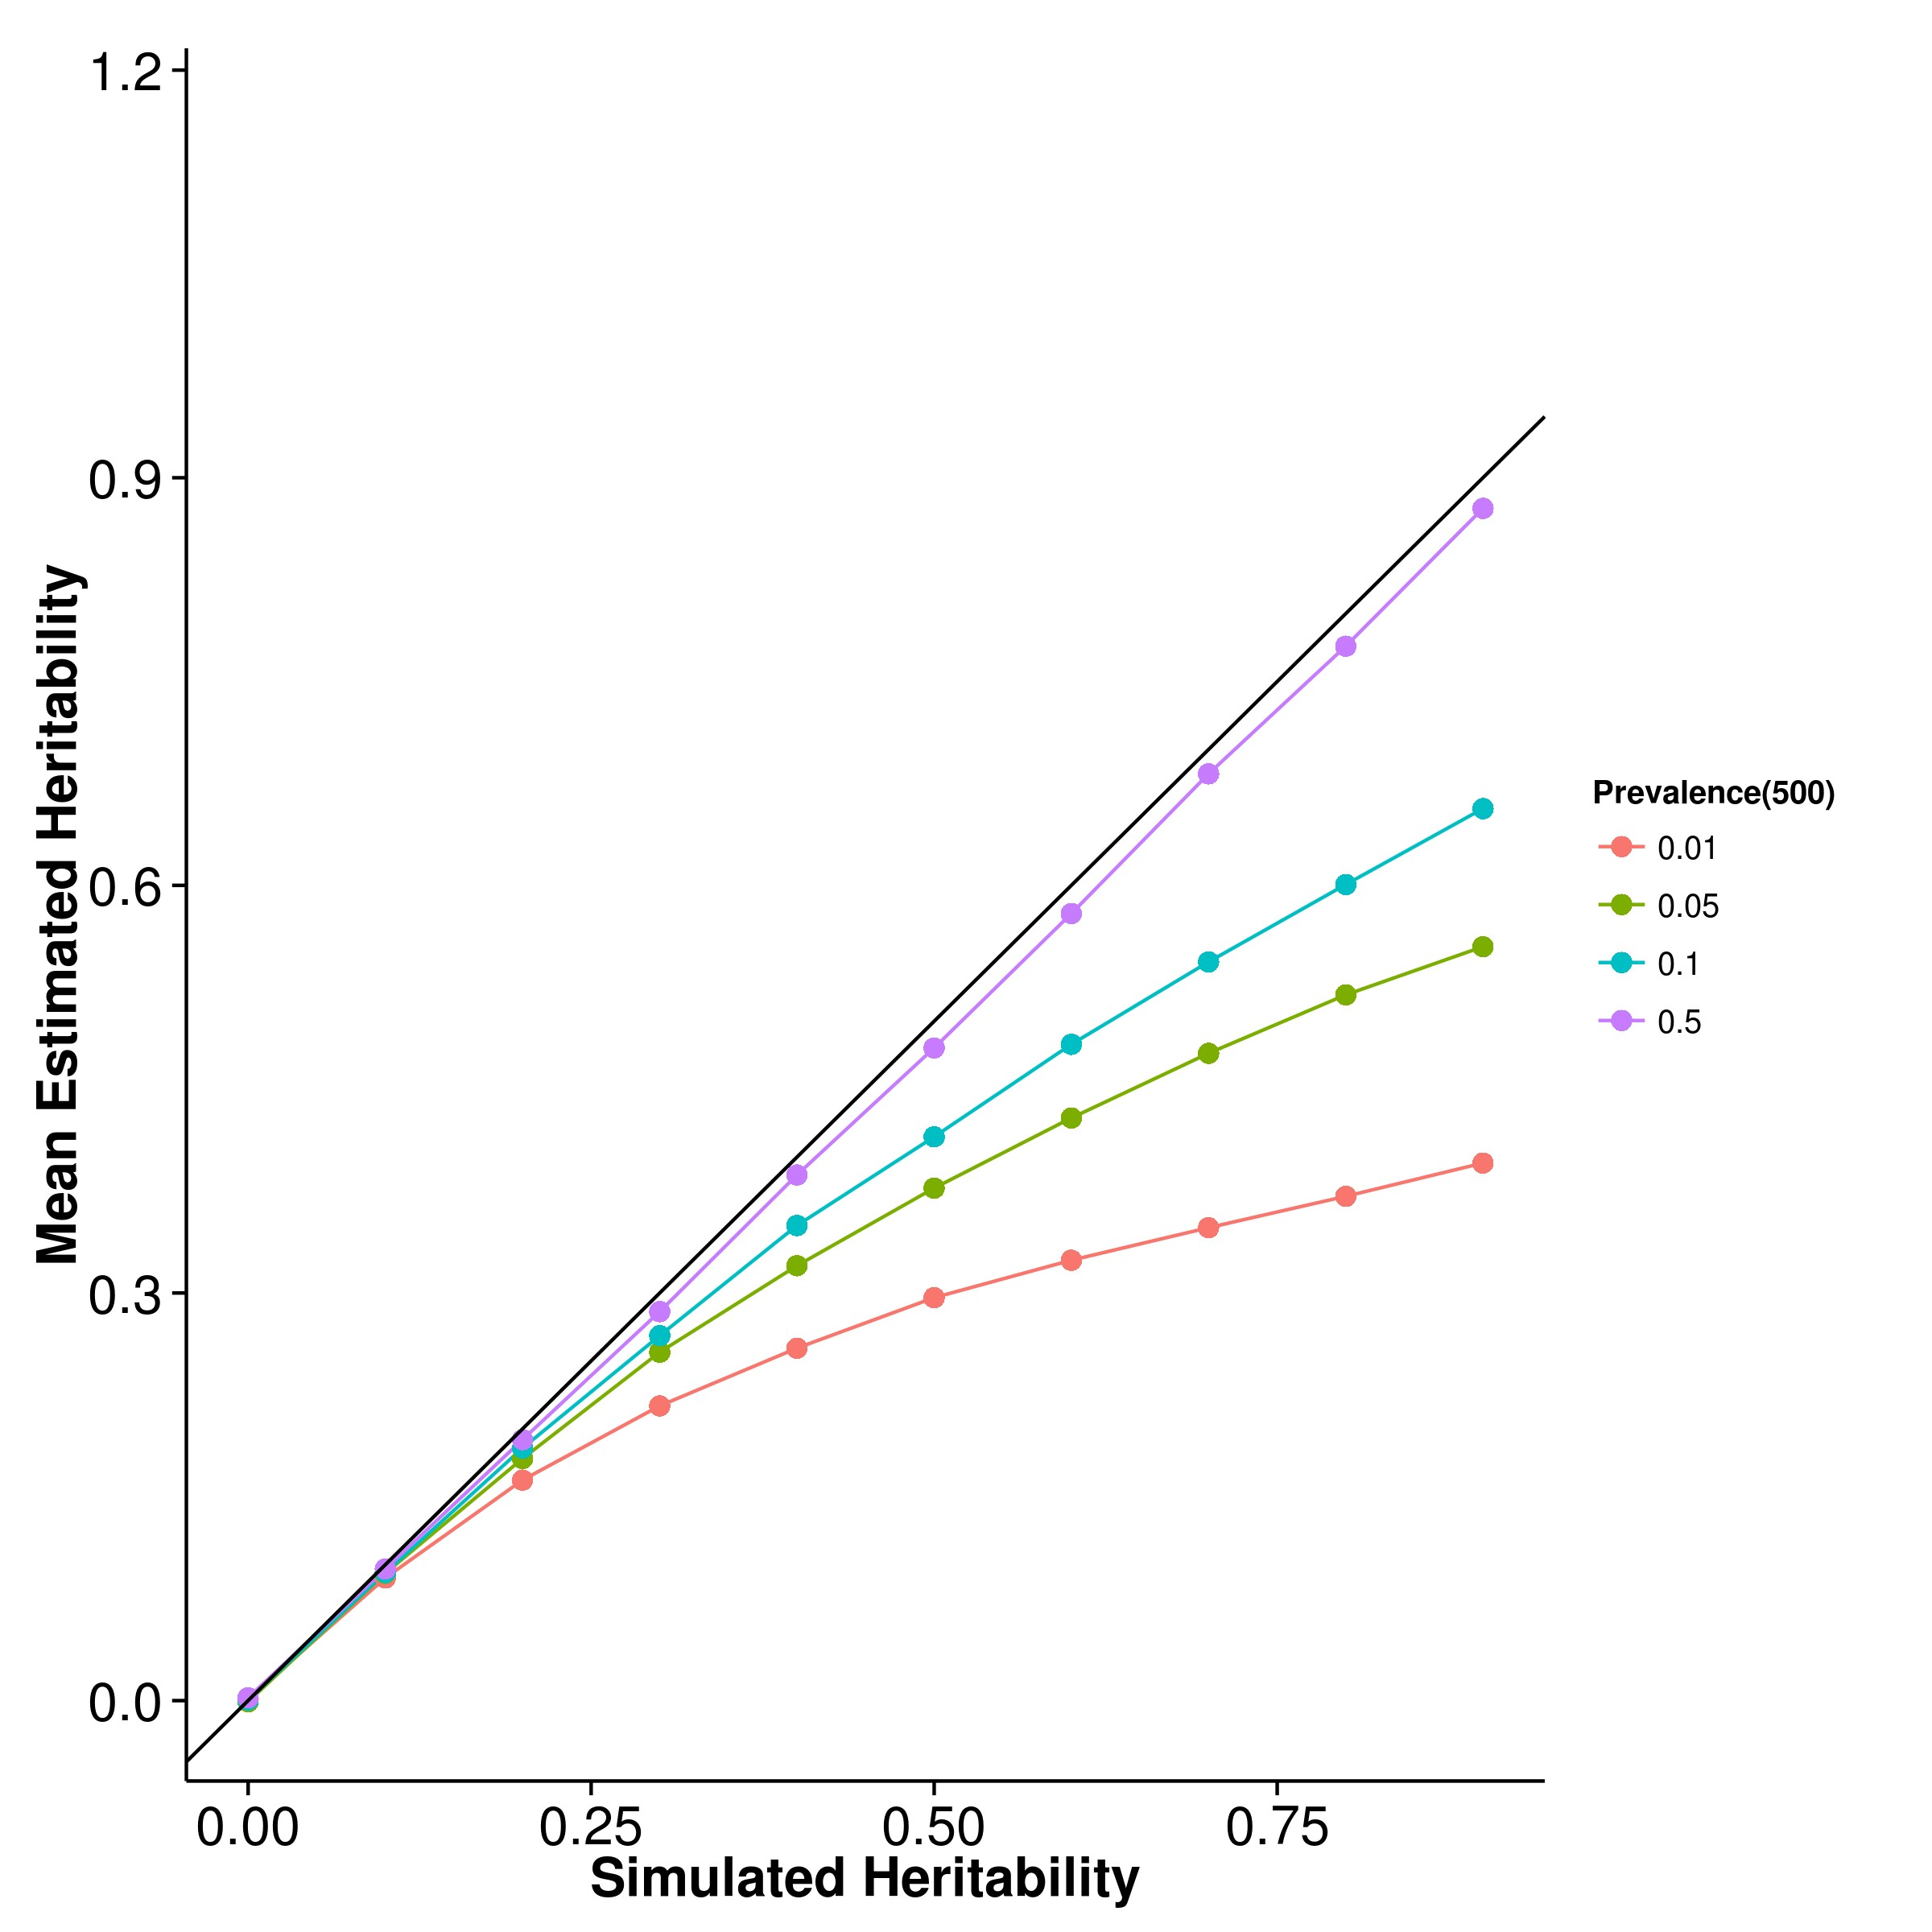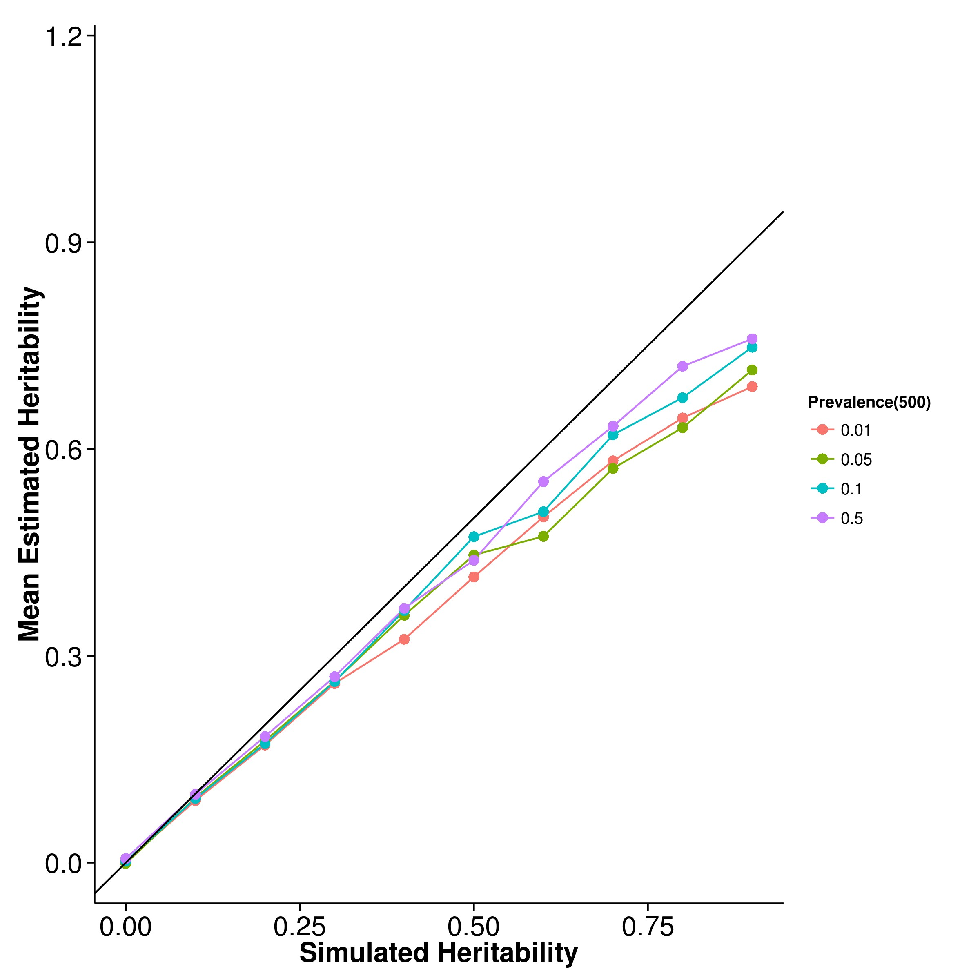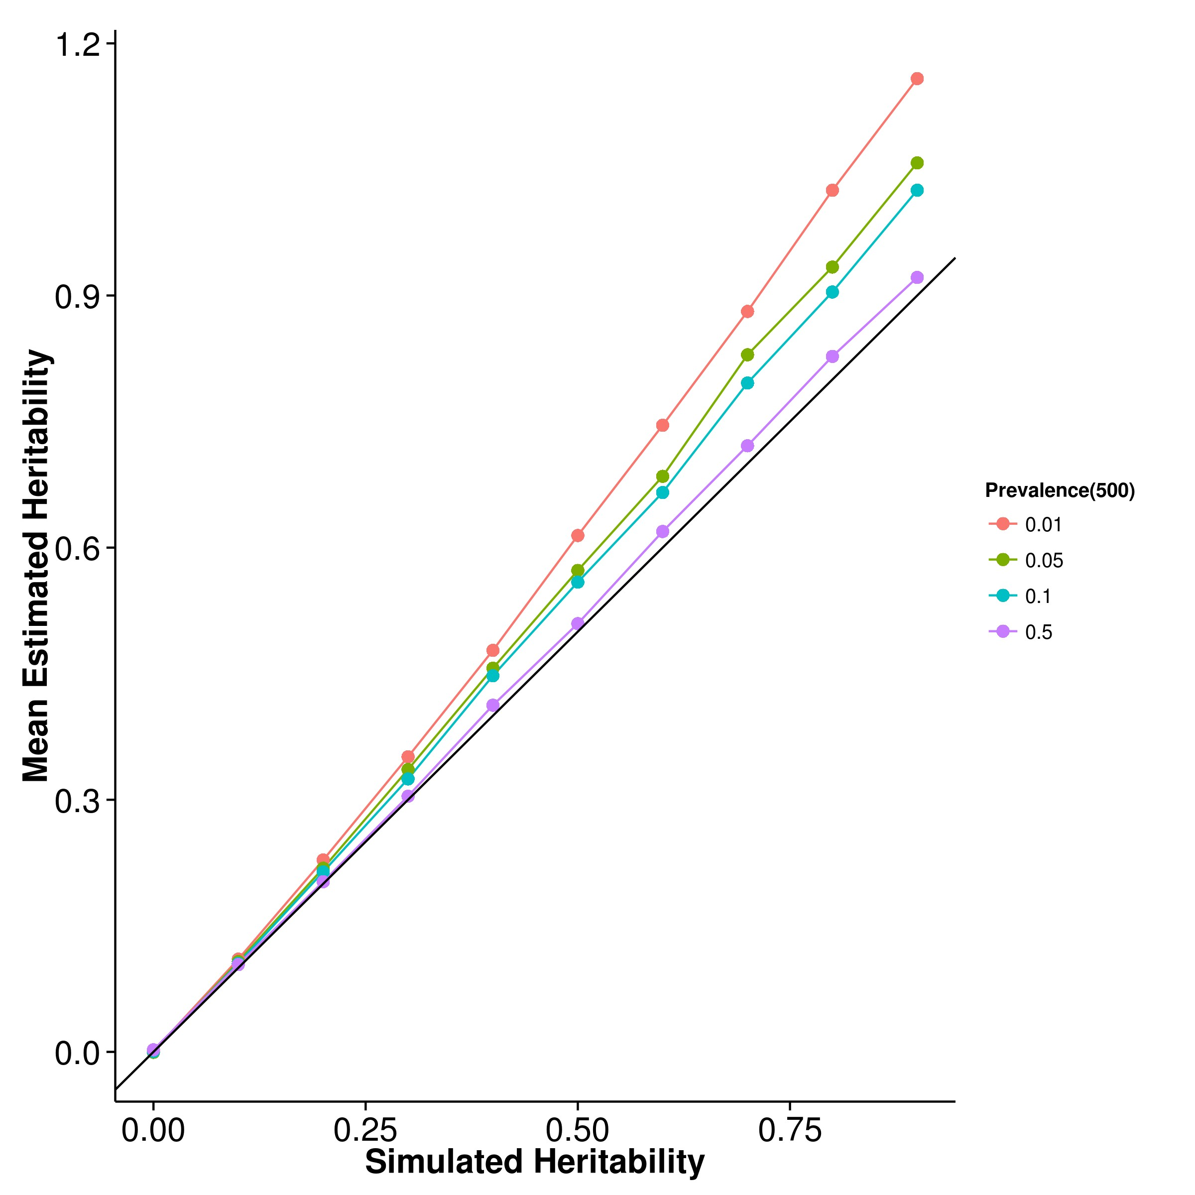

**(c)** LDSC with fix intercept **(d)** LDSC with intercept estimation

**Figure 2.24:** Mean of results from case control simulation with random effect size sim- ulation with 500 causal SNPs. Again, a clear pattern of underestimation was observed for GCTA and LDSC with intercept estimation whereas estimations from SHREK and LDSC with fixed intercepts tends to be upwardly biased, with the magnitude of bias increases as the population prevalence decreases.

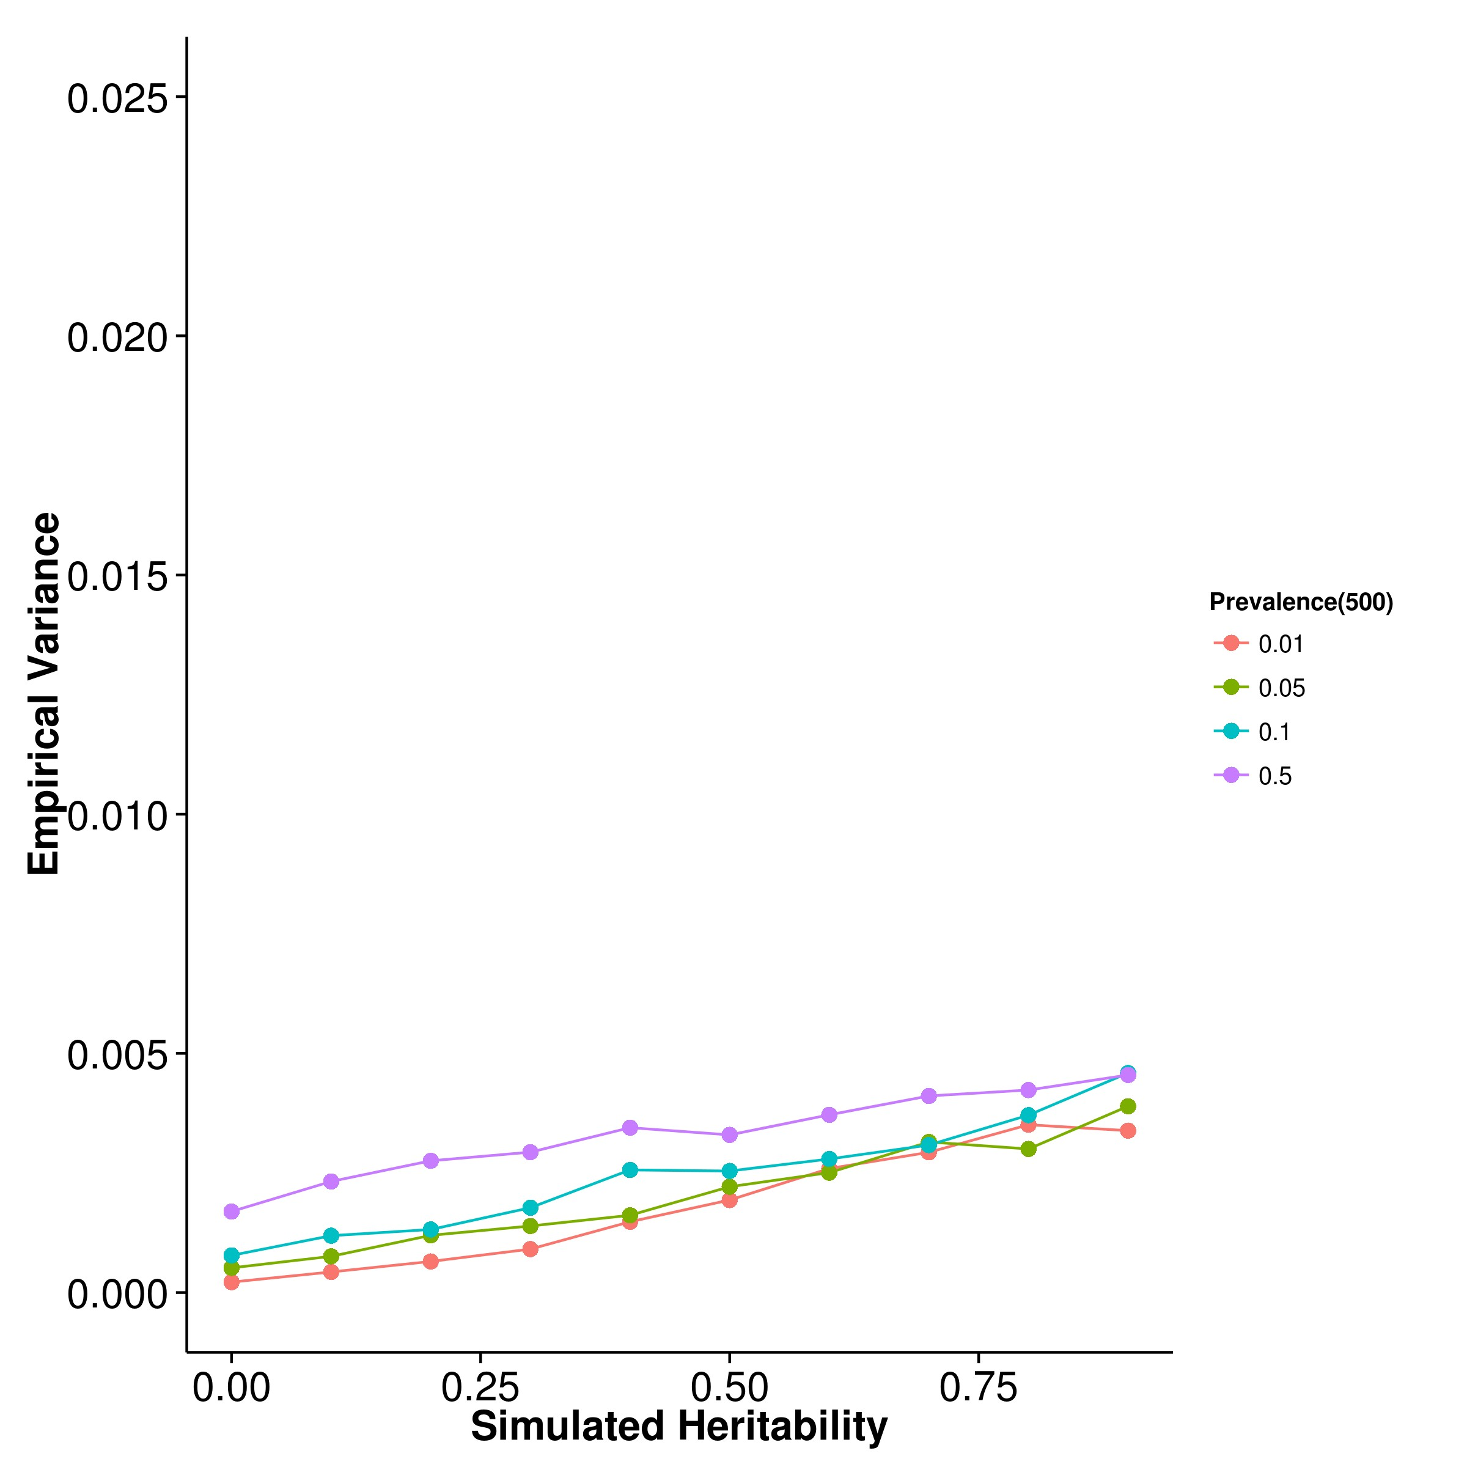

**(a)** SHREK **(b)** GCTA

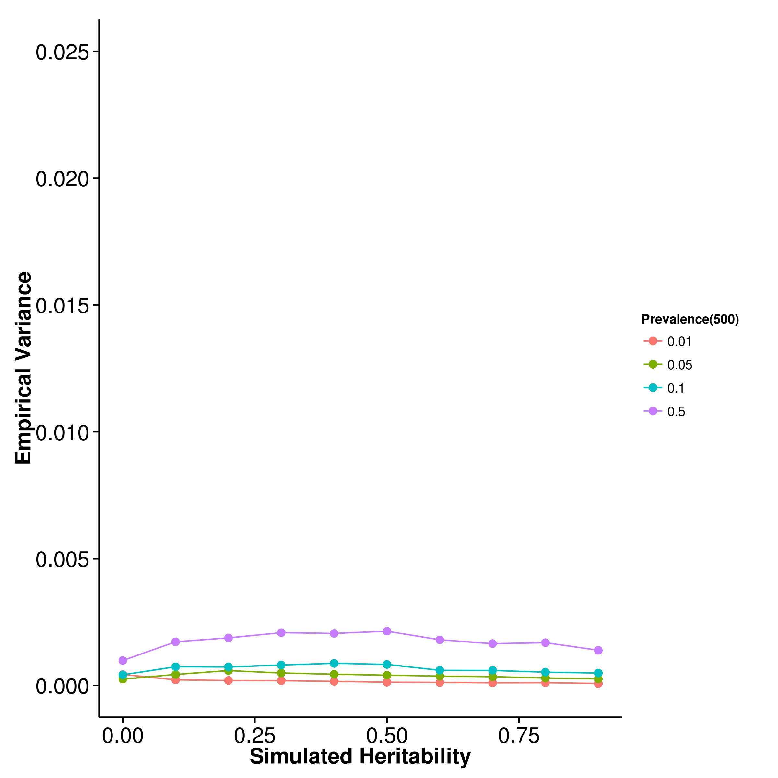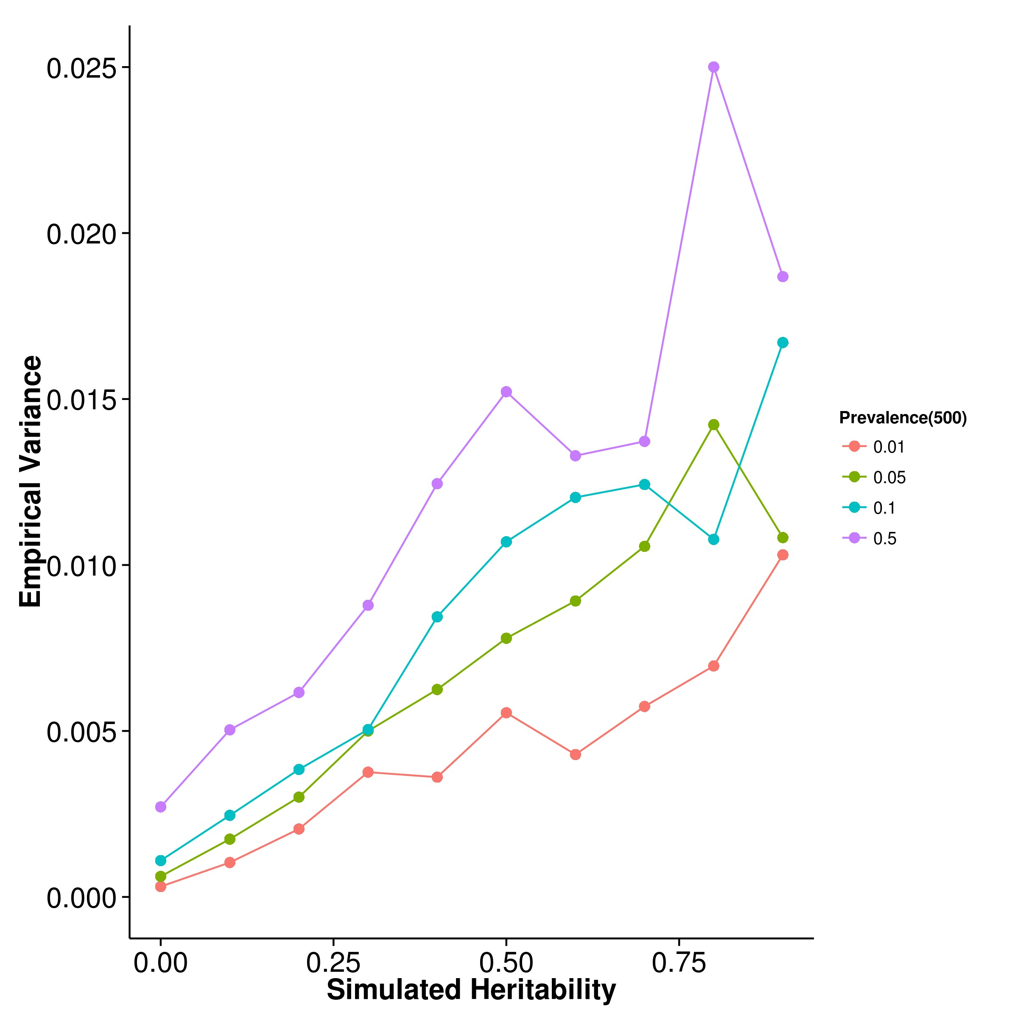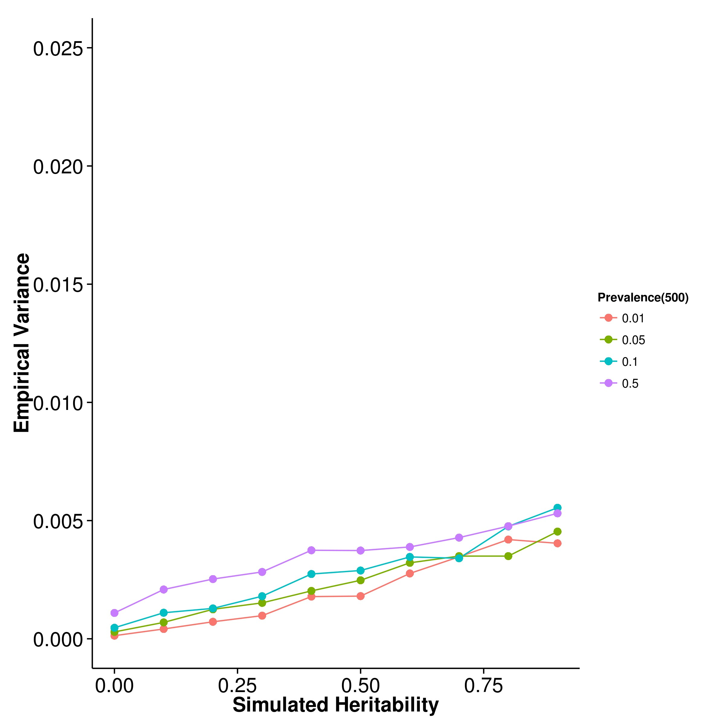

**(c)** LDSC with fix intercept **(d)** LDSC with intercept estimation

**Figure 2.25:** Variance of results from case control simulation with random effect size simulation with 500 causal SNPs. As the number of causal SNPs increased to 500, the empirical variance of SHREK and LDSC with fixed intercept converges. However, the empirical variance of LDSC with intercept estimations remains high.

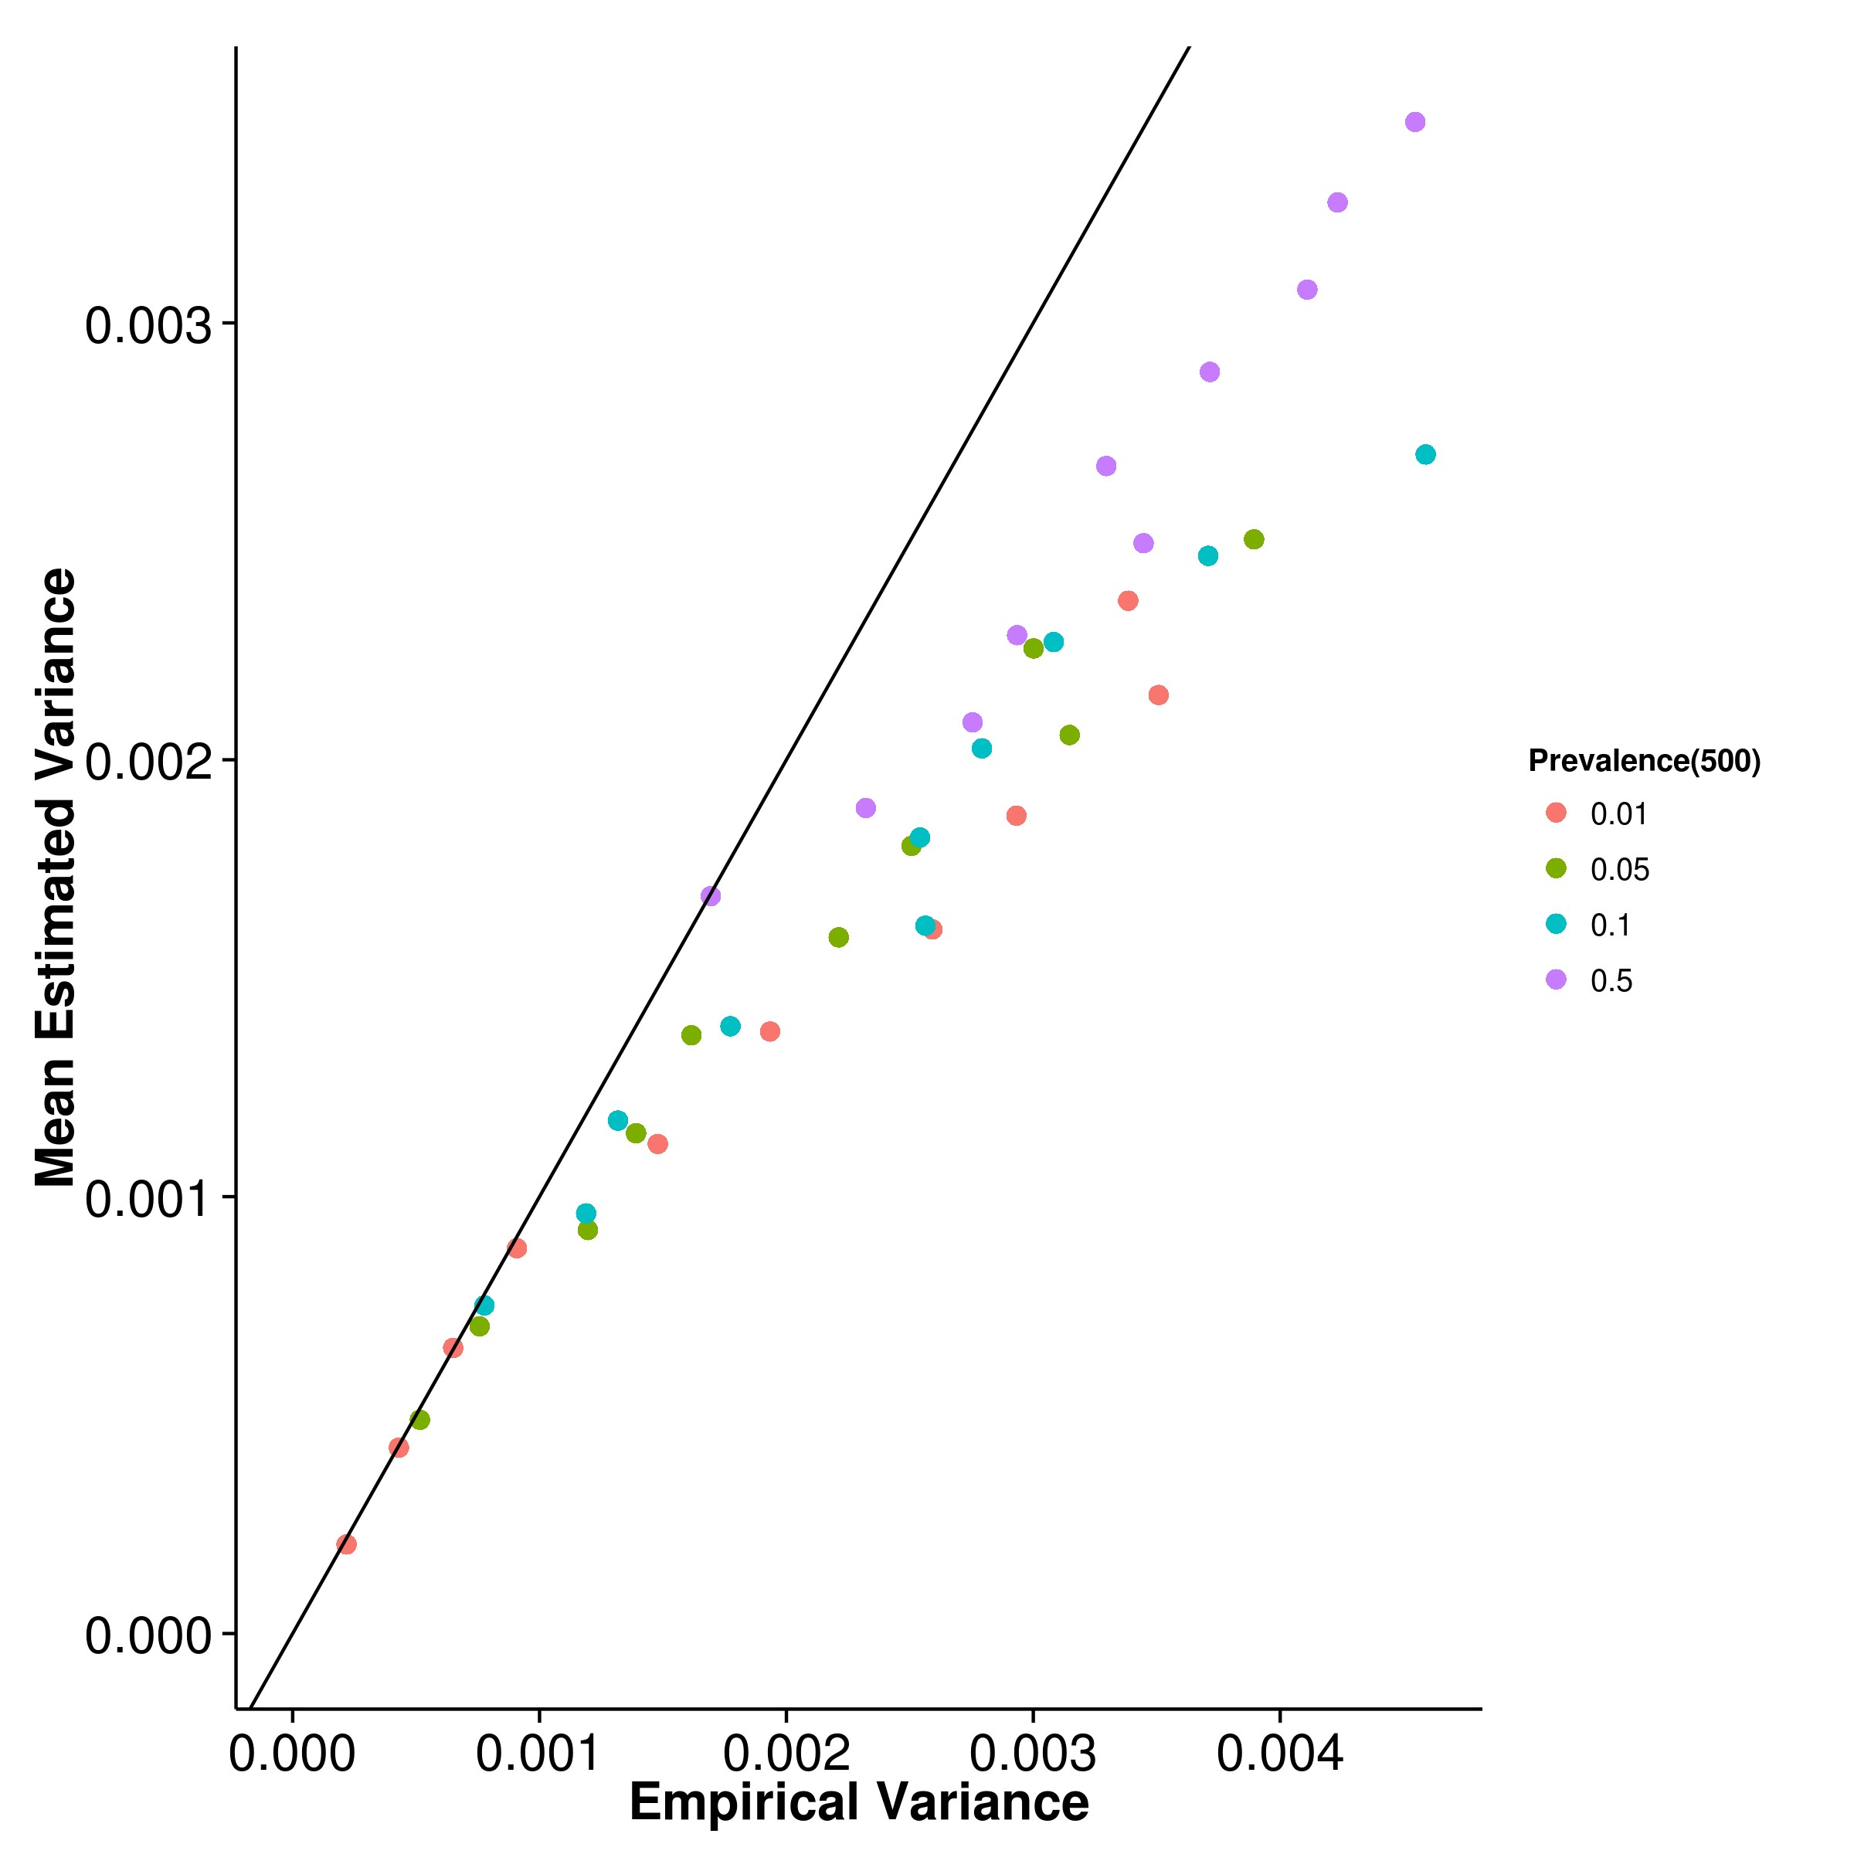

**(a)** SHREK **(b)** GCTA

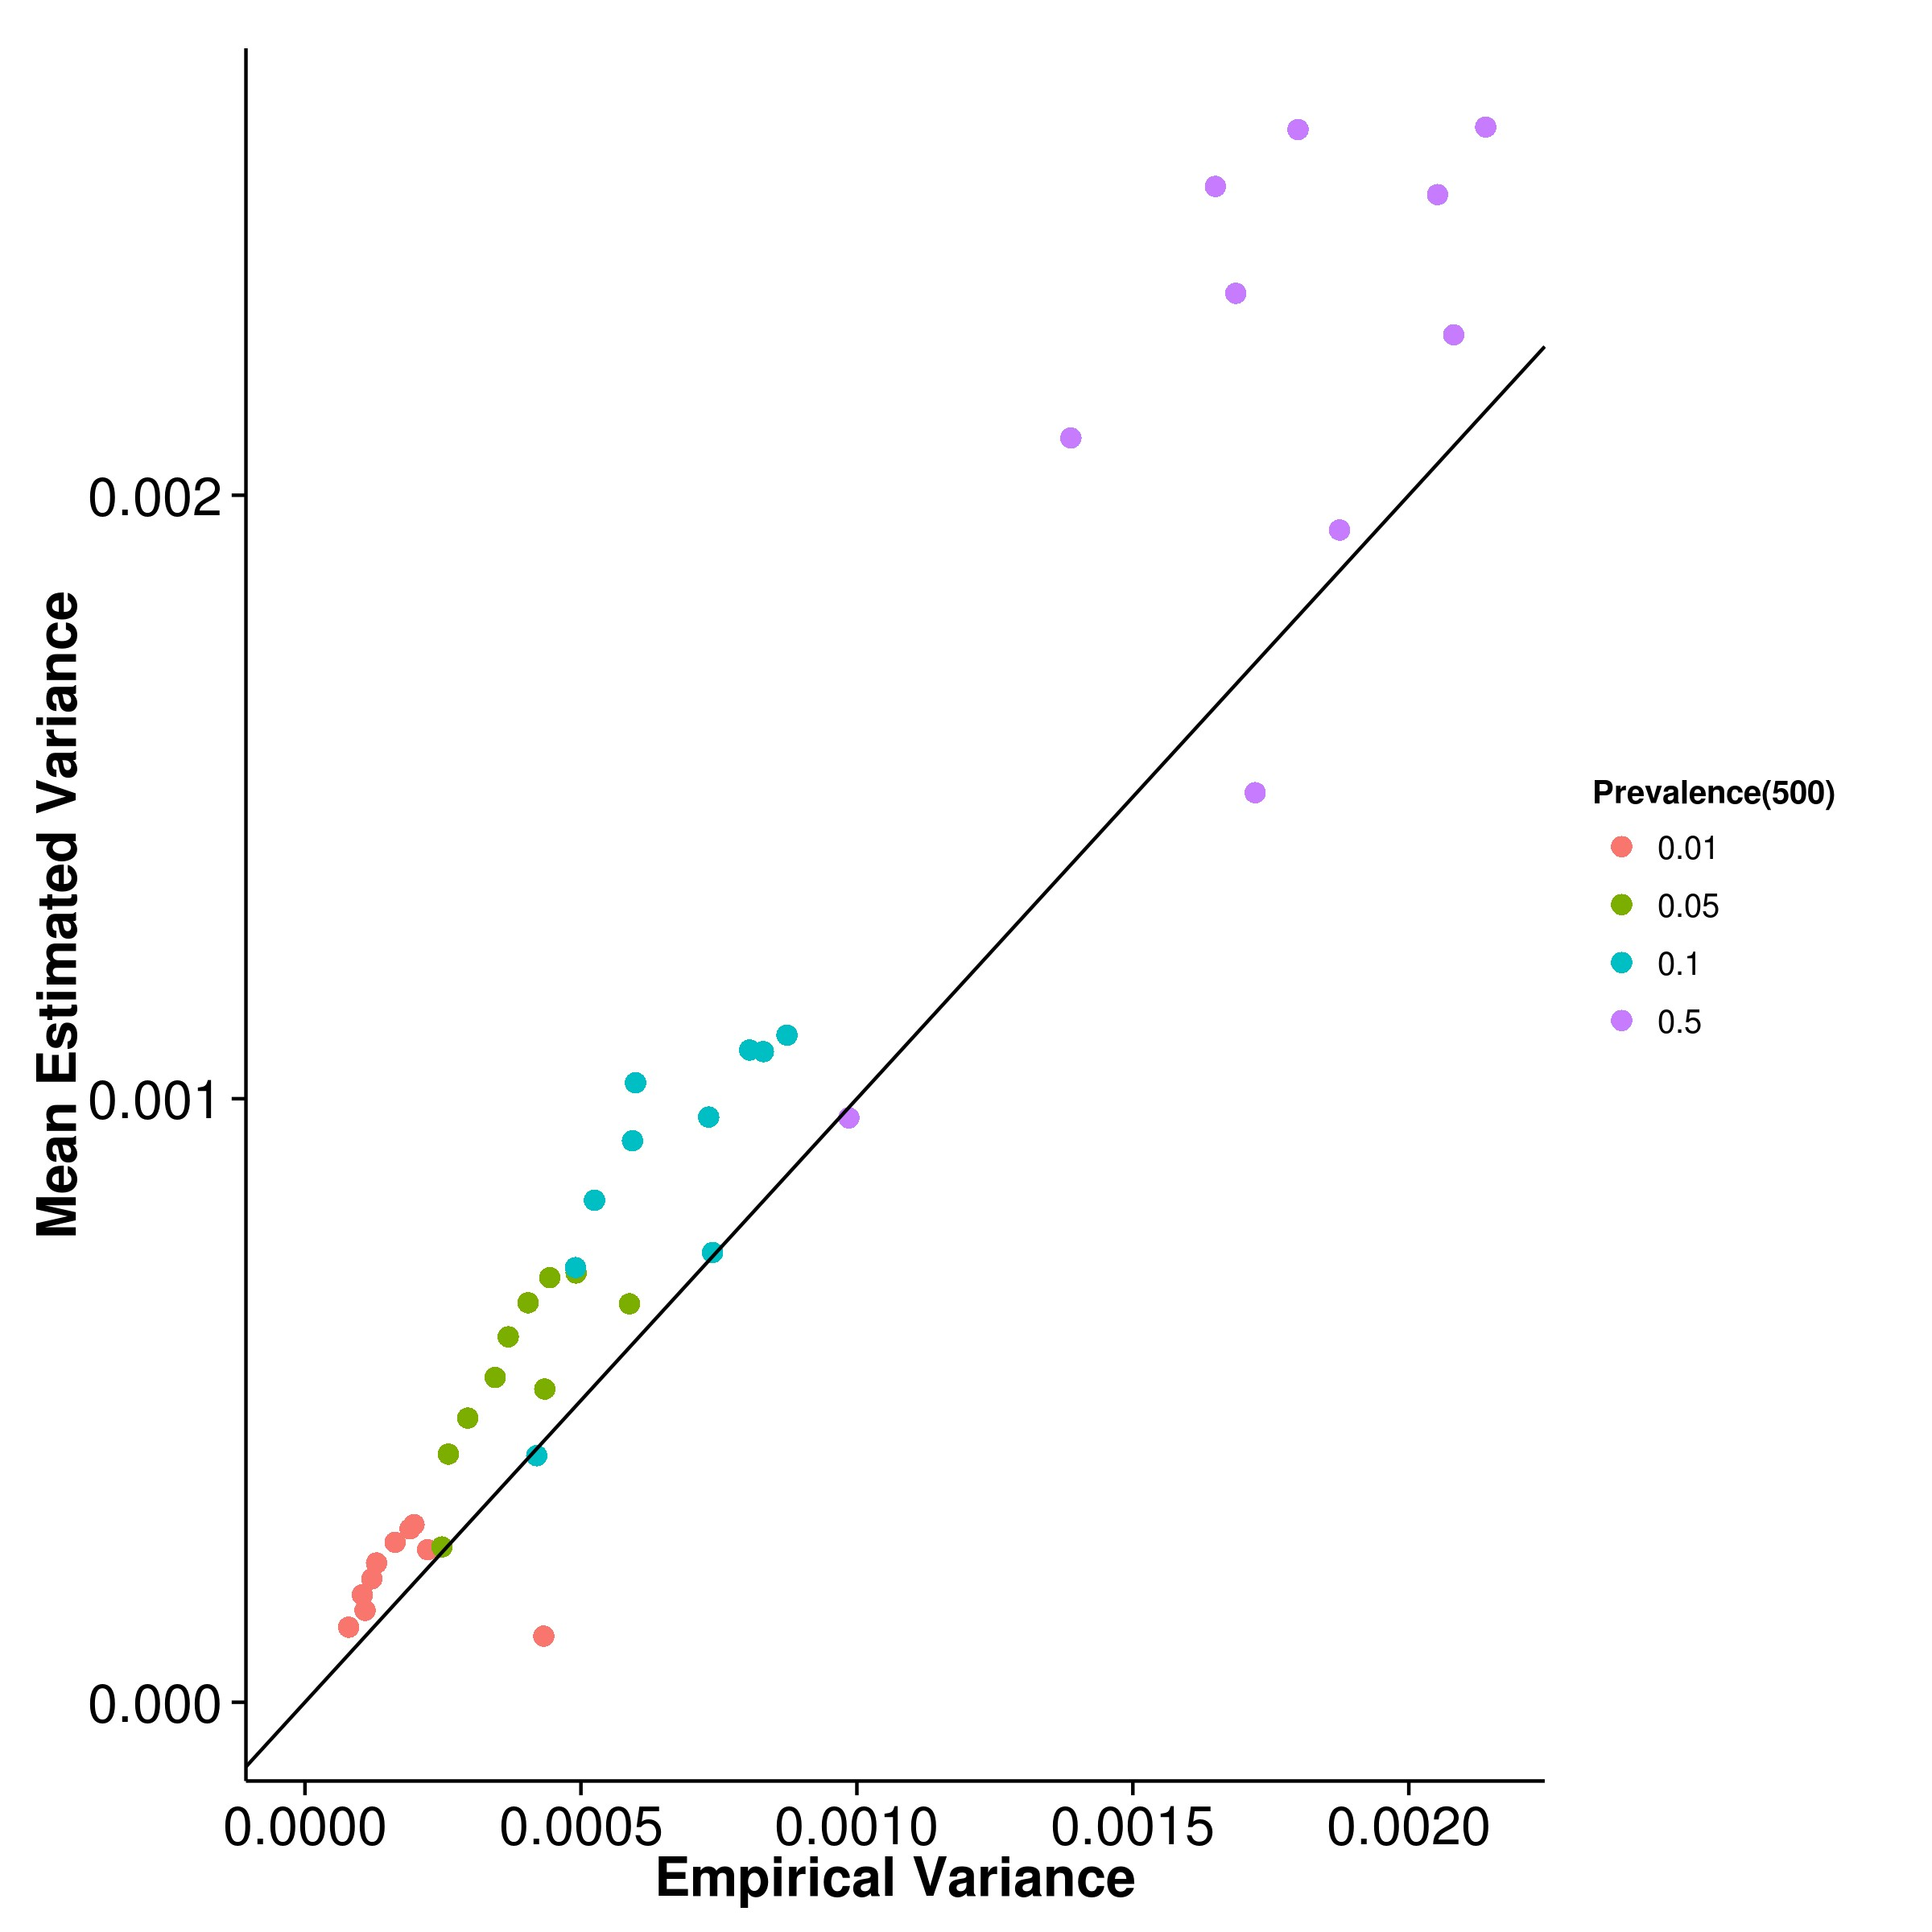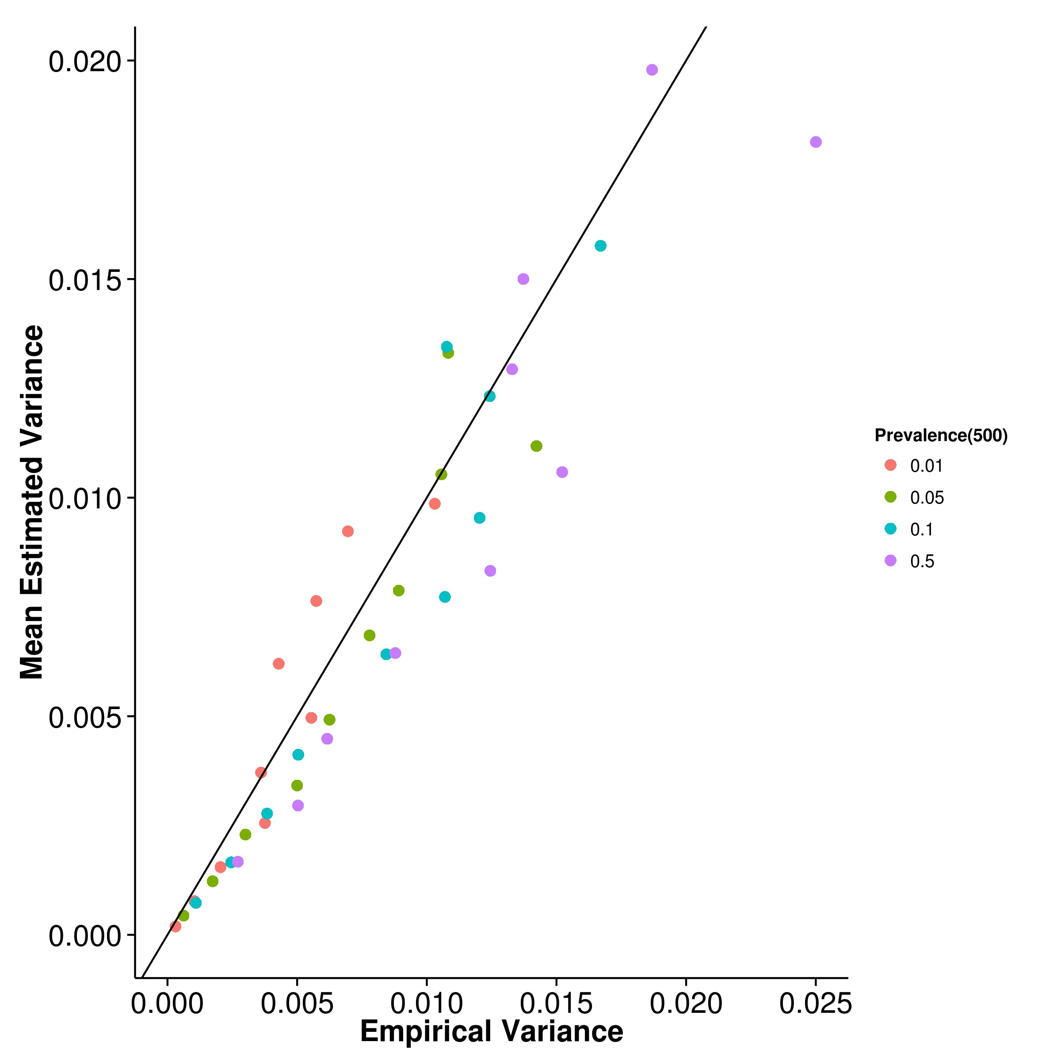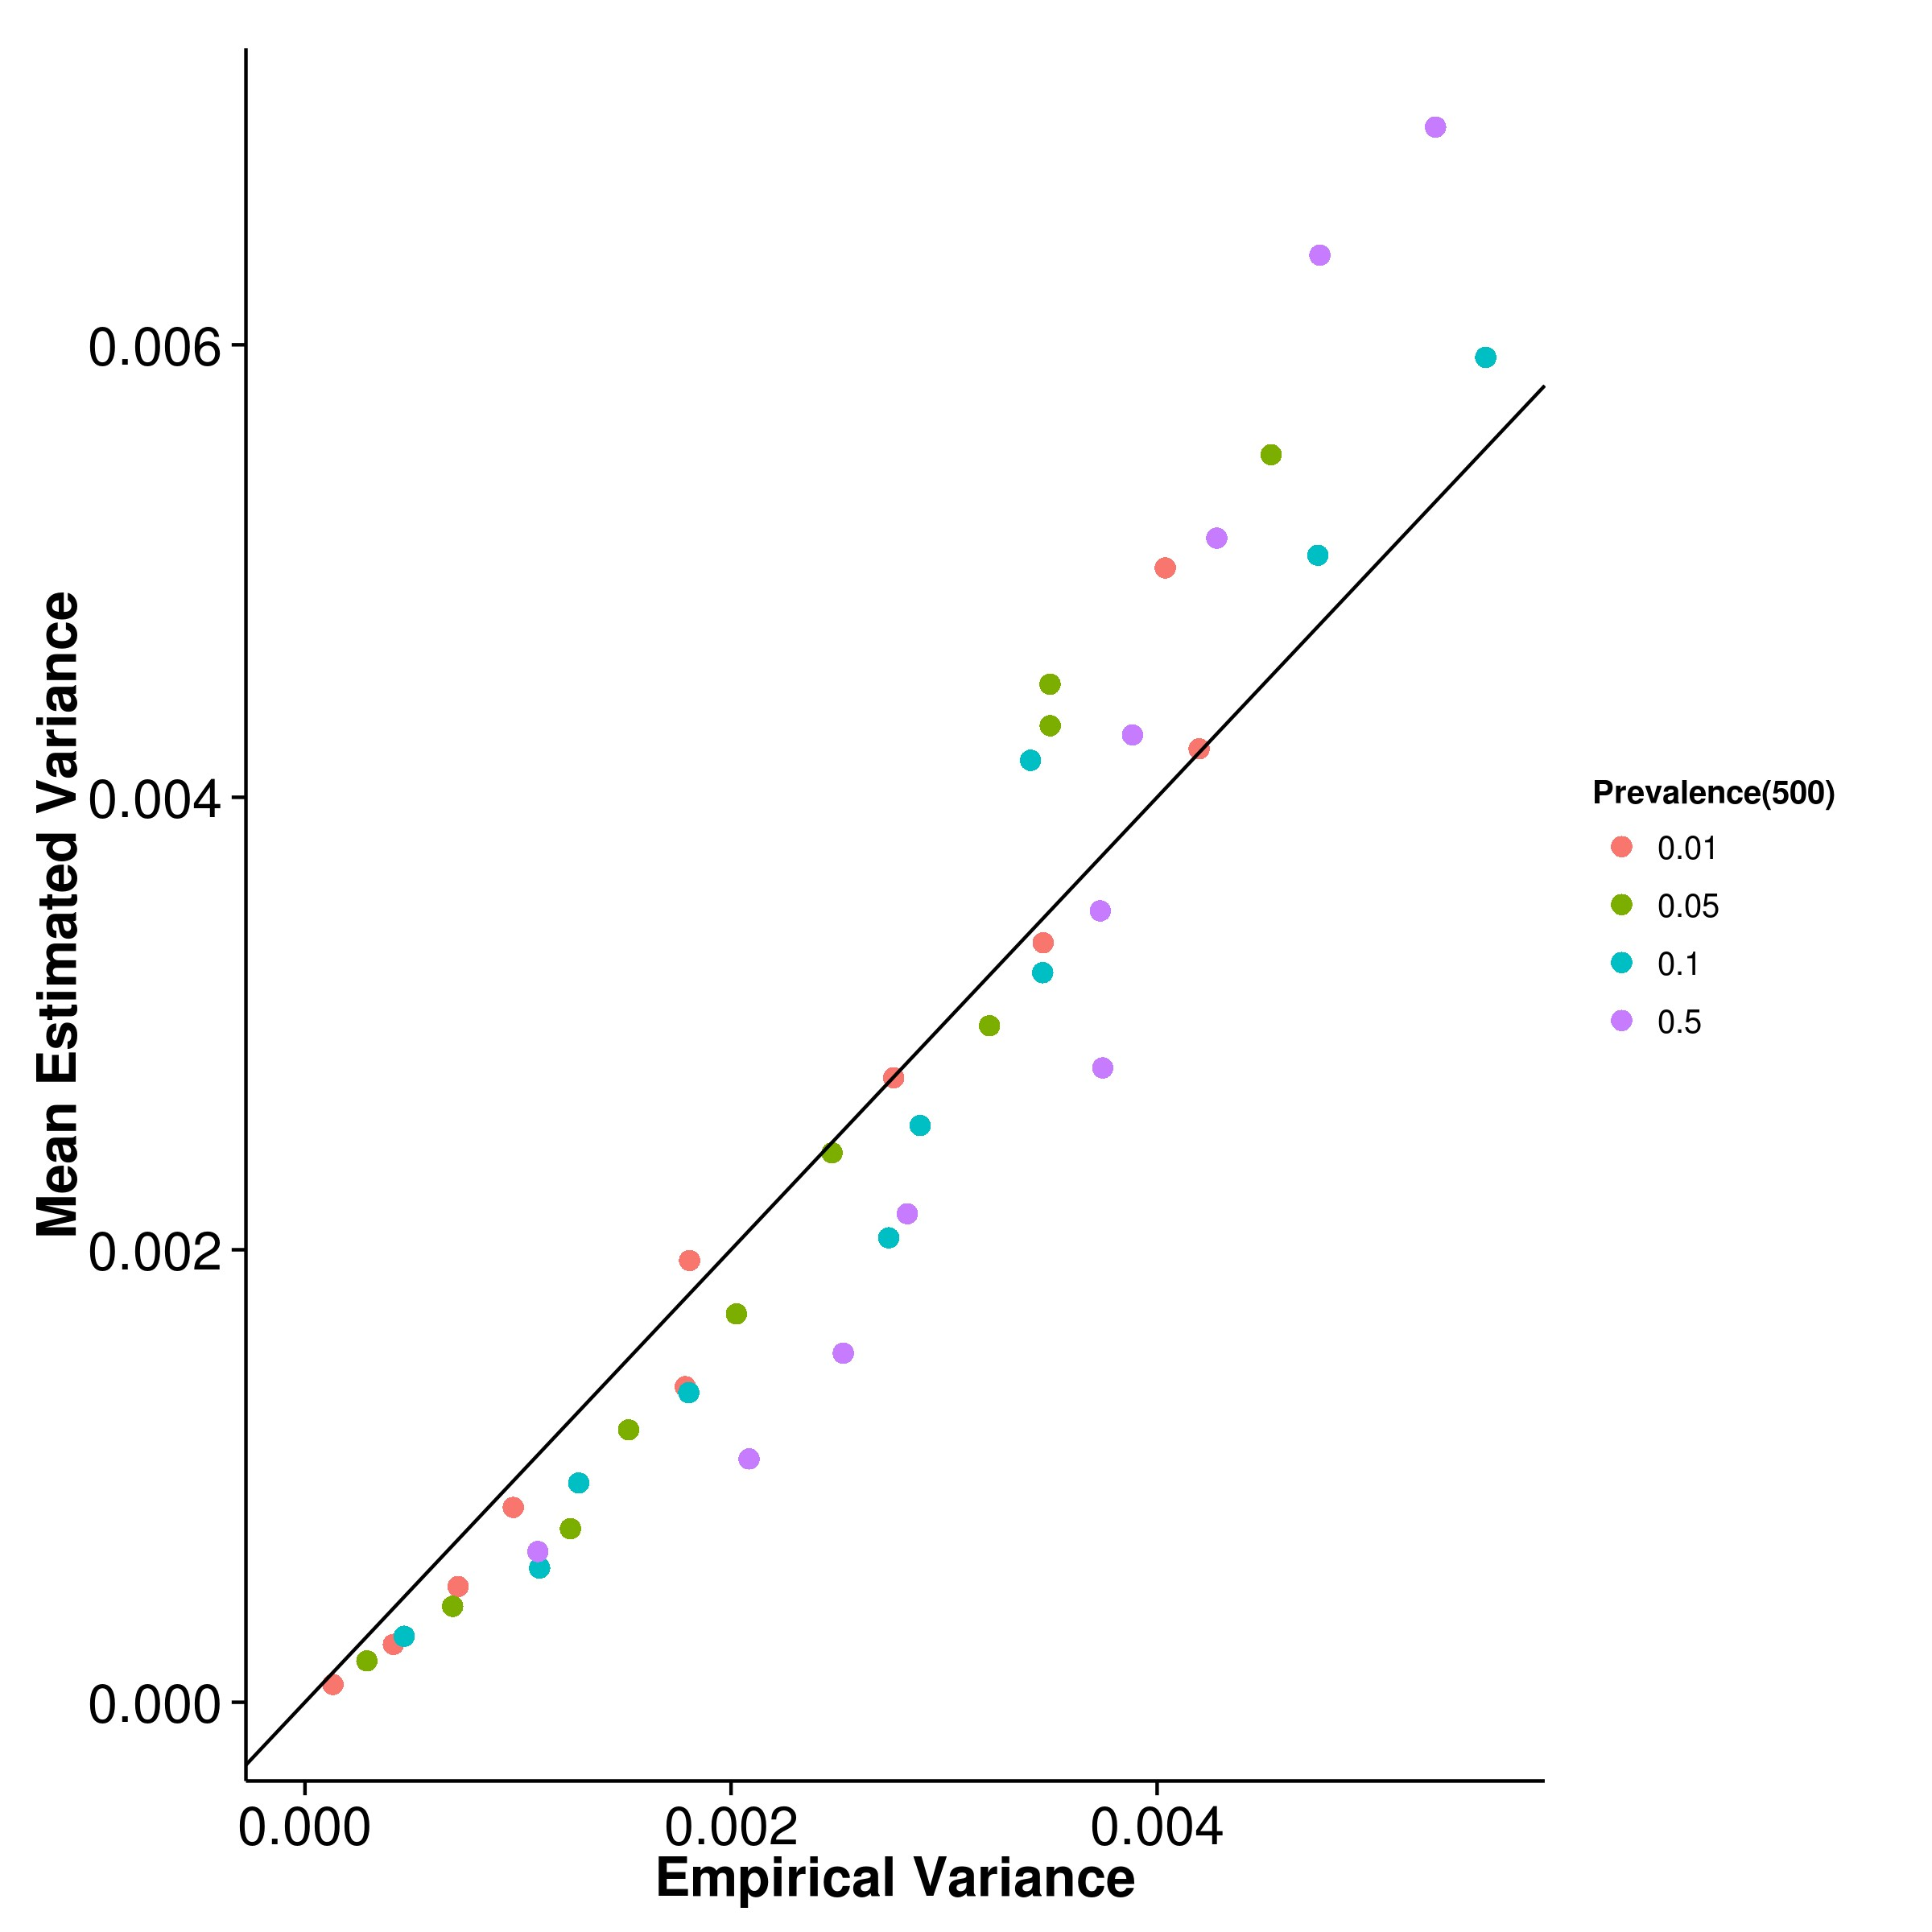

**(c)** LDSC with fix intercept **(d)** LDSC with intercept estimation

**Figure 2.26:** Estimated variance of results from case control simulation with random effect size simulation when compared to empirical variance when 500 causal SNPs was simulated. When the trait contains 500 causal SNPs, LDSC begins to provide a good estimation of its own empirical variance both with and without intercept estimation. On the other hand, SHREK’s estimation of its own empirical variance remains consistently lower than the true empirical variance.

**Chapter 3**

**n-3 Polyunsaturated Fatty Acid**

**Rich Diet in Schizophrenia**

**3.1 Introduction**

Schizophrenia is a complex disorder which is affected by a combination of genetic and environmental factors. Therefore to fully understand the disease mechanism for the development of proper treatments, it is important not only to examine how certain genetic polymorphisms can predispose individuals to the disease development, but also how environmental factors triggers the disorder in apparently healthy individuals.

Of all the environmental risk factors, prenatal infection has been identified as the single largest environmental risk factor for schizophrenia (Sullivan, 2005). Because of its importance, prenatal infection has been extensively studied. Early studies of prenatal infection in schizophrenia mainly relies on ecological data such as influenza epidemics in the population to define the exposure status (A S Brown and Derkits, 2010). The problem of these studies was that the exposure status was based solely on whether an individual was in gestation at the time of the epidemic without any confirmation of maternal infection during pregnancy. This leads to difficulties in replication of the findings. Subsequently, researchers uses birth cohorts where infection was documented using different biomarkers during pregnancies to provide a better labeling of the exposure status (A S Brown and Derkits, 2010). Through these rigorous studies it was found that the risk of schizophrenia increases as long as an individual’s mother was infected by different form of infectious agents such as influenza, HSV-2 and T.gondii during gestation (A S Brown and Derkits, 2010). As different infectious agents all increase the risk of schizophrenia, it leads to the hypothesis of MIA (A S Brown and Derkits, 2010) where it was hypothesized that instead of a particular infectious agents, it was the maternal immune response that disrupt the brain development in the offspring, thus leading to an elevated risk of schizophrenia.

To really understand how MIA increase the risk of schizophrenia, it is important to understand the molecular mechanism. A great challenge in the study of MIA was that one cannot carry out empirical experimental design in human samples due to ethical concerns. Thus a popular alternative is to employ rodent models. However, unlike physiological traits, psychiatric disorder such as that of schizophrenia often contain symptoms related to higher level functioning such as hallucinations, delusion, disorganized speech etc. (American Psychiatric Association, 2013) that are not readily detectable in rodents. This raise challenge in diagnosing whether if the rodent has demonstrated the symptoms of schizophrenia for not only it was difficult to check whether if the high level functioning of the rodent is disrupted, there were no available biomarkers for schizophrenia. Thus instead of labeling whether if the rodent is “schizophrenic” or “normal”, one would rather consider whether if the rodent demonstrate any “schizophrenia-like” behaviours such as impaired prepulse inhibition, impaired working memory and reduced social interaction (U Meyer, Yee, and J Feldon, 2007). An important point to note here is that as autism and schizophrenia shares most of these phenotypes, and that risk of autism is also increased by MIA (Alan S Brown, 2012), studies using these rodent models were usually non-specific to schizophrenia or autism. Rather, they should be considered together. However, for simplicity and focus of the current thesis, we would limit our discussion to schizophrenia.

Recent studies of global gene expression patterns in MIA-exposed rodent fetal brains (Oskviga et al., 2012; Garbett et al., 2012) suggest that the post-pubertal onset of schizophrenic and other psychosis-related phenotypes might stem from attempts of the brain to counteract the environmental stress induced by MIA during its early development (Garbett et al., 2012). To date, all these studies have focused on the changes elicited by a mid-to-late gestation exposure (e.g. Gestation Day (GD) 12.5 for mouse, or GD for rat). Even though U Meyer, Yee, and J Feldon (2007), Q. Li, C. Cheung, Wei, Hui, et al. (2009), and Q. Li, C. Cheung, Wei, V. Cheung, et al. (2010) have reported that MIA early in gestation might exert a more extensive impact on the phenotype of offspring, the effect of early MIA on gene expression in brain of adult offspring have not been thoroughly examined. It is therefore interesting to study the gene expression changes in adult offspring who were exposed to MIA during early gestation.

Ultimately, one would like to develop treatments for schizophrenia thus help to boost the quality of life of the schizophrenia patients. One candidate is the n-3 PUFA which can inhibits the production of IL-6 (Trebble et al., 2003), a major mediator in MIA (Smith et al., 2007). n-3 PUFA also plays a critical role in the development of central nervous system (Clandinin, 1999) and it has robust anti-inflammatory properties (Trebble et al., 2003) making it an attractive target. Indeed, previous study from our lab suggested that an n-3 PUFA rich diet can help to reduce the schizophrenia-like phenotype in mice exposed to early MIA insults (Q. Li, Leung, et al., 2015). Thus we would also like assess the effect of an n-3 PUFA rich diet on the gene expression pattern in the brain of the adult offspring.

Herein, we introduce a hypothesis generation study aiming to study the gene expression changes induced by early MIA exposure in the brain of the adult offspring and also expression changes induced by n-3 PUFA rich diet using RNA Sequencing - an approach considered to be more accurate and reliable compared to conventional microarrays (Zhong Wang, Gerstein, and Snyder, 2009). Moreover, RNA Sequencing are more flexible when compared to microarrays in that it can also detect alternative splicings and novel transcripts. Although we do not have sufficient sample size for such analysis in our pilot study, the use of RNA Sequencing allow subsequent replication studies to incorporate the pilot samples for such analysis, thus potentially reducing the cost of experiment.

Brain is a complex organ in that is subdivided into multiple regions, each with their own responsibility. Thus it is expected that the gene expression pattern differs from region to regions. It is then important for us to select a region of interest for our analysis. As a pilot study, we used brain tissues collected from our previous study on MIA and effect of n-3 PUFA (Q. Li, Leung, et al., 2015) where only the cerebellum remains. Although hippocampus (Velakoulis et al., 2006; Nugent et al., 2007) and prefrontal cortex (Knable and Weinberger, 1997; Perlstein et al., 2001) were the two most studied region in schizophrenia, the cerebellum has also been reported to be related to schizophrenia (Yeganeh-Doost et al., 2011; Andreasen and Pierson, 2008). Moreover, the cerebellum plays a central role in the cortico-cerebellar-thalamic-cortical neuronal circuit which is important to schizophrenia. Positron emission tomography (PET) studies have shown that a dysfunction in this circuit can contribute to “cognitive dysmetria”, e.g. impaired cognition and other symptoms of schizophrenia (Yeganeh- Doost et al., 2011). Altogether, this makes the cerebellum an interesting target to investigate.

To summarize, in this chapter, we conducted a hypothesis generation study on the effect of early MIA and n-3 PUFA rich diet on the gene expression pattern of the cerebellum of mouse using RNA Sequencing.

The work in this chapter were done in collaboration with my colleagues who have kindly provide their support and knowledges to make this piece of work possible. Dr Li Qi and Dr Basil Paul were responsible for generating the animal model and pro- viding the sample for our study; Dr Li Qi and Dr Desmond Campbell helped with the experimental design; Vicki Lin has helped with the RNA extraction; Tikky Leung for her high quality sequencing service; Nick Lin for his help in tackling problems encountered during sequencing quality control; Dr Johnny Kwan, Dr Desmond Campbell, Dr Timothy Mak and Professor Sham for their guidance in the statistical analysis.

**3.2 Methodology**

**3.2.1 Sample Preparation**

Female and male C57BL6/N mice were bred and mated by The University of Hong Kong, Laboratory Animal Unit. Timed-pregnant mice were held in a normal light–dark cycle (light on at 0700 hours), and temperature and humidity-controlled animal vivarium. All animal procedures were approved by the Committee on the Use of Live Animals in Teaching and Research (CULATR) at The University of Hong Kong.

The MIA model was generated following procedures previously reported (Q. Li, C. Cheung, Wei, Hui, et al., 2009). A dose of 5mg kg−1 PolyI:C in an injection volume 5ml kg−1, prepared on the day of injection was administered to pregnant mice on GD 9 via the tail vein under mild physical constraint. Control animals received an injection of 5ml kg−1 0.9% saline. The animals were returned to the home cage after the injection and were not disturbed, except for weekly cage cleaning. The resulting offspring were weaned and sexed at postnatal day 21. The pups were weighed and littermates of the same sex were caged separately, with three to four animal per cage. Half of the animal were fed on diets enriched with n-3 PUFAs and half were fed a standard lab diet until the end of the study. The latter ‘n-6 PUFA’ control diet had the same calorific value and total fat content as the n-3 PUFA diet. The diets were custom prepared and supplied by Harlan Laboratories (Madison, WI, USA). The n-

6 and n-3 PUFA were derived from corn oil or menhaden fish oil, respectively. The n-6 PUFA control diet, was based on the standard AIN-93G rodent laboratory diet (Reeves, Nielsen, and Fahey, 1993), and contained 65 g kg−1 corn oil and 5 g kg−1 fish oil with an approximate (n6)/(n3) ratio of 13:1. The n-3 PUFA diet contained

35 g kg−1 corn oil and 35 g kg−1 fish oil with an approximate (n6)/ (n3) ratio of 1:1

(Olivo and Hilakivi-Clarke, 2005). To avoid being confounded by sex difference, we only use the male offspring for our analysis. The male offspring were sacrificed by cervical dislocation on postnatal week 12, which roughly correspond to adulthood in human, and the cerebellum was extracted and stored in -80◦C until RNA extraction.

**3.2.2 RNA Extraction, Quality Control and Sequencing**

Total RNA was extracted from each cerebellum tissue using RNeasy midi kit (Qiagen) following the manufacturer’s instructions. RNA quality was assayed using the Agilent 2100 Bioanalyzer and RNA was quantified using Qubit 1.0 Flurometer. Samples with RNA integrity number (RIN) < 7 were not included in our study as the RNA are most likely degraded. As a hypothesis generation study, we select a minimum of 3 samples per group and each samples must come from a different litter to control for littering effect. The RNA Sequencing library was performed at the Centre for Genomic Sciences, the University of Hong Kong, using the KAPA Stranded mRNA-Seq Kit. All samples were sequenced using Illumina HiSeq 1500 at 2 lanes (2×101 base pair (bp) paired end reads). We distribute the samples such that each lane contain roughly the same amount of samples from different conditions.

|  |  |  |  |  |  |  |
| --- | --- | --- | --- | --- | --- | --- |
| SampleID | Litter | Diet | Condition | Lane | Batch | Rin |
| B1 | 3 | O3 | POL | 1 | B | 7.7 |
| B2 | 6 | O3 | POL | 2 | B | 7.7 |
| F1 | 4 | O3 | POL | 1 | F | 7.6 |
| F4 | 1 | O3 | SAL | 2 | F | 8.1 |
| B4 | 5 | O3 | SAL | 1 | B | 7.8 |
| B5 | 14 | O3 | SAL | 2 | B | 7.7 |
| F2 | 2 | O6 | POL | 1 | F | 7.5 |
| E3 | 11 | O6 | POL | 2 | E | 7.8 |
| C2 | 7 | O6 | POL | 2 | C | 7.9 |
| B6 | 13 | O6 | SAL | 2 | B | 7.4 |
| E6 | 14 | O6 | SAL | 1 | E | 8 |
| C6 | 1 | O6 | SAL | 1 | C | 7.8 |

**Table 3.1:** Sample information. O3 = n-3 PUFA diet; O6 = n-6 PUFA diet; POL =

PolyI:C exposed; SAL = Saline exposed. We have tried to separate the samples into different lane and batch to control for the lane and batch effect. Samples from different litters were also used with the exception of 1M_2 and 1M_3 which came from the same litter but were given a different diet.

**3.2.3 Sequencing Quality Control**

Quality control (QC) of the RNA Sequencing read data were rather standardized where FastQC (Andrews, n.d.) is the most widely adopted tools. It can generate the required per base QC and provide a general picture of how well the sequencing were done.

From the FastQC report, it was noted that some adapter sequences remained in the final sequence, by using trim_glore, a wrapper for cutadapt (version 1.9.1) (Martin, 2011), we trim the adapter sequences from the sequence reads and only retain reads that were at least 75 bp long for subsequent alignment.

**3.2.4 Alignment**

When aligning RNA sequencing reads, one can either directly align the reads to the transcriptome or to the genome. However, when aligning to the transcriptome, multiple isoforms can share part of the sequence (e.g. exons), thus leads to high level of multiple alignment, which can have an negative impact to the downstream analysis especially if one were only interested in the gene base expression. On the other hand, when directly aligning the reads to the genome, one need to use splicing aware aligners. The reason behind was that as the reads were originated from the mRNA where alternative splicing might have occurred, the reads might span multiple exons which were separated by intronic regions. The splicing algorithm will be able to “split” the reads and correctly align them onto the exons. Aligners such as TopHat2 (Kim et al., 2013), STAR (Dobin et al., 2013) and MapSplice (K. Wang et al., 2010) are some of the popular aligners that are designed to align RNA Sequencing reads to the genome. In a recent review by Engstrom et al. (2013), it was demonstrated that STAR has the best performance of all the aligners tested taking into account of accuracy and speed. Thus STAR aligner was used in our study. The RNA Sequencing reads were mapped to the *Mus musculus* reference genome (mm10, Ensembl GRCm38.82) using the STAR aligner (version 2.5.0a) (Dobin et al., 2013). And the quantification of the gene expression levels were conducted using featureCounts (version 1.5.0) (Liao, Gordon K Smyth, and Shi, 2014).

**3.2.5 Differential Expression Analysis**

Early RNA Sequencing experiment assumes the gene expression counts follows the Poisson distribution (Marioni et al., 2008) where the variance is assumed to be equal to the mean of the expression. However, it was found that the assumption of Poisson distribution is too restrictive where an over-dispersion was typically observed in RNA Sequencing data (S Anders and W Huber, 2010). Taking into account of the over-dispersion, modern RNA Sequencing statistical package usually models the RNA Sequencing counts using the negative binomial distribution (S Anders and W Huber, 2010; Robinson, McCarthy, and G K Smyth, 2010) or the beta negative binomial distribution (Trapnell et al., 2012). Based on the review of Seyednasrollah, Laiho, and Elo (2015), it was suggested that DESeq2 and limma are the most robust statistical packages for analyzing RNA Sequencing data. Considering that the authors of DESeq2 were very active in providing supports for the package, we selected DESeq2 (version 2.1.4.5) (Love, Wolfgang Huber, and Simon Anders, 2014) as the statistic package for the differential gene expression analysis.

Perhaps one of the most controversial study in RNA Sequencing was the mouse ENCODE paper by Yue et al. (2014) where Gilad and Mizrahi-Man (2015) demonstrated that most of the findings from Yue et al. (2014) was confounded by lane and batch effect. This highlights the importance of lane and batch effect in the design of RNA Sequencing. To avoid batch and lane effect, the whole sampling collection procedure and sequencing was performed in a way where we minimize the batch and lane difference between conditions (table 3.1). However, because of the sample quality differs across different batches, we were unable to fully balance out the batch effect. Therefore, in our analysis, we must control for the batch effect.

In our study, we were interested in the following comparisons:

1. Saline exposed samples with n-3 PUFA rich diet vs Saline exposed samples with n-6 PUFA rich diet

2. PolyI:C exposed samples with n-3 PUFA rich diet vs PolyI:C exposed samples with n-6 PUFA rich diet

3. Saline exposed samples with n-6 PUFA rich diet vs PolyI:C exposed samples with n-6 PUFA rich diet

To obtain the desire comparison, and also control for batch effect, we used *∼ Batch* + *Condition*+*Diet*+*C ondition*:*Diet* as our model of statistical analysis where Condition is the MIA exposure status. We did not incorporate the RIN into our statistic model because it was advised against by the author.

We would also like to see if the batch effect can leads to false positive results. Therefore we performed the likelihood ratio test (LRT). The LRT examines two models for the counts, a full model with a certain number of terms and a reduced model, in which some of the terms of the full model are removed. The test determines if the increased likelihood of the data using the extra terms in the full model is more than expected if those extra terms are truly zero. Thus we compared the full model

*∼ Batch* + *Condition* + *Diet* + *Condition:* *Diet* with *∼ Condition* + *Diet* + *Condition: Diet* to understand the effect of batch on our data.

In our analysis, we removed all genes with base mean count < 10 to reduce the noise associated with low expression and the Benjamini and Hochberg method were then used to correct for multiple testing.

**3.2.6 Functional Annotation**

Usually, one would like to perform functional annotation of the differentially expressed genes (DEGs) which allow one to identify biological processes (e.g. pathways) that were disrupted (e.g. enriched by the DEGs). However, if only a small number of DEGs were identified, the common enrichment analysis, which usually were an inclusion / exclusion based, can be biased or can become impractical. An alternative method was to perform the Wilcoxon Rank Sum test to test whether if genes within the pathway are more significant the genes outside pathway. We downloaded the canonical pathways from the Molecular Signatures Database (MSigDB) (v5.0 updated April 2015) (Subramanian et al., 2005) as our reference pathways. To avoid testing overly narrow or broad functional pathways, we selected pathways that contains at least 10 and at most 300 genes. The Wilcoxon Rank Sum test was then performed for each pathway to test for significance. Pathways with adjusted p-value < 0.05 (using Benjamini and Hochberg adjustment) were considered as significant.

**3.2.7 Designing the Replication Study**

Another important goal of our current study is to provide information for further replication studies. In order to estimate the power and required samples for the replication studies, we performed the power estimation using Scotty (Busby et al., 2013). We provided the count data from our pilot samples to Scotty to estimate the minimal required samples for our replication study if we would like to detect at least 90% of the genes that are differentially expressed by a 2× fold change at p< 0.01 and that at least 80% of genes has at least 80% of the maximum power.

**3.3 Results**

**3.3.1 Sample Quality**

On average, 87 million reads were generated for each sample of which more than 90% of the read bases has quality score > 30. A quality score at 30 represents the probability of having an incorrect base call is less than 1 in 1,000. After removing the adapter sequences from the reads, more than 97% of the reads remains. Over 90% of the trimmed reads could be uniquely mapped to the *Mus musculus* reference genome (mm10, Ensembl GRCm38.82) using the STAR aligner (version 2.5.0a) (Dobin et al., 2013). To obtained the expression count, we used the featureCounts (version 1.5.0) (Liao, Gordon K Smyth, and Shi, 2014) to generate the count matrix required for downstream analysis.

Next, we were interested in whether if there are any contamination of samples or series confounding effect of bath or lane. We therefore performed an unsupervised clustering on the sample count data. It was observed that none of the samples were clustered by lane or batch, suggesting that there were no serious batch or lane effect presented in our samples. However, one sample from the n3-PolyI:C group was found to be substantially different from all other samples (fig. 3.1). It was unclear whether if the difference was due to sample contaminations (from other source) or was due to sample mislabel. To avoid problems in down-stream analysis, we excluded this sample from subsequent analyses

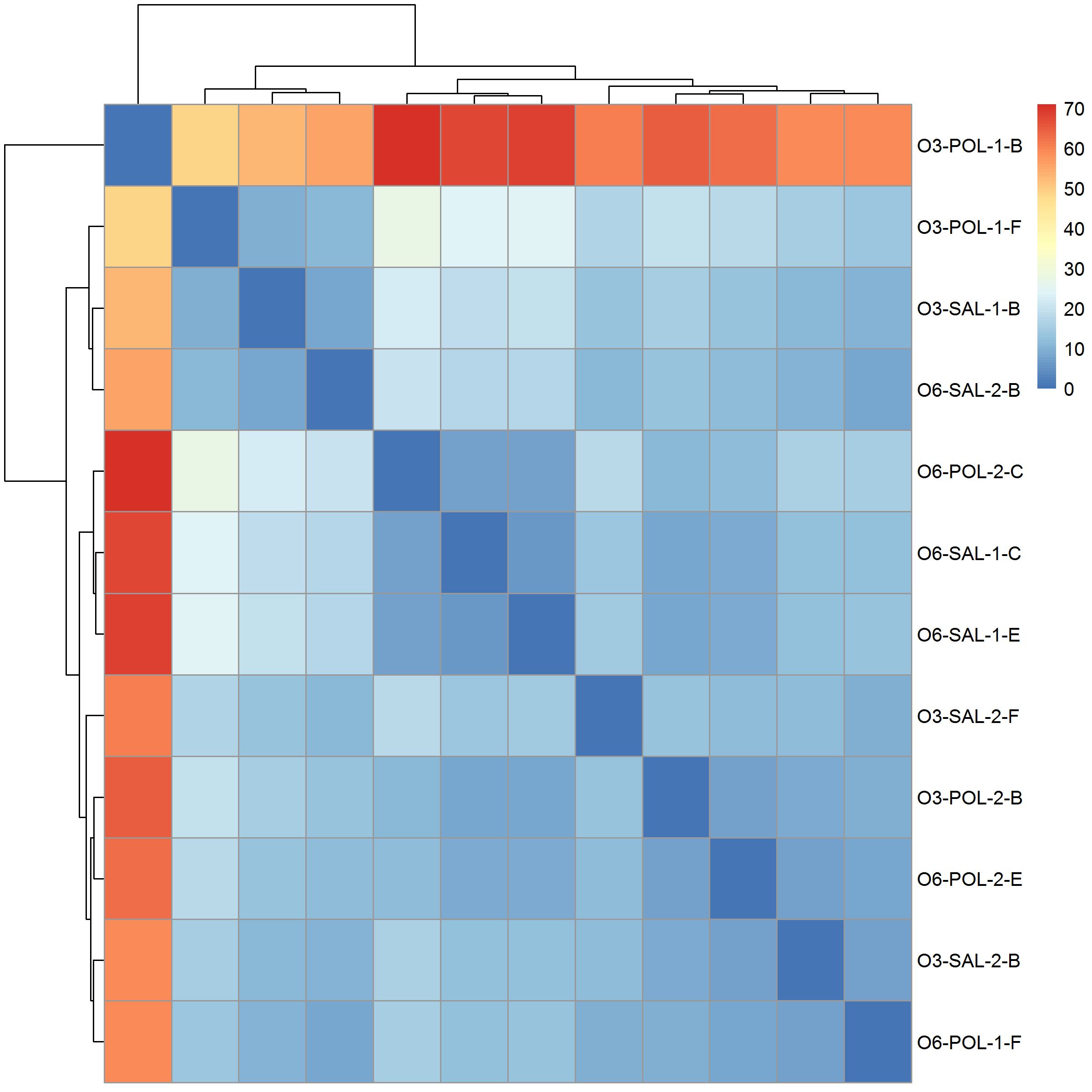

**Figure 3.1:** Sample Clustering results. It was observed that there was no clear clustering for lane or batch effects. However, one sample from the n3-PUFA-PolyI:C group was found to be substantially different from all other samples.

It was unclear whether if the difference was due to sample contaminations or was due to sample mislabel. To avoid problems in down-stream analysis, we excluded this sample from subsequent analyses

**3.3.2 Differential Expression Analysis**

After excluding the problematic samples, we performed the DESeq2 analysis. Of the 16,747 genes that passed through quality control, only one gene, *Sgk1* (p-adjusted=0.00186) was found to be significantly differentiated when we examines the effect of n-3 PUFA rich diet on the gene expression in the cerebellum of PolyI:C exposed mice (fig. 3.2c). No genes were found to be significant for the other two comparisons (figs. 3.2a and 3.2b).

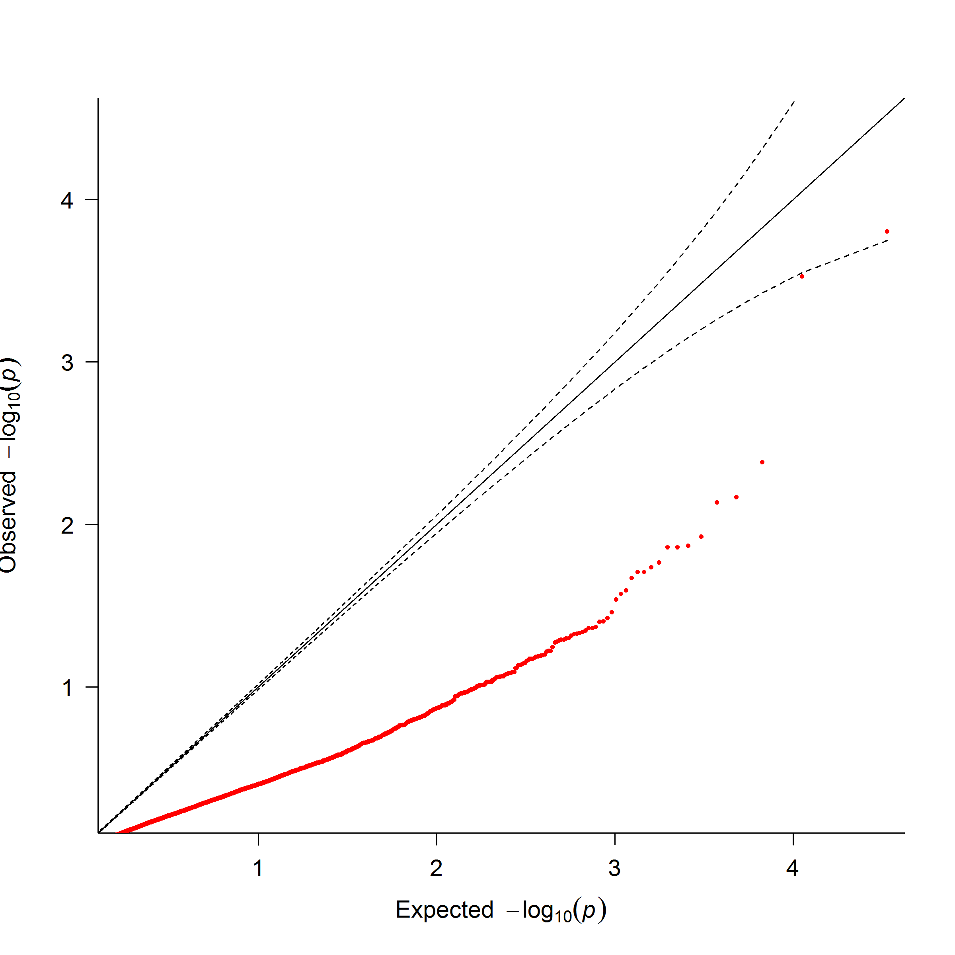

**(a)** O6-Saline mice vs O6-PolyI:C mice **(b)** O6-Saline mice vs O3-Saline mice

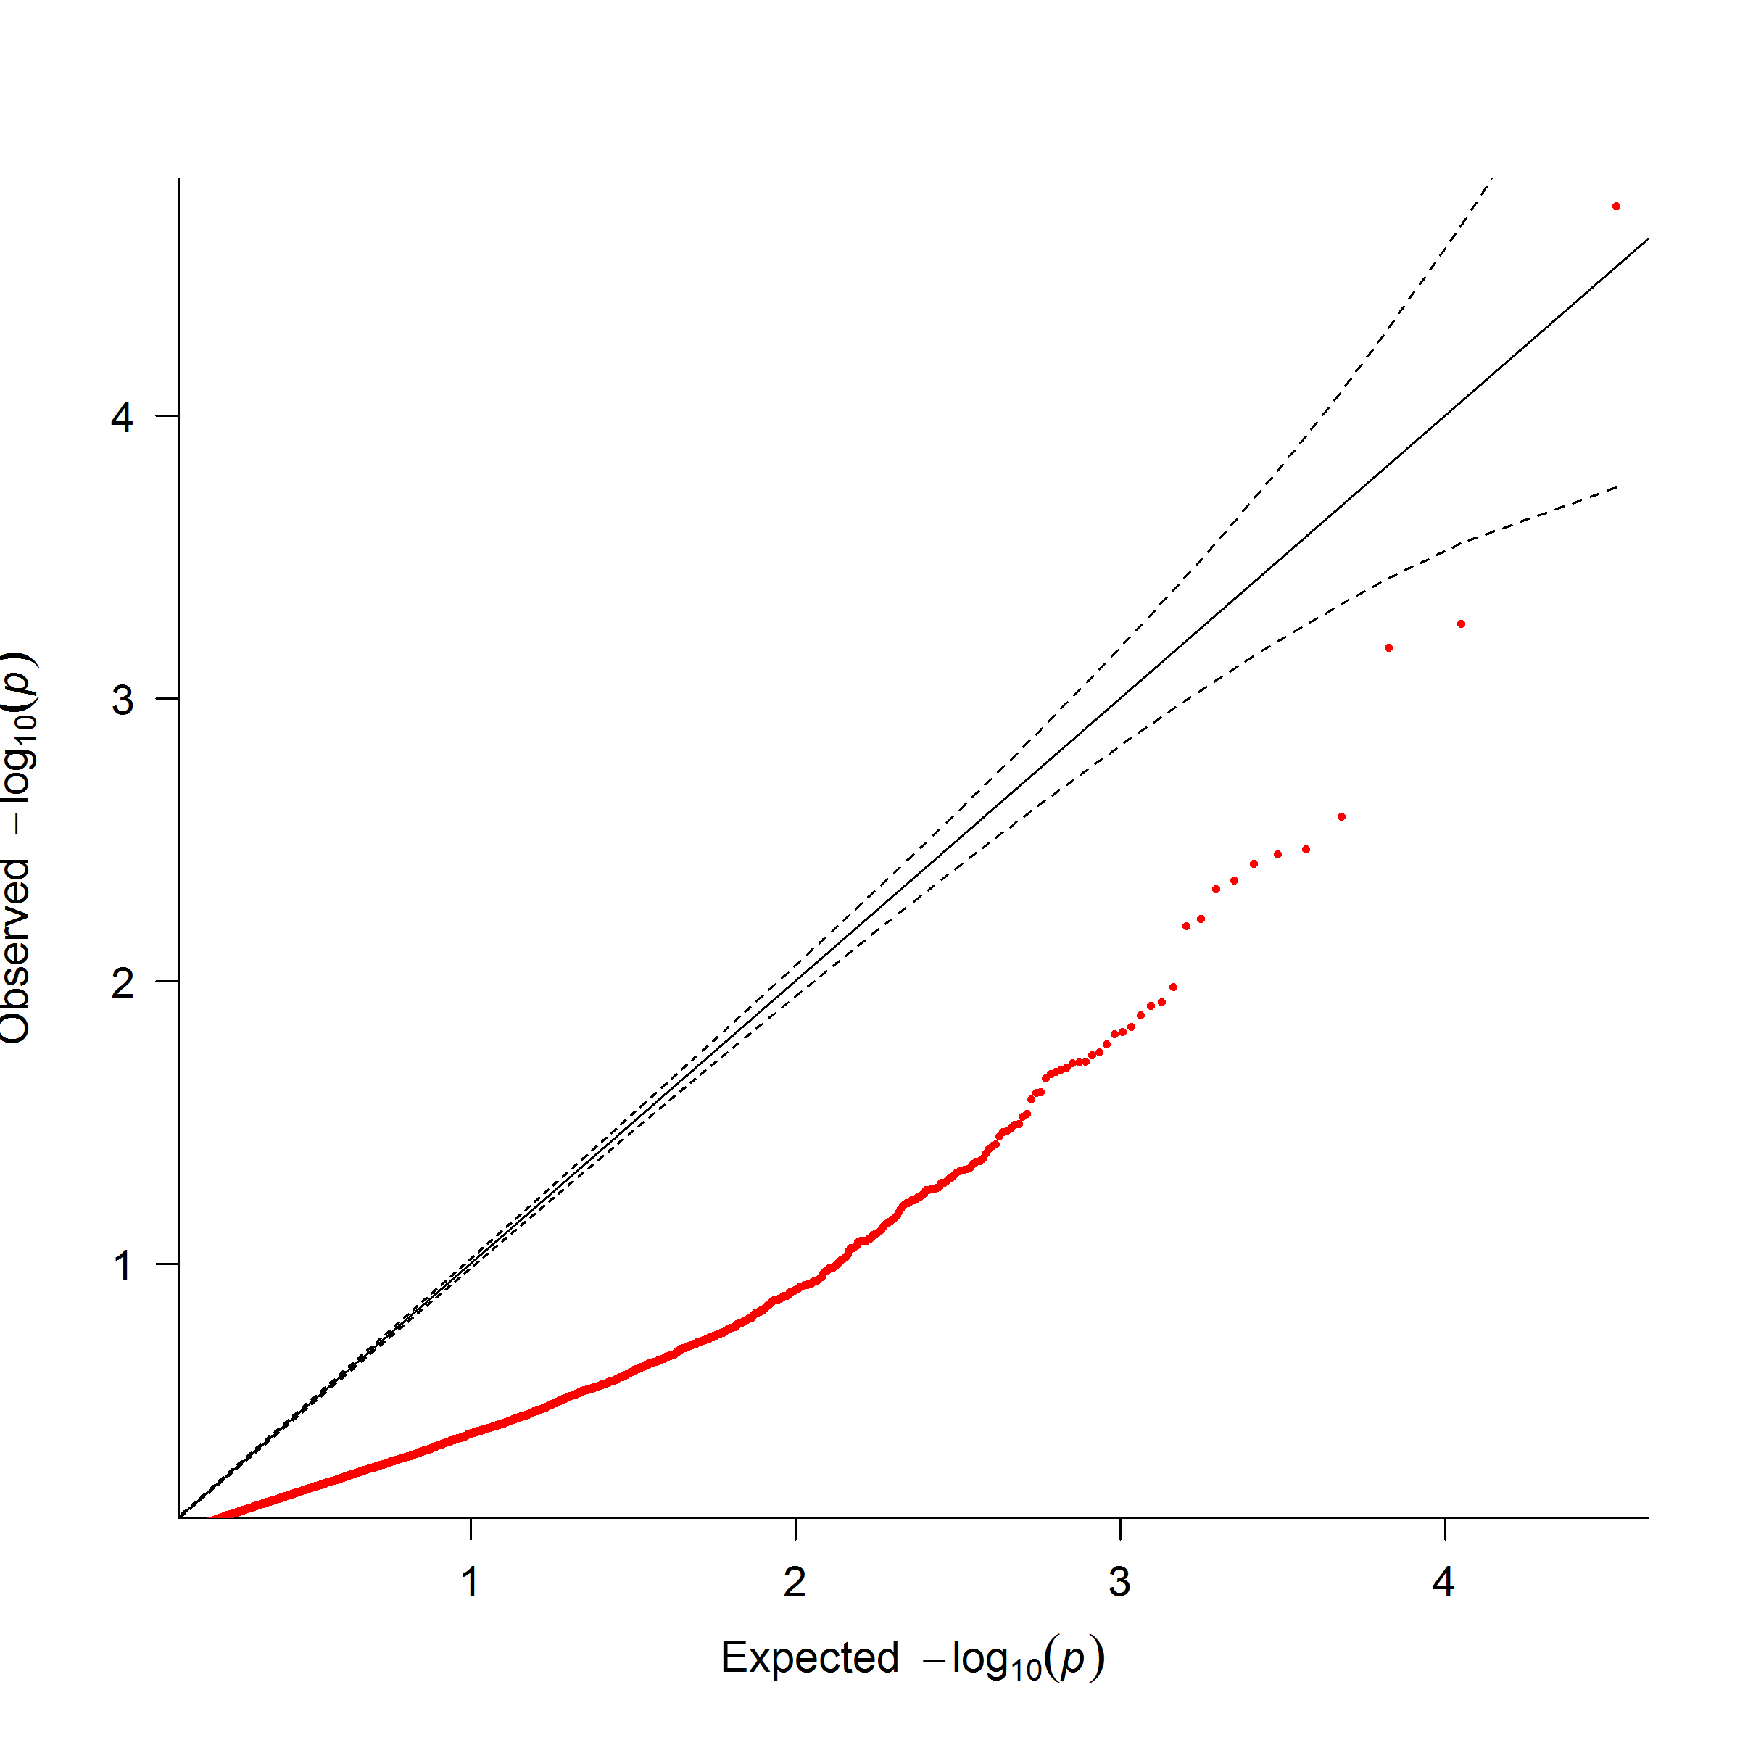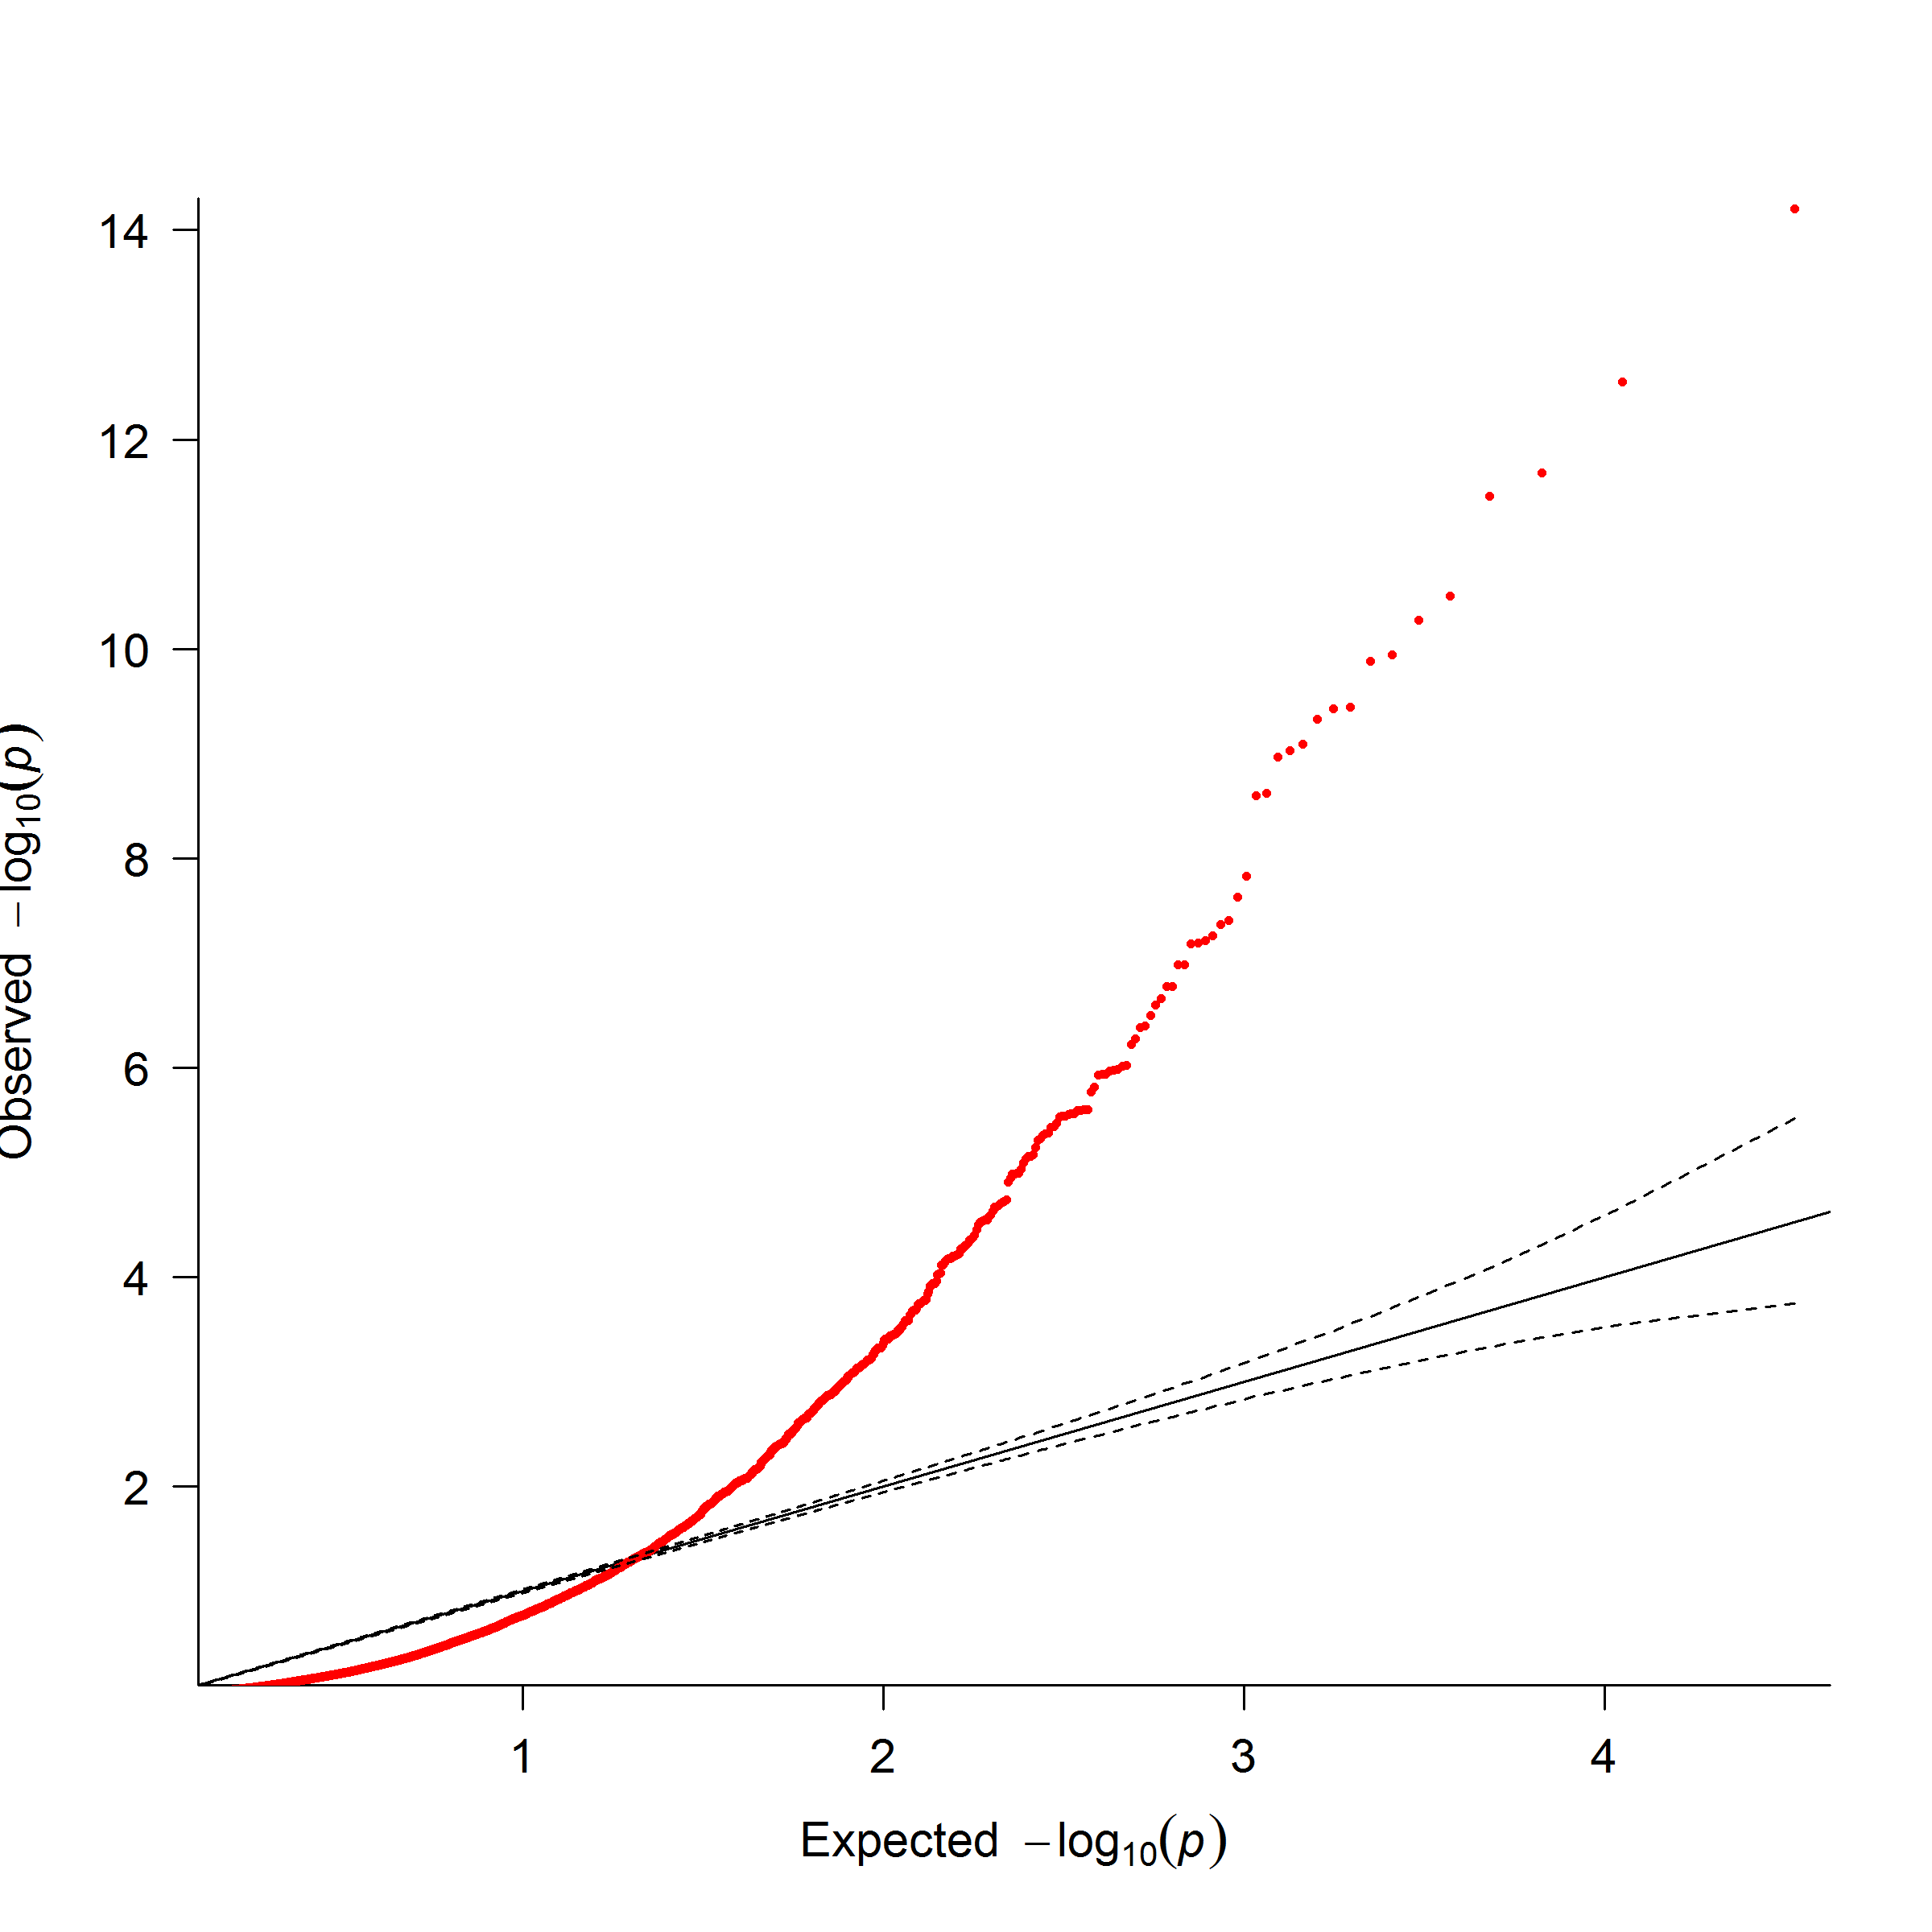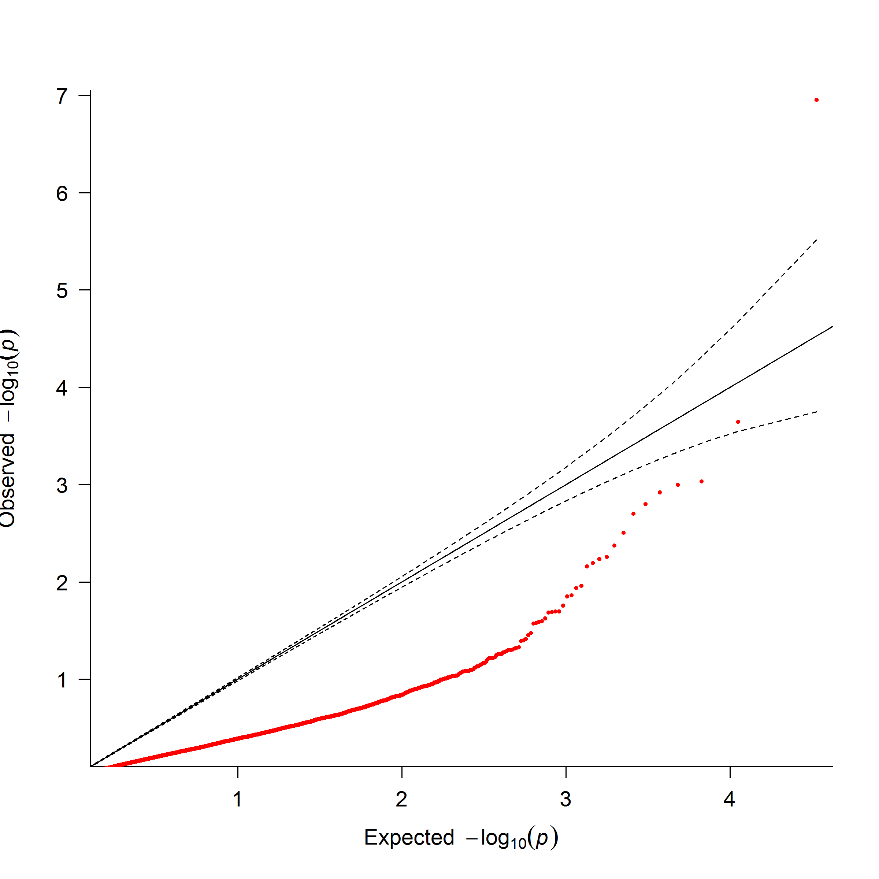

**(c)** O6-PolyI:C mice vs O3-PolyI:C mice **(d)** Batch Effect

**Figure 3.2:** QQ Plot of statistic results. From the QQ plot, it was observed that most of the observed p-value was less than what would have been expected. This is likely due to the small sample size of our study which leads to an under powered association. The only exception was the analysis of batch effect were a large amount of genes were found to be significant. This demonstrate the importance of adjusting for batch effect

We also performed the LRT to compare test the effect of batch on our analysis. A total of 178 genes were found to be significant differentiated (fig. 3.2d), suggesting that the “Batch” is indeed an important factor to consider in our analysis.

**3.3.3 Functional Annotation**

It is common practice to try and perform functional annotation to the DEGs. However, in most of our analysis, there were either no DEG or only 1 DEG, making it difficult to perform functional annotation. We therefore used the Wilcox rank sum test to analysis whether if a pathway contain genes that are more significant than genes not within the pathway instead of trying to identify pathways that were enriched by DEGs.

None of the pathway were found to be significant when comparing the effect of the n-3 rich diet in Saline exposed mice. On the contrary, 17 pathways were found significant when comparing the effect of n-3 PUFA rich diet in PolyI:C exposed samples (table 3.2) where 4 pathways were related to growth factors such as fibroblast growth factor (FGF) or epidermal growth factor (EGF) and 4 others were related to kinases such as phosphatidylinositol 3-kinase (PI3K) or mitogen-activated protein kinase (MAPK).

Finally, 12 pathways were found to significant when comparing Saline and PolyI:C exposed mice given the n-6 PUFA rich diet (table 3.3) with pathways such as neuroactive ligand-receptor interaction (p-adj = 1.27×10−3), calcium signaling pathway (p-adj = 2.79 × 10−3) and genes involved in Neuronal System (p-adj=0.00153) among the significant pathways.

|  |  |  |  |  |
| --- | --- | --- | --- | --- |
| ID | Size | Source | Description | Adjusted P-Value |
| M508 | 78 | REACTOME | Genes involved in Signaling by SCF-KIT | 0.00671 |
| M570 | 44 | REACTOME | Genes involved in PI3K events in ERBB2 signaling | 0.0242 |
| M3008 | 196 | NABA | Genes encoding structural ECM glycoproteins | 0.0309 |
| M1090 | 112 | REACTOME | Genes involved in Signaling by FGFR | 0.0309 |
| M563 | 109 | REACTOME | Genes involved in Signaling by EGFR in Cancer | 0.0309 |

M17776 100 REACTOME Genes involved in Downstream signaling of activated

FGFR

0.0309

|  |  |  |  |  |
| --- | --- | --- | --- | --- |
| M1076 | 83 | REACTOME | Genes involved in Amyloids | 0.0309 |
| M850 | 56 | REACTOME | Genes involved in PI-3K cascade | 0.0309 |
| M10450 | 38 | REACTOME | Genes involved in GAB1 signalosome | 0.0309 |
| M16227 | 24 | REACTOME | Genes involved in Cholesterol biosynthesis | 0.0309 |
| M5872 | 17 | KEGG | Steroid biosynthesis | 0.0309 |
| M16334 | 10 | BIOCARTA | Eph Kinases and ephrins support platelet aggregation | 0.0309 |
| M5884 | 275 | NABA | Ensemble of genes encoding core extracellular matrix in- | 0.0456 |
|  |  |  | cluding ECM glycoproteins, collagens and proteoglycans |  |
| M635 | 127 | REACTOME | Genes involved in Signaling by FGFR in disease | 0.0456 |
| M568 | 38 | REACTOME | Genes involved in PI3K events in ERBB4 signaling | 0.0456 |
| M165 | 32 | PID | Syndecan-4-mediated signaling events | 0.0456 |
| M1262 | 15 | REACTOME | Genes involved in GRB2:SOS provides linkage to MAPK | 0.0456 |
|  |  |  | signaling for Intergrins |  |

**Table 3.2:** Significant Pathways when comparing effect of diet in PolyI:C exposed mice. The pathway IDs are the

CHAPTER 3. N-3 POLYUNSATURATED FATTY ACID RICH DIET IN

SCHIZOPHRENIA

134

systematic name from MSigDB. Most of the significant pathways were related to the kinase such as PI3K and MAPK or growth factors such as FGF and EGF.

3.3.

RESULTS

135

|  |  |  |  |  |
| --- | --- | --- | --- | --- |
| ID | Size | Source | Description | Adjusted P-Value |
| M13380 | 272 | KEGG | Neuroactive ligand-receptor interaction | 1*.*27 *×* 10*−*3 |
| M2890 | 178 | KEGG | Calcium signaling pathway | 2*.*79 *×* 10*−*3 |
| M12289 | 188 | REACTOME | Genes involved in Peptide ligand-binding receptors | 0.00118 |
| M5884 | 275 | NABA | Ensemble of genes encoding core extracellular matrix in- | 0.00119 |
|  |  |  | cluding ECM glycoproteins, collagens and proteoglycans |  |
| M735 | 279 | REACTOME | Genes involved in Neuronal System | 0.00153 |
| M15514 | 186 | REACTOME | Genes involved in Transmission across Chemical | 0.00401 |
|  |  |  | Synapses |  |
| M4904 | 121 | REACTOME | Genes involved in G alpha (s) signalling events | 0.0127 |
| M3008 | 196 | NABA | Genes encoding structural ECM glycoproteins | 0.0131 |
| M752 | 137 | REACTOME | Genes involved in Neurotransmitter Receptor Binding | 0.0131 |
|  |  |  | And Downstream Transmission In The Postsynaptic |  |
|  |  |  | Cell |  |
| M10792 | 267 | KEGG | MAPK signaling pathway | 0.0195 |
| M17 | 59 | PID | Notch signaling pathway | 0.0406 |

M18437 184 REACTOME Genes involved in G alpha (q) signalling events 0.0406

**Table 3.3:** Significant Pathways When Comparing Effect PolyI:C in Mouse Given n-6 PUFA Rich Diet. The pathway IDs are the systematic name from MSigDB. Interestingly, we observed a lot of neural related pathways and even got significant signal in the calcium signaling pathway, which was reported to be associated with schizophrenia (S M Purcell et al., 2014).

**3.3.4 Designing the Replication Study**

Other than generation of hypothesis, we would also like to use the current information to help designing subsequent replication studies. Using Scotty (Busby et al., 2013), given that we would like to detect at least 90% of the genes that are differentially expressed by a 2× fold change at p< 0.01 and that at least 80% of genes has at least 80% of the maximum power, we will need at least 10 samples per group in the replication study given the current sequencing depth.

**3.4 Discussion**

In this hypothesis generation study, we demonstrated that *Sgk1* might be affected by n-3 PUFA rich diet in the cerebellum of MIA exposed mice. *Sgk1* is a serine/threonine kinase activated by PI3K signals and studies have shown that the expression of *Sgk1* is associated with spatial learning, fear-conditioning learning and recognition learning in rat (Tsai et al., 2002; Lee et al., 2003). For example, Tsai et al. (2002) observed a 4 fold increase of *Sgk1* in the hippocampus of fast learners when compared to slow learners where transfection of *Sgk1* mutant DNA impairs the water maze performance in rat.

On the other hand, it was found that *Sgk1* can regulates the AMPA and kainate glutamate receptors, especially GluR6 which is encoded by *Grik2* (Lang, Bohmer, et al., 2006; Lang, Strutz-Seebohm, et al., 2010). The kainate receptors contributes to the excitatory postsynaptic current and are important to the synaptic transmission and plasticity in the hippocampus (Lang, Bohmer, et al., 2006). The upregulation of AMPA and kainate receptors are therefore expected to enhance the excitatory effects of glutamate (Lang, Strutz-Seebohm, et al., 2010). Moreover, *Sgk1* also up-regulates the glutamate transporters such as EAAT4 (Bohmer et al., 2004). The glutamate receptors are vital for clearance of glutamate from the synaptic cleft. This prevents excessive glutamate accumulation and therefore help to prevent the neurotoxic effects of glutamate (Lang, Strutz-Seebohm, et al., 2010). Considering the complexity of the glutamatergic system and the conflicting role of *Sgk1*, it is likely for more genes to play a role in the tight regulation of the glutamatergic system. However, it is likely that the disruption of *Sgk1* might be have an impact to the normal functioning of the glutamatergic system.

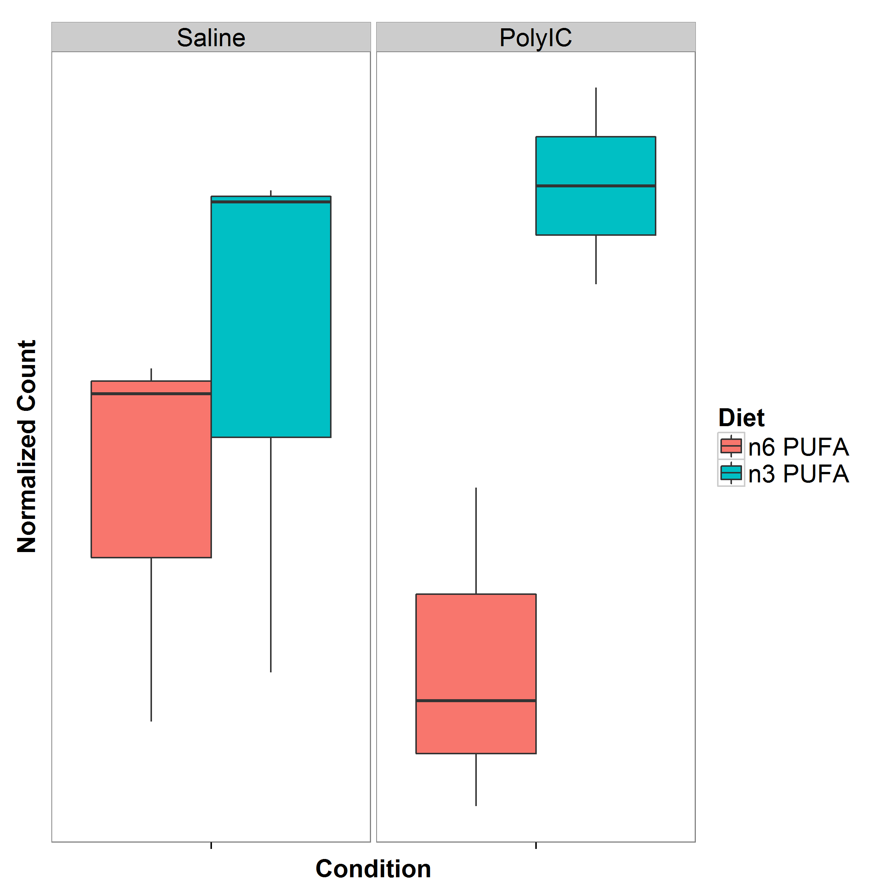

**Figure 3.3:** Normalized Expression of *Sgk1*. It was observed that the expression level of *Sgk1* increases after the mice was given a n3-PUFA rich diet where a significant increase was observed in mice exposed to PolyI:C.

In our study, it was observed that upon given the n-3 PUFA rich diet, the *Sgk1* expression in the cerebellum increases (fig. 3.3). Although the increase was not significant in the saline mice, a significant up-regulation was observed in the PolyI:C exposed mice (fig. 3.3). Additionally, it was also observed that PI3K pathways and pathways related to FGF receptors and EGF receptors were significant when studying the effect of n-3 PUFA rich diet to PolyI:C exposed mice. Upon further investigation, it was found that the FGF receptors and EGF receptors are upstream of the PI3K-Akt pathway (fig. 3.4) which is responsible for the activation of *Sgk1*. Although we were unable to provide direct connection between the expression of *Sgk1* and the improve functioning of the PolyI:C mice given n-3 PUFA diet, our results do suggest a possible effect of the n-3 PUFA rich diet in the expression of genes related to the PI3K/Akt pathway and might affect the expression of *Sgk1*. Further studies are therefore required to understand whether if the change in expression of *Sgk1* can account for the improved functioning of the PolyI:C mice. A possible design will be to induce the expression of *Sgk1* in PolyI:C mice through transfection and examine whether if the PolyI:C mice with higher expression of *Sgk1* display a reduction in schizophrenia-like behaviours.

An important point to note was that previous research of *Sgk1* has been focusing on the hippocampus and not the cerebellum. Thus, it is possible that *Sgk1* might have a different function in the cerebellum. It is therefore vital for subsequent research to study the effect of Sgk1 in the cerebellum or for one to study the effect of n-3 PUFA rich diet on the gene expression in the hippocampus.

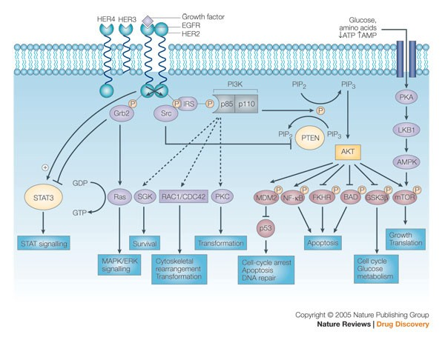

**Figure 3.4:** Schematic of signaling through the PI3K/AKT pathway. It was observed that the growth factors were upstream of the PI3K/AKT pathway of which *Sgk1* is one of the member of the pathway. Figure adopted from Hennessy et al. (2005) with permission from journal.

When examine the expression change in mice exposed to PolyI:C, none of the genes were significantly differentiated. However, we do observe 12 pathways that contains genes that were more significant than genes not within the pathway (table 3.3). Interestingly, of the 12 significant pathways, 5 pathways were related to neuronal functions such as neuroactive ligand-receptor interaction (padj=1.27 ×10−3), genes involved in neuronal system (padj=0.00153) and genes involved in transmission across chemical synapses (padj=0.00401). Most importantly, it was found that the calcium signaling pathway was significant when comparing the effect of MIA. The association of the calcium signaling pathway with schizophrenia was not a new finding (Lidow, 2003; S M Purcell et al., 2014; Stephan Ripke, B. M. Neale, et al., 2014). Previous exome sequencing study of schizophrenia by S M Purcell et al. (2014) has already report the enrichment of non-synonymous variants within the voltage gate calcium ion channel genes in the schizophrenia cases and the PGC schizophrenia GWAS has also found association between genes encoding the calcium channel subunits with schizophrenia. As calcium signaling pathway is the key component of the mechanism responsible for regulating neuronal excitability (Berridge, 2014), the disruption of the calcium signaling pathway is likely to have a profound effect on the neural function. Together, our results suggest that MIA might have disrupted the normal functioning of the neural system in the cerebellum, thus lead to schizophrenia-like behaviours in the adult mice yet follow up studies are required to validate our findings.

Finally, it is important to note that this is a pilot study and the sample size was modest. One of the main purpose of this study was to provide an estimation of sample size required for a replication study. By using Scotty (Busby et al., 2013), we have estimated that the replication study should contain at least 10 samples for each group in order for us to detect at least 80% of genes has at least 80% of the maximum power. We have also demonstrated that the batch effect can have a big impact to the association (fig. 3.2d), therefore one should always control for the batch effect whenever possible. Given the current resources, one of the preferred design for the follow up study are given in table 3.4.

**3.4.1 Limitation**

We first acknowledge that the sample size of the current study is small and are underpowered. This is reflected in the QQ-plots (fig. 3.) where the observed p-values were generally smaller than would have expected. A better study design will include more samples yet we are limited by our budget. However, the importance of a pilot study is to identify potential targets for replications, hypothesis generation or to provide guidance for follow up studies. With our data, we were able to identify *Sgk1* as an interesting candidate for follow up and were able to estimate the required number of samples in the follow up studies to achieve substantial power. Moreover, our study demonstrated the importance of controlling the batch effect which can severally con- found the results. Therefore our study do provide the necessary information required for replication and follow up studies.

Second, we examined only the male brains in the current study. The decision to direct experimental resources to males was made because there is evidence that the male fetus is more vulnerable to environmental exposures such as inflammation in prenatal life (Bergeron et al., 2013; Lein et al., 2007). We acknowledge that an interesting follow up study would be to investigate the gender difference in response to MIA and dietary change.

Third, although RNA Sequencing was performed, we have not performed any analysis on possible alternative splicing events or denovo transcript assembly. The reason behind such decision is that our sample size is simply too small. Without sufficient information, denovo transcript assembly can return noisy results. On the other hand, in order to investigate possible alternative splicing events, we would need to perform the analysis on transcript level instead of gene level. This increase the possible candidates from 47,400 genes to 114,083 transcripts. Combined with the difficulties of the quantification of different isoforms, a much larger power is required for the alternative splicing analysis. On top of that, the functional annotation of transcripts is another difficult aspect to tackle. While there are a lot of information for the annotation of genes, information on functional difference between isoforms of the same gene were generally lacking. The lack of annotation simply leads to difficulties in making sense of the data. Thus although we acknowledge the possible importance of alternative splicing and denovo transcripts, we did not perform any alternative splicing analysis or denovo transcripts assembly. Nonetheless, the use of RNA Sequencing allow us to easily perform these experiments once sufficient samples are obtained.

Forth, it is important to note that a high RNA expression level does not guarantee a high protein concentration (Vogel and Marcotte, 2012). Post transcriptional, translational and degradation regulation can all affect the rates of protein production and turnover, therefore contributes to the determination of protein concentrations, at least as much as transcription itself (Vogel and Marcotte, 2012). The RNA Sequencing thus only provide an approximation to the concentration of a particular protein in the samples. However, we do argues that RNA Sequencing can help to identify potential targets for protein assays where detail analysis can be performed on the protein level.

Finally, at the time of this thesis, we have yet completed any real time PCR (rt-PCR) or any functional studies to validate our findings. One of the most vital steps after any RNA Sequencing results is to validate the differential expression findings using the rt-PCR. Ideally, not only should one perform the rt-PCR on the sequenced samples, one should also perform the rt-PCR on an independent set of samples. Moreover, the RNA Sequencing only helps to identify possible candidates that were “associated” with a particular trait. It does not however provide any causal linkage between the phenotype and the differential expression. If one would like to establish a direct linkage between the phenotype and the gene, one will need to carry out functional studies such as knock- in knock-out mouse design. So take for example, in order to understand the functional impact of the differential expression of *Sgk1*, one might try to examine whether if the pure up-regulation of *Sgk1* through transfection can reduce the schizophrenia-like behavior in PolyI:C exposed mice.

Currently, we are planning to perform the rt-PCR on *Sgk1* on all available samples. Shall the results be validated, we can then perform subsequent functional studies.

**3.5 Supplementary**

|  |  |  |  |  |  |
| --- | --- | --- | --- | --- | --- |
| Litter | Condition | Diet | Cage | Batch | Lane |
| 1 | PolyIC | n-3 PUFA | 1 | 1 | 1 |
| 1 | PolyIC | n-6 PUFA | 2 | 5 | 1 |
| 2 | PolyIC | n-3 PUFA | 3 | 4 | 2 |
| 2 | PolyIC | n-6 PUFA | 4 | 3 | 3 |
| 3 | PolyIC | n-3 PUFA | 5 | 2 | 4 |
| 3 | PolyIC | n-6 PUFA | 6 | 1 | 1 |
| 4 | PolyIC | n-3 PUFA | 7 | 5 | 1 |
| 4 | PolyIC | n-6 PUFA | 8 | 4 | 2 |
| 5 | PolyIC | n-3 PUFA | 9 | 3 | 3 |
| 5 | PolyIC | n-6 PUFA | 10 | 2 | 4 |
| 6 | PolyIC | n-3 PUFA | 1 | 2 | 1 |
| 6 | PolyIC | n-6 PUFA | 2 | 1 | 2 |
| 7 | PolyIC | n-3 PUFA | 3 | 5 | 2 |
| 7 | PolyIC | n-6 PUFA | 4 | 4 | 3 |
| 8 | PolyIC | n-3 PUFA | 5 | 3 | 4 |
| 8 | PolyIC | n-6 PUFA | 6 | 2 | 1 |
| 9 | PolyIC | n-3 PUFA | 7 | 1 | 2 |
| 9 | PolyIC | n-6 PUFA | 8 | 5 | 2 |
| 10 | PolyIC | n-3 PUFA | 9 | 4 | 3 |
| 10 | PolyIC | n-6 PUFA | 10 | 3 | 4 |
| 11 | Saline | n-3 PUFA | 1 | 3 | 1 |
| 11 | Saline | n-6 PUFA | 2 | 2 | 2 |

Continued

|  |  |  |  |  |  |
| --- | --- | --- | --- | --- | --- |
| Litter | Condition | Diet | Cage | Batch | Lane |
| 12 | Saline | n-3 PUFA | 3 | 1 | 3 |
| 12 | Saline | n-6 PUFA | 4 | 5 | 3 |
| 13 | Saline | n-3 PUFA | 5 | 4 | 4 |
| 13 | Saline | n-6 PUFA | 6 | 3 | 1 |
| 14 | Saline | n-3 PUFA | 7 | 2 | 2 |
| 14 | Saline | n-6 PUFA | 8 | 1 | 3 |
| 15 | Saline | n-3 PUFA | 9 | 5 | 3 |
| 15 | Saline | n-6 PUFA | 10 | 4 | 4 |
| 16 | Saline | n-3 PUFA | 1 | 4 | 1 |
| 16 | Saline | n-6 PUFA | 2 | 3 | 2 |
| 17 | Saline | n-3 PUFA | 3 | 2 | 3 |
| 17 | Saline | n-6 PUFA | 4 | 1 | 4 |
| 18 | Saline | n-3 PUFA | 5 | 5 | 4 |
| 18 | Saline | n-6 PUFA | 6 | 4 | 1 |
| 19 | Saline | n-3 PUFA | 7 | 3 | 2 |
| 19 | Saline | n-6 PUFA | 8 | 2 | 3 |
| 20 | Saline | n-3 PUFA | 9 | 1 | 4 |
| 20 | Saline | n-6 PUFA | 10 | 5 | 4 |

**Table 3.4:** Design for follow up study. This will be the idea design for follow up study where litter effect, cage effect, batch effect and lane effects are all balanced out for the conditions. One can also include the External RNA Controls Consortium (ERCC) spike in control to serves as an internal standard for additional level of control (Jiang et al, 2011).

**Chapter 4**

**Conclusion**

SNP HeRitability Estimation Kit (SHREK), an algorithm for the estimation of SNP heritability using Genome Wide Association Study (GWAS) test statistics are reported in this thesis. To our knowledge, this is the only algorithm other than LD SCore regression (LDSC) that can perform heritability estimation using summary statistics from GWAS. Our simulation results suggest that when compared to LDSC, SHREK can provide a more robust estimate for oligogentic traits and in case-control designs where no confounding variables was present. Using the latest GWAS summary statistics released by the Psychiatric Genomics Consortium (PGC), we estimated that schizophrenia has a Single Nucleotide Polymorphism (SNP)-heritability of 0.174 (SD=0.00453), which is similar to the estimate of 0.197 (SD=0.0058) by LDSC.

On the other hand, we report a pilot RNA Sequencing study aiming to investigate the effect of maternal immune activation (MIA) and n-3 polyunsaturated fatty acid (PUFA) rich diet on the gene expression pattern in adult cerebellum. Overall, our results suggest the maternal immune activation (MIA) exposure might disrupt gene expressions that are related to neural function or the calcium ion signaling in the cerebellum of adult mice. In addition, we observed a significant up-regulation of Sgk1 in polyriboinosinic-polyribocytidilic acid (PolyI:C) exposed mice that were given the n-3 PUFA rich diet. Consider the regulatory role of *Sgk1* in the glutamatergic system, it is possible that the n-3 PUFA rich diet can help to “rescued” some of the impaired functions in the glutamatergic system yet further studies are required. Based on our data, we were able to design a follow up study with adequate sample size and control for different confounding variables such as batch effect and cage effect.

**4.1 Challenge in SNP-Heritability Estimation**

Although it is now possible to estimates the SNP heritability based on the summary statistic from GWAS, a lot of questions remain unanswered in the estimation of SNP heritability. One major problem of SHREK and LDSC is that they both heavily re- lies on the Linkage Disequilibrium (LD) structures from the reference panel. However, GWAS samples can come from large variety of ethnic background thus the LD pattern estimated from the reference panel might not be representative of the sample LD. If the fundamental LD structure was not as expected, both SHREK and LDSC will not be able to provide an accurate estimate. For example, if a GWAS was conducted with 50% European and 50% African, population stratification may confound the results. Even if one control for the population stratification using the principle component analysis (PCA), the question remains whether if one should use the African reference panel or the European reference panel in the estimation of SNP heritability. Moreover, information regarding the population stratification (e.g. the Principle Component (PC)) were usually unavailable making the problem more complicated. Further researches are therefore required to tackle the problem of population stratification before one can confidently estimate the SNP heritability from summary statistics from GWAS that might contain samples from large variety of ethnic background.

An important observation in our simulation study was that there was a general bias observed in all the SNP-heritability estimation algorithm under the case control scenario. This is likely due to the ascertainment bias introduced through case control sampling. Although the liability adjustment was performed, bias was still observed. This suggested that we will need a better liability adjustment algorithm if we would like to accurately estimate the SNP-heritability from case control studies.

As technology advances, researchers can now use the next generation sequencing (NGS) technology to sequence the genome at per base resolution. This brings great prospect in the genetic studies for now we can directly identify the causal variants and can even detect rare causal variants providing sufficient sample size. However, both SHREK and LDSC are designed to work on the summary statistics from GWAS where common SNPs are usually the focus. Because of the huge sampling error associating with rare variants, the LD calculated for rare variants usually has a larger standard error (SE). As SHREK and LDSC are both heavily rely on an accurate LD estimation, they might be unsuitable for the estimation of the contribution of rare variants to schizophrenia. In fact, it was found that when all causal variants are rare (minor allele frequency (maf) < 1%), LDSC will often generate a negative slope, and the intercept will exceed the mean χ2 statistic (B. K. Bulik-Sullivan et al., 2015). As a result of that, a different algorithm must be developed in order to estimates the heritability from rare variants.

**4.2 Schizophrenia: Future Perspectives**

With the success of the PGC schizophrenia GWAS, research in schizophrenia genetics has finally entered an era of success. Through international collaboration, the PGC has finally identified 108 genetic loci that were associated with schizophrenia using GWAS approach (Stephan Ripke, B. M. Neale, et al., 2014). The results from the GWAS was based on the statistical association between variants and schizophrenia yet the functional involvement of these variants in the etiology of schizophrenia remains unknown. Functional analysis of these variants, and their contribution to the etiology of schizophrenia will become an important topic for further research in schizophrenia genetics.

On the other hand, when estimating the SNP-heritability of schizophrenia, it was found that no more than 20% of the heritability has been accounted for by the current GWAS. By continuing to increase the sample size of the GWAS, more associated variants will be able to be identified, thus increasing the SNP heritability. However, it is important to note that the heritability estimated from twin studies were not restricted to common SNPs. It is highly possible that other factors such as rare variants and epigenetic variants such as methylation might also contribute to the heritability of schizophrenia.

Clear evidences suggest that schizophrenia patients has a higher mortality than the general population (Saha, Chant, and Mcgrath, 2007). Given this strong selective pressure, it is likely that the causal variants of schizophrenia with large effect size will be selected against in the population. As a result of that, causal variants with large effect size are likely to be rare (fig. 4.1). With the technological advancement in NGS, we are now able to investigate the human genome at per base resolution using

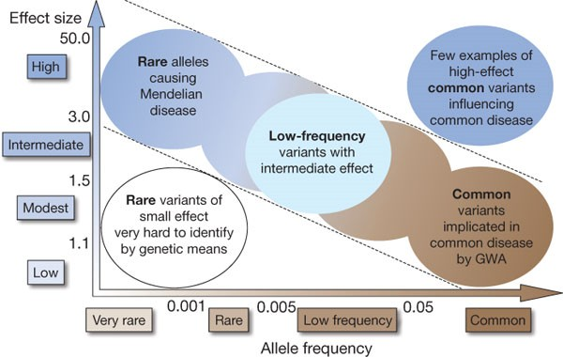

**Figure 4.1:** Relationship between effect size and allele frequency. It is expected that rare variants with large effect size were actively selected against in the population and therefore should be rare.

Exome Sequencing and even Whole Genome Sequencing technology. Recent study by S M Purcell et al. (2014) was able to identify gene sets enriched by rare variants that were associated with schizophrenia using Exome Sequencing. This demonstrate the power of the sequencing technology in the identification of possible risk variants. Moreover, there was overlaps observed between genes harboring rare risk variants and those within the PGC schizophrenia GWAS (S M Purcell et al., 2014), suggesting that the rare variants and common variants studies are complementing each other. As more resources are devoted in to sequencing the genome of schizophrenia patients, more rare variants associated with schizophrenia are expected to be identified.

Currently, most of the focus in schizophrenia was directed to genetic variation yet it is possible that the heritability of schizophrenia is also transmitted in the form of epigenetic changes such as methylation. It was observed that the risk for individual born from a schizophrenic mother is larger than that from a schizophrenic father. This suggest that maternal specific elements, such as maternal imprinting and mitochondria might account for part of the risk of schizophrenia. Epigenetic studies in schizophrenia (Wockner et al., 2014; Nishioka et al., 2012) has identified genes with differential DNA methylation patterns associated with schizophrenia, suggesting the important of epigenetic in the etiology of schizophrenia.

As a genetic disorder, most of the research of schizophrenia has been focusing on the genetic factors. Although the genetic variation accounted for majority of the variations in schizophrenia, the environmental factors, especially prenatal infection is also an important factor to consider. It was estimated that prenatal infection accounts for roughly 33% of all schizophrenia cases (A S Brown and Derkits, 2010). The MIA rodent model has provide vital information on the possible interaction between the immune and neuronal system in the etiology of schizophrenia (U Meyer, Yee, and J Feldon, 2007). For example, Interleukin-6 (IL-6), a pro-inflammatory cytokine has been found to be an important mediator in generating the schizophrenia-like behaviour in rodent model (Smith et al., 2007). More importantly, there are evidence of the interaction between prenatal infection and genetic variation, supporting a mechanism of gene-environment interaction in the causation of schizophrenia (Clarke et al.,2009). As the SNP-heritability estimation does not take into account of the gene environmental interactions, it is possible that the “missing” heritability can be due to gene-environmental interactions. Efforts is now made by the European network of national schizophrenia networks studying Gene-Environmental Interaction (EUGEI) to identify possible genetic and environmental interaction that contributes to the disease etiology of schizophrenia.

With the sophistication of technologies, we can now perform whole genome sequencing with the HiSeq X Ten system costing less than $1,000. Therefore, the largest challenge now resides in how to make sense of the data instead of data generation. For example, the alignment of sequence read to low complexity sequence or low-degeneracy repeats remains challenging and might be error prone, thus have a negative impact to the quality of the results (Sims et al., 2014). New sequencing technology such as Oxford Nanopore which can provide extra-long-reads, might help to make alignment easier due to the extra information for each individual reads. However, the Oxford Nanopore is still under development and has a relatively high error rate (Mikheyev and Tin, 2014). Only until the error rate is dramatically decreased can the use of Oxford Nanopore system become feasible.

Even if the reads can perfectly aligned to the genome, the functional annotation of variants remains challenging. When it comes to complex disease such as schizophrenia, there can be a lot of causal variants observed throughout the genome yet currently one can only provide estimates of the functional impact of variants on the exomic regions. The development of ENCODE project (ENCODE Project Consortium, 2012) and Genotype-Tissue Expression (GTEx) project (T. G. Consortium, 2015) have helped provide reference point for the annotation of genetic variations in the intergenic regions yet there are still many genetic variation in the genome where their function remains unknown. Only through the tireless effort of the molecular biologist can we gain sufficient information required to make sense of the sequencing data obtained.

In conclusion, we have only catch a glimpse of the etiology of schizophrenia and there are still a lot of questions left unanswered. It is expected that only by combining the study of epigenetic, genomic variation, gene expressions, and gene environmental interaction can a deeper understanding of the complex disease mechanism of schizophrenia be obtained. Hopefully, in the near future, enough information can be gathered to start translating the research findings into clinical applications to help improving the quality of life of schizophrenia patients.

**Bibliography**

Altshuler, David M et al. (2010). “Integrating common and rare genetic variation in diverse human populations.” In: *Nature* 467.7311, pp. 52–58 (cit. on pp. 51, 55). American Psychiatric Association (2013). *Diagnostic and Statistical Manual of Mental*

*Disorders*. American Psychiatric Publishing, p. 991 (cit. on pp. 1, 3, 120).

Anders, S and W Huber (2010). “Differential expression analysis for sequence count data”. eng. In: *Genome Biol* 11.10, R106 (cit. on p. 127).

Andreasen, Nancy C and Ronald Pierson (2008). “The role of the cerebellum in schizophre- nia.” eng. In: *Biological psychiatry* 64.2, pp. 81–88 (cit. on p. 122).

Andrews, S. *FastQC A Quality Control tool for High Throughput Sequence Data* (cit. on p. 126).

Bergeron, J D et al. (2013). “White matter injury and autistic-like behavior predom- inantly affecting male rat offspring exposed to group B streptococcal maternal in- flammation”. eng. In: *Dev Neurosci* 35.6, pp. 504–515 (cit. on p. 141).

Bernstein, Bradley E et al. (2010). “The NIH Roadmap Epigenomics Mapping Consor- tium.” eng. In: *Nature biotechnology* 28.10, pp. 1045–1048 (cit. on p. 30).

Berridge, Michael J (2014). “Calcium signalling and psychiatric disease: bipolar disorder and schizophrenia.” eng. In: *Cell and tissue research* 357.2, pp. 477–492 (cit. on p. 139).

153

Bohmer, Christoph et al. (2004). “Stimulation of the EAAT4 glutamate transporter by SGK protein kinase isoforms and PKB.” eng. In: *Biochemical and biophysical research communications* 324.4, pp. 1242–1248 (cit. on p. 137).

Bouchard, Thomas J (2013). “The Wilson Effect: the increase in heritability of IQ with age.” In: *Twin research and human genetics : the official journal of the International Society for Twin Studies* 16.5, pp. 923–30 (cit. on p. 9).

Brown, A S and E J Derkits (2010). “Prenatal infection and schizophrenia: a review of epidemiologic and translational studies”. eng. In: *Am J Psychiatry* 167.3, pp. 261–

280 (cit. on pp. 4, 7, 119, 120, 150).

Brown, Alan S (2012). “Epidemiologic studies of exposure to prenatal infection and risk of schizophrenia and autism.” eng. In: *Developmental neurobiology* 72.10, pp. 1272–

1276 (cit. on p. 121).

Buckley, Peter F et al. (2009). “Psychiatric Comorbidities and Schizophrenia”. In:

*Schizophrenia Bulletin* 35.2, pp. 383–402.

Bulik-Sullivan, Brendan (2015). *Replicating MDD heritability Estimation* (cit. on p. 104). Bulik-Sullivan, Brendan K et al. (2015). “LD Score regression distinguishes confounding

from polygenicity in genome-wide association studies”. In: *Nature Genetics* 47.3, pp. 291–295 (cit. on pp. 26–28, 36, 37, 59, 75, 104, 147).

Bulik-Sullivan, Brendan et al. (2015). “An atlas of genetic correlations across human diseases and traits”. In: *Nat Genet* advance online publication.

Busby, Michele A et al. (2013). “Scotty: a web tool for designing RNA-Seq experiments to measure differential gene expression”. In: *Bioinformatics* 29.5, pp. 656–657 (cit. on pp. 129, 136, 140).

Cadenhead, K S et al. (2000). “Modulation of the startle response and startle laterality in relatives of schizophrenic patients and in subjects with schizotypal personality

disorder: evidence of inhibitory deficits.” eng. In: *The American journal of psychi- atry* 157.10, pp. 1660–1668 (cit. on p. 4).

Clandinin, M T (1999). “Brain development and assessing the supply of polyunsatu- rated fatty acid.” eng. In: *Lipids* 34.2, pp. 131–137 (cit. on p. 121).

Clarke, Mary C et al. (2009). “Evidence for an interaction between familial liability and prenatal exposure to infection in the causation of schizophrenia.” eng. In: *The American journal of psychiatry* 166.9, pp. 1025–1030 (cit. on p. 150).

Consortium, The GTEx (2015). “The Genotype-Tissue Expression (GTEx) pilot anal- ysis: Multitissue gene regulation in humans”. In: *Science* 348.6235, pp. 648–660 (cit. on p. 151).

Consortium, The International HapMap (2005). “A haplotype map of the human genome”. In: *Nature* 437, pp. 1299–1320 (cit. on p. 19).

Deverman, B E and P H Patterson (2009). “Cytokines and CNS development”. eng.

In: *Neuron* 64.1, pp. 61–78 (cit. on p. 21).

Dobin, A et al. (2013). “STAR: ultrafast universal RNA-seq aligner”. eng. In: *Bioin- formatics* 29.1, pp. 15–21 (cit. on pp. 126, 127, 130).

ENCODE Project Consortium (2012). “An integrated encyclopedia of DNA elements in the human genome”. In: *Nature* 489.7414, pp. 57–74 (cit. on pp. 30, 151).

Engstrom, Par G et al. (2013). “Systematic evaluation of spliced alignment programs for RNA-seq data”. In: *Nat Meth* 10.12, pp. 1185–1191 (cit. on p. 126).

Falconer, Douglas S (1965). “The inheritance of liability to certain diseases, estimated from the incidence among relatives”. In: *Annals of Human Genetics* 29.1, pp. 51–76 (cit. on pp. 12, 13).

Falconer, Douglas S and Trudy F C Mackay (1996). *Introduction to Quantitative Ge- netics (4th Edition)*. Vol. 12, p. 464 (cit. on pp. 8, 11, 15).

Feuk, Lars, Andrew R Carson, and Stephen W Scherer (2006). “Structural variation in the human genome”. In: *Nat Rev Genet* 7.2, pp. 85–97 (cit. on p. 21).

Finucane, Hilary K et al. (2015). “Partitioning heritability by functional annotation using genome-wide association summary statistics”. In: *Nat Genet* advance online publication (cit. on pp. 30, 32).

Garbett, K a et al. (2012). “Effects of maternal immune activation on gene expression patterns in the fetal brain”. In: *Translational Psychiatry* 2.4, e98 (cit. on pp. 5,

121).

Gilad, Yoav and Orna Mizrahi-Man (2015). “A reanalysis of mouse ENCODE compar- ative gene expression data.” eng. In: *F1000Research* 4, p. 121 (cit. on p. 127). Giovanoli, S. et al. (2013). “Stress in puberty unmasks latent neuropathological conse-

quences of prenatal immune activation in mice”. eng. In: *Science* 339.6123, pp. 1095–

1099 (cit. on pp. 5, 6).

Golan, David, Eric S Lander, and Saharon Rosset (2014). “Measuring missing heritabil- ity: Inferring the contribution of common variants”. In: *Proceedings of the National Academy of Sciences* 111.49, E5272–E5281 (cit. on pp. 36, 81, 82, 99).

Gottesman, I I and J Shields (1967). “A polygenic theory of schizophrenia”. In: *Pro- ceedings of the National Academy of Sciences* 58.1, pp. 199–205 (cit. on pp. 15, 16,

28).

Gottesman, II (1991). *Schizophrenia genesis: The origins of madness.* WH Freeman/Times

Books/Henry Holt & Co (cit. on p. 17).

Gottesman, II and J Shields (1967). “A polygenic theory of schizophrenia”. In: *Pro- ceedings of the National Academy of Sciences* 58.1, pp. 199–205 (cit. on p. 17). Gottesman, Irving I and James Shields (1982). *Schizophrenia: The Epigenetic Puzzle*.

Cambridge University Press (cit. on pp. 8, 16).

Guennebaud, Ga¨el, Benoˆıt Jacob, et al. (2010). *Eigen v3*. [http://eigen.tuxfamily.org](http://eigen.tuxfamily.org/)

(cit. on pp. 49, 52).

Guey, Lin T. et al. (2011). “Power in the phenotypic extremes: A simulation study of power in discovery and replication of rare variants”. In: *Genetic Epidemiology* 35.4, pp. 236–246 (cit. on pp. 47, 48).

Gui, Hongsheng et al. (2013). “RET and NRG1 interplay in Hirschsprung disease.”

eng. In: *Human genetics* 132.5, pp. 591–600 (cit. on p. 63).

Hansen, Per Christian (1987). “The truncated SVD as a method for regularization”.

In: *Bit* 27.4, pp. 534–553 (cit. on pp. 50, 51).

Harrison, P J and D R Weinberger (2005). “Schizophrenia genes, gene expression, and neuropathology: on the matter of their convergence.” In: *Molecular psychiatry* 10.1,

40–68, image 5 (cit. on p. 18).

Harvey, Philip D. et al. (2012). “Diagnosis of schizophrenia: Consistency across infor- mation sources and stability of the condition”. In: *Schizophrenia Research* 140.1-3, pp. 9–14 (cit. on p. 3).

Hennessy, Bryan T et al. (2005). “Exploiting the PI3K/AKT Pathway for Cancer Drug

Discovery”. In: *Nat Rev Drug Discov* 4.12, pp. 988–1004 (cit. on p. 139).

Heston, Leonard L (1966). “Psychiatric Disorders in Foster Home Reared Children of Schizophrenic Mothers”. In: *The British Journal of Psychiatry* 112.489, pp. 819–825 (cit. on p. 14).

Hinrichs, A S et al. (2006). “The UCSC Genome Browser Database: update 2006.” eng.

In: *Nucleic acids research* 34.Database issue, pp. D590–8 (cit. on p. 68).

Ho, Nghia (2011). *OPENCV VS. ARMADILLO VS. EIGEN ON LINUX* (cit. on pp. 52, 108).

Jablensky, Assen (2010). “The diagnostic concept of schizophrenia: its history, evolu- tion, and future prospects.” In: *Dialogues in clinical neuroscience* 12.3, pp. 271–87 (cit. on p. 3).

Jiang, Lichun et al. (2011). “Synthetic spike-in standards for RNA-seq experiments”.

In: *Genome Research* 21.9, pp. 1543–1551 (cit. on p. 144).

Kelly, C and R G McCreadie (1999). “Smoking habits, current symptoms, and premor- bid characteristics of schizophrenic patients in Nithsdale, Scotland.” eng. In: *The American journal of psychiatry* 156.11, pp. 1751–1757 (cit. on p. 8).

Kim, Daehwan et al. (2013). “TopHat2: accurate alignment of transcriptomes in the presence of insertions, deletions and gene fusions”. In: *Genome Biology* 14.4, R36 (cit. on p. 126).

Knable, M B and D R Weinberger (1997). “Dopamine, the prefrontal cortex and schizophrenia.” eng. In: *Journal of psychopharmacology (Oxford, England)* 11.2, pp. 123–131 (cit. on p. 122).

Knapp, Martin, Roshni Mangalore, and Judit Simon (2004). “The global costs of schizophrenia.” In: *Schizophrenia bulletin* 30.2, pp. 279–293 (cit. on p. 1).

Lander, E S et al. (2001). “Initial sequencing and analysis of the human genome.” eng.

In: *Nature* 409.6822, pp. 860–921 (cit. on p. 18).

Lang, Florian, Christoph B¨ohmer, et al. (2006). “(Patho)physiological Significance of the Serum- and Glucocorticoid-Inducible Kinase Isoforms”. In: *Physiological Re- views* 86.4, pp. 1151–1178 (cit. on p. 136).

Lang, Florian, Nathalie Strutz-Seebohm, et al. (2010). “Significance of SGK1 in the regulation of neuronal function”. In: *The Journal of Physiology* 588.18, pp. 3349–

3354 (cit. on pp. 136, 137).

Lee, Eminy H Y et al. (2003). “Enrichment enhances the expression of sgk, a glucocorticoid- induced gene, and facilitates spatial learning through glutamate AMPA receptor

mediation.” eng. In: *The European journal of neuroscience* 18.10, pp. 2842–2852 (cit. on p. 136).

Lein, E S et al. (2007). “Genome-wide atlas of gene expression in the adult mouse brain”. eng. In: *Nature* 445.7124, pp. 168–176 (cit. on p. 141).

Li, Miao-Xin Xin et al. (2011). “Evaluating the effective numbers of independent tests and significant p-value thresholds in commercial genotyping arrays and public im- putation reference datasets”. In: *Human Genetics* 131.5, pp. 747–756 (cit. on pp. 20,

45).

Li, Na and Matthew Stephens (2003). “Modeling linkage disequilibrium and identify- ing recombination hotspots using single-nucleotide polymorphism data.” eng. In: *Genetics* 165.4, pp. 2213–2233 (cit. on p. 56).

Li, Q, C Cheung, R Wei, V Cheung, et al. (2010). “Voxel-based analysis of postnatal white matter microstructure in mice exposed to immune challenge in early or late pregnancy”. eng. In: *Neuroimage* 52.1, pp. 1–8 (cit. on pp. 4, 121).

Li, Q, C Cheung, R Wei, E S Hui, et al. (2009). “Prenatal immune challenge is an environmental risk factor for brain and behavior change relevant to schizophrenia: evidence from MRI in a mouse model”. eng. In: *PLoS One* 4.7, e6354 (cit. on pp. 4,

121, 124).

Li, Q, Y O Leung, et al. (2015). “Dietary supplementation with n-3 fatty acids from weaning limits brain biochemistry and behavioural changes elicited by prenatal exposure to maternal inflammation in the mouse model.” eng. In: *Translational psychiatry* 5, e641 (cit. on pp. 33, 122).

Liao, Yang, Gordon K Smyth, and Wei Shi (2014). “featureCounts: an efficient gen- eral purpose program for assigning sequence reads to genomic features.” eng. In: *Bioinformatics (Oxford, England)* 30.7, pp. 923–930 (cit. on pp. 127, 130).

Lichtenstein, Paul et al. (2009). “Common genetic determinants of schizophrenia and bipolar disorder in Swedish families: a population-based study”. In: *The Lancet*

373.9659, pp. 234–239 (cit. on pp. 16, 28).

Lidow, Michael S (2003). “Calcium signaling dysfunction in schizophrenia: a unifying approach.” eng. In: *Brain research. Brain research reviews* 43.1, pp. 70–84 (cit. on p. 139).

Love, Michael I, Wolfgang Huber, and Simon Anders (2014). “Moderated estimation of fold change and dispersion for RNA-seq data with DESeq2.” eng. In: *Genome biology* 15.12, p. 550 (cit. on p. 127).

Marioni, J C et al. (2008). “RNA-seq: an assessment of technical reproducibility and comparison with gene expression arrays”. eng. In: *Genome Res* 18.9, pp. 1509–1517 (cit. on p. 127).

Martin, Marcel (2011). “Cutadapt removes adapter sequences from high-throughput sequencing reads”. In: *EMBnet.journal; Vol 17, No 1: Next Generation Sequencing Data Analysis* (cit. on p. 126).

McClellan, Jon M, Ezra Susser, and Mary-Claire King (2007). “Schizophrenia: a com- mon disease caused by multiple rare alleles”. In: *The British Journal of Psychiatry*

190.3, pp. 194–199 (cit. on p. 18).

McGrath, John et al. (2008). “Schizophrenia: A Concise Overview of Incidence, Preva- lence, and Mortality”. In: *Epidemiologic Reviews* 30.1, pp. 67–76 (cit. on p. 8). Mednick (1958). “Schizophrenia Following Prenatal Exposure to an Influenza Epi-

demic”. In: 1111.1 (cit. on p. 3).

Meyer, U, J Feldon, and B K Yee (2009). “A review of the fetal brain cytokine imbalance hypothesis of schizophrenia”. eng. In: *Schizophr Bull* 35.5, pp. 959–972 (cit. on p. 21).

Meyer, U, B K Yee, and J Feldon (2007). “The neurodevelopmental impact of pre- natal infections at different times of pregnancy: the earlier the worse?” eng. In: *Neuroscientist* 13.3, pp. 241–256 (cit. on pp. 5, 6, 121, 150).

Meyer, Urs, Joram Feldon, and S Hossein Fatemi (2009). “In-vivo rodent models for the experimental investigation of prenatal immune activation effects in neurodevelop- mental brain disorders”. In: *Neuroscience & Biobehavioral Reviews* 33.7, pp. 1061–

1079 (cit. on p. 4).

Mikheyev, Alexander S and Mandy M Y Tin (2014). “A first look at the Oxford

Nanopore MinION sequencer.” eng. In: *Molecular ecology resources* 14.6, pp. 1097–

1102 (cit. on p. 151).

Mu¨ller, Norbert and Markus J Schwarz (2010). “Immune System and Schizophrenia”.

In: *Current immunology reviews* 6.3, pp. 213–220 (cit. on p. 7).

Neumaier, Arnold (1998). “Solving Ill-Conditioned and Singular Linear Systems: A Tutorial on Regularization”. In: *SIAM Review* 40.3, pp. 636–666 (cit. on p. 49). Nishioka, Masaki et al. (2012). “DNA methylation in schizophrenia: progress and chal-

lenges of epigenetic studies.” eng. In: *Genome medicine* 4.12, p. 96 (cit. on p. 150). Nugent, Tom F. et al. (2007). “Dynamic mapping of hippocampal development in childhood onset schizophrenia”. In: *Schizophrenia Research* 90.1-3, pp. 62–70 (cit.

on p. 122).

Olivo, Susan E and Leena Hilakivi-Clarke (2005). “Opposing effects of prepubertal low- and high-fat n-3 polyunsaturated fatty acid diets on rat mammary tumorigenesis.” eng. In: *Carcinogenesis* 26.9, pp. 1563–1572 (cit. on p. 124).

Onore, C E et al. (2014). “Maternal immune activation leads to activated inflammatory macrophages in offspring”. eng. In: *Brain Behav Immun* 38, pp. 220–226 (cit. on p. 7).

Ording, Anne Gulbech et al. (2013). “Comorbid Diseases Interact with Breast Cancer to Affect Mortality in the First Year after Diagnosis—A Danish Nationwide Matched Cohort Study”. In: *PLoS ONE* 8.10, e76013.

Orr, H Allen (1998). “The Population Genetics of Adaptation: The Distribution of Factors Fixed during Adaptive Evolution”. In: *Evolution* 52.4, pp. 935–949 (cit. on p. 56).

Oskviga, Devon B. et al. (2012). “Maternal immune activation by LPS selectively alters specific gene expression profiles of interneuron migration and oxidative stress in the fetus without triggering a fetal immune response”. In: *Brain, Behavior, and Immunity* 26.4, pp. 623–634 (cit. on pp. 5, 121).

Paolicelli, R C et al. (2011). “Synaptic pruning by microglia is necessary for normal brain development”. eng. In: *Science* 333.6048, pp. 1456–1458 (cit. on p. 6).

Peloso, Gina M et al. (2015). “Phenotypic extremes in rare variant study designs.” ENG. In: *European journal of human genetics : EJHG* (cit. on p. 86).

Perlstein, W M et al. (2001). “Relation of prefrontal cortex dysfunction to working memory and symptoms in schizophrenia.” eng. In: *The American journal of psychi- atry* 158.7, pp. 1105–1113 (cit. on p. 122).

Project, Genomes et al. (2012). “An integrated map of genetic variation from 1,092 human genomes”. In: *Nature* 491.7422, pp. 56–65 (cit. on pp. 55, 68).

Psychiatric GWAS Consortium Bipolar Disorder Working Group (2011). “Large-scale genome-wide association analysis of bipolar disorder identifies a new susceptibility locus near ODZ4.” eng. In: *Nature genetics* 43.10, pp. 977–983 (cit. on p. 68).

Purcell, S M et al. (2014). “A polygenic burden of rare disruptive mutations in schizophre- nia”. eng. In: *Nature* 506.7487, pp. 185–190 (cit. on pp. 135, 139, 149).

Purcell, S, S S Cherny, and P C Sham (2003). “Genetic Power Calculator: design of linkage and association genetic mapping studies of complex traits”. en. In: *Bioin- formatics* 19, pp. 149–150 (cit. on p. 20).

Purcell, Shaun M et al. (2009). “Common polygenic variation contributes to risk of schizophrenia and bipolar disorder.” eng. In: *Nature* 460.7256, pp. 748–752.

Purcell, Shaun et al. (2007). “PLINK: A Tool Set for Whole-Genome Association and

Population-Based Linkage Analyses”. In: *The American Journal of Human Genetics*

81.3, pp. 559–575 (cit. on p. 57).

Reeves, P G, F H Nielsen, and G C Jr Fahey (1993). *AIN-93 purified diets for laboratory rodents: final report of the American Institute of Nutrition ad hoc writing committee on the reformulation of the AIN-76A rodent diet.* eng (cit. on p. 124).

Rijsdijk, Fruhling V and Pak C Sham (2002). “Analytic approaches to twin data using structural equation models.” eng. In: *Briefings in bioinformatics* 3.2, pp. 119–133 (cit. on p. 15).

Riley, Brien and Kenneth S Kendler (2006). “Molecular genetic studies of schizophre- nia.” In: *European journal of human genetics : EJHG* 14.6, pp. 669–680 (cit. on p. 17).

Ripke, Stephan, Benjamin M. Neale, et al. (2014). “Biological insights from 108 schizophrenia- associated genetic loci”. In: *Nature* 511, pp. 421–427 (cit. on pp. 20–22, 28–30, 35,

68, 92, 139, 148).

Ripke, Stephan, Naomi R Wray, et al. (2013). “A mega-analysis of genome-wide asso- ciation studies for major depressive disorder.” eng. In: *Molecular psychiatry* 18.4, pp. 497–511 (cit. on p. 68).

Ripke, S et al. (2013). “Genome-wide association analysis identifies 13 new risk loci for schizophrenia”. eng. In: *Nat Genet* 45.10, pp. 1150–1159 (cit. on p. 29).

Risch, N (1990a). “Linkage strategies for genetically complex traits. I. Multilocus mod- els.” In: *American Journal of Human Genetics* 46.2, pp. 222–228 (cit. on pp. 17,

18).

— (1990b). “Linkage strategies for genetically complex traits. II. The power of affected relative pairs.” In: *American Journal of Human Genetics* 46.2, pp. 229–241 (cit. on p. 18).

Robinson, M D, D J McCarthy, and G K Smyth (2010). “edgeR: a Bioconductor package for differential expression analysis of digital gene expression data”. eng. In: *Bioinformatics* 26.1, pp. 139–140 (cit. on p. 127).

Saha, Sukanta, David Chant, and John Mcgrath (2007). “A Systematic Review of

Mortality in Schizophrenia”. In: *Archives of general psychiatry* 64.10, pp. 1123–

1131 (cit. on pp. 1, 148).

Sanderson, Conrad (2010). *Armadillo: An Open Source C++ Linear Algebra Library for Fast Prototyping and Computationally Intensive Experiments*. Tech. rep. (cit. on pp. 52, 108).

Schultz, Stephen H., Stephen W. North, and Cleveland G. Shields (2007). “Schizophre- nia: A review”. In: *American Family Physician* 75.12, pp. 1821–1829 (cit. on p. 1). Seyednasrollah, Fatemeh, Asta Laiho, and Laura L Elo (2015). “Comparison of software packages for detecting differential expression in RNA-seq studies”. In: *Briefings in*

*Bioinformatics* 16.1, pp. 59–70 (cit. on p. 127).

Sham, Pak C and Shaun M Purcell (2014). “Statistical power and significance testing in large-scale genetic studies.” In: *Nature reviews. Genetics* 15.5, pp. 335–46 (cit. on pp. 48, 67, 68, 101).

Sims, David et al. (2014). “Sequencing depth and coverage: key considerations in ge- nomic analyses”. In: *Nat Rev Genet* 15.2, pp. 121–132 (cit. on p. 151).

Smith, S E et al. (2007). “Maternal immune activation alters fetal brain development through interleukin-6”. eng. In: *J Neurosci* 27.40, pp. 10695–10702 (cit. on pp. 4,

121, 150).

Søgaard, Mette et al. (2013). “The impact of comorbidity on cancer survival: a review”.

In: *Clinical Epidemiology* 5.Suppl 1, pp. 3–29.

Su, Zhan, Jonathan Marchini, and Peter Donnelly (2011). “HAPGEN2: Simulation of multiple disease SNPs”. In: *Bioinformatics* 27.16, pp. 2304–2305 (cit. on pp. 56,

61).

Subramanian, Aravind et al. (2005). “Gene set enrichment analysis: A knowledge-based approach for interpreting genome-wide expression profiles”. In: *Proceedings of the National Academy of Sciences* 102.43, pp. 15545–15550 (cit. on p. 129).

Sullivan, Patrick F (2005). “The Genetics of Schizophrenia”. In: *PLoS Med* 2.7, e212 (cit. on pp. 8, 119).

Sullivan, Patrick F, Kenneth S Kendler, and Michael C Neale (2003). “Schizophrenia as a Complex Trait”. In: *Archives of general psychiatry* 60, pp. 1187–1192 (cit. on pp. 16, 28).

Szatkiewicz, J P et al. (2014). “Copy number variation in schizophrenia in Sweden”.

In: *Mol Psychiatry* 19.7, pp. 762–773 (cit. on pp. 23, 28).

Talkowski, Michael E et al. (2007). “Dopamine Genes and Schizophrenia: Case Closed or Evidence Pending?” In: *Schizophrenia Bulletin* 33.5, pp. 1071–1081 (cit. on p. 21).

Tienari, Pekka et al. (2004). “Genotype-environment interaction in schizophrenia-spectrum disorder”. In: *The British Journal of Psychiatry* 184.3, pp. 216–222 (cit. on pp. 28,

29).

Trapnell, Cole et al. (2012). “Differential gene and transcript expression analysis of

RNA-seq experiments with TopHat and Cufflinks”. In: *Nat. Protocols* 7.3, pp. 562–

578 (cit. on p. 127).

Trebble, Timothy et al. (2003). “Inhibition of tumour necrosis factor-alpha and in- terleukin 6 production by mononuclear cells following dietary fish-oil supplementa- tion in healthy men and response to antioxidant co-supplementation.” eng. In: *The British journal of nutrition* 90.2, pp. 405–412 (cit. on p. 121).

Tsai, Kuen J et al. (2002). “sgk, a primary glucocorticoid-induced gene, facilitates mem- ory consolidation of spatial learning in rats.” eng. In: *Proceedings of the National Academy of Sciences of the United States of America* 99.6, pp. 3990–3995 (cit. on p. 136).

Tsuang, Ming T., William S. Stone, and Stephen V. Faraone (2000). “Toward reformu- lating the diagnosis of schizophrenia”. In: *American Journal of Psychiatry* 157.7, pp. 1041–1050 (cit. on p. 3).

Velakoulis, Dennis et al. (2006). “Hippocampal and amygdala volumes according to psychosis stage and diagnosis”. In: *Archives of general psychiatry* 63, pp. 139–149 (cit. on p. 122).

Visscher, Peter M, William G Hill, and Naomi R Wray (2008). “Heritability in the genomics era [mdash] concepts and misconceptions”. In: *Nat Rev Genet* 9.4, pp. 255–

266 (cit. on pp. 10, 12).

Vogel, Christine and Edward M Marcotte (2012). “Insights into the regulation of protein abundance from proteomic and transcriptomic analyses.” eng. In: *Nature reviews. Genetics* 13.4, pp. 227–232 (cit. on p. 141).

Vuillermot, St´ephanie et al. (2010). “A longitudinal examination of the neurodevel- opmental impact of prenatal immune activation in mice reveals primary defects in dopaminergic development relevant to schizophrenia”. eng. In: *J Neurosci* 30.4, pp. 1270–1287 (cit. on p. 5).

Wang, K et al. (2010). “MapSplice: accurate mapping of RNA-seq reads for splice junction discovery”. eng. In: *Nucleic Acids Res* 38.18, e178 (cit. on p. 126).

Wang, Zhong, Mark Gerstein, and Michael Snyder (2009). “RNA-Seq: a revolutionary tool for transcriptomics”. In: *Nat Rev Genet* 10.1, pp. 57–63 (cit. on p. 122).

Wang, Zhongmiao and Bruce Thompson (2007). “Is the Pearson r 2 Biased, and if So, What Is the Best Correction Formula?” In: *The Journal of Experimental Education*

75.2, pp. 109–125 (cit. on p. 55).

Weir, B S and W G Hill (1980). “EFFECT OF MATING STRUCTURE ON VARIA- TION IN LINKAGE DISEQUILIBRIUM”. In: *Genetics* 95.2, pp. 477–488 (cit. on p. 55).

Welter, Danielle et al. (2014). “The NHGRI GWAS Catalog, a curated resource of SNP-trait associations”. In: *Nucleic Acids Research* 42.D1, pp. 1001–1006 (cit. on p. 59).

Wockner, L F et al. (2014). “Genome-wide DNA methylation analysis of human brain tissue from schizophrenia patients”. In: *Transl Psychiatry* 4, e339 (cit. on p. 150).

World Health Organization (2013). *WHO methods and data sources for global burden of disease estimates*. Tech. rep. Geneva (cit. on p. 2).

Yang, Jian, Beben Benyamin, et al. (2010). “Common SNPs explain a large proportion of the heritability for human height.” eng. In: *Nature genetics* 42.7, pp. 565–569 (cit. on pp. 25, 29).

Yang, Jian, Michael N Weedon, et al. (2011). “Genomic inflation factors under polygenic inheritance”. In: *Eur J Hum Genet* 19.7, pp. 807–812 (cit. on p. 26).

Yang, Jian, Naomi R. Wray, and Peter M. Visscher (2010). “Comparing apples and oranges: Equating the power of case-control and quantitative trait association stud- ies”. In: *Genetic Epidemiology* 34.3, pp. 254–257 (cit. on p. 46).

Yang, J et al. (2011). “GCTA: a tool for genome-wide complex trait analysis”. eng. In:

*Am J Hum Genet* 88.1, pp. 76–82 (cit. on pp. 24, 25, 59).

Yeganeh-Doost, Peyman et al. (2011). “The role of the cerebellum in schizophrenia: from cognition to molecular pathways”. In: *Clinics* 66.Suppl 1, pp. 71–77 (cit. on pp. 122, 123).

Yue, Feng et al. (2014). “A comparative encyclopedia of DNA elements in the mouse genome.” eng. In: *Nature* 515.7527, pp. 355–364 (cit. on p. 127).

Zhao, B and J P Schwartz (1998). “Involvement of cytokines in normal CNS develop- ment and neurological diseases: recent progress and perspectives”. eng. In: *J Neu- rosci Res* 52.1, pp. 7–16 (cit. on p. 21).

Zheng, Gang, Boris Freidlin, and Joseph L Gastwirth (2006). “Robust genomic control for association studies.” eng. In: *American journal of human genetics* 78.2, pp. 350–

356 (cit. on p. 26).